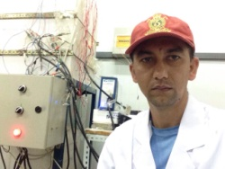
CORROSION BEHAVIOR AND DURABILITY OF MICROSTRUCTURE OF STAINLESS STEEL REBARS IN SIMULATED CONCRETE PORE SOLUTION CONTAINING CHLORIDE WITH DIFFERENT PH

D.B. Subedi, J.H. Dong
State Key Laboratory of Corrosion and Protection, Institute of Metal Research,
Chinese Academy of Sciences, 62 Wencui Road, Shenyang 110016, China

Corrosion is a problem of science and technology. It cannot eliminate completely although the corrosion control is becoming more practical and achievable to decrease its rate. Nowadays, the corrosion control method of metals and alloys using various types of eco-friendly coating to save passive film on metal surface is becoming a fundamental academic and research concerns corrosion scientists.

All the experiments were conducted under static or dynamic flow conditions at room temperature. The corrosion rate evaluations were implemented by electrochemical measurements (open circuit potential, linear polarization, potentiodynamic polarization, and electrochemical impedance spectroscopy), while surface analytical techniques (SEM/EDS, XRD and XPS) were employed to examine and characterize the compositions, microstructure of alloys and the corrosion product films.
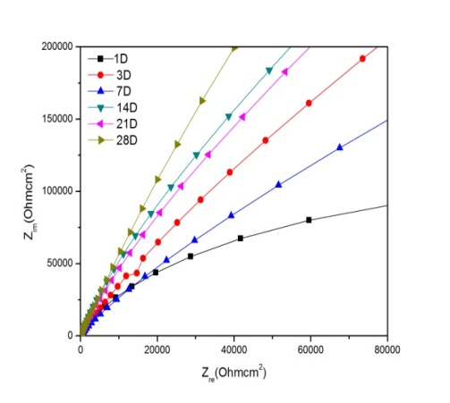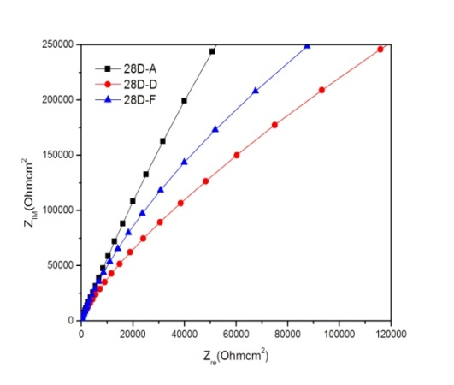
Fig1;Nyquist plot, 1-28day Austenitic Stainless Steel Fig1; Nyquist plot of three Stainless Steel

The corrosion resistance performance of the different stainless steel, 304ss, 410ss and 2304ss
Ware evaluated in different chloride condition at 9.3 pH comparing with microstructure and mechanism of passivation film formation. EIS results of both accelerated corrosion tests showed the corrosion resistance performanceof different alloys
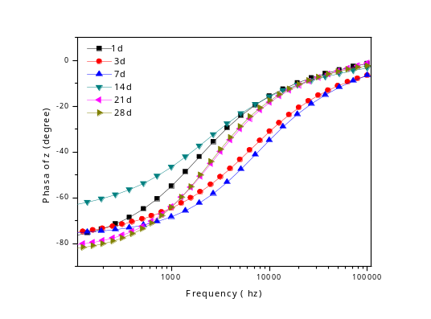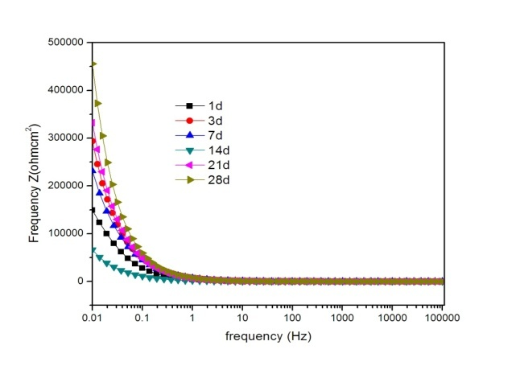
Fig; Phase and Bode plot of Austenitic stainless steel for 1- 28day

The results of a study examining the Cl_ induced corrosion resistance of austenitic,duplex, and ferritic high-strength stainless steels in simulated alkaline and carbonated concretesolutions during exposed to carbonated solutions, corrosion resistancewas reduced and only duplex grades 2304SS exhibited high corrosion resistance.
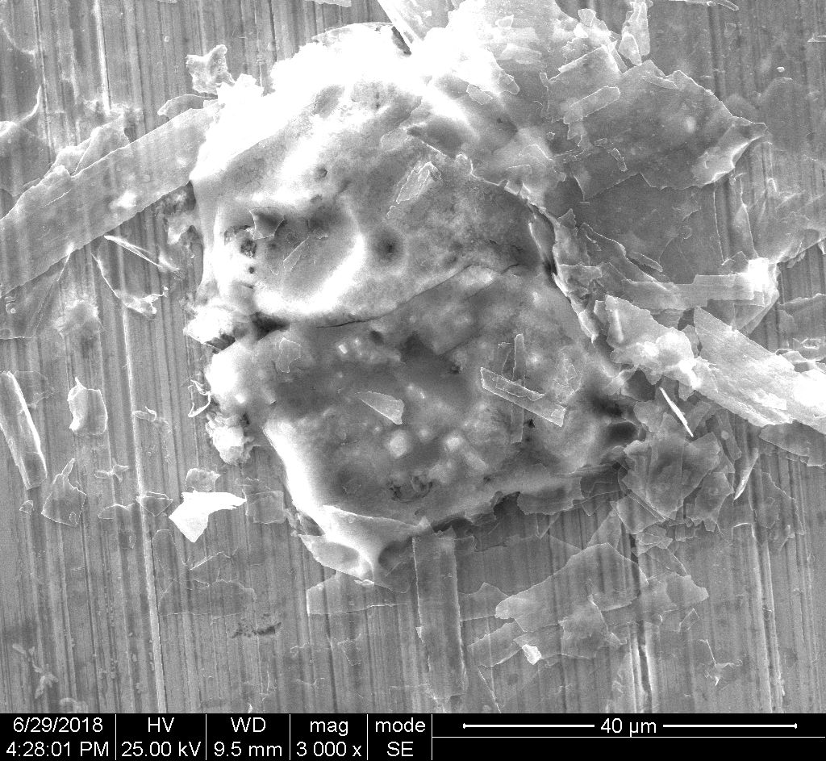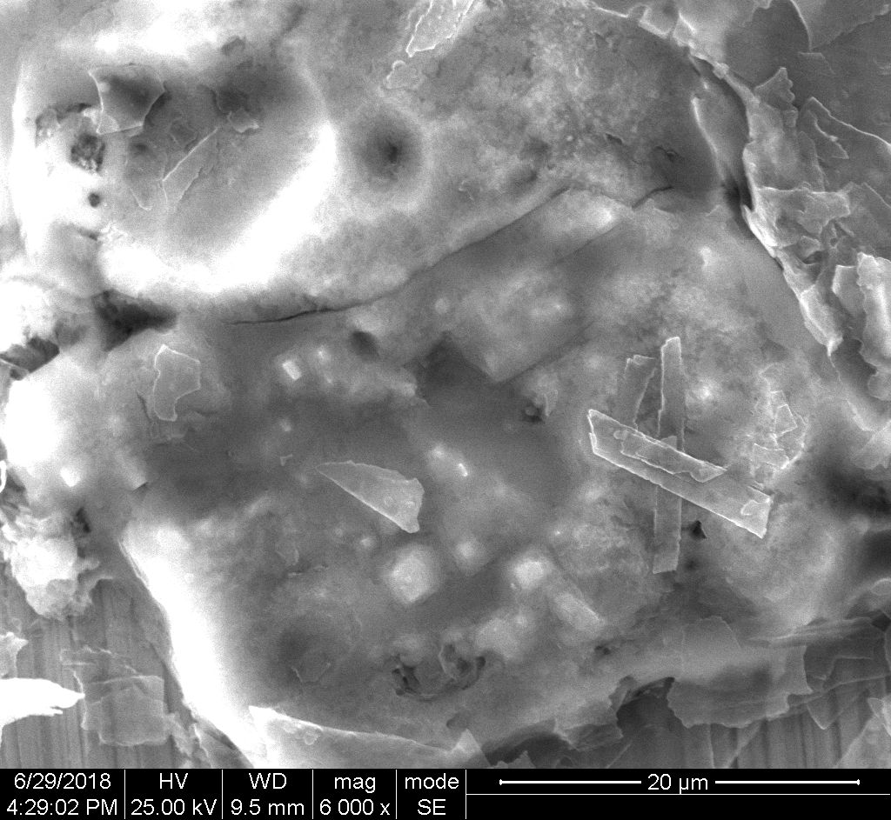
Fig; surface srtructure of duplex stainless steel after 14 days

A strong correlation between microstructural defects and corrosion damage was observed by the help of morphology of SEM picture and optical observations. The pitting corrosion behavior of 304ss, 2304ss and 410ss in 3.5% NaCl solution has been investigated by electrochemical noise M-S Curve and the experimental data was analyzed based on stochastic theory. The change in the pit initiation site and the outstanding repassivation ability of 2304ss thin film determined that metastable pit events occurred more frequently and the probability of stable pits developing from metastable pits was lower than that of 304ss and 410ss, which improved the pit corrosion resistance of duplex thin film.he difference between growth mechanisms of stable pits on two materials led to different corrosion resistance, thus enhancing the pit corrosion resistance of duplex thin film compare to other two alloys.

Resarch work related image/table (If Applicable)

Recent Publications

1. Dhruba babu subedi, Durga Bhakta pokhrel and Jagadeesh Bhattarai, Study the Corrosion Inhibition Effect of Sodium Tungstate for Chromium-based Ternary Alloys in 0.5 M NaCl solution, Chem Sci Rev Lett 2014, 3(12), 1190-1198

2. Dhruba babu subedi, Durga Bhakta pokhrel and Jagadeesh Bhattarai, Study the Corrosion Inhibition Mechanism of Sputter-Deposisited W-42Cr-5Ni and Cr-10Zr-10W Alloys By Sodium Nitrate As Green Inhivitor in 0.5 M NaCl and 1 M NaOH Solutions, (2014) Int J Appl Sci Biotechnol, Vol 2(4): 537-543

3. Durga Bhakta pokhrel, Dhruba babu subedi and Jagadeesh Bhattarai, Study the Effect of Sodium Nitrite as a Green Corrosion Inhibitor for the Sputter-deposited Tungsten-based Ternary Alloys in 0.5 M NaCl Solution, BIBECHANA 12 (2015) 1-12 : p. 2

Biography (100-200 words)

XXXX has completed his PhD at the age of 25 years from Andhra University and postdoctoral studies from Stanford University School of Medicine. He is the director of XXXX, a premier Bio-Soft service organization. He has published more than 25 papers in reputed journals and has been serving as an editorial board member of repute.

Dhruba babu Subedi is a Physical Chemistry Graduate with a research interest on the material chemistry, corrosion and nano science. He has completed M. Sc. in Physical Chemistry with first division with dissertation from Tribhuvan University, Kathmandu, Nepal.
I had completed my dissertation entitled “STUDY OF THE CORROSION INHIBITION EFFECT ON SPUTTER-DEPOSITED W-xCr-yNi ALLOYS BY NITRITE, MOLYBDATE AND TUNGSTATE IN 0.5 M NaCl.” under the guidance of Prof. Dr. Jagadeesh Bhattarai, my supervisor, for the partial fulfillment of masters degree of science in chemistry.

His research is mainly focused to measure the corrosion inhibition mechanism, to measure open circuit potential and study the effects of different concentrations of sodium nitrite, sodium molybdate and sodium tungstate as a corrosion inhibitor on the passivation behavior of the sputter-deposited ternary amorphous or/and nanocrystalline W-xCr-yNi alloys in 0.5 M NaCl solution open to air at 25ºC. He has published more than 3 papers in reputed journals and has been serving as member of nepal chemical society and nepal polymer society. He had present his research work at more than 15 international conference in different country.

At present he has doing reseach work at institute if metal research, china as a phd scholar regarding chnese goverment scholarship.

E-mail:dhrubacsubedi@gmail.com
Presenting author details
** Full name: DHRUBA BABU SUBEDI
**Mobile Number: +86 18524436250
**Linked In account :
**Session name/ number:
**Category: Oral presentation
**Date of Birth: 1985/06/06

