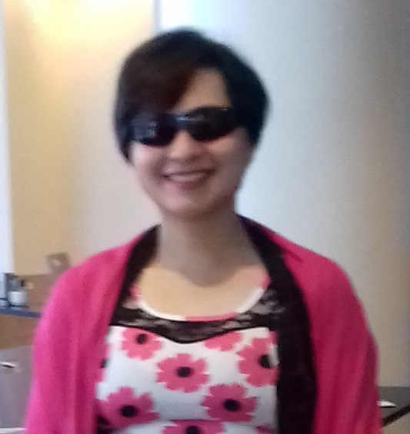

Title: An E-Survey of Proton therapy in Cancer treatment in USA.

Name: Auj-E Taqaddas
Research Medical Physicist (Independent), Research Wormhole, Canada.

Abstract

Proton therapy (PT) is used in Radiation Oncology to treat cancer patients. PT offers advantages in terms of high Linear energy transfer (LET), better Radiobiological Effect (RBE), low integral dose and less dose to organs at risks while providing conformal plans. Various techniques are employed to plan and deliver Proton Therapy across the world. Comparative studies of PT and Photon 3DCRT, IMRT, and VMAT are limited and in some cases provide conflicting data. More over there is shortage of studies comparing various PT planning and delivery techniques.

The use of Proton Therapy in cancer treatment is increasing globally. New centres are in line to open up in near future. Therefore it is important to draw on the knowledge and experience of experts already working in PT centres and hospitals to provide better PT treatment to cancer patients.

This e-survey was carried out in United states of America (USA) to better understand the role of proton therapy in treatment planning and delivery and to improve the education and skill base of Proton therapy treatment. This is a unique study and first of its kind. The results of the study intend to provide beneficial information to both current Proton therapy centres/hospitals but also to upcoming new centres in different parts of the world so that cancer management could be improved.

Biography

Miss A. Taqaddas is British-national with degrees in two disciplines from UK-MSc Medical Physics and BSc (Hons) Therapeutic Radiography. In 2012 she completed Radiation Protection Supervisor training. Her publications cover multiple disciplines and is author of first concise physics book on VMAT. She was first person to do A survey of IMRT and VMAT in UK in 2014. She did research projects in various countries from 2010-2018 and presented her work in international conferences/seminars in USA, Norway and Australia. She acted as a program-chair in ICRM-2014 conference. She works as independent Research Medical Physicist and a journal reviewer.

Presenting Author details

Full name: Auj-E Taqaddas
Email: aet97@my.open.ac.uk
Category: Oral presentation

