Abstract
Background: Laryngeal cancer and oral cancer are not always correlated with genetic mutations, HPV infection, smoking, and alcohol abuse. In the absence of these risk factors, there is an increase on these cancers with a parallel increase of diabetes. The aim of this study is to verify if diabetes could be a risk factor for the laryngeal cancer.
Methods: A questionnaire was given to a group of ninety laryngectomees to verify if these patients have presented diabetes and xerostomia before surgery. In two groups, diabetics and healthy persons, the values of the salivary mucins and the pH were evaluated. The results were statistically analysed using Fisher Exact Test and Chis quareTest
Results: Diabetes is a risk factor: p= 0.0445 for laryngectomees male vs control group. Xerostomia inlaryngectomees male is a risk factor: p= 0.050. The values of mucins and pH in diabetic group show significant difference: p=0.05 vs control group
Discussion: In all autoimmune diseases, a decrease in the value of pH and salivary flow consequently decreases the value of spinnbarkeit which measures the capacity of the mucous layer to adhere to the epithelium and alter the protective oral mucin layer. We find that diabetes is epidemiologically correlated with laryngeal cancer. In fact, only diabetes increases the concentration of salivary mucins with a formation of mucin layer even more reduced, and so completely ineffective in protecting the mucosa. Conclusions: The increase of mucin secretion in diabetes alters much the protective layer allowing the risk factors to promote cancer growth

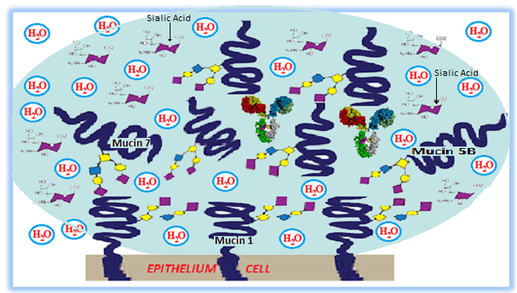
REFERENCES

1-Menicagli, R., Duca, M., Rancoita, Course - Conference on “ update on the Laryngeal cancer “ Milan 9April 9 ;2016
2-Végh D, Bányai D, Ujpál M. [Change in the incidence of diabetes mellitus in oral cancer patients based on a long-term comparative study].FogorvSz. 2015 Mar;108(1):9-12.

3-Vijay A¹, Inui T², Dodds M², Proctor G¹, Carpenter G¹ Factors That Influence the Extensional Rheological Property of Saliva.PLoS One. 2015 Aug 25;10(8):13-22
4-Gibbins HL¹, Proctor GB, Yakubov GE, Wilson S, Concentration of salivary protective proteins within the bound oral mucosal pellicle.Oral Dis. 2014 Oct;20(7):707-13
5-Behera SK¹, Praharaj AB², Dehury B¹, Negi S^{3.} Exploring the role and diversity of mucins in health and disease with special insight into non-communicable diseases Glycoconj J. 2015 Nov;32(8):575-613.

