Using anti-poly(ethylene glycol) bioparticles for the quantitation of PEGylated nanoparticles
Yuan-Chin Hsieh, PhD, Kaohsiung Medical University,Taiwan

Abstract (300 word limit)

Attachment of polyethylene glycol (PEG) molecules to nanoparticles (PEGylation) is a widely-used method to improve the stability, biocompatibility and half-life of nanomedicines. However, the evaluation of the PEGylated nanomedicine pharmacokinetics (PK) requires the decomposition of particles and purification of lead compounds before analysis by high performance liquid chromatography (HPLC), mass spectrometry, etc. Therefore, a method to directly quantify un-decomposed PEGylated nanoparticles is needed. In this study, we developed anti-PEG bioparticles and combined them with anti-PEG antibodies to generate a quantitative enzyme-linked immunosorbent assay (ELISA) for direct measurement of PEGylated nanoparticles without compound purification. The anti-PEG bioparticles quantitative ELISA directly quantify PEG-quantum dots (PEG-QD), PEG-stabilizing super-paramagnetic iron oxide (PEG-SPIO), Lipo-Dox and PEGASYS and the detection limits were 0.01 nM, 0.1 nM, 15.63 ng/mL and 0.48 ng/mL, respectively. Furthermore, this anti-PEG bioparticle-based ELISA tolerated samples containing up to 10% mouse or human serum. There was no significant difference in pharmacokinetic studies of radiolabeled PEG-nanoparticles (Nano-X-¹¹¹In) through anti-PEG bioparticle-based ELISA and a traditional gamma counter. These results suggest that the anti-PEG bioparticle-based ELISA may provide a direct and effective method for the quantitation of any whole PEGylated nanoparticles without sample preparation.
Image
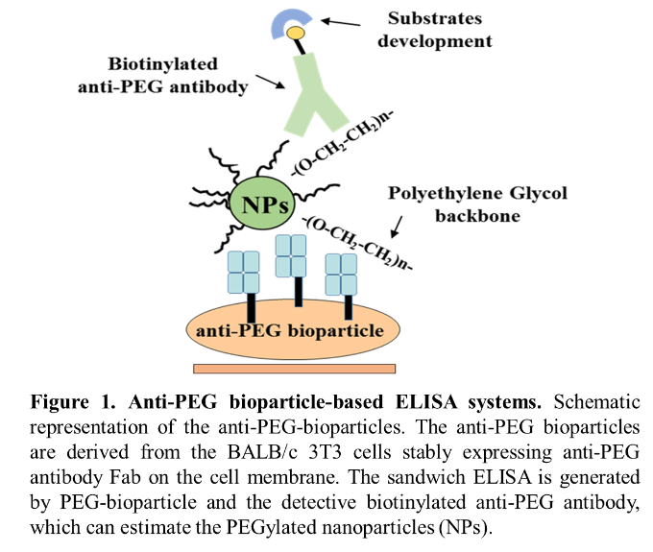
Recent Publications (minimum 5)
- Hsieh YC (2016) Using anti-poly(ethylene glycol) bioparticles for the quantitation of PEGylated nanoparticles. Sci Rep. 2016 Dec 19;6:39119.
- Lin WW, Hsieh YC (2016) Optimization of an Anti-poly(ethylene glycol) (anti-PEG) Cell-Based Capture System To Quantify PEG and PEGylated Molecules. Anal Chem. 2016 Dec 20;88(24):12371-12379.
- Chuang KH, Hsieh YC (2014) High-throughput sorting of the highest producing cell via a transiently protein-anchored system. PLoS One. 2014 Jul 18;9(7):e102569.

Biography (150 word limit)
Yuan-Chin Hsieh has expertise in antibody engineering (antibody cloning & murine antibody humanization) and development PEGylated drug sandwich quantification system. He develops the bioparticle based ELISA system for sensitivity quantitate the concentration of PEGylated nanomedicine. The anti-PEG antibody Fab were expressed on the cell surface to form anti-PEG bioparticles and combined it with anti-PEG antibodies to generate a quantitative ELISA. The system provides a direct and effective method for the quantitation of any whole PEGylated nanoparticles without sample preparations.

Email:yangchin1014@gmail.com

Notes/Comments:

