“remote sensing assessment and spati-temporal analysis of ecological carrying capacity”



Hamza Sadaqat [18-ARID-3301]
ADNAN SAJID [18-ARID-3286]
Salar Ali [18-ARID-3326]

Faculty of Agricultural Engineering and Technology
Institute of Geo-Information & Earth Observation
PIR MEHR ALI SHAH
ARID AGRICULTURE UNIVERSITY RAWALPINDI
PAKISTAN
2021

DEDICATION
This work is dedicated to my beloved friends and our project supervisor.

CONTENTS
Page
List of Tables ix
List of Figures x
Acknowledgements xi
Chapter 1 Introduction 1
1.1 BACKGROUND 1
1.1.1 INDUS BASIN 1
1.1.1.1 PROBLEM STATEMENT 2
Chapter 2 Literature Review 4
2.1 SPATIO TEMPORAL ANALYSIS 3
2.1.1 INDICES SELECTION 4
2.1.1.1 WEIGHT DETERMINATION 5
Chapter 3 Material and Methods 6
3.1 FLOW CHART 7
3.1.1DATA SOURCES 8
3.1.1.1 PROCEDURE 8
Chapter 4 Results and Discussion 9

4.1.1 OVER ALL SPATIO TEMPORAL ANALYSIS 10
4.1.1.1 DISCUSSIONS 11
SUMMARY 12
LITERATURE CITE 13

Abbreviations

USGS – United states geological survey
et – evapotranspiration
ndvi – normalized difference vegetation index
ndwi – normalized difference water index
ecc – ecological carrying capacity
dem – digital elevation model

List of Tables

TABLE: PAGE:
Table 1: Results of factors on ECC 10
Table 2 : Effects of NDVI on ECC 10
Table 3 : NDVI and NDWI effect on ECC 11
Table 4 : Resultant Table 11

List of Figures

FIGURE: PAGE
Figure 1: STUDY AREA 03
FIGURE 2: RESULTANT MAPS OF ECC 09

Acknowledgements

First thing first, I am thankful to Allah who granted us courage and will to fulfill this task. Then, we want to mention our supervisor Sir Farhan because of being under his supervision we completed our project as he guided us completely with his knowledge and experience whenever we ended up in blind valley.

SALAR ALI
ADNAN SAJID
HAMZA SADAQAT

Introduction

background:-
This research entitled Remote Sensing Assessment and Spatio-Temporal Analysis of Ecological Carrying Capacity. The study area that we mainly focused on was Indus Basin and our area of interest is Central Basin of Indus in Pakistan that is located in Punjab. Formula for Ecological Carrying Capacity was derived on basis of Weight Determination through AHP (Analytical Hierarchy Process.

INDUS BASIN:
The Indus River is one of the most important water systems in Asia. The Indus River originates near Kailash Range in Tibet and, thereafter, it flows to the west, eventually falling into Arabian Sea. The main river Indus is about 2,000 miles long. The total area of Indus basin, the area draining the Himalayan water into the Arabian Sea, is about 365,000 square miles.

PROBLEM STATEMENT:
Growing populations and increasing development are placing mounting pressures on the Indus Basin’s water supplies. In Pakistan, total annual water withdrawals have risen from 153.4 km3 in 1975 to 183.5 km3 in 2008, while total annual renewable water resources per capita have plunged from 3,385 cubic meters (m3) in 1977 to 1,396 m3 in 2011. Over the same period, total annual water withdrawals in India have doubled, leaping from 380 km3 in 1975 to 761 km3 in 2010, while annual renewable water resources per capita have tumbled from 2,930 m3 in 1977 to 1,539 m3 in 2011. The intensifying strain on Indus basin can result in diminishing water flow and lower water tables.(www.wikipedia/indusbain.com)
Stalinization and water logging is also increasing in the Indus basin area which is also alarming and problem for water resources in downstream countries and upstream countries are also aggravating the ecological crisis in Indus Basin. Therefore, it is important to identify the trends and causes of ecological change in the whole region.( He Y, Xie H.2019)
There have been very researches made on ecological changes of Indus Basin. Some of analyses were like crop intensities of irrigation systems or run-off formations. These researches mainly concentrated on the analysis of water resources and vegetation changes. They only analyzed the changes of the single ecological factor in one article. Therefore, these studies can’t fully reflect the ecological changes in the Indus Basin.
Ecological carrying capacity (ECC) was advanced on the basis of carrying capacity, along with an understanding of human -resources -environment social economic systems. . In the existing researches, the main methods used in ECC assessment of arid and semi -arid regions are the net primary productivity (NPP), the ecological footprint (EF), comprehensive index evaluation method and system dynamics model
Recently, the geographic information systems (GIS) and remote sensing (RS) technology have developed rapidly. The development provides abundant data for the study of the ECC and enables the results to have more obvious and accurate spatiotemporal characteristics. Based on Landsat images we can explore Spatiotemporal changes in Ecological Carrying Capacity of Indus Basin from given period of time and can propose policy suggestions, including improving urban land use efficiency and implementing scientific planning landscape patterns. .( He Y, Xie H.2019)
STUDY AREA:
The Indus River is one of the most important water systems in Asia. The Indus River originates near Kailash Range in Tibet and, thereafter, it flows to the west, eventually falling into Arabian Sea. The main river Indus is about 2,000 miles long. The total area of Indus basin, the area draining the Himalayan water into the Arabian Sea,
is about 365,000 square miles.

(FIGURE 1.1)
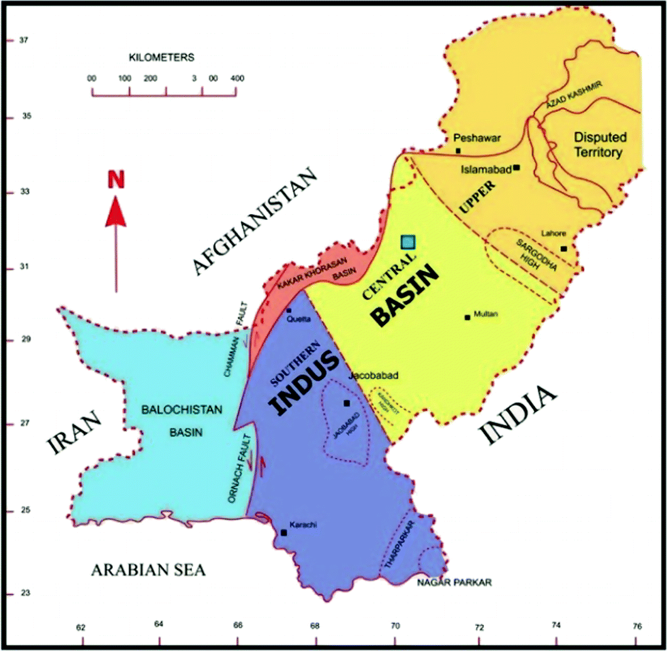

data literature

2.1 SPATIO TEMPORAL ANALYSIS:
Spatio-Temporal Analysis is a scientific approach to analyze clusters encouraged by increasing data collection and processing power due to technology advancement. At time t and location X an event will be enlisted as Spatio temporal event because these both X and t is used to describe the event. Spatio temporal Analysis of Indus basin is carried to check the change detection in 2011, 2016 and 2021. These changes were cross checked with different datasets like precipitation data or temprature data Etc.

Ecological Carrying capacity:
The carrying capacity of an environment is the maximum size or amount of biological species that can sustained in an environment given food, water and other resources. ECC was found for Indus basin to verify that changes occurring naturally due to urbanization and increased population. ECC can be effected by different factors like Evapotranspiration, Vegetation, Urbanization, Rainfall, and temprature.

Indices selection:
With the feature of the continental climate, annual precipitation in the Indus basin is low. The runoff of two major rivers in the Indus Basin is mostly concentrated in the upstream region. The percentage of the annual runoff in the upstream region is 59%. However, irrigated crop production is mainly existed in the downstream countries which own few water resources. Due to the scanty rainfall and uneven distribution of the runoff, water is a crucial factor that affects the eco -environment in the Indus Basin. According to the importance of water, the main watercourse buffer, the downstream buffer and Evapotranspiration (ET) were selected as three evaluation indices. Considering the ecological significance of the water, regions which are closer to rivers have better eco -environment. The main watercourse buffer represents the accessibility of water resources. Regions near the main watercourse have low buffer value and good eco -environment. So, the main watercourse buffer was chosen as a negative index. The drainage system data were used to calculate the main watercourse buffer by the Arc GIS software. Dams and reservoirs operations strengthen the uneven distribution of the water in upstream and downstream regions. Thus, the downstream buffer reflects the difference of water supply in the upstream and downstream areas and was chosen as a positive index. The country boundary data were used to calculate the downstream buffer by the Arc GIS software. Journal Pre-proof Journal Pre-proof 9 Evaporation is an essential part of the water cycle. It is the main causes of water losses. MODIS ET product provides the terrestrial ET data which includes evaporation from wet and moist soil, from rain water intercepted by the canopy before it reaches the ground, and the transpiration through stomata on plant leaves and stems (Mu et al., 2005). It was used to obtain the ET value. And ET was chosen as a negative index. Vegetation plays a significant role in the ecosystem and is sensitive to the changes of ecological factors. The quality of vegetation growth indicates the vitality of the ecosystem, especially, in arid and semi -arid areas (Yang et al., 2012). It is an important indicator of the eco -environment assessment (Liu et al., 2019). Normalized difference vegetation index (NDVI) is the normalized ratio of red and near -infrared (NIR) reflectance, which is generally considered as a good indicator of vegetation activity. Therefore, NDVI was selected as the fourth evaluation index. MODIS NDVI product was used to acquire the NDVI value in the study.

WEIGHT DETERMINATION:

AHP is a multi -objective decision analysis method combining the qualitative and quantitative criteria. It is widely used to determine weights. The study combines d the AHP and Expert s Mark to ascertain the weight of each index. The weights of water and vegetation were determined by the Expert s Mark and weights of indicators in the index layer were decided by the AHP.
- AHP (ANALYTIC HERARCHY PROCESS) AND WEIGHT DETERMINATION OF INDICATORS REPRESENTED BY (H):
- Precipitation=h1=(1*1/6*1/8*1/9*1/4) p=1/5-------------0.2252
- ET=h2=(6*1*5*7*3) p=1/5--------0.129
- Temperature=h3=(8*1/5*1*4*2) p= 1/5------0.3490
- Urban projects=h4=(9*1/7*1/4*1*9) p= 1/5------0.2788
- Waste material=h5=(4*1/3*1/2*1/9*1) p= 1/5--------0.4345
VECC=0.6*VNDVI-0.1*VET+0.2*Vdownstream -0.1* Vwatercourse
Where VECC is the value of the ecological carrying capacity, VNDVI is the value of NDVI, VET is the value of ET, Vdownstream is the value of downstream buffer and V(watercourse) is the value of main watercourse buffer. Divided the value of ECC into 5 parts with the same interval and each interval represents different level of the ECC
-0.2 - 0 Worse Ecological Carrying Capacity
0.0 – 0.2 Bad Ecological Carrying Capacity
0.4 – 0.6 Good Ecological Carrying Capacity
0.6 – 0.8 Well Ecological Carrying Capacity

3.1 MATERIALS AND METHODS:

3.1.1 FLOW CHART:
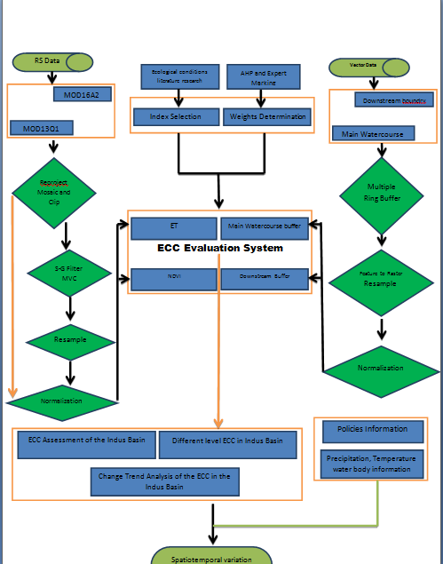

3.1.1.1 DATA SOURCE:
Data used in this study are MODIS DATA products MOD13Q1 and MOD16A2 which were used to calculate NDVI and Evapotranspiration. First the data was normalized and then NDVI and Evapotranspiration were calculated. DEMs were used to calculate Main water course and downstream. Landsat Images were used to identify land use and land cover. Temprature and precipitation data was used for final analysis and results and decisions.
- Landsat images with 30m spatial resolution from USGS.
- DEMs downloaded from USGS.
- NDVI products from Climate Engine. (2011,2016,2021)
- NDSI products from Climate Engine. (2011,2016,2021)
- Evapotranspiration product from Climate Engine. (2011,2016,2021)
- Country Boundary from DIVA GIS.
- Temprature data from climate engine. (2011,2016,2021)
- Precipitation data from climate engine. (2011,2016,2021)
- Land Use data from European space agency.
- Indus basin shape file from Global Run-off data center.
- MOD13Q1 and MOD16A2 from climate engine.

3.1.1.1 PROCEDURE:
NORMALIZATION:
To eliminate the difference (magnitude, units and so on) among the indicators, this study adopted a unified dimensionless treatment to make the standard value between 0 and 1. All the indicator data were processed in this way.
Xs = x - min(x) / max (x ) –min (x)

DATA ABSTRACTION:
Data that has been normalized will be abstracted by area of interest using extract by mask tool. Now all the data downloaded will be abstracted in the same way.
STREAM FLOW:
- DEM will be uploaded and Fill tool will be applied.
- After Fill tool, Flow Direction tool will be applied on the resultant.
- Flow accumulation tool will be applied on the last resultant.
- Stream order will be applied on Flow accumulation resultant.
- Finally the stream order will be converted into poly line using Raster to Poly line tool.
- Our mainstream and downstream is calculated.
MULTI BUFFER ANALYSIS:
Multi buffer analysis will be performed on our vector data which we have recently extracted from our DEM data. Buffers are applied to view our area of interest more precisely. Once multiple buffers are applied we have complete data to find out ECC of one year.
RASTER CALCULATOR:
Raster calculator is used to compute formulas and generate resultant maps. Hence we will open our raster calculator and apply the formula of ECC on it and our maps will be generated for one year same procedure will be repeated for other two years as well.

4.1 RESULTS AND DICUSSION:

4.1.1 OVERALL SPATIO TEMPORAL VARIATIONS OF ECC IN INDUS:
Considering the little spatial heterogeneity in the smaller grids, the study set up grids with 1 0 km × 1 0 km to evaluate the ECC of the Indus basin. The grids contain the Journal Pre-proof Journal Pre-proof 15 result of four normalized indexes weighted calculation and facilitate the intuitive spatial expression and regional analysis of the ECC. Then, the study calculated the percentage of areas in the ASB of the ECC with different level.
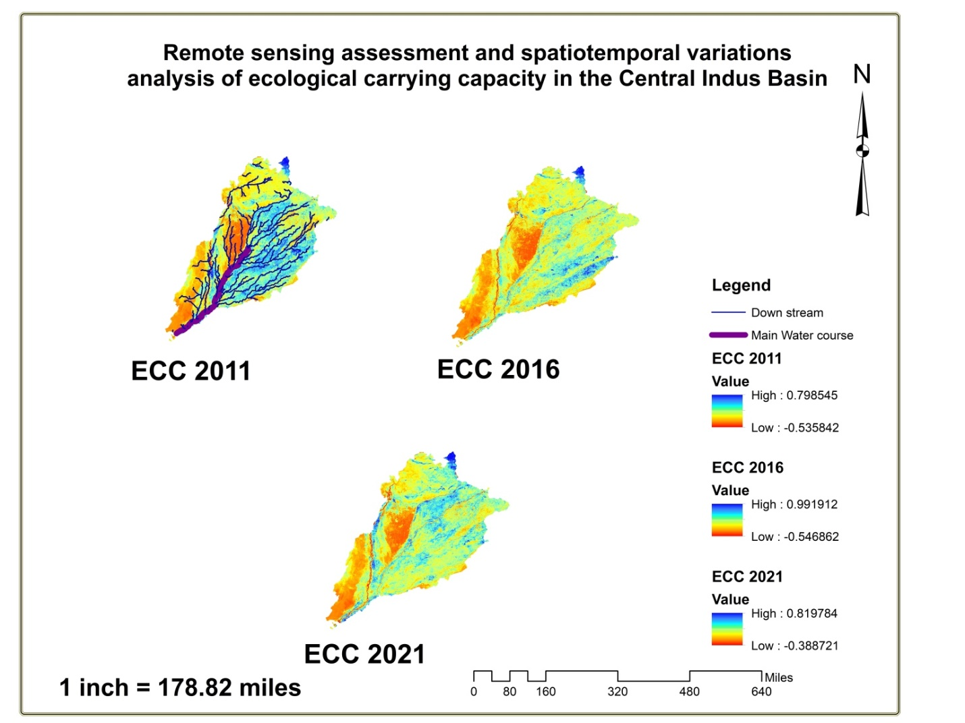

RECOMMENDATIONS:
On the basis of analysis performed we have came to an opinion that ECC of central basin of Pakistan is yet stable. But as we know ECC depends upon different factors so Annual Rainfall, temprature may affect ECC of the basis. Most of the basin can be affected by urbanization and increase of population that will not be helpful in sustaining our eco environment. So by controlling population and water losses in the basin we can control Ecological Carrying Capacity.
4.1.1.1 DISCUSSIONS:
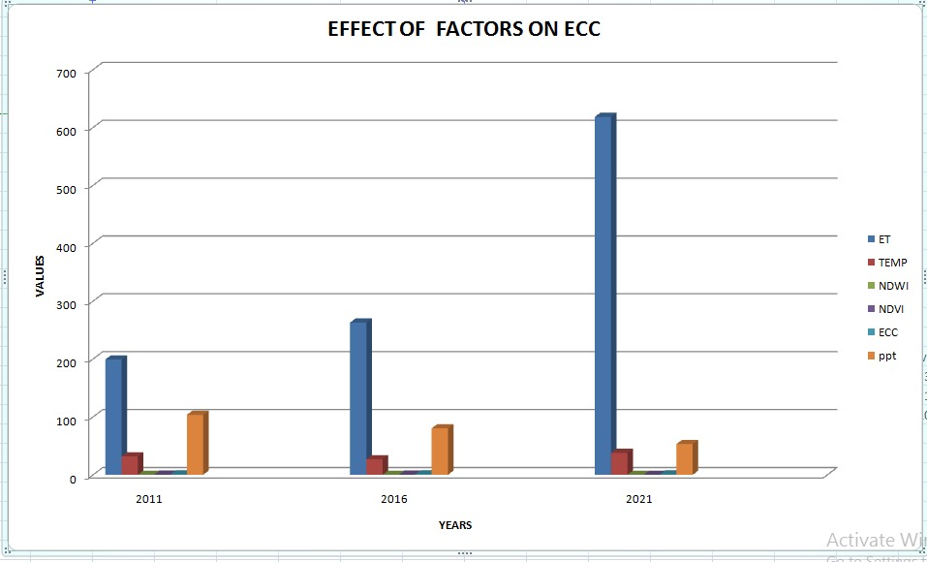
TABLE NO.1
- This chart is showing the effect of Evapotranspiration on ECC. As you can see it in the chart. The value of ET has increased significantly with the passage of time.
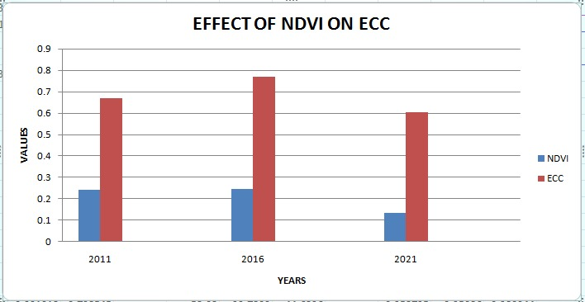
TABLE N0.2
- The results are absolutely clear that NDVI is directly proportional ECC. The more good is vegetation the better would be our ECC.

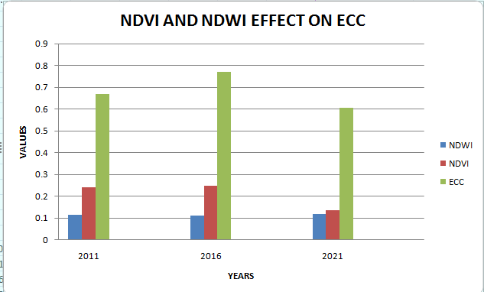
TABLE NO.3

RESULTANT TABLE:
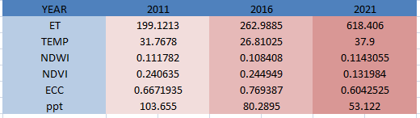
TABLE NO.2

Summary
Spatio temporal Analysis performed to calculate ECC of Indus Basin. Indus basin is facing threatening alarms like melting of glaciers, rise of temprature, flooding, water losses, water logging, salinity and urbanization. This will overall affect the ecology of Indus basin. Hence Remote Sensing and GIS techniques were used to calculate this problem. Data was downloaded from different sited of NDVI, ET, LANDSAT IMAGES, MODIS IMAGES, DEMs, Drainage Data, Precipitation Data, Water Data, and Temprature Data. All of these were combined and were analyzed in software like ERDAS and ARC GIS. Formula of ECC was used in raster calculator to find ECC. ECC of three different years was calculated and was analyzed deeply. The ECC is changing place to place as you can see in resultant maps. ECC of 2011 was medium but improved in 2016 and still good in 2021 but the figures can come down as the urbanization is increasing and temprature is also significantly increasing. So all the necessary steps must be taken to control the ecology of Indus basin.

Literature cited
- Zhang,M.;Liu,Y.;Wu,J.;Wang,T.Indexsystemofurbanresourceandenvironmentcarryingcapacitybased on ecological civilization. Environ. Impact Assess. Rev. 2018
- TaixiaWu,ShanSang,ShudongWang,YingyingYang,Mengyao LiRemote sensing assessment and spatiotemporal variations analysis of ecological carrying capacity in the Aral Sea Basin, 18 MAY 2020
- Bekchanov M, Ringler C, Bhaduri A, Jeuland M. Optimizing irrigation efficiency improvements in the Aral Sea Basin. Water Resources and Economics 2016; 13: 30-45. http://dx.doi.org/10.1016/j.wre.2015
- xiefuju ,zhengmingxi, zhanghong research on ecological environment carrying capacity in yellow river delta 2018;
- He Y, Xie H. Exploring the spatiotemporal changes of ecological carrying capacity for regional sustainable development based on GIS: A case study of Nanchang City

