Inundation patterns in the Moxos Plains in the Yacuma Province, Beni, Bolivia: Mapping the 2014 event.
Javier G. Villegas M.Sc.

Abstract
In the Moxos plains of northern Bolivia, floods cause huge damages. In this region of cattle raising as the main economic activity there is also a unique biodiversity of flora and fauna. Farm and wild animals are affected and many of them dye in a massive manner.
Rainy season begins on November and continues until April. Floods and droughts can occur within a short time span.
The last big inundation event in 2014 was one of an unprecedented magnitude and became a natural disaster with serious consequences; the previous big one occurred in 2008. The rain of year 2014 was reported to be 200% more than usual. The event was analyzed spatially at two scales: regional using MODIS imagery and local using Landsat 8 imagery. The areas were classified according their level of water; inundation covered more than half of the total surface. Using TRMM time series of data, the monthly precipitation was represented geographically also.
The flat slope and the loamy soils are obstacles to the water drainage. Deforestation in the upper hills for implementing crops is mentioned as one of the causes of the flooding. Water remains stagnated for months.
The results of the image analysis became a big help for farmers to recognize the flood patterns; locate heights where the animals can be safe; locate areas suitable for pasture seeding; plan for control measures; and other management measures. In the farm Estancias Espiritu in the Yacuma Province, the managers are incorporating GIS technology like this to carry out their daily duties.

Image
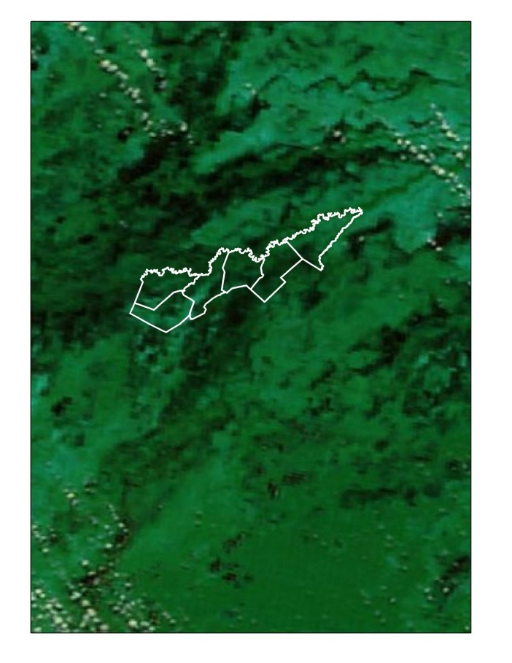
Figure 1. MODIS Terra image of April 18, 2014 showing Estancias Espiritu and surroundings. Band combination 721.

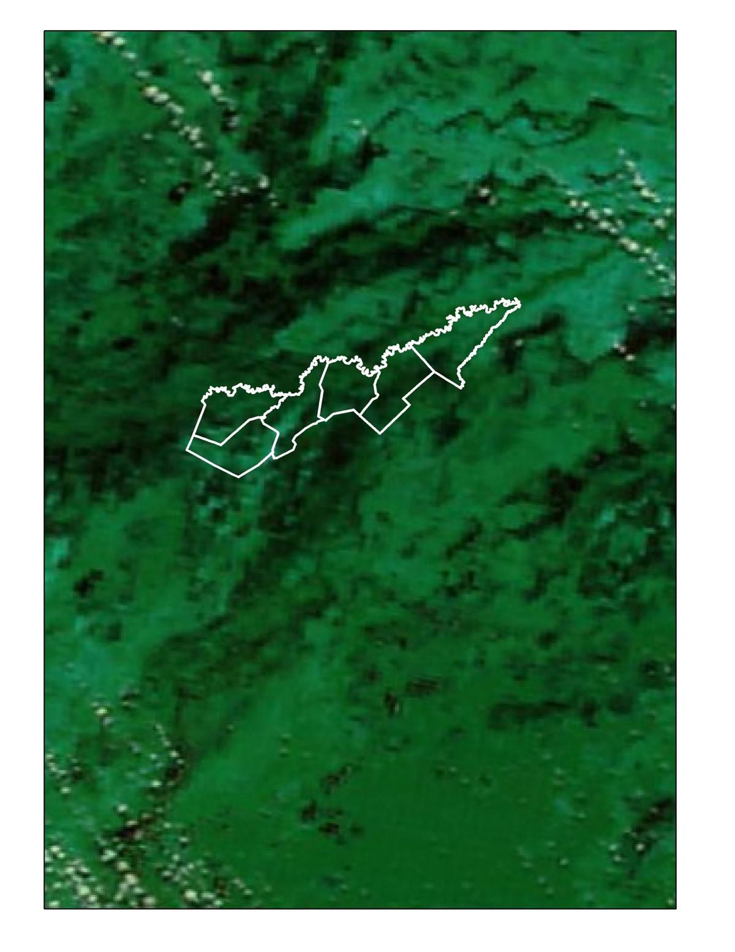
Recent Publications
- Hamilton S, Sippel S, Melack J (2002) Comparison of inundation patterns among major Southamerican floodplains. Journar of Geophysical Research. 107: LBA 5-1-LBA 5-14.
- Huffman G, Bolvin D (2015) TRMM and other data set documentation. 44p.
- Lombardo U, Prümers H (2010) Precolumbian human occupation patterns in the eastern plains of the Llanos de Moxos, Bolivian Amazonia. Journal of Archaeological Science 37:1875-1885.
- Ordoyne C, Friedl M (2008) Using MODIS data to characterize seasonal inundation patterns in the Florida everglades. Remote Sensing of Environment 112: 4107-4119.
- Sippel S, Hamilton S, Melack J, Novo EM (1998) Passive microwave observations of inundation area and the area/stage relation in the Amazon River floodplain. Int. J. Remote Sensing 19(16):3055-3074.

 Biography
Paste your Logo here
Javier Villegas is an agronomist with expertise in the use of Geographical Information Systems and its applications to agriculture and natural resources management. Lately he has been involved in modeling climate change impact on crop productivity and their related socioeconomic consequences.

Email: j.villegas@gpsbolivia.com

Notes/Comments:

Presenting author details
Full name:
Contact number:
Mail id:
Category: (Oral presentation/ Poster presentation)

