SURFACE TEMPERATURE EMISSIVITY ASSESSMENT ON URBAN LAND-USE
IN MINNA,NIGER STATE. NIGERIA
MOHAMMED Abdulkadir and OSEIENEMO Rachel. S
Department of Geography, Ibrahim Badamasi Babangida University, Lapai.
Niger State, Nigeria.
Email:abdulkadirmohammed98@yahoo.com
osesie@gmail.com

Abstract
The aimed of this research is to assess Normalized Difference Vegetation Index( NDVI )emissivity per pixel using Landsat TM and ETM+ satellite data for 2001,2006 and 2012 Landsat satellite data. Continuous monitoring of this parameter is likely to yield information about the suspected climate change. NDVI, vegetation condition index (VCI), and temperature vegetation index (TVX) have been widely used for determining temporal emission on Land surface Temperature (LST) changes and monitoring drought .This was estimated as narrow band emissivity at the satellite sensor in order to have the minimal error in the surface temperature evaluation. Corresponding correlations were obtained between high surface temperature and negative NDVI valuesNDVI,. refers to the difference ratio between land surface reflectance in the Near-infra red and Visible (Red) band. The study further showed that the built up area has expanded by 0.422%of the total land area of Minna in 2001 to 48.17in 2012, vegetation covers reduced from 46.30%to 22.15.The implication of this unprecedented growth is the resulting environmental and ecological problems associated with unplanned urban growth and development such as flooding, urban heat island, etc. Nevertheless greening and due adherence to development control were suggested as measures to control the impending environmental crisis
KEY WORDS: Urban Growth, Land use/ change , Agricultural and Emissivity
  - INTRODUCTION
Status of the vegetation cover is a good indicator of the prevailing climatic conditions of a particular area. Satellite remote sensing facilitates the identification of vegetation cover and the changes over time very effectively compared to the conventional field surveying techniques. The NDVI is a vegetation sensitive indicator that reflects the pattern of pectral responses of ground objects in the visible and near-infrared regions of the electromagnetic spectrum. It is found to be a good indicator of the vegetation characteristics over the land surface. Rouse et al. (1974) defined the NDVI as (NIR-R)/ (NIR+R) where, NIR and IR are the radiances or reflectance’s in the red and near- infrared spectral channels respectively. Chlorophylls in plant leaves causes considerable absorption in the red light region of the electromagnetic spectrum in the incoming light while plant spongy mesophyll leaf structure creates considerable reflectance in the near
infra-red region of the spectrum (Tucker, 1979; Jackson et al, 1983, Tucker et al, 1991).
As a result, vigorously growing healthy vegetation has lower reflectance in the red light region and a higher reflectance in the near infra-red region of the spectrum. This ultimately results in higher NDVI values for the vigorously growing healthy vegetation and it tends to become lower as the greenness of the vegetation decreases. The algorithm produces output values in the range of -1.0 to 1.0. Increasing positive NDVI values indicates increasing amounts of healthy and vigorous green vegetation. The values closer to zero and decreasing negative values indicate non vegetated features such as barren surfaces and water, snow, ice and clouds. Previous works have introduced that the AVHRR derived NDVI images are useful for analyzing spatial vegetation pattern and for assessing vegetation dynamics. Reed et al. (1994) and Yang et al. (1998) have shown that the satellite derived NDVI data have the potential to provide temporal indicators of the onset, end, peak and duration of Vegetation greenness as well as the rate of growth, senescence and periodicity of photosynthetic activity. Through long term data analysis,
trends in such ecological Indicators can also be assessed. Such analyses will then be helpful in improving our forecasting capabilities and could be used in making inferences about climate and drought conditions. Bayarjargal et al. (2000) have used the NOAA/AVHRR data for the detection of drought-affected regions by calculating the
Normalized Difference Vegetation Index (NDVI) and the Land Surface Temperature
(LST) values for the drought and wet years separately. They also have developed a NDVI- LST space based drought indicator that can be used to detect and monitor drought distribution over Mongolia. Adyasuren and Bayarjargal (1995) mapped drought conditions of the Central Asian zone based on the multi-temporal Global Vegetation Index data from 1982-1987. They noticed that when a drought events occur in the Mongolian Gobi Desert zone, The Normalized Difference Vegetation Index (NDVI) values reduce to low values; 0.0-0.05 units, same as value of the extra-arid land. Vegetation cover over the land surface is a good indicator of the occurrence of rainfall over an area. Therefore, NDVI values can also be used in monitoring the occurrences of rainfall at different spatio-temporal scales. Natural Resources and Animal Affairs
Research Centre have studied the vegetation responses and rainfall relationship for the period from 1995 to 1997 for the south western part of Iran using NOAA/AVHRR Images. Their findings showed a higher dependence of NDVI on the rainfall in the previous month. Dayawansa et al. (2002) reported strong correlations among NDVI and the one month lag rainfall for the semiarid, dry and intermediate zones of Sri Lanka for the year 2002. The comparison between the AVHRR derived NDVI values and rainfall data shows dependence of the NDVI values on the sum of the amount of Rainfall during the concurrent month and the two previous months during the two years period from 1996-1997 in two types of semi-arid environments; sand dune and rocky located in the Negev Desert of Israel (Schmidt, 2000). The NDVI values could also be used in prediction of the changes of climatic parameters such as LST. In the Split Window
Algorithm developed by Price (1984), the NDVI values are used to approximate the mean pixel emissivity of each pixel of the images. The combination of NDVI and LST was also proposed as a method for assessing the surface moisture status and fractional vegetation cover over non uniform land surfaces (Carlson et al., 1990; Nemani et al., 1993)
2.1 Study Area
Minna is a town in the middle belt of region of Nigeria it lie at latitude 9 °38 "North to 9 °40 north of the equator and longitude 6°33 "East to 6°37 " east of the Greenwich meridian time, at elevation of 218meters above sea level Minna is located in Niger state. it lies on the valley bed i.e. low land bored to east by Paida mountain spreading east ward toward Maitumbi and northwards towards Maikunkele village to west, and southwards are highlands with all areas essentially savannah with its rich soil capable of sustaining agricultural activities Minna (Bosso and Chanchaga LGAs) share borders with the following Local Government Areas; Shiroro LGA to the North, Wushishi LGA to the West, Gbako LGA to the South-West, Katcha LGA to the South-East and Paikoro LGA to the East.
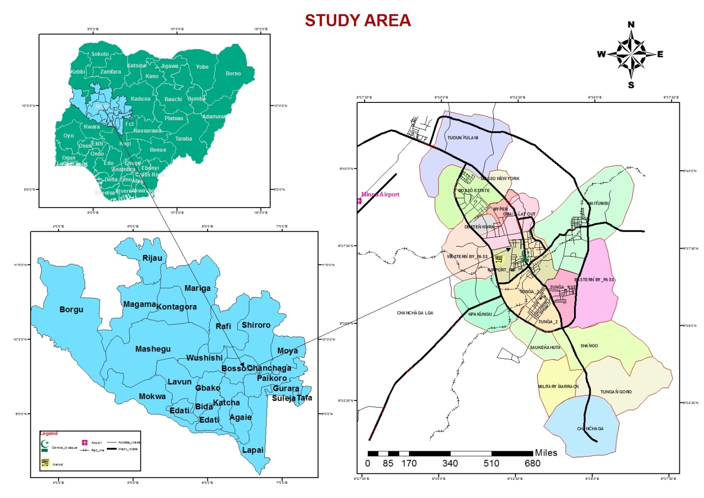
Figure 1.2: Location of Minna Town in Niger state
Source; NASRDA, 2015.
3.1 MATERIALS AND METHODS

3.2 Source of data
The digital data used for this study were collected by Landsat TM and ETM+, and their spectral and spatial characteristics as well as acquisition .
3.3 Data Acquisition
Table: 1
Sensor | Date of  acquisition | Number of  reflective  bands | Number  of thermal  band | Resolution  of  reflective  bands | Resolution  of thermal  bands | Source
TM | 17-03-2001 | 6 | 1 | 30m | 120m | GLCF
ETM+ | 30-01-2006 | 6 | 1 | 30m | 60m | GLCF
ETM+ 6 1 | 20-01-2012 | 6 | 1 | 30m | 60m | GLCF
Source: Author data analysis, 2015
PROCEDURE
The radio- metrically corrected Landsat TM and ETM band 3, 4 and the thermal Infra-red (TIR) data (band6) , was used for this purpose.
The following steps are:
Step 1: Extraction of digital number(DN) from the TIR image;
Step 2: conversion of DN to spectral radiance using
Lᴧ=0.0370588 X DN + 3.2 , Where Lλ is the spectral radiance
Step 3: calculate the effective satellite Temperature using TEs = (K2)/In {(K1/Lλ) +1} , Where K2 and K1 are constants and the values are Landsat TM and Landsat ETM
K1 607.76 666.09 mWcm^2
K2 1260.56 1282.71 K
Step 4: calculate the NDVI , NDVI= (R band 4-R band 3)/(R band 4-R band 3)
Step 5: calculate Emissivity (e) from the NDVI Emissivity (e) =1.094 + 0.047 x In (NDVI)
Step 6: compute the surface temperature (Ts)
Ts = (TEs)/ {1+ [λ x (TEs/ρ)] Ine} , Where λ is the wavelength of the emitted radiance = 11.5µm (Markham and Baker,1985); and ρ = hc/s = 1.438 x 10^2 mK; s =Stefan Boltzmann
constant (5.67 x 10^-8Wm^-2K^4), h = Planck’s constant (6.626 x10^-34Js) and c =2.998 x 10^8 m/s. Lλ=0.0370588 X DN + 3.2
TEs = (K2)/In {(K1/Lλ) +1}
NDVI= (R band 4-R band 3)/(R band 4-R band 3)
4.1 DATA ANALYSIS AND INTERPRETATION OF RESULTS
4.1.1 Analysis of the spatial pattern of NDVI
Spatial variation of NDVI is not only subject to the influence of vegetation amount, but also to topography, slope, solar radiation availability, and other factors (Walsh et al.,1997). NDVI is commonly used as a measure of land surface greenness based on the assumption that NDVI value is positively proportional to the amount of green vegetation in an image pixel area (Liu, 2009). This was verified in this study, the variation of NDVI across Minna, The NDVI values shown in the table are of ranges 0.31 and 0.31 for the years considered. It is observed that lower NDVI corresponds to built-up areas while high NDVI values corresponds to the less developed natural surface all through the year 2005 has the highest NDVI value while 2015 has the lowest NDVI value which indicates that the NDVI value of a place tends to decrease with Urban growth. This low value of NDVI can be mainly attributed to the time of the year in which the images used (Landsat ETM+ bands 3 and 4) were taken. The images were acquired in the early part of the year, when there is little or no rain to aid the greenness of the vegetation which in turn will increase the reflectance of the vegetated area. This shows that most of the vegetation’s across Minna are not photosynthentically active at that part of the year.

LAND USE/ COVER SATELLITE IMAGERY FOR MINNA, 2005
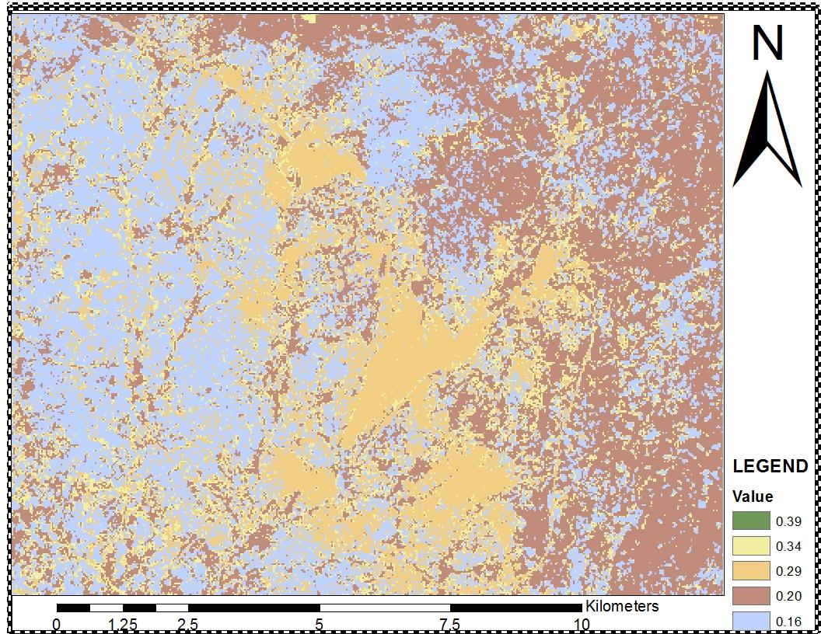
Figure 4.1: NDVI across Minna, 2005.
Source: Field work survey, 2015

4 .2 Land Surface Temperature and Emissivity Distribution.
To examine the spatial pattern of Surface Temperature in Minna, twenty transects were
drawn across the city. This transects passes over various landscapes with different environmental settings, an inquiry into the Urban Heat Island characteristics of the profile will help to understand the factors shaping the city’s thermal landscape. These factors include the spatial pattern of different land–cover classes, the occurrence of water bodies, parks, buildings and population densities and the division of the city’s functional districts, among others (Weng, 2003). The NDVI across minna in 2005 , indicates that the reflectance values of 24.55(Bare-surface), 29.21(Bult-up areas), 15.22(Vegetation), and 23.11(water body).
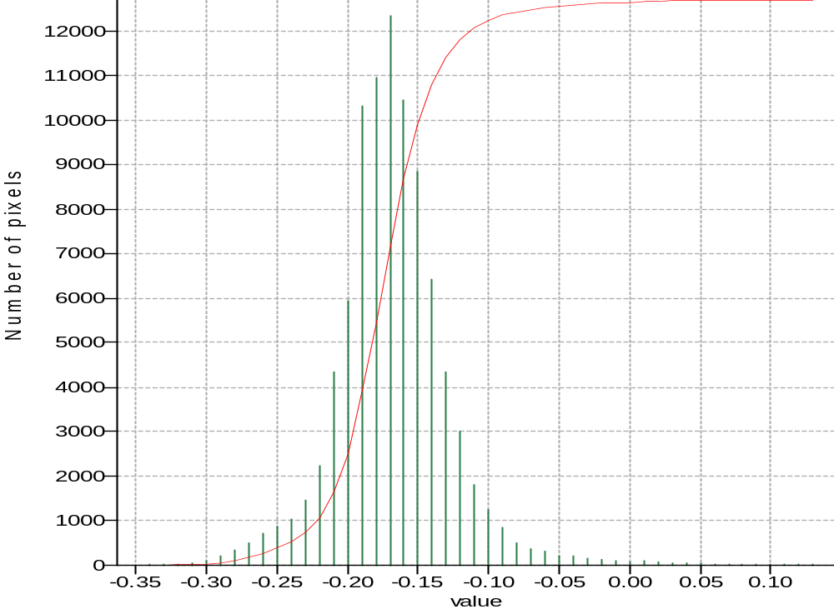
FIG 4.2: Histogram of the Vegetation Reflection in 2001
The NDVI values of vegetation reflectance shown in the histogram in Fig 4.2 ranges from - 0.31 and - 0.00 for the years , indicates that built-up areas has lower values while less developed natural surface all through the year 2005 has the highest NDVI value, 2015 has the lowest NDVI value which indicates that the NDVI value of a place tends to decrease with Urban growth. This low value of NDVI can be mainly attributed to the time of the year in which the images used (Landsat ETM+ bands 3 and 4) were taken. The images were acquired in the early part of the year, when there is little or no rain to aid the greenness of the vegetation which in turn will increase the reflectance of the vegetated area. This shows that most of the vegetation’s across Minna are not photosynthentically active at that part of the year.

LAND USE/ COVER SATELLITE IMAGERY FOR MINNA, 2010
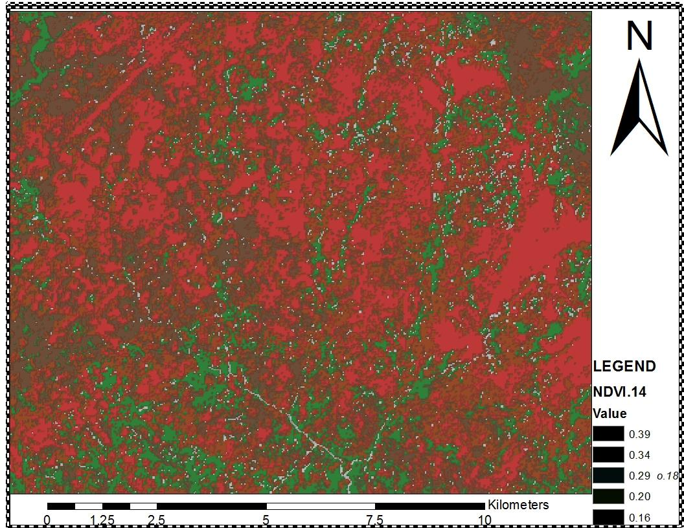
Figure 4.3: NDVI across Minna, 2010.
Source: Author data analysis, 2015
Fig 4.3 show ,that NDVI across Minna in 2010 , indicates that the reflectance values of 22.01(Bare-surface), 30.57(Bult-up areas), 17.40(Vegetation), and 29.11(water body).

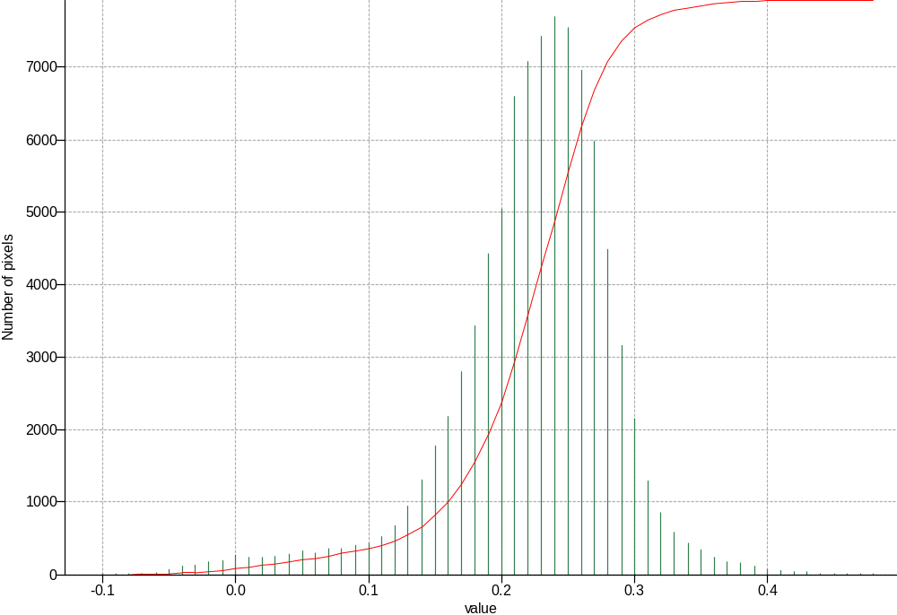
FIG 4.4: Histogram of the Vegetation Reflection in 2006
The NDVI values shown in the Fig 4.4 historam of the vegetation reflectance ranges from - 0.1 and 0.4 for the years . It is observed that built-up areas recorded the lower reflectance values, which corresponds to the less developed natural surface all through the year( 2005 ) which has the highest NDVI value, 2015 has the lowest NDVI value . The range values of NDVI can be mainly attributed to the time of the year in which the images used (Landsat ETM+ bands 3 and 4) were taken. The images were acquired in the early part of the year, when there is little or no rain to aid the greenness of the vegetation which in turn will increase the reflectance of the vegetated area as a result of high temperature. This further indicates that most of the vegetation’s across Minna are not photosynthentically active at that part of the year.

LAND USE/ COVER SATELLITE IMAGERY FOR MINNA, 2015
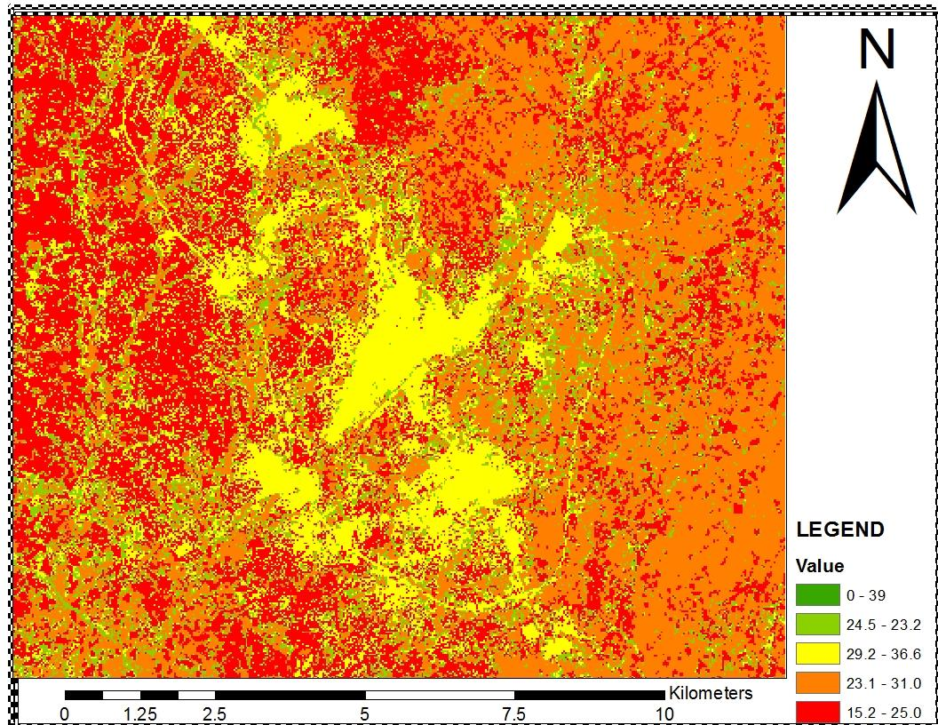
Figure 4.4: Landsat Imagery, 2015
Land Surface Temperature and Emissivity Distribution.
. This transects passes over various landscapes with different environmental settings, an inquiry into the Urban Heat Island characteristics of the profile will help to understand the factors shaping the city’s thermal landscape. These factors include the spatial pattern of different land–cover classes, the occurrence of water bodies, parks, buildings and population densities and the division of the city’s functional districts, among others (Weng, 2003). The NDVI across minna in 2015 , indicates that the reflectance values of 23.21(Bare-surface), 36.60(Bult-up areas), 25.04(Vegetation), and 31.09(water body).
Table 4.1 Summary of Land surface temperatures values for different land use/land cover for 2005,2010 and 2015

S/NO | Land use/land cover | 2005 | 2010 | 2015
1 | Bare -Surface | 24.55 | 22.01 | 23.21
2 | Bult-up Areas | 29.21 | 30.57 | 36.60
3 | Vegetation | 15.22 | 17.40 | 25.04
4 | Water body | 23.11 | 29.11 | 31.09

The Thermal signatures of each land use land cover studied revealed the average values of surface temperature for each of these land use/cover type is shown in Table 4.1 . There was an obvious gradual thermal change from the urban area out into the suburban area.This is observed in the table 4.1 above . In 2005 , 2010, 2015, Bare-Surface temperature reflectance values are 24.55°C, 22.01°C , 23.21°C respectively. Built-up areas are 29.21°C,30.57°C,36.60°C respectively. Vegetation are 15.22°C,17.40°C, 25.04°C respectively and Water body are 23.11°C, 29.11°C, 31.09°C respectively. This implies that the urban area is majorly dominated by impervious surfaces such as concrete, metals and also asphalt on roads which are non-evaporating and non- transpiring. And also exhibits a high potential for absorption and radiation of heat alike with blackbodies, thereby having the highest temperature. The high rate of energy consumption, air-conditioning system, emission of plumes from cars are also part of the factors responsible for the high surface temperature in the urban area.While in table 4.2 below, indicates the LST values for maximum and minimum temperature obtained for different years(2005,2010,2015 in Minna. Maximum temperature(°C ) 29.21, 30.57, 36.60 , and Minimum Temperature(°C ) 17.40, 25.04, 34.22

Table 4.2: LST values obtained for different years in Minna
Year | 2005 | 2010 | 2015
Maximum Temperature(C) | 29.21 | 30.57 | 36.60
Minimum Temperature(C) | 17.40 | 25.04 | 34.22

FIG 4.5: Histogram of the Vegetation Reflection in 2015
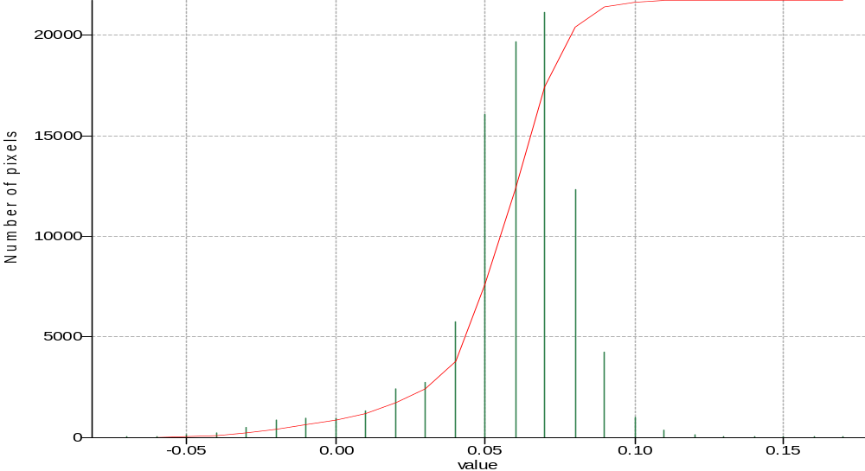
The NDVI values of vegetation reflectance shown in the histogram in Fig 4.2 ranges from - 0.05 and - 0.10 for the years , indicates that built-up areas has lower values while less developed natural surface all through the year 2005 has the highest NDVI value, 2015 has the lowest NDVI value which indicates that the NDVI value of a place tends to decrease as Urban growth. This low value of NDVI can be mainly attributed to the time of the year in which the images used (Landsat ETM+ bands 3 and 4) were taken. The images were acquired in the early part of the year, when there is little or no rain to aid the greenness of the vegetation which in turn will increase the reflectance of the vegetated area. This shows that most of the vegetation’s across Minna are not photosynthentically active at that part of the year.

Accuracy of Image Classification
The overall accuracy of the land cover classification for the 2001, 2006 and 2012 94.24%, 97.70% and 95.25% respectively. Generally, the frequency of confusion matrix classification was low but did occur. Savanna orchard bush were sometimes confused with both dense Forest and Grassland/cropland.
Table 2 : Confusion matrix for 2001 classification
 | BUA | DV | EL | GCL | SOB | WB | ACCURACY
BUA | 539 | 0 | 0 | 10 | 0 | 0 | 0.98
DV | 0 | 116 | 0 | 1 | 4 | 0 | 0.96
EL | 0 | 0 | 50 | 0 | 0 | 0 | 1
GCL | 3 | 0 | 0 | 601 | 15 | 0 | 0.97
SOB | 0 | 59 | 0 | 12 | 395 | 0 | 0.85
WB | 0 | 0 | 0 | 0 | 0 | 0 | 0
RELIABILITY | 0.99 | 0.66 | 1 | 0.96 | 0.95 | 0
*Note *BUA-Built up Area, *DV-Dense Vegetation, *EL-Expose Land, *GCL-Grass/Cropland, *SOB-Savanna Orchard Bush, *WB- Water Body.

Average Accuracy: 95.18%, Average Reliability: 91.49%, Overall Accuracy: 94.24%

Table 3a: Confusion matrix for 2006 classification
 | BUA | DV | EL | GCL | SOB | WB | ACCURACY
BUA | 540 | 0 | 0 | 9 | 0 | 0 | 0.98
DV | 0 | 117 | 0 | 1 | 3 | 0 | 0.97
EL | 0 | 0 | 50 | 0 | 0 | 0 | 1
GCL | 4 | 0 | 0 | 686 | 15 | 0 | 0.97
SOB | 0 | 7 | 0 | 0 | 264 | 0 | 0.97
WB | 0 | 0 | 0 | 0 | 0 | 0 | 0
RELIABILITY | 0.99 | 0.94 | 1 | 0.99 | 0.94 | 0
*Note *BUA-Built up Area, *DV-Dense Vegetation, *EL-Expose Land, *GCL-Grass/Cropland, *SOB-Savanna Orchard Bush, *WB- Water Body.
Average Accuracy: 97.96%, Average Reliability: 97.16%, Overall Accuracy: 97.70%
Table 3b: Confusion matrix for 2012 classification
 | BUA | DV | EL | GCL | SOB | WB | ACCURACY
BUA | 1539 | 0 | 0 | 1 | 0 | 0 | 1
DV | 0 | 94 | 0 | 0 | 4 | 0 | 0.96
EL | 0 | 0 | 178 | 1 | 0 | 0 | 0.99
GCL | 3 | 0 | 0 | 378 | 51 | 0 | 0.88
SOB | 0 | 5 | 0 | 64 | 395 | 0 | 0.85
WB | 0 | 0 | 0 | 0 | 0 | 0 | 0
RELIABILITY | 1 | 0.95 | 1 | 0.85 | 0.88 | 0
*Note *BUA-Built up Area, *DV-Dense Vegetation, *EL-Expose Land, *GCL-Grass/Cropland, *SOB-Savanna Orchard Bush, *WB- Water Body.
Average Accuracy: 93.58%, Average Reliability: 93.53%, Overall Accuracy: 95.25%
FIG 9: Overlay of 2001 and 2012 image
Table 4: Vegetation change matrix per pixel (2001 - 2012)
 | BUA | DV | EL | GCL | SOB | WB
BUA | 2950 | 0 | 149 | 611 | 105 | 0
DV | 360 | 1021 | 156 | 1792 | 1731 | 0
EL | 1416 | 32 | 568 | 1539 | 344 | 0
GCL | 18232 | 75 | 1872 | 25299 | 3773 | 0
SOB | 5226 | 337 | 744 | 15158 | 7187 | 0
WB | 0 | 0 | 0 | 0 | 0 | 0
*Note *BUA-Built up Area, *DV-Dense Vegetation, *EL-Expose Land, *GCL-Grass/Cropland, *SOB-Savanna Orchard Bush, *WB- Water Body.

CONCLUSIONS
Green coverage is one of the most important factors for sustaining life and the living environment for any rapidly growing town, like Minna; not only for preserving sustainable human habitat but also for safeguarding from the detrimental effects of urban pollution and Urban Heat Island (UHI). Rapid depletion of vegetation coverage in recent past might result adverse condition in Minna areas. Initiatives should have been taken to avert the area from the adverse effect of urban pollution and deforestation by various government and non-government organizations, but the situation seems to overdo the expected rate of change and expansion.
The study has indicated the potential use of remote sensing data in studying vegetation change. GIS techniques integrated in this study has proved beyond doubt its capabilities of spatial analysis. In this study LANDSAT images andNigeriasat-2 sensor were used satisfactorily for the identification of vegetation. It’s observed that the area under vegetation changed during 2001- 2012 remarkably decrease in vegetation has been as a result of anthropogenic activities in the study area. . If this process of change in vegetation cover continues at the same rate, there is a possibility that within no longer period of time there will be a severe mismanagement of land, and the impact could become severe especially on agriculture, and the environment.In conclusion for detecting changes in areas based on a subject e.g population increase, vegetation etc, over a period of years both spatial and in quantitative way, integrating remote sensing data and GIS techniques will be useful
RECOMMENDATION
Analyses of local patterns of vegetation change as carried out in this study could provide relevant information for policy makers who are responsible for land use planning and environment protection. As vegetation change is multicausal, a set of policy prescriptions is required to address the adverse effects of the phenomenon.
- Decline in the vegetation underscores the need for coercive environmental protection policies to relieve human pressure on vegetation resources.
- Phenomenal agricultural expansion at the expense of forest leading to nutrient mining should call for agricultural intensification-related policy initiatives to discourage expansion of cultivation on fragile lands. Such intensification strategies should address sustainable land cover management and farming techniques that replenish phosphate.
Afforestation is needed to restore the degraded parts of the landscape. The establishment of vigorous vegetation will lead to an increase in biomass. Afforestation strategies in Niger should involve the choice of appropriate species that are well adapted to the environment.

REFERENCES
Amgoali .J. and Kassi .M. (1989). Potential impact of climate change.
Bayarjargal, Yu., Ts. Adyasuren and S. Munkhtuya. Drought and Vegetation Monitoring
in the Arid and Semi-Arid Regions of the Mongolia using Remote Sensing
andGroundData[online]GISdevelopment.net<http://www.gisdevelopmen
t.net/aars/acrs/2000/ts8/hami0004a.shtml
Carlson, T. N., Gillies, R. R., & Perry, E. M. (1994). A method to make use of thermal
infrared temperature and NDVI measurements to infer surface soil water
content and fractional vegetation cover. Remote Sensing Reviews,
9,161-173.
Dayawansa, N.D.K., Ranjith Premalal De Silva and S.M.M.S.K. Sooriyakula (2002).
Identifying Relationships Between The Vegetation Cover And Climatic
Characteristics Using NOAA AVHRR[online] GISdevelopment.net, 2002
[cited in 27 August 2004] Available from internet <http://www.Gis
development.net/application/agriculture/cropping/mi04017abs.htm

Rosenzweig and Solecki (eds), (2001a): Climate Change And A Global City: The
potential Consequences of Climate Change Variability And change Metro
East coast. Columbia Earth institute, New York.

Reed , P. (2005). Land surface temperature and emissivity retrieval from satellite
measurements. Journal of environmental science, 1(1); p85-90.
Schmidt, H. and Karnieli, A. (2000). Remote sensing of the seasonal variability of
vegetation in a semi-arid environment. Journal of Arid environments, 45
(1): 43-59.
Markham, B.L., and J.L. Barker, 1986. Landsat MSS and TM post-calibration dynamic
ranges, exo atmospheric reﬂectance, and at-satellite temperatures,
Landsat Technical Notes, No. 1, pp. 3–8.
Tucker, C. J. (1979). Red and photographic infrared linear combinations for monitoring
vegetation. Remote Sensing of Environment, 8: 127–150.
Weng Q. (2005). Urban Classification using full Spectral Information of Landsat
TM + Imagery in Marion County, Indiana. Hazards, 3:2, 235 239
Wash,T.J.,P.leiby,R.Perlack,J.T. Ensminger, and S.B. Wright,2007a: toward an
integrated ansalysis of mitigation and adaptation: some preliminary
findings. Mitigation and adaptation strategies for global change, 12(5),
713-725

