Applications of GIS in Spatial Visitor Management of Protected Areas
Isabelle D. Wolf, NSW National Parks and Wildlife Service, Office of Environment and Heritage, Hurstville, NSW 2220, Australia; Centre for Ecosystem Science, University of New South Wales, Sydney, NSW 2052, Australia; i.wolf@online.ms

Abstract
Spatial land use planning is a critical component of visitor management in urban parks and other protected areas. It serves to manage visitor distributions in relation to park infrastructure and landscape features (Wolf, Hagenloh, & Croft, 2012; Wolf, Stricker, & Hagenloh, 2012; Wolf, Stricker, & Hagenloh, 2013). Participatory spatial planning of public lands is a relatively new development in visitor management. In this research we used public participation geographic information system (PPGIS) mapping and tracking combined with questionnaire-based surveying to monitor distributions, land use behavior, and certain impacts of visitors to selected national parks and surrounding land tenures in Northern Sydney, Australia (Wolf, Wohlfart, & Brown, 2014; Wolf, Wohlfart, Brown, & Bartolomé Lasa, 2015). Fundamental spatially implicit management questions were asked on (1) distributions of visitors; (2) spatial overlap of different visitor activities; (3) use of visitor infrastructure (e.g., time spent at specific infrastructure as an indicator for demand); (4) location-specific actions required to improve existing visitor experiences. This research showcases how effective spatial GIS planning tools are in visitor land use management to determine locations that people visit, manage visitor conflicts, identify demand for visitor infrastructure, and facilitate visitor experience development. We discuss methodological implications of using spatial visitor planning tools with a focus on sampling efficiency, time commitment, hardware requirements, technical knowledge of participants, sample audience, representativeness of data, spatio-temporal data coverage, and data processing.

Image
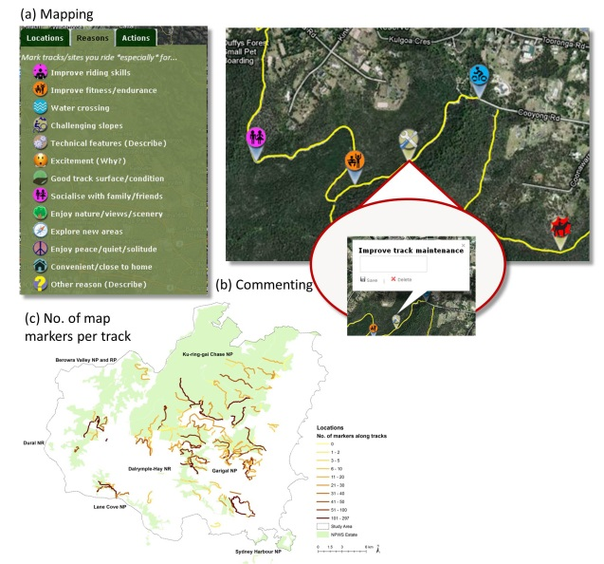
Fig. 1 Internet-based public participation geographic information system (PPGIS) to (a) map and (b) comment on locations, reasons and required actions for mountain biking experiences in northern Sydney. (c) Exemplary map showing number of location markers that were placed along specific tracks within northern Sydney, illustrating visitor distributions.

Recent Publications

- Wolf, I. D., Hagenloh, G., & Croft, D. B. (2012). Visitor monitoring along roads and hiking trails: How to determine usage levels in tourist sites. Tourism Management, 33, 16-28. doi: doi: DOI: 10.1016/j.tourman.2011.01.019
- Wolf, I. D., Stricker, H., & Hagenloh, G. (2012). The implementation of GPS tracking and GIS technology for park visitor monitoring: a key to managing visitor assets and experiences. In Proceedings of the 6th international conference on monitoring and management of visitors in recreational and protected areas.
- Wolf, I. D., Stricker, H. K., & Hagenloh, G. (2013). Interpretive media that attract park visitors and enhance their experiences: a comparison of modern and traditional tools using GPS tracking and GIS technology. Tourism Management Perspectives, 7, 59-72.
- Wolf, I. D., Wohlfart, T., & Brown, G. (2014). The role of public participation GIS in protected areas management: a case study of mountain biking and horse riding. In Proceedings of the 20th international symposium on society and resource management.
- Wolf, I. D., Wohlfart, T., Brown, G., & Bartolomé Lasa, A. (2015). The use of public participation GIS (PPGIS) for park visitor management: A case study of mountain biking. Tourism Management, 51, 112-130. doi: http://dx.doi.org/10.1016/j.tourman.2015.05.003

Biography
Dr. Isabelle D. Wolf is a Research and Analysis Officer at the Office of Environment and Heritage, Australia, and Adjunct Associate Lecturer at the University of New South Wales. Isabelle undertakes all aspects of innovative spatial park visitor research and monitoring, including visitor experience development and management. Trained as an ecologist, her specialty is the interface between people and their environment, with recent work on animal behavior and flora and fauna communities in fragmented and disturbed habitats. Isabelle has a PhD from the University of New South Wales and published in both social and environmental science journals.
Email: i.wolf@online.ms

Notes/Comments:

