Abstract

The surface of Earth is constantly evolving due to various geomorphic processes that shape the landscape. Glaciers are considered one of the most significant geomorphic agents, which have shaped a variety of geomorphic landforms, such as U-shaped valleys, moraines, and glacial lakes. Glaciers are extremely sensitive to climatic factors such as precipitation and temperature, because they affect the overall glacier mass-balance and are responsible for glacier's advance or retreat. The temporal scale of glacier’s response to temperature and precipitation changes ranges from years to decades, which is considered short on the geologic time scale (Dyurgerov and Meier, 2000). The objective of this research paper is to establish a correlation between the climatic variables and the rate of retreat for the Saskatchewan Glacier in the Colombia Icefield. The model that was developed after extensive data analysis had allowed us to establish the correlation, and project the further rate of retreat of the Saskatchewan glacier.

Introduction

Research Objectives

In the early 1830s, a group of Swiss naturalists have established the existence of Ice age by
recording the retreat of the alpine glaciers. This had led to a theory that majority of glaciers are remnants of vast ice sheets that once covered the majority of Earth’s landmass (Orlove, 2008). Until mid-1970, the glacial retreat was not quantitatively measured, partially due to the lack of research interest and difficulty of measurements due to the dynamic nature of the glaciers. Our research had challenged this task by implementing a variety of data-gathering techniques, and had allowed us to further understand the glacier dynamics and variables that influence it.
The objectives of this research were to:
- Visualize the retreat of Saskatchewan glacier over the temporal period of 1957 to 2016
- Create a digital geodatabase with GIS-ready data of Saskatchewan Glacier
- Measure the distance of glacial retreat between the years of 1957 and 2016
- Visualize the temperature change of the study region from 1957 to 2016
- Visualize the rate of rainfall, snowfall, total precipitation and temperature change rate
- Find correlation between the temperature data and rate of retreat of the glacier
- Develop a model that will allow predicting future trends of glacial retreat

Scope and Limitations

The scope of this project is to provide a descriptive analysis of the glacial retreat, and the climatic variables associated with it. The research will focus on Saskatchewan Glacier as a case study. However, the methodology developed for the analysis of this data could be applied to other glaciers in the Rocky Mountain region, and will allow to develop a model of retreat unique to the glacier of study.
The limitations of this object are based on the availability of data for the Saskatchewan glacier, which poses a constraint to a more detailed analysis of the glacier. The two methods that are applied to problem of data availability are interpolation and use of secondary data sources

Study Site

The Saskatchewan glacier is part of a massive
glacial structure called Colombia Icefield, which is located at the convergence of three major basins:
Arctic to the north, Pacific to the south & west, and Hudson Bay to the east. Saskatchewan glacier is flowing out to the Hudson Bay drainage basin, and its meltwater feeds one of the tributaries of North Saskatchewan River.
The Saskatchewan Glacier is surrounded in the U-shaped valley, surrounded by the Mt. Andromeda and Mt. Castleguard. The terminus of the glacier is located 6.5 kilometers away from the Icefields Parkway.

Late Holocene Dynamics

Around 3000 14C years BP (or 1000BC), the Saskatchewan Glacier had reached its maximum extent, marked by a terminal moraine. The glacier was flowing from the Colombia Icefield into the North Saskatchewan River valley (Wood, 2004). The glacier began to retreat, which was evident by the radiocarbon dating of the exposed detrital wood. This and other glacial deposits are the first evidence of the retreat of the glacier, on the relatively recent temporal scale.

Glacier Mass Balance

The dynamics of the glacier are best explained with the concept of glacier mass balance, which is vital to understanding the retreat of Saskatchewan glacier. Essentially, the glacier advances when the glacier’s zone of accumulation is exceeds zone of ablation (melt), which means more precipitation is being deposited and turned into solid ice. The glacier retreats when the vehicles zone of ablation exceeds the zone of accumulation, which indicates higher precipitation runoff and ice sublimation from the glacier.
Some of the factors involved in the dynamics of the accumulation and ablation zone are temperature and precipitation. For example, decreasing accumulation zone is affected by the decreased levels of snowfall, resulting in smaller mass added to the glacier. Decreasing accumulation zone can also be explained by the increasing temperatures, which contribute to solid ice being transformed into vapour, due to the process called sublimation.

Hypothesis

The hypothesis of this research proposes that the increasing rate of retreat of the Saskatchewan glacier is caused by climatic factors, such increase in temperature and decreased snowfall. The successful outcome of the statistical and GIS analysis will refuse the null hypothesis and accept the alternative hypothesis.
- Null hypothesis: H₀ = no correlation between the increasing change in temperature and rate of retreat
- Alt. hypothesis: Ha = correlation found between the increasing change in temperature and rate of retreat

Correlation is a measure of the degree of association of one variable with another (Urdan, 2011). Expected correlation coefficient should range between -1 and +1. Negative correlation strength indicates inverse while positive correlation strength indicates direct relationship between temperature change and rate of retreat. The Pearson product moment correlation coefficient (r) type is categorized such that:
When r ≤ ± 0.3, correlation is weak
When r is between ± 0.3 and ± 0.6, correlation is moderate
When r ≥ ± 0.6, correlation is strong

Data

Primary Data

Primary geographic data consisted of the field GPS data of the glacier terminus and the remote sensing data. The GPS data was gathered with the Tremble Juno SC unit with an accuracy range of 2 – 5 meters, which allowed the research team to gather data for 2016 location of the glacier terminus
Other forms of primary geographic data come from remote sensing, gathered by various satellites such as LANDSAT and Spot5. The raster images of glacier position for the years of 1982, 1986, and 2004 were captured by LANDSAT missions. The later 2014 image was captured with the Spot5 satellite.
Years | Satellite | Georeferenced | Cell Resolution (meters) | Source of Raster
1982 | LANDSAT4 | Yes | 30 x 30 | USGS
1986 | LANDSAT5 | Yes | 30 x 30 | USGS
2004 | LANDSAT5 | Yes | 15 x 15 | GeoGratis
2014 | Spot5 | Yes | 16 x 16 | GeoDiscover
Figure 1: Table summarizing the imagery of Saskatchewan glacier for years 1982, 1986, 2004, and 2014.

Secondary Data

The research group had to resort to seeking secondary geographic data, due to lack of availability of primary geographic data for the region of Saskatchewan Glacier. The secondary data comes in form of a scanned aerial photography, which was obtained from the archives at the SANDS, University of Calgary. This aerial photography was gathered by the Canadian Land Survey, which surveyed most of Canada by gathering aerial imagery from an airplane. The fly path of the airplane is shown in Figure 6, and the digitized format of the aerial photography can be found in Figure 3.
3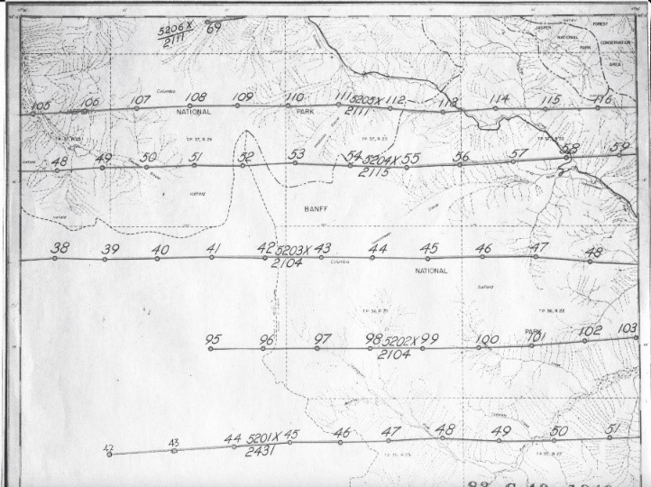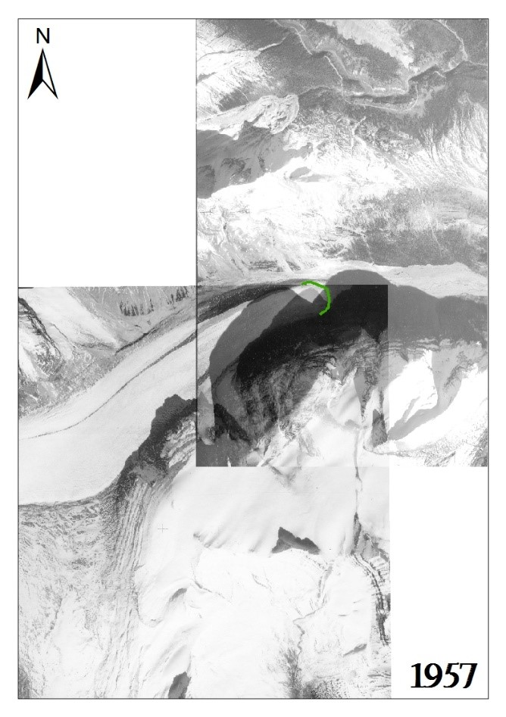

Figure 2
:
The flight path of the survey airplane,
gathering the aerial imagery of the Saskatchewan
glacier region in 1957. Each point represents location
where the image was shot, resulting in a series of
aerial photographs. Combination of the photographs
of the location 46 and 57 have resulted in the position
of the glacier terminus in 1957.

Figure 3
:
Digitized and georeferenced image of the
Saskatchewan glacier in 1957, which was created by
converting the hardcopy image into a digital format. The
terminus of the glacier had been digitized and illustrated
with the green line.

Climate Data

The data on annual climatic factors such as average of mean temperature, average of total rain, average of total snow, average of total precipitation, and temperature change. This data was obtained from the Environment Canada – Climate Data website . There were two datasets that were used to understand the climatic patterns in the region of Saskatchewan Glacier. The data involved extensive processing, due to several missing records for certain years, and absence of weather stations at the study site.

The first dataset is included in Appendix A, which was used to create a time-series map in Figure X. The second dataset in Appendix B, includes data used to find correlation between the change in temperature and rate of retreat. The dataset from Appendix A includes the weather data from Jasper, Banff, Revelstroke, and Golden, which had a consistent weather data from 1957-2014. Dataset from Appendix B includes the weather data from Lake Louise and Jasper weather stations, which have been operating from 1941 through 1995. The detailed analysis revealed in the Methodology section reveals how these datasets were used to interpolate the climate data for Saskatchewan Glacier.

Data Limitations

The major data limitation was lack of data availability for the project site. The only closest weather station that was proximate to the glacier is called Parker Ridge Station (ClimateID: 3054998), which began operate in 1978, and only contained the data for few months of the year. Other issues due to data limitations were inconsistent records of available weather stations, such as missing years or temperature/precipitation values. The other data limitations include inconsistent spatial resolution of the raster images, which ranges from 15 meter cell size to 30 meter cell size. This had made the digitizing component particularly tedious, since the error in digitizing of one cell could translate to 15 to 30 meters.

Methodology

Coordinate System

The study site of the Saskatchewan Glacier is located in NTS 83-C-3NE region of National Topographic System. This falls within the Zone 11 of Universal Transverse Mercator (UTM) system, which was used in conjunction with WGS1984 datum. One of the main reasons for using UTM projection is the fact that it preserves the shapes and angles, which is suited well for the digitizing component of analysis. All of the layers used for the GIS analysis have been projected to WGS 1984 UTM Zone 11 coordinate system.

GIS Technology

GIS, or Geographical Information Systems, is a comprehensive tool that allows for capturing, visualizing and analyzing spatial data using various technologies, such as Remote Sensing and GPS. The GIS technology was applied to this case study on glaciology, by integrating it into the methodology of this research project, which consisted of software and hardware components.
The hardware component consists of the Tremble Juno SC unit for GPS measurements for the current (2016) glacier location. The GPS unit includes the ArcPad software that was developed by ESRI, which acts as an interface between the GPS unit and ArcGIS 10.3 software. The ArcGIS software package was attained with on the highest Advanced licensing, which features a variety of tool-packs within the ArcGIS 10.3 such as Spatial Analyst and Geostatistical Analyst. Figure 4 summarizes different ArcGIS tools that were used for data analysis. All of the data was imported and stored in a dedicated file Geodatabase.

Name | Type | Use
Measure | Tool | Used to calculate overall retreat of the glacier
Editor | Toolpack | Used to digitize the glacier terminus for each of the years
Georeferencing | Toolpack | Used to georeference the  1957 Aerial Photos in  ArcGIS
  Define Projection | Tool | Used to project layers to same coordinate system
Project Raster   | Tool | Used to project the raster  images to same coordinate system
Merge  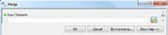 | Tool | Combined glacier terminus for each year into a single dataset
Colour Brewer   | Style | Used to add more colour schemes to map symbology
Spline  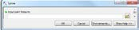 | Tool | Used to interpolate temperature data from pre-defined points
Figure 4: Summary of GIS tools used in the GIS analysis and creation of maps

Aerial Photography

The data for the glacier position during the year of 1957 was obtained from an aerial photograph. In order to quantify the data, the image had to be scanned and digitized. This was done using the Georeferencing toolbars, which allowed to overlap and georeference the aerial photographs. The editor toolbar was used to digitize the glacier terminus. The RMSE value for the georeferenced image was 4.37 meters, as shown in the figure below:

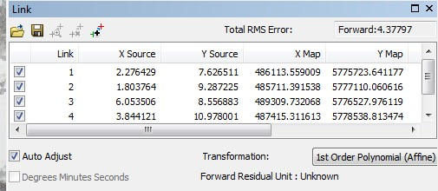

Use of Satellite Imagery

The satellite imagery consisted of the raster datasets for the years of 1982, 1986, 2004, and 2014. They have been projected to a common WGS1984 UTM Zone 11 coordinate system, and the glacier terminus was digitized using the Editor Toolbar. The data was imported as shapefiles and .pdf images, which was used in the later part of the analysis.

Compiling GIS data

The shapefiles for each glacier terminus were compiled into a single shapefile using the Merge tool. Then, the “Measure” tool was applied to calculate distance of retreat between the years of 1957 and 2016. The measured distance path was also digitized using the Editor tool-pack and exported as shapefile. The final step was to compile the imagery of the glacier for each year, which was accomplished using a few online software called “gifmaker.me”. The created graphics interchange format (GIF) was set at animation speed of 700 milliseconds and exported in .gif format. The resulting animated map series had visualized the retreat of the Saskatchewan Glacier between the years of 19572016. Unfortunately, this map was not able to be displayed in this report, so it was imported into the file geodatabase. As an alternative, more summarized single-frame map was created for the results of this report.

Temperature Change Map

The first step in climate data analysis was interpolating the temperature values for
Saskatchewan Glacier, which was done by compiling the data in Microsoft Excel and exporting it into ArcMap for GIS analysis. The change in temperature map was created by exporting the weather stations data from Figure 10 into the ArcMap, which consisted of climate data for each year, except for 2016.
NAME | STATION_ID | PROXIMITY | TEMP | PRECIP | ELEVATION | UTM_NORTHING | UTM_EASTING
Golden | 1173210 | 95.18 | 4.2 | 37.825 | 784.9 | 5682755.9 | 502570.18
Jasper | 3053520 | 113.37 | 2.4 | 31.875 | 1247.9 | 5858585.157 | 440636.7027
Revelstoke | 1176750 | 154.214 | 6.6 | 76.2 | 1062.2 | 5650295.65 | 416098.04
Banff | 3050520 | 117.58 | 2.1 | 31.75 | 1383.7 | 5670634.761 | 600241.39

Figure 6: Summary of weather station data and attributes. The data was extracted from Environment Canada, compiled in the Excel datasheet, and imported into ArcGIS 10.3.
The weather stations with the climate data was added to ArcMap software, and compared to the research site of Saskatchewan Glacier. Since there was no data available for Saskatchewan glacier’s climate over the years, the research team had to interpolate the new temperature data using the weather station data above. There interpolation technique used is called Spline Interpolation, which is best suited for continuous data such as temperature. The Spline estimates the values by minimizing overall surface curvature of the statistical surface, and allows for the curvature to pass through the series of inflection points (Weisstein, 2016). The Spline tool allows for smooth distribution of interpolated values, and is well-suited for the datasets with relatively small number of points, such as data from Figure 6.
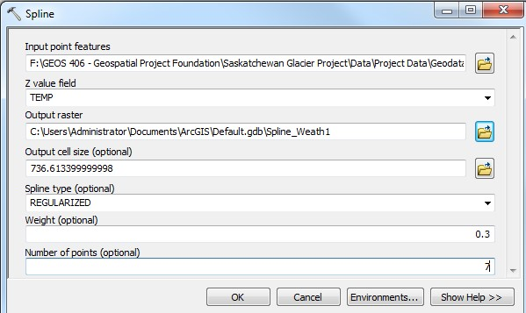
Figure 7: The Spine (Spatial Analyst) interpolation tool

The values used for creation of new points came from the “TEMP” field, which contains temperature data for each of the weather stations. The regularized spline type was chosen, because it incorporates the first, second, and third derivative into calculations of averaging the values (Wahbra & Johnson, 1998). In order to achieve a smoother “surface”, the weight of 0.3 was assigned within the range of 7 points.
The output of spline interpolation was a dataset with interpolated temperature values, which were symbolized with the additional styles from Coloubrewer. The maps were then exported, and compiled into a graphics interchange format (.gif), similar to the map of the glacial retreat.
Unfortunately, these maps were not able to be displayed in this report, so they were imported into the file geodatabase.

Climate Data Analysis

The second part of the temperature analysis was done in Excel on the dataset with climate data downloaded from Environment Canada Climate Data website (Environment Canada, 2016). The data consisted of an extensive dataset for Jasper and Lake Louise weather stations ranging from 1955-2005. These weather stations were the most proximate to the Saskatchewan Glacier, so the values were interpolated between the two stations using averaging. The data had to be intensively mined from the dataset in order to perform a statistical analysis between the variables. The results of statistical analysis had created the data tables and graphs for:
- Average of Mean Temperature (°C) versus Time (years)
- Temperature Change (°C) versus Time )years)
- Average of Total Rain (mm) versus Time (years)
- Average of Total snow (cm) versus Time (years)
- Average of Total Precipitation (mm) versus Time (years)
- Change in Temperature (°C) versus Time (years)
- Average Total Rainfall (mm) versus Average Mean Temperature (°C)
- Average Total Snowfall (mm) versus Average Mean Temperature (°C)
- Average of Total Precipitation (mm) versus Average Mean Temperature (°C)
- Recession Distance (m) versus Recession Time (years)
- Recession Rate (metres/year) versus Temperature Change (°C)
- Pearson product-moment correlation coefficient between the Change in Temperature (°C) and Rate of Retreat (meters/year)
- Equation for estimation for the projected rate of retreat in the future

The dataset that was used in calculation in the statistical analysis can be found in Appendix A.
The correlation coefficient found from this analysis was used to accept or reject the null hypothesis. This means that if correlation is strong, there is a strong relationship between the rate of retreat of the glacier and change in temperature.

Results

Glacial Retreat Map

The following map describes the retreat of Saskatchewan Glacier, which since 1957 had retreated further southwest towards the middle of the Colombia Icefield. The overall distance of glacial retreat from 1957 to 2016 was measured at 1209.64 meters.
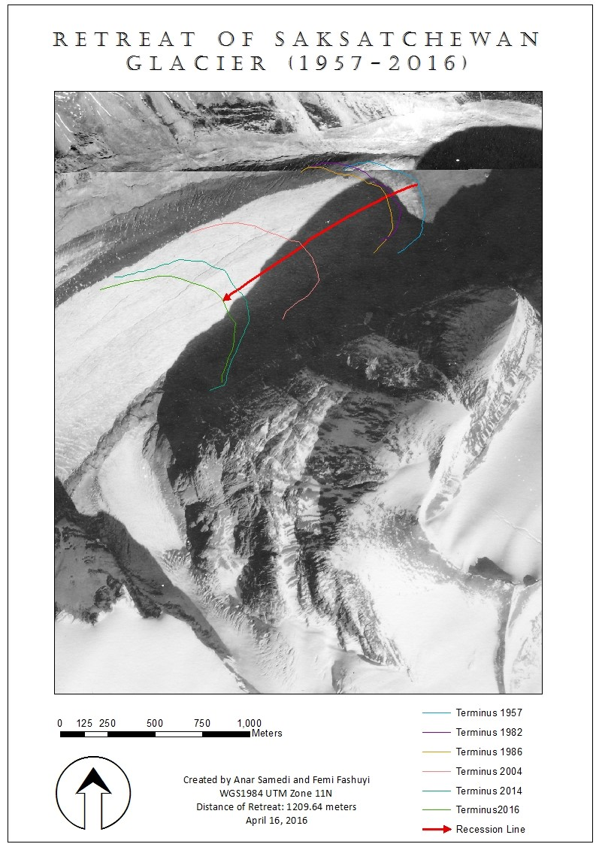
Figure 8: Air photo of Saskatchewan Glacier, showing the retreat of the glacier from 1957 to 2016.

Change in Temperature Map

The following temperature maps depict the interpolated annual temperature values for the region of Saskatchewan Glacier, using the Spline Interpolation method. The average mean temperature for the study region is in the range of 1-2 (°C) in 1957 and 2.5-3.5(°C) in 2014. This indicates an increase of the temperature by about 0.5-1.5 (°C), and shows the trend of increasing temperature on the temporal scale.
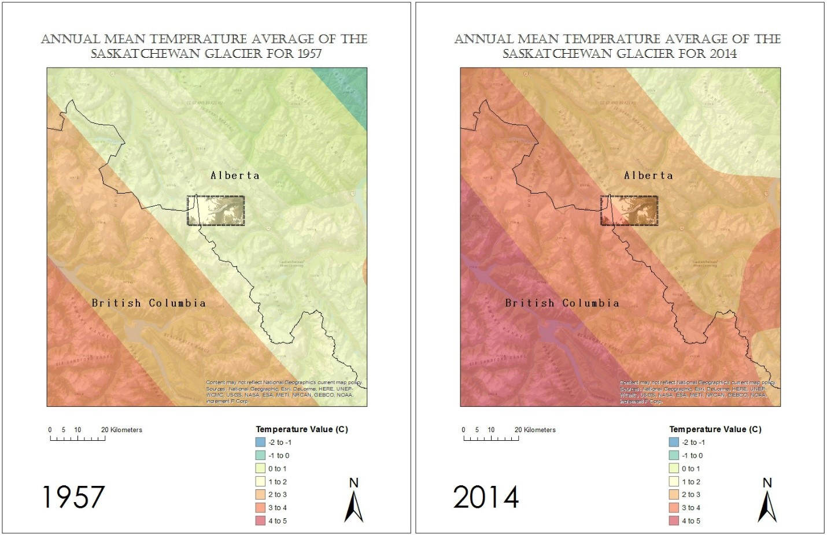
Figure 9: Temperature Change of the Saskatchewan Glacier, found by using interpolation of temperature data points.

Statistical Analysis Results

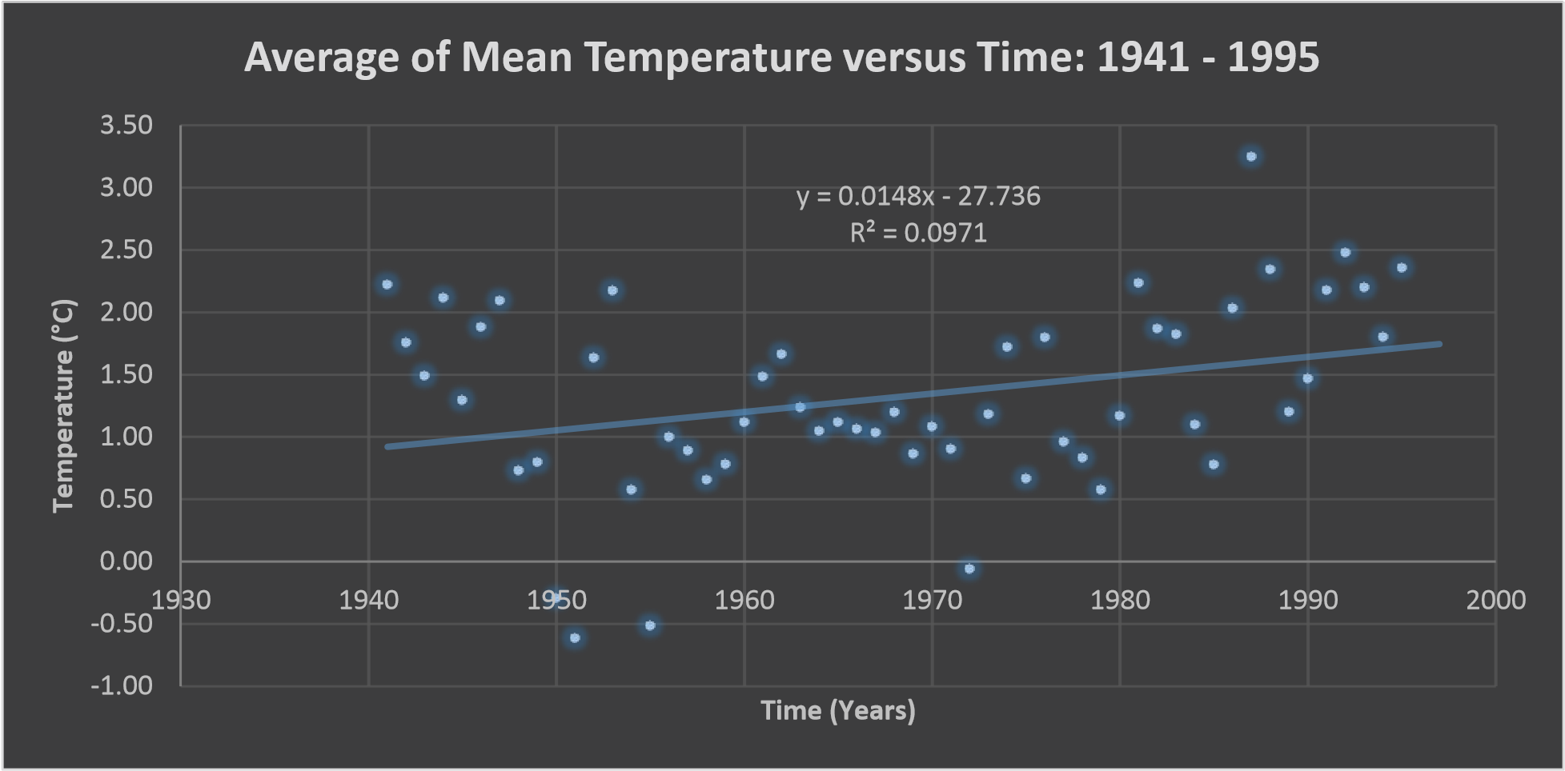
Figure 10: The Average of Mean Temperature (°C) versus Time (Years) graph, with the trendline showing an increasing in temperature.

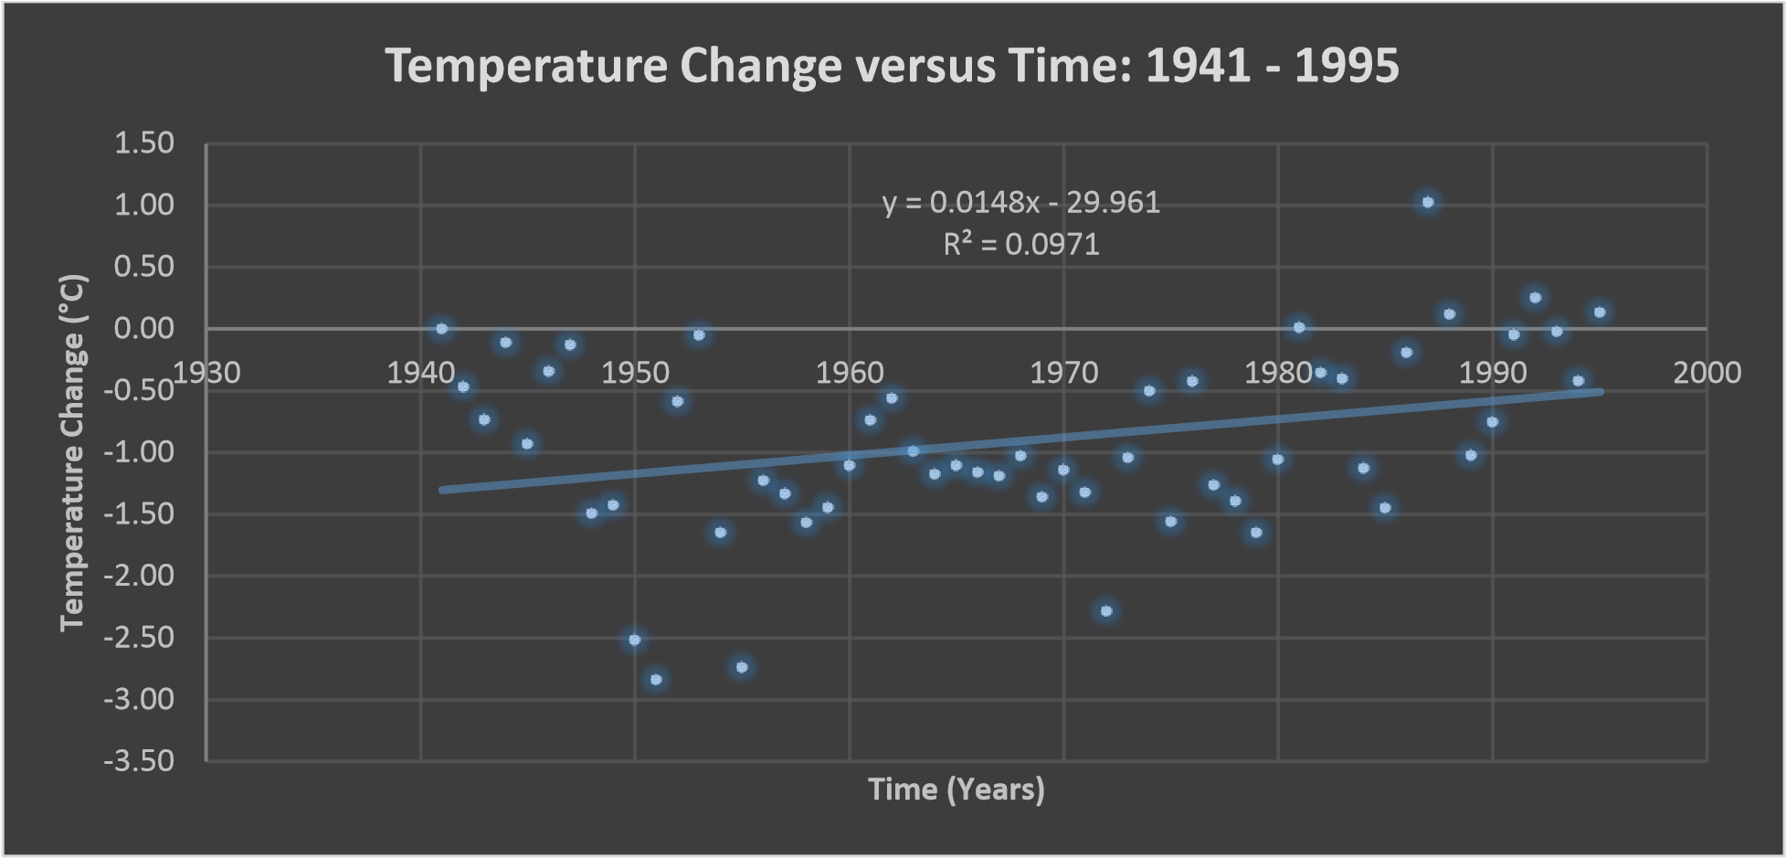
Figure 11: The Temperature change (°C) versus Time (Years) graph, with the trendline showing an increase over the years.
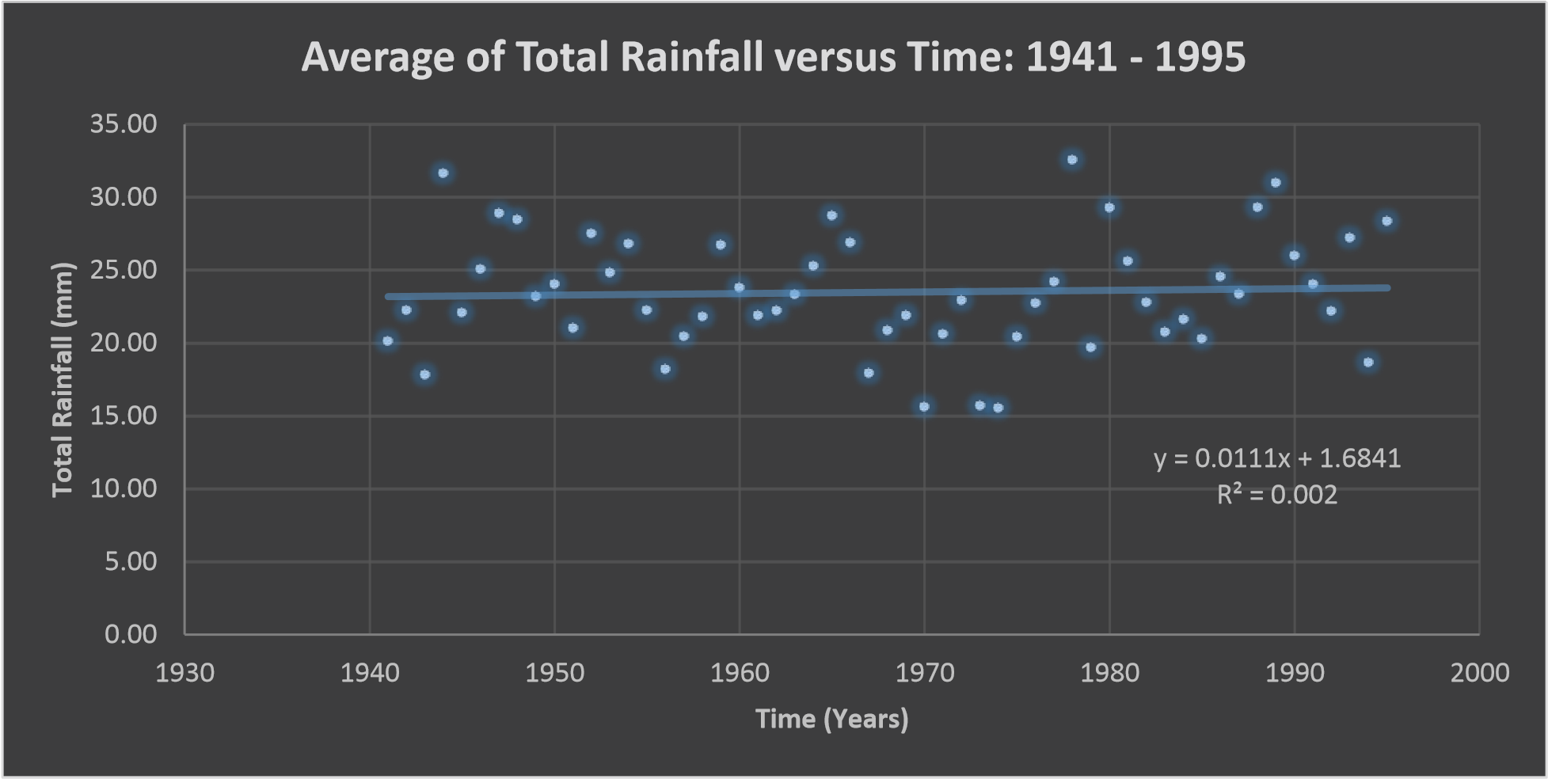
Figure 12: The Average of Total Rainfall (mm) versus Time (Years) graph, with the trendline showing a slight increase in rainfall over the years.

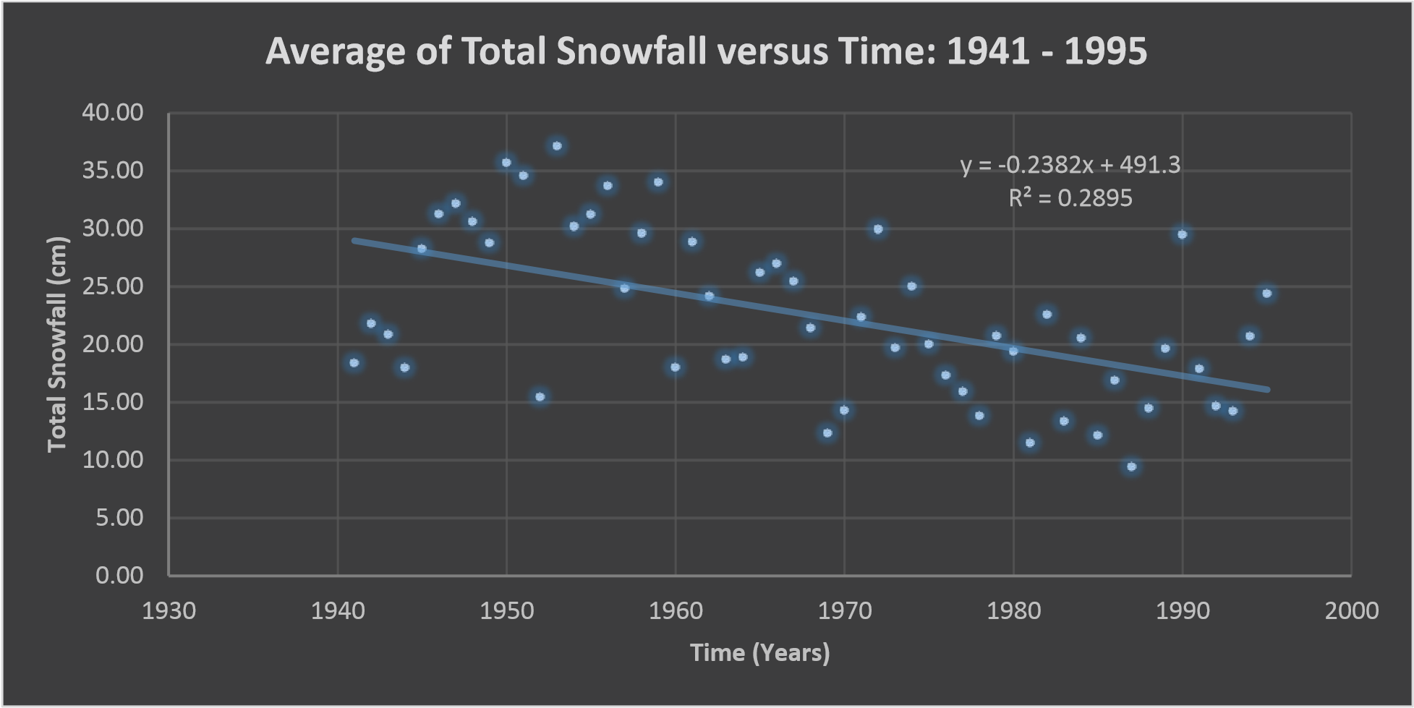
Figure 13: The Average of Total Snowfall (cm) versus Time (Years) graph, with the trendline showing a decrease in snowfall over the years.
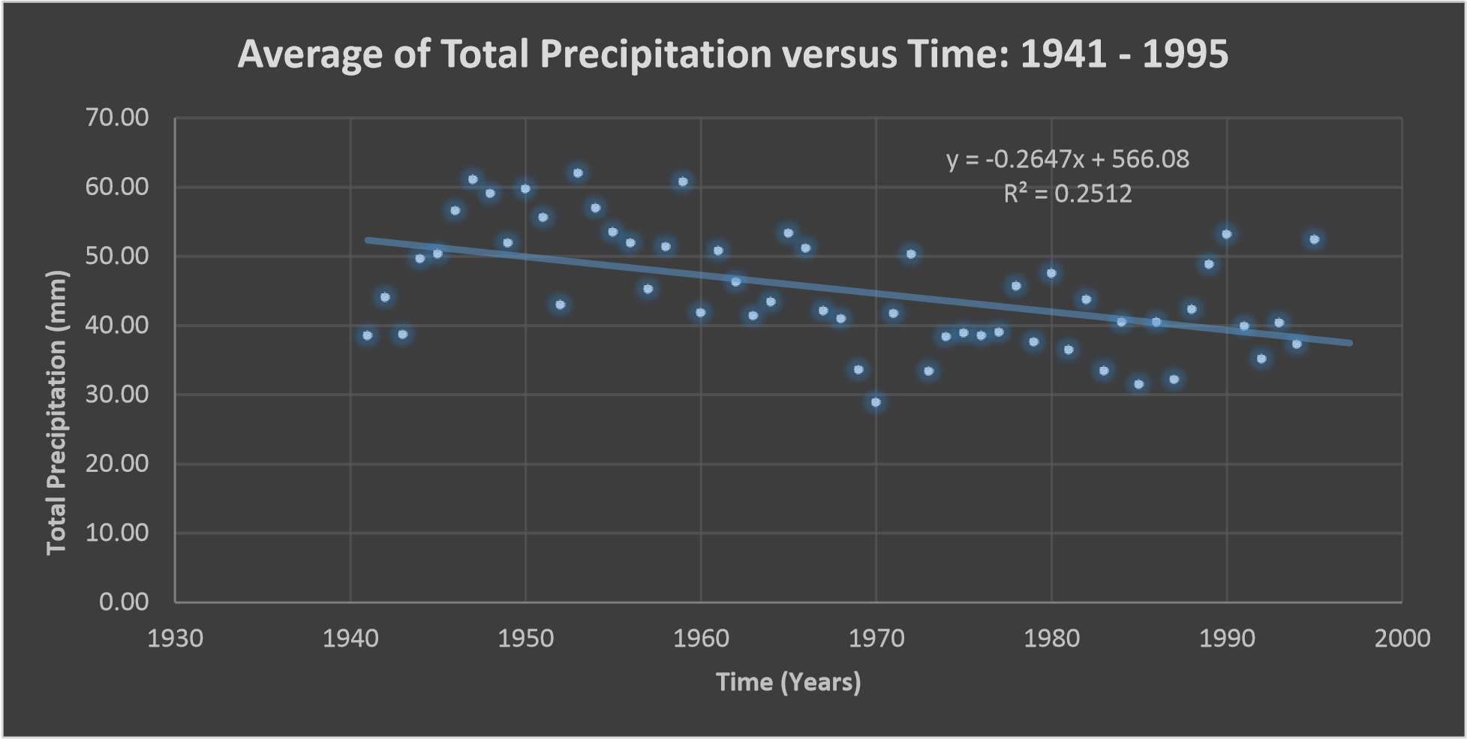
Figure 14: The Average of Total Precipitation (mm) versus Time (Years) graph, with the trendline showing a decrease in average of total precipitation over the years.

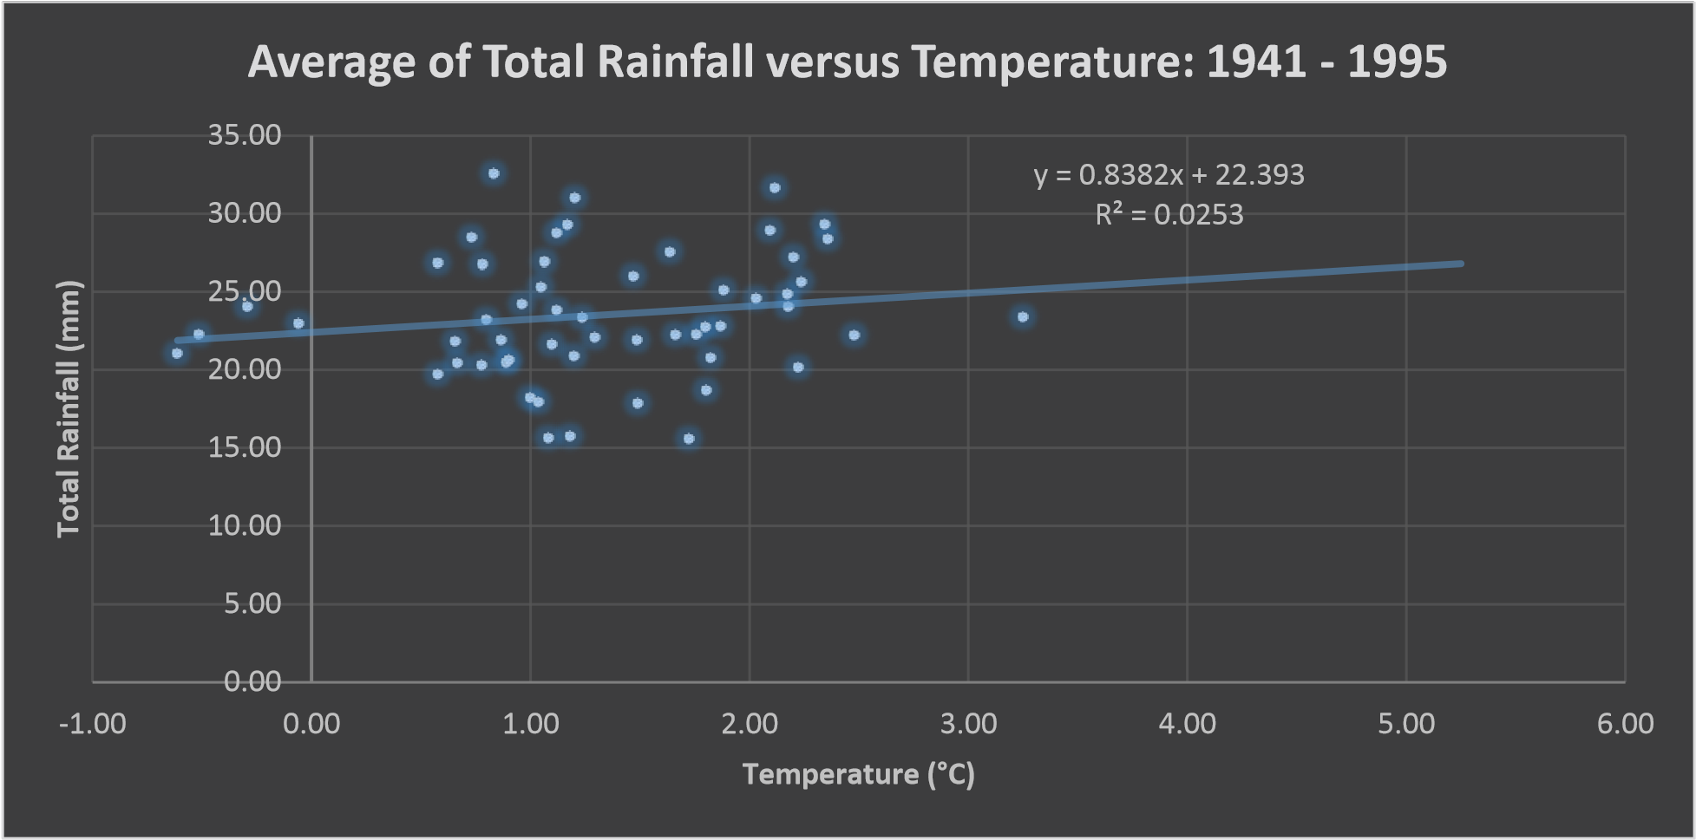
Figure 15: The Average of Total Rainfall (mm) versus Temperature (°C) graph, with the trendline showing increase in rainfall with temperature.
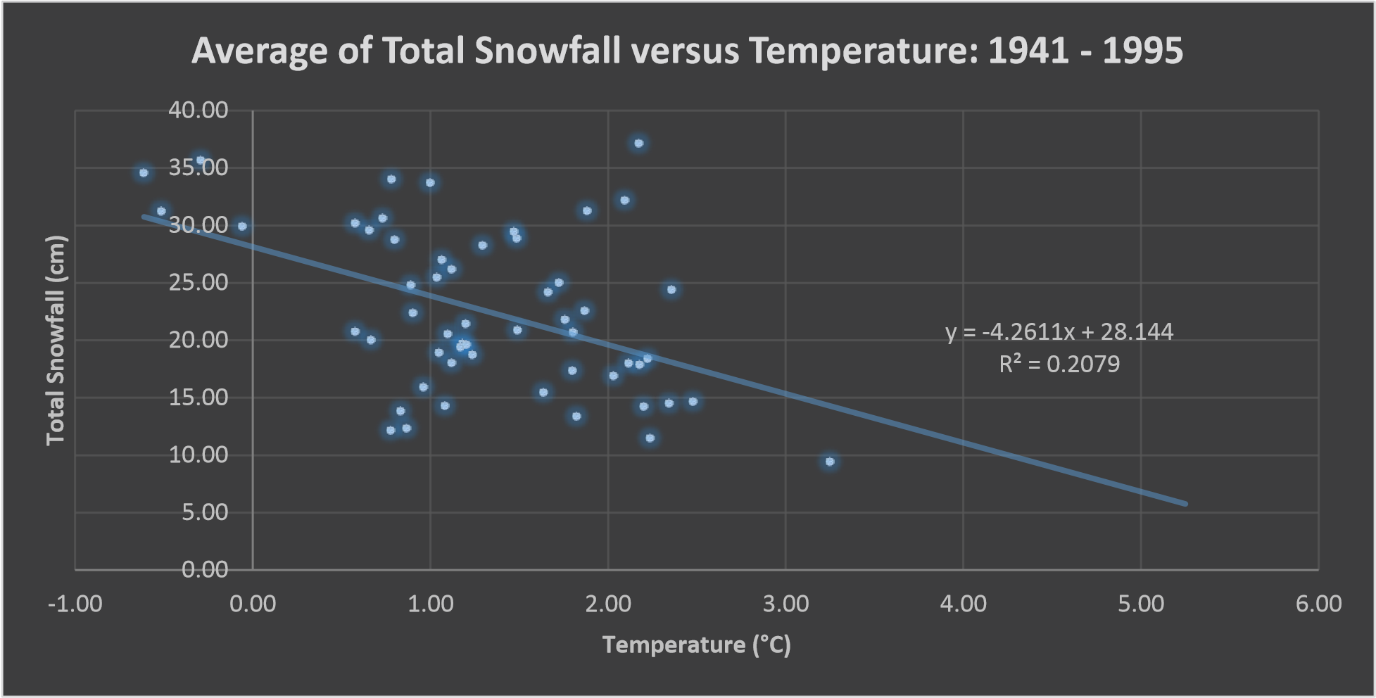
Figure 16: The Average of Total Snowfall (cm) versus Temperature (°C) graph, with the trendline showing decrease in snowfall with temperature.

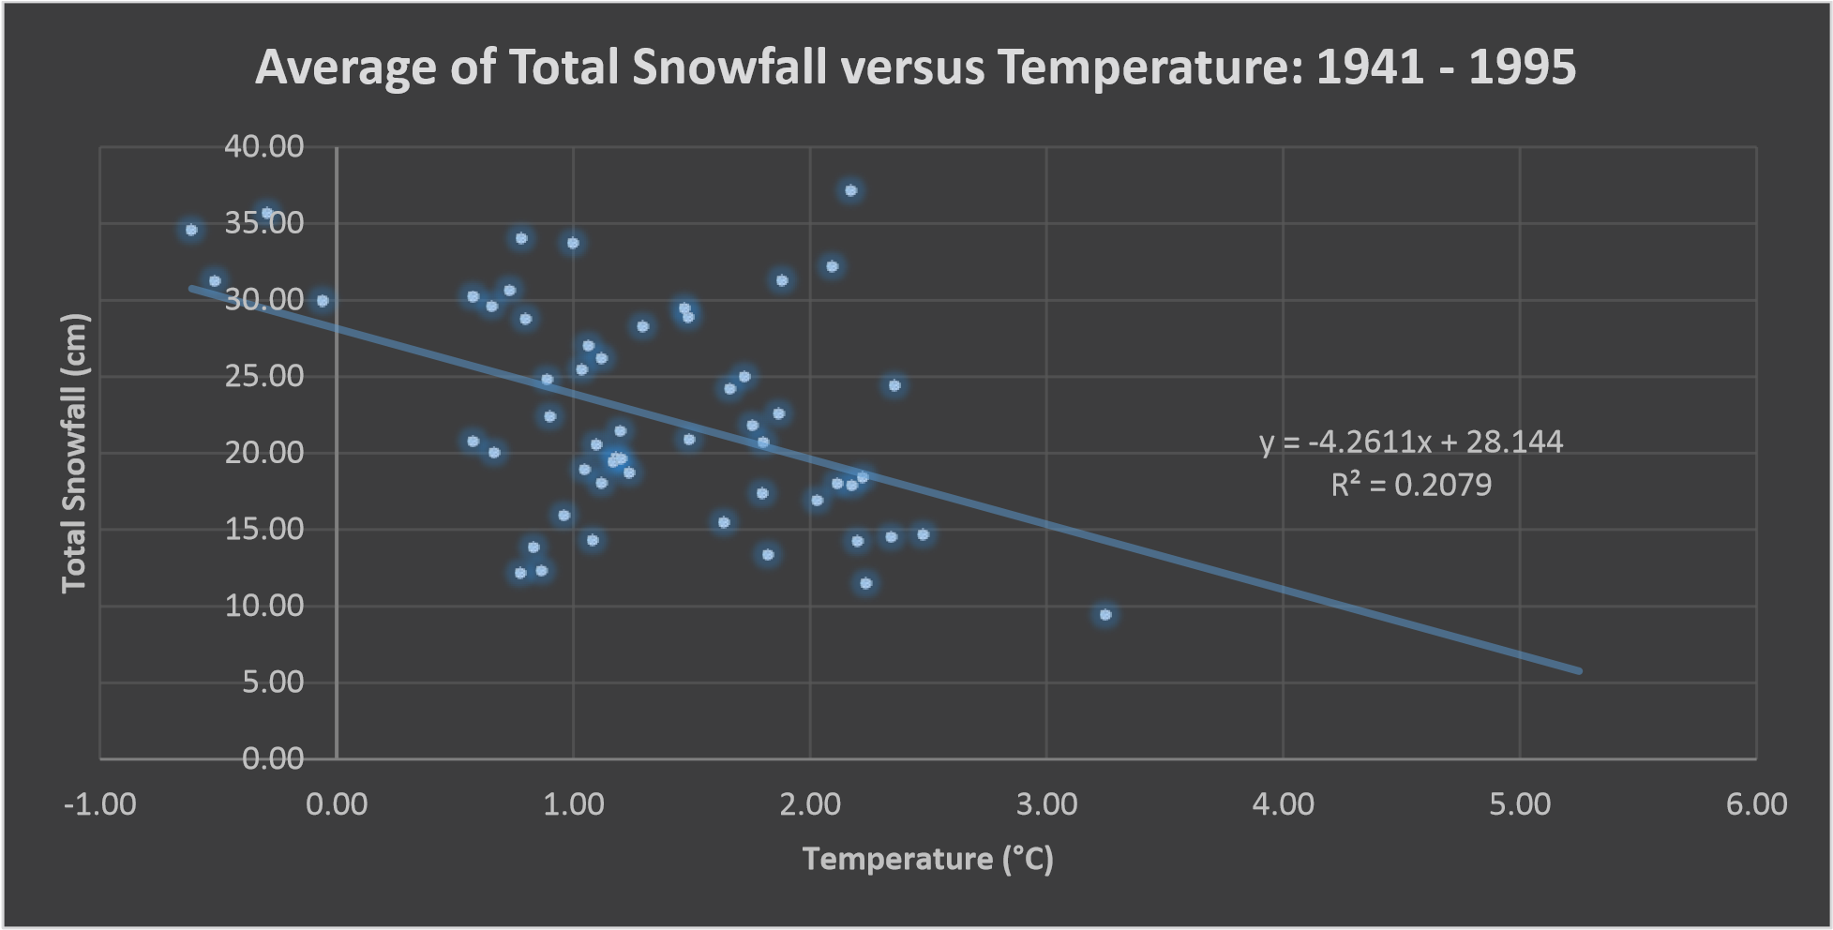
Figure 17: The Average of Total Snowfall (cm) versus Temperature (°C) graph, with the trendline showing decrease in snowfall with temperature.

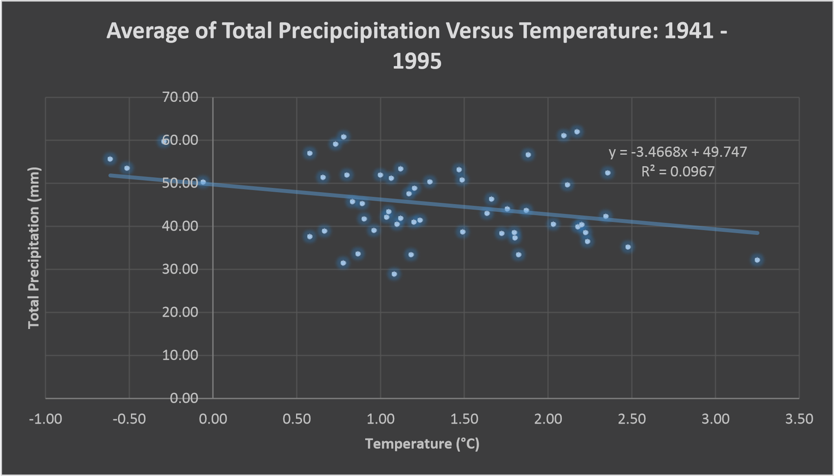
Figure 18: The Average of Total Precipitation (mm) versus Temperature (°C) graph, with the trendline showing an overall decrease increase in precipitation with temperature.

y = 31.481x -
694.52
R² = 0.9843
0.00
200.00
400.00
600.00
800.00
1000.00
1200.00
1400.00
0
10
20
30
40
50
60
70
Recession Distance (Meters)
Recession Time (Years)
Recession Distance versus Recession Time: 1957 -
1995
Figure 19: The Recession Distance (meters) versus Recession Time (years) graph, with the trendline showing an increase over the years.

y = 1x -
1968.2
R² = 0.9121
0.00
5.00
10.00
15.00
20.00
25.00
30.00
35.00
40.00
45.00
50.00
1960
1970
1980
1990
2000
2010
2020
Rate of Recession (Meters/Year)
Time (Years)
Rate of Recession versus Time: 1957 -
1995
Figure 20: The Rate of Recession (meters per year) versus Recession Time (years) graph, with the trendline showing an increase with time.

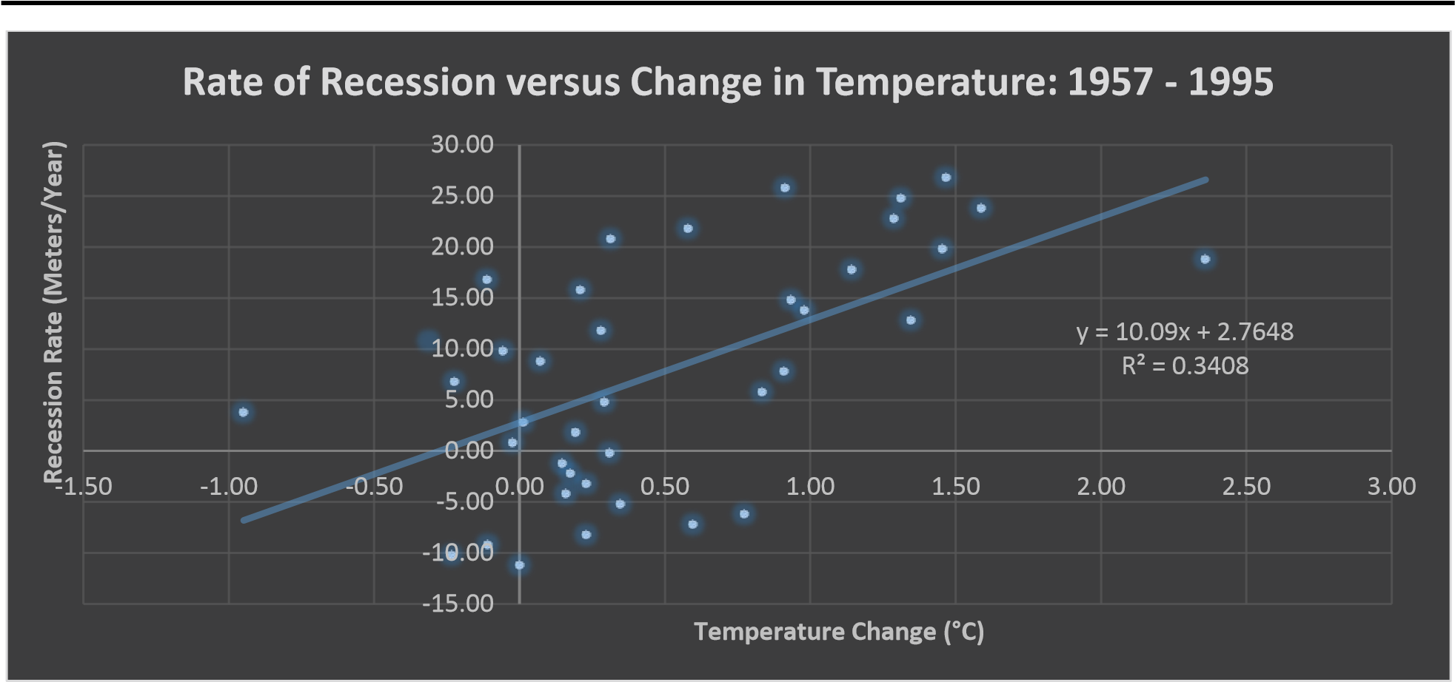
Figure 21: The Recession Rate (meters per year) versus Temperature Change (°C) graph, with the trendline showing an increase over the years.

The Pearson product-moment correlation coefficient (r) was calculated using the data from figures 24 and 15. This means that the two variables that were correlated are:
- Recession rate of the glacier (meters)
- Rate of temperature change (°C)
The Pearson correlation coefficient value was found to be at:

r = 0.5838

The equation that models the future rate of retreat of the glacier was obtained from the slope of the trendline in Figure 24. The equation allows to input the number of years (independent variable) to calculate the recession rate (dependent variable).

y = 1x - 1968.2

where:
- x is the inputted value for the give year
- y is the corresponding distance recession rate in meters/year

Discussion

Glacial Change over Time

The results of the research have revealed that Saskatchewan glacier had been steadily retreating over the predetermined temporal time scale (1957-2016). The retreat of an overall distance of 1209.64 meters indicates that the zone of ablation had been increasing, while the zone of accumulation had been steadily decreasing. The reason for such glacial dynamics have resulted due to proximity of glacier to the melting point, which is considered an effective natural indicator of climate change (Zemp, 2006). This melting point of the glacier is affected by several climatic factors that were analyzed in this research, such as total annual rainfall, snowfall, and change in temperature.
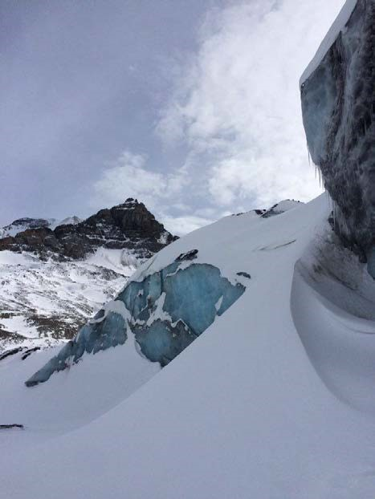
Figure 22: The terminus of Saskatchewan glacier. The key to understanding the glacier dynamics lies in the variables responsible for change of zones of accumulation and ablation. Typically, the glacier retreats when the snowfall decreases, which decreases the zone of accumulation. Increasing rainfall and temperatures are responsible for the increasing zone of ablation, where the mass of the glacier is steadily reduced resulting in the retreat of the glacier.

The map of retreat of the glacier in Figure 12, revealed that the glacier receded towards the
Colombia Icefield by a distance of 1209.64 meters. The sediment deposited by the glacier during the process can be analyzed to further understand the glacier dynamics, such as using carbon dating on detrital wood (Luckman, 1993).

Temperature and Precipitation

The main factors that are responsible for the retreat of the glacier are rainfall, snowfall, and rate of temperature change. The results of analysis have revealed that the Saskatchewan glacier region had been receiving fewer precipitation in form of snowfall from 1941-1995 (Figure 17). This means that the glacier’s zone of accumulation had been steadily decreasing as a result of the decreasing rate of snowfall, which lead to substantial thinning of the glacier in the accumulation zone (Pelto, 2010). Similarly, the increasing temperature and rainfall have contributed to an increase of the glacier’s ablation zone, where the glacier have had most of its mass. The results from the temperature map have also revealed that an increase in temperature by a fraction of a degree results in glacier retreating by a significant distance.
The correlation between the independent variable (change in temperature) and corresponding dependent variable (rate of retreat) have revealed a moderate strength of relationship, summarized by the spearman’s coefficient of r = 0.5838. From this we can infer that the glacier retreats in distance as a response to the rising average annual temperatures. The correlation value is accepts the alternate hypothesis, proving that there is a correlation between the two variables. The moderate strength of the correlation can be explained by the inconsistencies in the climate dataset, which required the research team to interpolate average values for the missing fields of the Environment Canada climate dataset. Other possible explanations for the moderate correlation between the variables is the cell-size of the datasets affecting the digitized position of the glacier terminus, which would affect RMS positional value and the overall recession distance values.

Modelling Future Retreat

The results of the research have allowed us to develop an equation based on the rate of recession corresponding to the given year. The trendline indicates the increasing rate of the glacial retreat over years, which means that the glacial melt is accelerating over the given time, as seen from figure 23. The model requires to input the projected year above 1969, and returns the value of the recession rate in meters/year.

y = 1x -
1968.2
R² = 0.9121
0.00
5.00
10.00
15.00
20.00
25.00
30.00
35.00
40.00
45.00
50.00
1960
1970
1980
1990
2000
2010
2020
Rate of Recession (Meters/Year)
Time (Years)
Rate of Recession versus Time: 1957 -
1995
Figure 23: The graph that visualizes the rate of recession of Saskatchewan glacier for any given year from 1957.

For example, in order to find the rate of retreat in 2050, the year has to be entered in the model equation, which results in 74.79 meters per year. The calculation is as follows:
Rate of retreat = (1* 2050) – 1968.2 = 81.80 meters/year

Since the difference between the current year of 2016 and 2050 is 34 years, we can find that the glacier will retreat further by 2781.2 meters. This is a considerable distance which indicates that the glacier is at a threat of disappearing, since the rate is increasing each year. The correlation between the rate and temperature had shown that there is a moderate relationship between the two variables, which indicates that increasing temperatures are a major factor in the retreat of the glacier.

Conclusion

Research Hypothesis and Findings

The results of the analysis have rejected the null hypothesis, and accepted the alternative (research) hypothesis, which deems the research successful. The alternative hypothesis stated that there is a correlation between the increasing change in temperature and rate of glacial retreat. This trendline of the graph from bellow indicates a positive correlation, and spearman’s correlation coefficient indicates the moderate relationship between the variables at r = 0.5837.

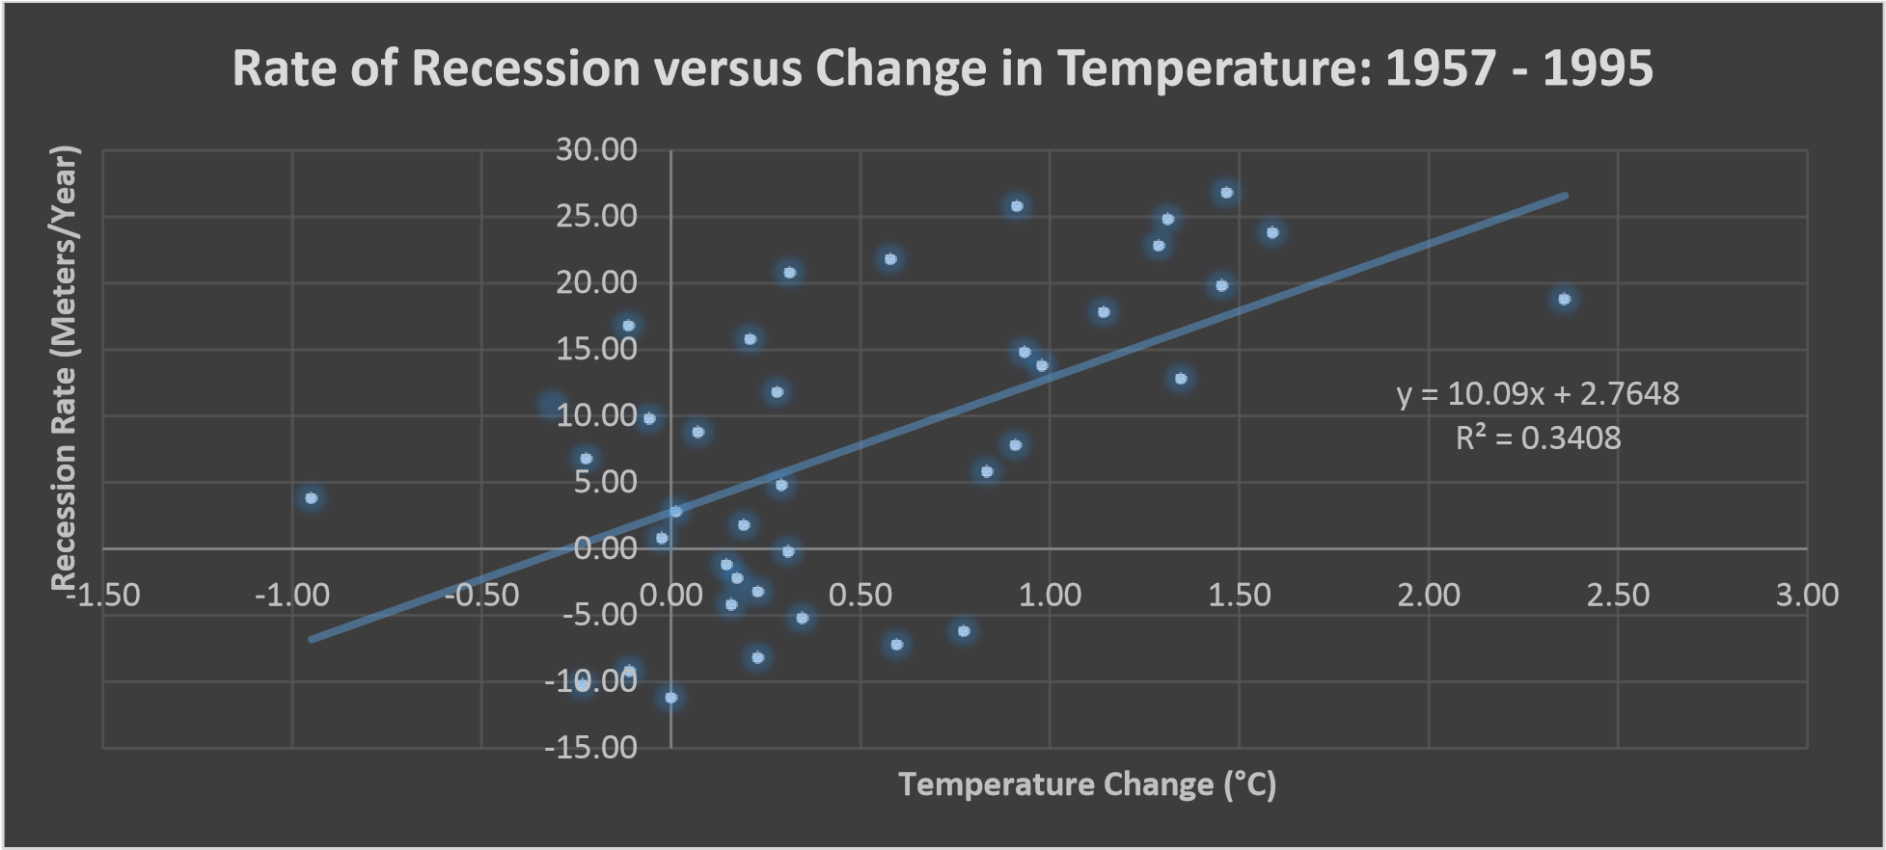
Figure 24: Final output of the climatic data analysis, showing the relationship between the recession rate and change of temperature.
Positive relationship between the recession rate and change in temperature indicates that if the change in temperature increases, the recession rate is accordingly increases. This was proven true by visually comparing the change of temperature (Figure 13) and glacier retreat maps (Figure 12). The glacier reacts to the increase of temperature by retreating towards it origin at the Colombia Icefield. The mechanism by which the glacier is retreating is the increase in ablation zone, which disturbs the glacier mass balance (Dyurgerov & Meirer, 2000).

Research Hypothesis and Findings

The results of the analysis have rejected the null hypothesis, and accepted the alternative (research) hypothesis, which deems the research analysis successful. The alternative hypothesis stated that there is a correlation between the increasing change in temperature and rate of glacial retreat. This trendline of the graph from bellow indicates a positive correlation, and spearman’s correlation coefficient indicates the moderate relationship between the variables at r = 0.5838.

Implementation of Model

The model developed based on the results of the analysis, had allowed us to approximate the future retreat of the glacier. The model is based on the trendline from Figure 27 follows an equation bellow:

y = 1x - 1968.2

The equation allows to predict the rate at which the glacier retreats for any given year, from which the distance of retreat can be calculated. The equation is deemed accurate, since it is based on the numeric data from two correlated variables. However, this equation applies only to the geographic region of Saskatchewan Glacier, since the climatic patterns used for calculations are unique to this region. The model, however, can be modified to include data from various stations that contain datasets for other weather stations. The GIS technology was proven invaluable in this experiment, because it allowed for spatial and geostatistical functionalities that allowed us to digitize the glacier terminus and interpolate the temperature values using spline interpolation.

Future Improvements

The improvements for the future research of similar nature will be integrated into the data manipulation and analysis techniques. Based on the project risk management plan, the data will be stored on the cloud-based system in the future. This will ensure safe and reliable storage of data, with the functionality of auto-backup. Other improvements will include the use of python to disseminate the climate data, and assist in developing a more efficient and automated model. This model will allow us to automatically input the given values for the given glacier, and produce a meaningful output values for the rate of retreat. Lastly, the cartographic output for the glacial analysis will be enhanced by a 3-D flythrough of the glacier, which will be accurately captured using other methods of remote sensing, such as aerial survey drones.

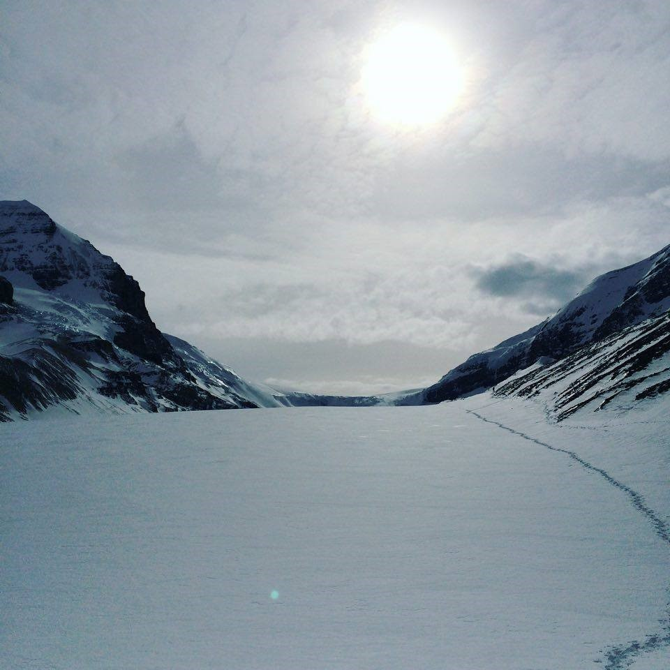
Figure 25: The extent current extent of Saskatchewan glacier, which will eventually retreat further into the Colombia Icefield where it originates. The change in mass-balance of the glacier is the determining factor, which is caused by increased zone of ablation.

References

Dyurgerov M. and Meirer M. (2000). Twentieth century climate change: evidence from small glaciers. Proc Natl Acad. Sci. USA (PNAS), 97 (4), 1406-1411
Orlove, B. S., Wiegandt, E., & Luckman, B. H. (2008). Darkening peaks: glacier retreat, science, and society. Univ of California Press.

Wood, C., & Smith, D. (2004). Dendroglaciological Evidence For A Neoglacial Advance Of the
Saskatchewan Glacier, Banff National Park, Canadian Rocky Mountains. Tree-Ring Research, 60(1), 59-
65. doi:10.3959/1536-1098-60.1.59

Haeberli, W. (2011). Glacier mass balance (pp. 399-408). Springer Netherlands.
Urdan, T. C. (2010). Statistics in plain English. Routledge.
Weisstein, E. (2016). Inflection Point from MathWorld. Wolfram Web Resource. Retrieved on April 16,
2016 from http://mathworld.wolfram.com/InflectionPoint.html
Luo, Z., Wahba, G., & Johnson, D. R. (1998). Spatial-temporal analysis of temperature using smoothing spline ANOVA. Journal of Climate, 11(1), 18-28.
Environment Canada Climate Data. (2016). Retrieved April 17, 2016, from http://climate.weather.gc.ca/

Zemp, M. (2006). Glaciers and climate change: spatio-temporal analysis of glacier fluctuations in the European Alps after 1850. Geographisches Inst. d. Univ. Zürich.
Pelto, M. S. (2010). Forecasting temperate alpine glacier survival from accumulation zone observations. The Cryosphere, 4(1), 67-75.
Luckman, B. H., Holdsworth, G., & Osborn, G. D. (1993). Neoglacial glacier fluctuations in the Canadian Rockies. Quaternary Research, 39(2), 144-153.

Napieralski, J., Harbor, J., & Li, Y. (2007). Glacial geomorphology and geographic information systems. Earth-Science Reviews, 85(1), 1-22.

Appendix A

The following data from Appendix A contains the climatic data for the Saskatchewan glacier. A more extensive dataset can be found in the attached Excel datasheet.

Year | Average of  Mean  Temp (°C) | Average of Total  Rain (mm) | Average of  Total Snow  (cm) | Average of  Total Precip  (mm) | Temp  Change  (°C) | Recession Rate (Metres/year)
1957 | 0.89 | 20.47 | 24.83 | 45.29 | 0.00 | 0.7806
1958 | 0.66 | 21.84 | 29.59 | 51.42 | -0.23 | 1.5764
1959 | 0.78 | 26.75 | 34.04 | 60.79 | -0.11 | 2.3722
1960 | 1.12 | 23.83 | 18.05 | 41.88 | 0.23 | 3.1680
1961 | 1.49 | 21.91 | 28.88 | 50.81 | 0.60 | 3.9638
1962 | 1.66 | 22.25 | 24.19 | 46.34 | 0.77 | 4.7596
1963 | 1.24 | 23.37 | 18.73 | 41.47 | 0.35 | 5.5554
1964 | 1.05 | 25.30 | 18.92 | 43.45 | 0.16 | 6.3512
1965 | 1.12 | 28.77 | 26.20 | 53.39 | 0.23 | 7.1470
1966 | 1.07 | 26.93 | 27.00 | 51.20 | 0.18 | 7.9428
1967 | 1.04 | 17.95 | 25.47 | 42.13 | 0.15 | 8.7386
1968 | 1.20 | 20.88 | 21.44 | 41.03 | 0.31 | 9.5344
1969 | 0.87 | 21.92 | 12.33 | 33.64 | -0.02 | 10.3302
1970 | 1.08 | 15.65 | 14.32 | 28.92 | 0.19 | 11.1260
1971 | 0.90 | 20.64 | 22.39 | 41.74 | 0.01 | 11.9218
1972 | -0.06 | 22.96 | 29.94 | 50.34 | -0.95 | 12.7176
1973 | 1.18 | 15.74 | 19.71 | 33.41 | 0.29 | 13.5134
1974 | 1.73 | 15.58 | 25.01 | 38.38 | 0.84 | 14.3092
1975 | 0.67 | 20.45 | 20.03 | 38.93 | -0.22 | 15.1050
1976 | 1.80 | 22.75 | 17.36 | 38.56 | 0.91 | 15.9008
1977 | 0.96 | 24.23 | 15.94 | 39.08 | 0.07 | 16.6966
1978 | 0.83 | 32.58 | 13.85 | 45.75 | -0.06 | 17.4924
1979 | 0.58 | 19.71 | 20.76 | 37.65 | -0.31 | 18.2882
1980 | 1.17 | 29.30 | 19.41 | 47.59 | 0.28 | 19.0840
1981 | 2.24 | 25.63 | 11.49 | 36.50 | 1.35 | 19.8798
1982 | 1.87 | 22.81 | 22.58 | 43.75 | 0.98 | 20.6756
1983 | 1.83 | 20.77 | 13.38 | 33.45 | 0.94 | 21.4714
1984 | 1.10 | 21.64 | 20.57 | 40.52 | 0.21 | 22.2672
1985 | 0.78 | 20.31 | 12.15 | 31.52 | -0.11 | 23.0630
1986 | 2.03 | 24.58 | 16.91 | 40.51 | 1.14 | 23.8588
1987 | 3.25 | 23.39 | 9.43 | 32.22 | 2.36 | 24.6546
1988 | 2.35 | 29.33 | 14.51 | 42.34 | 1.46 | 25.4504
1989 | 1.20 | 31.03 | 19.64 | 48.88 | 0.31 | 26.2462
1990 | 1.47 | 26.00 | 29.48 | 53.21 | 0.58 | 27.0420
1991 | 2.18 | 24.06 | 17.90 | 39.92 | 1.29 | 27.8378
1992 | 2.48 | 22.21 | 14.68 | 35.23 | 1.59 | 28.6336
1993 | 2.20 | 27.23 | 14.26 | 40.43 | 1.31 | 29.4294
1994 | 1.80 | 18.69 | 20.72 | 37.33 | 0.91 | 30.2252
1995 | 2.36 | 28.37 | 24.41 | 52.43 | 1.47 | 31.0210

Appendix B

Appendix B contains the data used to extract and interpolate values for Saskatchewan glacier in Appendix A.
Station Name | JASPER | 113.37 Km from Study Site
Province | ALBERTA
Latitude | 52.88
Longitude | -118.07
Elevation | 1062.2
Climate Identifier | 3053520
WMO Identifier
TC Identifier
Year | Average of Mean Temp (°C) | Average of Total Rain (mm) | Average of Total Snow (cm) | Average of Total Precip (mm) | Temp Change (°C)
1941 | 3.13 | 11.07 | 7.18 | 18.24 | 0.00
1942 | 3.31 | 14.75 | 9.18 | 23.94 | 0.18
1943 | 3.30 | 14.67 | 6.02 | 20.70 | 0.17
1944 | 3.79 | 32.83 | 4.47 | 37.29 | 0.66
1945 | 2.96 | 18.53 | 8.82 | 27.37 | -0.17
1946 | 3.60 | 18.73 | 9.09 | 27.88 | 0.47
1947 | 3.56 | 24.81 | 10.51 | 35.31 | 0.43
1948 | 2.05 | 32.39 | 15.83 | 48.22 | -1.08
1949 | 1.99 | 23.13 | 12.86 | 35.98 | -1.14
1950 | 0.70 | 29.43 | 14.42 | 43.83 | -2.43
1951 | 0.63 | 15.83 | 10.33 | 26.17 | -2.51
1952 | 3.23 | 26.95 | 4.18 | 31.13 | 0.09
1953 | 3.60 | 26.61 | 20.99 | 47.61 | 0.47
1954 | 1.93 | 29.18 | 12.96 | 42.13 | -1.20
1955 | 0.90 | 25.19 | 16.32 | 41.50 | -2.23
1956 | 2.40 | 18.54 | 13.36 | 31.93 | -0.73
1957 | 2.41 | 20.48 | 11.41 | 31.88 | -0.72
1958 | 2.21 | 20.18 | 13.86 | 34.04 | -0.92
1959 | 2.41 | 25.66 | 14.73 | 40.39 | -0.72
1960 | 3.25 | 29.24 | 6.67 | 35.91 | 0.12
1961 | 2.61 | 23.27 | 12.37 | 35.65 | -0.52
1962 | 3.00 | 20.37 | 9.86 | 30.02 | -0.14
1963 | 2.42 | 22.64 | 10.58 | 31.97 | -0.71
1964 | 2.33 | 22.38 | 10.01 | 30.85 | -0.80
1965 | 2.33 | 27.87 | 15.90 | 40.62 | -0.80
1966 | 2.02 | 23.87 | 17.38 | 35.78 | -1.11
1967 | 2.68 | 21.66 | 12.93 | 32.01 | -0.45
1968 | 2.74 | 22.28 | 11.94 | 31.65 | -0.39
1969 | 2.63 | 25.59 | 6.98 | 31.34 | -0.51
1970 | 2.88 | 15.49 | 11.60 | 24.98 | -0.26
1971 | 2.72 | 24.58 | 15.97 | 37.98 | -0.41
1972 | 1.48 | 25.58 | 20.22 | 40.67 | -1.66
1973 | 2.73 | 14.93 | 14.78 | 25.63 | -0.41
1974 | 3.23 | 16.00 | 19.78 | 31.37 | 0.09
1975 | 2.09 | 23.71 | 11.78 | 32.38 | -1.04
1976 | 3.78 | 23.11 | 10.19 | 30.20 | 0.65
1977 | 3.00 | 26.08 | 10.80 | 34.69 | -0.13
1978 | 2.82 | 35.87 | 5.42 | 39.92 | -0.31
1979 | 2.55 | 17.45 | 17.98 | 29.78 | -0.58
1980 | 3.34 | 26.07 | 9.62 | 33.44 | 0.21
1981 | 4.80 | 23.27 | 4.65 | 26.66 | 1.67
1982 | 4.49 | 25.73 | 15.50 | 37.93 | 1.36
1983 | 3.53 | 21.55 | 6.83 | 27.00 | 0.40
1984 | 2.95 | 22.80 | 12.55 | 31.98 | -0.18
1985 | 3.12 | 17.80 | 9.78 | 25.69 | -0.01
1986 | 4.02 | 23.44 | 7.73 | 29.21 | 0.89
1987 | 5.37 | 24.45 | 4.98 | 28.23 | 2.24
1988 | 4.31 | 23.85 | 9.45 | 30.31 | 1.18
1989 | 3.14 | 32.23 | 12.75 | 41.40 | 0.01
1990 | 3.31 | 29.36 | 18.75 | 43.56 | 0.18
1991 | 4.20 | 29.80 | 12.52 | 38.24 | 1.07
1992 | 4.36 | 21.57 | 10.98 | 29.23 | 1.23
1993 | 3.39 | 32.48 | 6.93 | 37.30 | 0.26
1994 | 3.69 | 26.77 | 10.50 | 33.10 | 0.56
1995 | 4.26 | 28.65 | 7.77 | 35.70 | 1.13

Station Name | LAKE LOUISE |  | 116.08 from study Site
Province | ALBERTA
Latitude | 51.43
Longitude | -116.22
Elevation | 1524
Climate Identifier | 3053760
WMO Identifier
TC Identifier
Year | Average of Mean Temp (°C) | Average of Total Rain (mm) | Average of Total Snow (cm) | Average of Total Precip (mm) | Temp Change (°C)
1941 | 1.32 | 29.26 | 29.64 | 58.89 | 0.00
1942 | 0.21 | 29.78 | 34.45 | 64.23 | -1.11
1943 | -0.32 | 21.04 | 35.74 | 56.78 | -1.64
1944 | 0.44 | 30.51 | 31.53 | 62.04 | -0.88
1945 | -0.37 | 25.66 | 47.73 | 73.38 | -1.69
1946 | 0.17 | 31.48 | 53.44 | 85.40 | -1.15
1947 | 0.63 | 33.05 | 53.88 | 86.92 | -0.69
1948 | -0.58 | 24.59 | 45.43 | 70.03 | -1.90
1949 | -0.39 | 23.28 | 44.67 | 67.94 | -1.71
1950 | -1.28 | 18.68 | 56.98 | 75.65 | -2.60
1951 | -1.85 | 26.29 | 58.84 | 85.14 | -3.17
1952 | 0.05 | 28.13 | 26.78 | 54.91 | -1.27
1953 | 0.75 | 23.12 | 53.32 | 76.43 | -0.57
1954 | -0.78 | 24.47 | 47.43 | 71.91 | -2.10
1955 | -1.93 | 19.37 | 46.17 | 65.53 | -3.25
1956 | -0.40 | 17.91 | 54.08 | 72.00 | -1.72
1957 | -0.63 | 20.47 | 38.24 | 58.71 | -1.95
1958 | -0.89 | 23.50 | 45.32 | 68.79 | -2.21
1959 | -0.85 | 27.85 | 53.34 | 81.19 | -2.17
1960 | -1.01 | 18.41 | 29.43 | 47.84 | -2.33
1961 | 0.37 | 20.56 | 45.40 | 65.97 | -0.95
1962 | 0.33 | 24.13 | 38.53 | 62.67 | -0.99
1963 | 0.06 | 24.09 | 26.88 | 50.97 | -1.26
1964 | -0.23 | 28.22 | 27.83 | 56.05 | -1.55
1965 | -0.09 | 29.67 | 36.50 | 66.16 | -1.41
1966 | 0.11 | 29.98 | 36.63 | 66.62 | -1.21
1967 | -0.61 | 14.24 | 38.01 | 52.25 | -1.93
1968 | -0.34 | 19.48 | 30.93 | 50.41 | -1.66
1969 | -0.89 | 18.25 | 17.69 | 35.94 | -2.21
1970 | -0.71 | 15.82 | 17.04 | 32.86 | -2.03
1971 | -0.91 | 16.70 | 28.81 | 45.51 | -2.23
1972 | -1.59 | 20.34 | 39.67 | 60.01 | -2.91
1973 | -0.36 | 16.55 | 24.65 | 41.20 | -1.68
1974 | 0.23 | 15.16 | 30.25 | 45.40 | -1.10
1975 | -0.76 | 17.20 | 28.28 | 45.48 | -2.08
1976 | -0.18 | 22.40 | 24.53 | 46.93 | -1.50
1977 | -1.08 | 22.38 | 21.08 | 43.46 | -2.40
1978 | -1.15 | 29.30 | 22.28 | 51.58 | -2.47
1979 | -1.39 | 21.98 | 23.54 | 45.52 | -2.71
1980 | -1.00 | 32.53 | 29.21 | 61.73 | -2.32
1981 | -0.33 | 28.00 | 18.33 | 46.33 | -1.65
1982 | -0.75 | 19.89 | 29.67 | 49.56 | -2.07
1983 | 0.12 | 19.99 | 19.92 | 39.91 | -1.20
1984 | -0.75 | 20.48 | 28.58 | 49.06 | -2.07
1985 | -1.57 | 22.83 | 14.53 | 37.35 | -2.89
1986 | 0.05 | 25.73 | 26.08 | 51.81 | -1.27
1987 | 1.13 | 22.33 | 13.88 | 36.20 | -0.19
1988 | 0.38 | 34.80 | 19.58 | 54.38 | -0.94
1989 | -0.73 | 29.82 | 26.53 | 56.35 | -2.05
1990 | -0.37 | 22.65 | 40.21 | 62.86 | -1.69
1991 | 0.16 | 18.32 | 23.28 | 41.59 | -1.16
1992 | 0.60 | 22.85 | 18.37 | 41.22 | -0.72
1993 | 1.01 | 21.98 | 21.58 | 43.56 | -0.31
1994 | -0.08 | 10.62 | 30.93 | 41.55 | -1.40
1995 | 0.46 | 28.10 | 41.06 | 69.15 | -0.86
1996 | -0.54 |  |  |  | -1.86
1997 | 0.80 |  |  |  | -0.52
1998 | 2.22 |  |  |  | 0.90
1999 | 1.25 |  |  |  | -0.07
2000 | 0.09 | 20.59 | 17.08 | 37.68 | -1.23
2001 | 0.63 | 15.92 | 15.80 | 32.55 | -0.70
2002 | 0.13 | 11.78 | 22.07 | 33.85 | -1.20
2003 | 0.90 | 20.53 | 23.41 | 42.21 | -0.42
2004 | 1.38 | 26.36 | 19.00 | 44.30 | 0.06
2005 | 0.93 | 32.95 | 16.14 | 48.08 | -0.39
2006 | 1.81 | 19.21 | 28.33 | 42.02 | 0.49
2007 | 1.05 | 23.43 | 20.86 | 43.67 | -0.27

Station N |  | Projected for Saskatchewan Glacier
Province |  | ALBERTA
Latitude
Longitude
Elevation
Climate Identifier
WMO Identifier
TC Identifier
Year |  | Average of Mean Temp (°C) |  | Average of Total Rain (mm) |  | Average of Total Snow (cm) |  | Average of Total Precip (mm) |  | Temp Change (°C)
1941 |  | 2.23 |  | 20.16 |  | 18.41 |  | 38.57 |  | 0.00
1942 |  | 1.76 |  | 22.27 |  | 21.82 |  | 44.09 |  | -0.47
1943 |  | 1.49 |  | 17.85 |  | 20.88 |  | 38.74 |  | -0.73
1944 |  | 2.12 |  | 31.67 |  | 18.00 |  | 49.67 |  | -0.11
1945 |  | 1.30 |  | 22.10 |  | 28.28 |  | 50.38 |  | -0.93
1946 |  | 1.88 |  | 25.10 |  | 31.26 |  | 56.64 |  | -0.34
1947 |  | 2.10 |  | 28.93 |  | 32.20 |  | 61.11 |  | -0.13
1948 |  | 0.73 |  | 28.49 |  | 30.63 |  | 59.13 |  | -1.49
1949 |  | 0.80 |  | 23.21 |  | 28.76 |  | 51.96 |  | -1.43
1950 |  | -0.29 |  | 24.05 |  | 35.70 |  | 59.74 |  | -2.52
1951 |  | -0.61 |  | 21.06 |  | 34.58 |  | 55.65 |  | -2.84
1952 |  | 1.64 |  | 27.54 |  | 15.48 |  | 43.02 |  | -0.59
1953 |  | 2.18 |  | 24.86 |  | 37.15 |  | 62.02 |  | -0.05
1954 |  | 0.58 |  | 26.82 |  | 30.20 |  | 57.02 |  | -1.65
1955 |  | -0.51 |  | 22.28 |  | 31.24 |  | 53.52 |  | -2.74
1956 |  | 1.00 |  | 18.23 |  | 33.72 |  | 51.96 |  | -1.23
1957 |  | 0.89 |  | 20.47 |  | 24.83 |  | 45.29 |  | -1.33
1958 |  | 0.66 |  | 21.84 |  | 29.59 |  | 51.42 |  | -1.57
1959 |  | 0.78 |  | 26.75 |  | 34.04 |  | 60.79 |  | -1.44
1960 |  | 1.12 |  | 23.83 |  | 18.05 |  | 41.88 |  | -1.10
1961 |  | 1.49 |  | 21.91 |  | 28.88 |  | 50.81 |  | -0.74
1962 |  | 1.66 |  | 22.25 |  | 24.19 |  | 46.34 |  | -0.56
1963 |  | 1.24 |  | 23.37 |  | 18.73 |  | 41.47 |  | -0.99
1964 |  | 1.05 |  | 25.30 |  | 18.92 |  | 43.45 |  | -1.18
1965 |  | 1.12 |  | 28.77 |  | 26.20 |  | 53.39 |  | -1.10
1966 |  | 1.07 |  | 26.93 |  | 27.00 |  | 51.20 |  | -1.16
1967 |  | 1.04 |  | 17.95 |  | 25.47 |  | 42.13 |  | -1.19
1968 |  | 1.20 |  | 20.88 |  | 21.44 |  | 41.03 |  | -1.03
1969 |  | 0.87 |  | 21.92 |  | 12.33 |  | 33.64 |  | -1.36
1970 |  | 1.08 |  | 15.65 |  | 14.32 |  | 28.92 |  | -1.14
1971 |  | 0.90 |  | 20.64 |  | 22.39 |  | 41.74 |  | -1.32
1972 |  | -0.06 |  | 22.96 |  | 29.94 |  | 50.34 |  | -2.28
1973 |  | 1.18 |  | 15.74 |  | 19.71 |  | 33.41 |  | -1.04
1974 |  | 1.73 |  | 15.58 |  | 25.01 |  | 38.38 |  | -0.50
1975 |  | 0.67 |  | 20.45 |  | 20.03 |  | 38.93 |  | -1.56
1976 |  | 1.80 |  | 22.75 |  | 17.36 |  | 38.56 |  | -0.43
1977 |  | 0.96 |  | 24.23 |  | 15.94 |  | 39.08 |  | -1.26
1978 |  | 0.83 |  | 32.58 |  | 13.85 |  | 45.75 |  | -1.39
1979 |  | 0.58 |  | 19.71 |  | 20.76 |  | 37.65 |  | -1.65
1980 |  | 1.17 |  | 29.30 |  | 19.41 |  | 47.59 |  | -1.05
1981 |  | 2.24 |  | 25.63 |  | 11.49 |  | 36.50 |  | 0.01
1982 |  | 1.87 |  | 22.81 |  | 22.58 |  | 43.75 |  | -0.35
1983 |  | 1.83 |  | 20.77 |  | 13.38 |  | 33.45 |  | -0.40
1984 |  | 1.10 |  | 21.64 |  | 20.57 |  | 40.52 |  | -1.13
1985 |  | 0.78 |  | 20.31 |  | 12.15 |  | 31.52 |  | -1.45
1986 |  | 2.03 |  | 24.58 |  | 16.91 |  | 40.51 |  | -0.19
1987 |  | 3.25 |  | 23.39 |  | 9.43 |  | 32.22 |  | 1.03
1988 |  | 2.35 |  | 29.33 |  | 14.51 |  | 42.34 |  | 0.12
1989 |  | 1.20 |  | 31.03 |  | 19.64 |  | 48.88 |  | -1.02
1990 |  | 1.47 |  | 26.00 |  | 29.48 |  | 53.21 |  | -0.75
1991 |  | 2.18 |  | 24.06 |  | 17.90 |  | 39.92 |  | -0.05
1992 |  | 2.48 |  | 22.21 |  | 14.68 |  | 35.23 |  | 0.25
1993 |  | 2.20 |  | 27.23 |  | 14.26 |  | 40.43 |  | -0.02
1994 |  | 1.80 |  | 18.69 |  | 20.72 |  | 37.33 |  | -0.42
1995 |  | 2.36 |  | 28.37 |  | 24.41 |  | 52.43 |  | 0.13
Station | Projected for Saskatchewan Glacier: 1957 - 1995
Provinc | eALBERTA
Latitude
Longitude
Elevation
Climate Identifier
WMO Identifier |  |  |  |  |  |  |  |  | Y = 1x - 1968.2
TC Identifier |  |  |  |  |  |  |  |  | R² = 0.9121
 |  |  |  |  |  |  |  |  | x = Year
Year | Average of Mean Temp (°C |  | Average of Total Rain (mm)  ) |  | Average of Total Snow (cm) |  | Average of Total Precip (mm) | Temp Change (°C) | Recession Rate (Metres/year)
1957 | 0.89 |  | 20.47 |  | 24.83 |  | 45.29 | 0.00 | -11.20
1958 | 0.66 |  | 21.84 |  | 29.59 |  | 51.42 | -0.23 | -10.20
1959 | 0.78 |  | 26.75 |  | 34.04 |  | 60.79 | -0.11 | -9.20
1960 | 1.12 |  | 23.83 |  | 18.05 |  | 41.88 | 0.23 | -8.20
1961 | 1.49 |  | 21.91 |  | 28.88 |  | 50.81 | 0.60 | -7.20
1962 | 1.66 |  | 22.25 |  | 24.19 |  | 46.34 | 0.77 | -6.20
1963 | 1.24 |  | 23.37 |  | 18.73 |  | 41.47 | 0.35 | -5.20
1964 | 1.05 |  | 25.30 |  | 18.92 |  | 43.45 | 0.16 | -4.20
1965 | 1.12 |  | 28.77 |  | 26.20 |  | 53.39 | 0.23 | -3.20
1966 | 1.07 |  | 26.93 |  | 27.00 |  | 51.20 | 0.18 | -2.20
1967 | 1.04 |  | 17.95 |  | 25.47 |  | 42.13 | 0.15 | -1.20
1968 | 1.20 |  | 20.88 |  | 21.44 |  | 41.03 | 0.31 | -0.20
1969 | 0.87 |  | 21.92 |  | 12.33 |  | 33.64 | -0.02 | 0.80
1970 | 1.08 |  | 15.65 |  | 14.32 |  | 28.92 | 0.19 | 1.80
1971 | 0.90 |  | 20.64 |  | 22.39 |  | 41.74 | 0.01 | 2.80
1972 | -0.06 |  | 22.96 |  | 29.94 |  | 50.34 | -0.95 | 3.80
1973 | 1.18 |  | 15.74 |  | 19.71 |  | 33.41 | 0.29 | 4.80
1974 | 1.73 |  | 15.58 |  | 25.01 |  | 38.38 | 0.84 | 5.80
1975 | 0.67 |  | 20.45 |  | 20.03 |  | 38.93 | -0.22 | 6.80
1976 | 1.80 |  | 22.75 |  | 17.36 |  | 38.56 | 0.91 | 7.80
1977 | 0.96 |  | 24.23 |  | 15.94 |  | 39.08 | 0.07 | 8.80
1978 | 0.83 |  | 32.58 |  | 13.85 |  | 45.75 | -0.06 | 9.80
1979 | 0.58 |  | 19.71 |  | 20.76 |  | 37.65 | -0.31 | 10.80
1980 | 1.17 |  | 29.30 |  | 19.41 |  | 47.59 | 0.28 | 11.80
1981 | 2.24 |  | 25.63 |  | 11.49 |  | 36.50 | 1.35 | 12.80
1982 | 1.87 |  | 22.81 |  | 22.58 |  | 43.75 | 0.98 | 13.80
1983 | 1.83 |  | 20.77 |  | 13.38 |  | 33.45 | 0.94 | 14.80
1984 | 1.10 |  | 21.64 |  | 20.57 |  | 40.52 | 0.21 | 15.80
1985 | 0.78 |  | 20.31 |  | 12.15 |  | 31.52 | -0.11 | 16.80
1986 | 2.03 |  | 24.58 |  | 16.91 |  | 40.51 | 1.14 | 17.80
1987 | 3.25 |  | 23.39 |  | 9.43 |  | 32.22 | 2.36 | 18.80
1988 | 2.35 |  | 29.33 |  | 14.51 |  | 42.34 | 1.46 | 19.80
1989 | 1.20 |  | 31.03 |  | 19.64 |  | 48.88 | 0.31 | 20.80
1990 | 1.47 |  | 26.00 |  | 29.48 |  | 53.21 | 0.58 | 21.80
1991 | 2.18 |  | 24.06 |  | 17.90 |  | 39.92 | 1.29 | 22.80
1992 | 2.48 |  | 22.21 |  | 14.68 |  | 35.23 | 1.59 | 23.80
1993 | 2.20 |  | 27.23 |  | 14.26 |  | 40.43 | 1.31 | 24.80
1994 | 1.80 |  | 18.69 |  | 20.72 |  | 37.33 | 0.91 | 25.80
1995 | 2.36 |  | 28.37 |  | 24.41 |  | 52.43 | 1.47 | 26.80
 |  |  |  |  |  |  | Correlation between Temp Change and Recession Rate
 |  |  |  |  |  |  | Correlation | 0.583798683

Start Year | End Year | Time Difference (Years) | Recession Distance (Metres) | Cumulative Time (Years) | Cumulative Distance (Metres) | Year Midpoint | Rate of Recession (Metres/Year)
1957 | 1981 | 25 | 156.90 | 25 | 156.90 | 1969 | 6.28
1982 | 1985 | 4 | 22.23 | 29 | 179.13 | 1983.5 | 5.56
1986 | 2003 | 18 | 519.30 | 47 | 698.43 | 1994.5 | 28.85
2004 | 2013 | 10 | 416.26 | 57 | 1114.69 | 2008.5 | 41.63
2014 | 2016 | 2 | 94.95 | 59 | 1209.64 | 2015 | 47.48

