Case Report
Tuberculosis; A Common Disease of Developing Countries with Uncommon presentation as Gastric Tuberculosis

Bhavesh Bhut, Akshay Kulkarni, Abhai Verma, Uday C Ghoshal

Departments of Gastroenterology, Sanjay Gandhi Postgraduate Institute of Medical Sciences, Lucknow, 226014, India

Correspondence to:
Dr. Uday C. Ghoshal MD, DNB, DM, FACG, FNAMS
Professor, Department of Gastroenterology
Sanjay Gandhi Post Graduate Institute of Medical Sciences
Lucknow-226014 (India)
Email: udayghoshal@gmail.com
Fax: +91-522-2668017 or 2668078
Abstract
We report an uncommon presentation of gastric tuberculosis with adjacent left liver lobe infiltration which presented as a left lobe liver abscess and also mimicking advanced gastric cancer with liver metastasis. This 30-year-old male patient presented with epigastric pain, Epigastric lump, high grade fever and significant weight loss. This case report highlights the diagnostic dilemma that we encounter in clinical practice and in this case gastric Lymphoma/Carcinoma was the primary suspicion on the basis of high avidity on PET-CT scan but repeated endoscopic biopsies were inconclusive for malignancy and final diagnosis was made by Xpert MTB/RIF Assay on gastric Biopsy and also emphasize role of Xpert MTB/RIF assay in PUO/Undiagnosed stomach lesion.
Introduction
Tuberculosis (TB) is a life threatening disease which can affect virtually any organ system. India has the world’s highest tuberculosis case burden (around 25% of the world TB cases)¹. Of Gastrointestinal tuberculosis, Abdominal lymphadenopathy is the most common presentation. Primary involvement of the stomach is rare (0.4%-2%)² consequent to the bactericidal property of the gastric acid, scarcity of lymphoid tissue in gastric wall, the rapid emptying of gastric contents and thick intact gastric mucosa³. GTB usually develops secondary to pulmonary tuberculosis. A cases of primary gastric tuberculosis who presented as prolonged pyrexia is well described in case reports ⁴
Case presentation
- A 30-year-old male, presented with epigastric pain, high grade fever and significant weight loss. There was no past or family history of tuberculosis. There was no history of cough, altered bowel habits or gastro intestinal bleeding. On examination epigastric lump (8 X 7cm) felt, Lab investigations showed anemia (hemoglobin 7.9 gm%), polymorphonuclear leucocytosis (22,800, 80% neutrophils), serum Bilirubin 1.2mg/dl, 2 fold elevated Alkaline phosphastase. His HIV status was negative. Patient was treated with intravenous antibiotics based on Ultrasound finding of Suspected liver abscess, fever persisted inspite of course of antibiotics. chest X-ray was normal Hence Computed tomography (CT) of abdomen done. which revealed diffuse asymmetrical thickening in body and fundus of stomach with exophytic growth, hepatic space occupying lesions and lymphadenopathy (Fig-1&2). Endoscopy showed diffuse nodular lesions in gastric body with surface erosion, friability and on probing, pus extruded from nodule (Fig-3&4). Gastric biopsy showed chronic gastritis and was negative for Helicobacter pylori and malignancy. Xpert MTB/RIF Assay for tuberculosis was negative twice. With a suspiscion of malignant lesion, PET-CT was performed, which showed metabolically active tumor of stomach with liver infiltration and upper abdominal and retroperitoneal lymph nodes. Maximum standardized uptake value (SUVmax: 8.45) and hypermetabolic (SUVmax: 8.60) hypodense lesion noted in left lobe of liver consistent with malignancy(Fig-5). Liver SOL biopsy revealed fibro-collagenous tissue and necrotic area with mixed inflammatory cell infiltrate of neutrophils, plasma cells, lymphocytes, occasional giant cells. No granuloma, acid fast bacilli or fungal element were seen. In view of PET-CT findings and inconclusive histopathology, tuberculosis was suspected and repeat gastric biopsy was done and sent for Xpert MTB/RIF Assay which turned out to positive and sensitive to rifampicin. The patient was prescribed four drug Anti-tuberculous therapy (HRZE), and started on 4 drug ATT. after 6 months of ATT now patient is afebrile, gain 10 Kg weight, Computed tomography (CT) show satisfactory improvement in lesion (Fig-6 &7)
Discussion
Tuberculosis may affect any part of the gastrointestinal tract, but it most commonly involves the terminal ileum and ileocaecal region, followed by the ascending colon,jejunum, appendix, duodenum, stomach, and rectosigmoid colon⁵.This high risk group includes HIV-infected individuals, immigrants from endemic areas, and immunosuppressed patients with transplantations, or who are undergoing prolonged steroid therapy. Other groups at high risk include alcohol abusers, injection drug users, elderly persons, and diabetic patients⁶. Conventional endoscopic biopsies may not provide adequate tissue for diagnosis, especially in the hypertrophic and nodular varieties of GTB. Endoscopic brush cytology and biopsy is only occasionally successful in diagnosis. Submucosal location of the lesion has been cited as a reason for failure of endoscopic biopsies. Due to inaccurate clinical diagnoses, most patients end up requiring surgical intervention, only after which is gastric tuberculosis diagnosed⁷. Regarding the present case, we were able to demonstrate neither AFB bacilli, nor caseating granulomas, but we did obtain a positive PCR test from the endoscopic biopsy. In the case of extrapulmonary specimens, the sensitivities of smear (51%) and culture (53%), though comparable, were found to be low in comparison with that of the Xpert test (81%); Culture is seen to have a low sensitivity in cases of smear-positive patients most of the patients were on ATT for various periods so they are expected to become culture negative^{8,9}. Finally, not only M. tuberculosis detection but also rapidly determining the patient's MDR status is of prime importance in bringing to an end the spread of MDR-TB and decreasing mortality
GI tuberculosis responds well to chemotherapy. Although six months duration of therapy has been shown to be effective for GI tuberculosis, the duration of therapy is best individualised and guided by the response to treatment⁷. Surgery is usually required if gastric outlet obstruction is present

Conclusion
Though gastric tuberculosis is rare, patients presenting with PUO, Epigastric mass (Mimicking malignancy) or with endoscopic evidence of diffuse chronic inflammatory activity, the possibility of gastric tuberculosis should be kept in mind especially in areas endemic for tuberculosis. Also in Endoscopic biopsy/culture negative cases there is important role of PCR based method, Which particularly obiviating the necessity of operation.
References
1. WHO Global TB Report 2017 www.who.int/tb/publications/global_report/en/
2. U. Debi, V. Ravisankar, K. K. Prasad, S. K. Sinha, and A. K. Sharma, “Abdominal tuberculosis of the gastrointestinal tract: revisited,” World Journal of Gastroenterology, vol. 20, no. 40, pp. 14831–14840, 2014
3. Gorbach S. Tuberculosis of the gastrointestinal tract. In: Schleisenger M, Fordtran J, editors. Gastrointestinal disease 5th ed. Vol 2. WB Saunders; Philadelphia: 1993
4. Salpeter S.R., Shapiro R.M., Gasman J.D. Gastric tuberculosis presenting as fever of unknown origin. West J Med 1991;155:412-3
5. Lin OS, Wu SS, Yeh KT, Soon MS. Isolated gastric tuberculosis of the cardia. J Gastroenterol Hepatol 1999;14:258–261
6.Settbas Y, Alper M, Akcan Y, Gurbuz Y, Oksuz S. Massive gastrointestinal tuberculosis in a young patient without immunosuppression. World J Gastroenterol 2003;9:2382–2384
7. Amarapurkar DN, Patel ND, Amarapurkar AD. Primary gastric tuberculosis: report of 5 cases. BMC Gastroenterol 2003;3:6

8.Vadwai V, Boehme C, Nabeta P et al Xpert MTB/RIF: a new pillar in diagnosis of extrapulmonary tuberculosis? J Clin Microbiol 2011; 49:2540-5

9.Tortoli E, Russo C, Piersimoni C, et al. Clinical validation of Xpert MTB/RIF for the diagnosis of extrapulmonary tuberculosis. Eur Respir J 2012; 40:442-7.

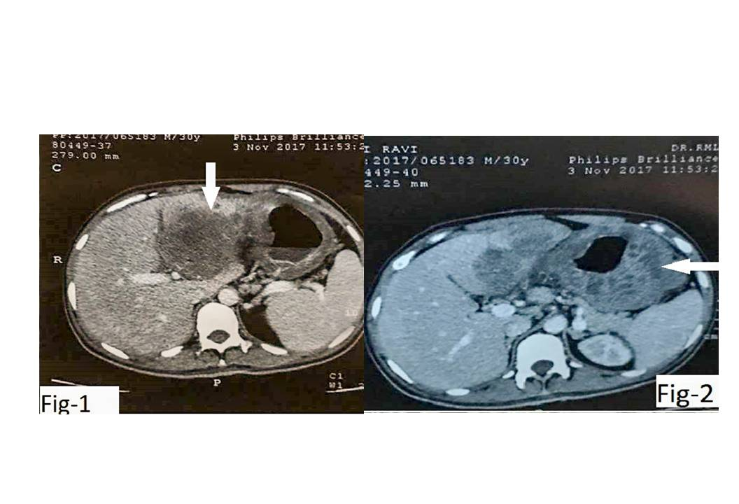

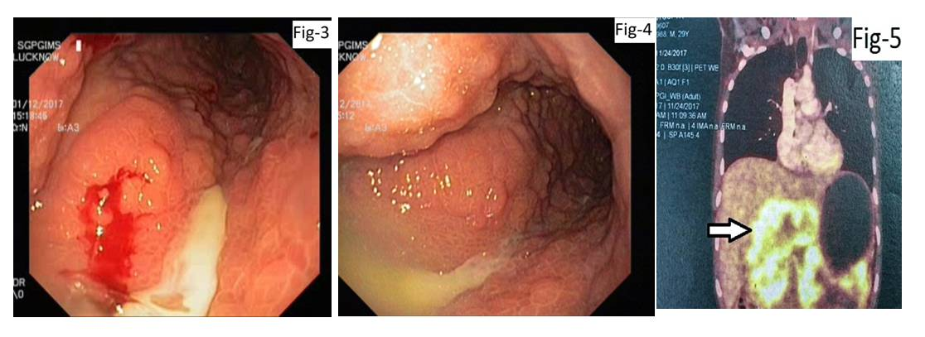
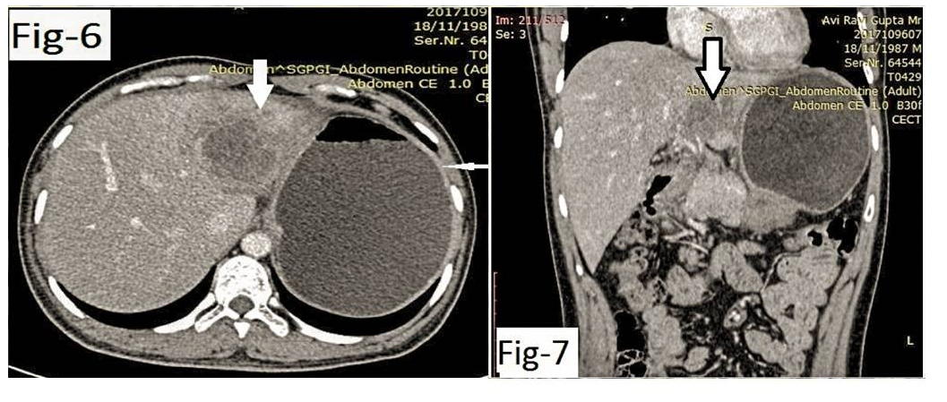

Legends to Figures
Figure-1. Computed Tomography (CT) showing Heterogenously enhancing hypodense lesion in left lobe of liver (Solid Arrow) with assymetric gastric wall thickening and loss of fat plane between left lobe of liver and stomach
Figure-2. Computed Tomography (CT) showing diffuse assymetric gastric wall thickening involving Gastric body and pylorus (Solid Arrow) with adjacent left liver lobe infiltration
Figure-3. Endoscopic image showing Nodular mucosa in body of stomach with pus extruding from it
Figure-4. Endoscopic image showing Limited distensibility and Nodular Congested gastric mucosa (Cobblestone appearance)
Figure-5. Positron Emission Tomography (PET) showing Metabolically active lesion of stomach infiltrating in to adjacent liver(Solid Arrow)
Figure-6. Computed Tomography (CT) after 6 months of Anti-Tubercular Therapy showing Reduction in liver lesion( Thick Arrow) and Disappearance of gastric wall thickening(Thin arrow)
Figure-7.Computed Tomography (CT) (Coronal section) after 6 months of Anti-Tubercular Therapy showing > 70% Reduction in liver lesion( Solid Arrow)

