


Title: Outbreak Investigation of Scabies, Dembiya District, North Gondar Zone, Amhara Region, Ethiopia, November 2017

Name: Girma Birhanu Nurie (Mr.)
Addis Ababa University/Addis Ababa Regional Health Bureau, Dept. of Public Health Emergency Management, Addis Ababa, Ethiopia

ABSTRACT
Background: Scabies affects people of all countries. In developing countries, children in particular are most susceptible, with an average prevalence of 5–10%. It is very common in Ethiopia, especially during natural or manmade disasters, such as flooding, drought, civil war and conflict, poor water supply and sanitation, and overcrowded living condition.
Methods and materials: We conducted 1:2 unmatched case-control study from August 28-November 2, 2017 in Dembiya District, North Gondar Zone, Amhara Region. 40 Cases and 80 controls were randomly selected from the community. Data was collected using structured questionnaire. Analysis was made using Epi Info and SPSS software. Odds Ratio, 95% CI and P-value were used to measure the significance of association in bivariate and multivariate analysis. Variables with p value of equal to or less than 0.05 were reported to be significantly associated with dependent variable.
Results: We identified 141 Scabies cases with overall attack rate of 2% and Zero case fatality rate. Of reported cases 55% of them were male and the median age of affected population was 16yrs (IQR= 19yrs). Sex (AOR: 0.4, 95% CI: 0.1-0.7), Hand washing with soap (AOR: 0.6, 95% CI: 0.1--0.6), Body bath more than a week (AOR: 1.5, 95% CI: 1.2-4.1), Cloth exchange with infected person (AOR: 3.1, 95% CI: 2.0-4.0), contact history (AOR: 17.0, 95% CI: 13.4-20.0), and water shortage (AOR: 3.3, 95% CI: 2.4-4.5) were significantly associated with scabies.
Conclusion: We found poor hygienic practices, sharing of clothing materials, sleeping with people that had contracted scabies was associated with higher frequency of scabies disease. Therefore, increasing awareness creation about the transmission, prevention and control methods of scabies disease is recommended.
Key words: Scabies, case-control, Dembiya, Ethiopia, 2017

Images/Graphs/Tables

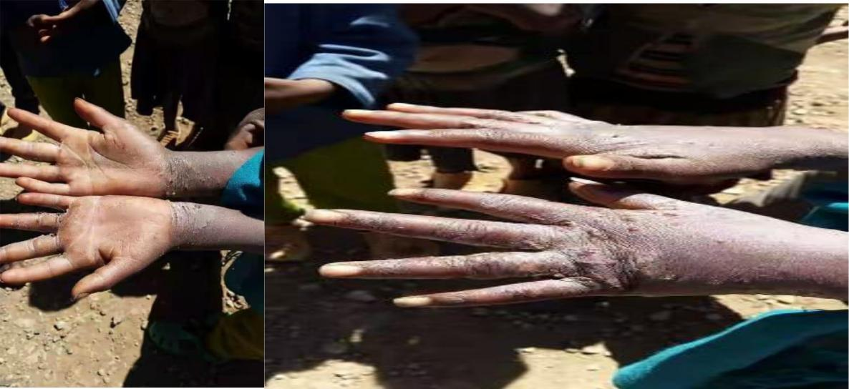

Biography: Mr. Girma Birhanu Nurie holds a Master of Public Health in Epidemiology from Addis Ababa University, Ethiopia. He did his BSc in Environmental Health at University of Gondar, and Diploma in Environmental Health at Jimma University, all in Ethiopia. Currently, he is working as Field Epidemiologist, Researcher/ Disease Prevention and Control Officer at Addis Ababa Regional Health Bureau, Department of Public Health Emergency Management/Bole Sub City Health Office. His passion is taking preventive medicine closer to the rural populations in Ethiopia. Mr. Girma Birhanu Nurie is a former basketball player. He enjoys community work/volunteering, and is a member of Ethiopian Public Health Association .

Presenting author details
Full name: Girma Birhanu Nurie
University/Industry/Organization name: Addis Ababa Regional Health Bureau, Department of Public Health Emergency Management/Bole Sub City Health Office
Designation: Field Epidemiologist, Researcher/ Disease Prevention and Control Officer
Country: Ethiopia
Mobile number: 251-937450410
Official Email ID: girma.birhanunurie@gmail.com
Presentation type: Oral
Category: Invited talk
Track number: 18
Follow this link https://biomarkers.conferenceseries.com/call-for-abstracts.php

Research interest:

Your profile page URL in your department:
Date of birth as per the passport: 3 August 1978
Linked In: www.linkedin.com/in/girma-birhanu-n-8619b1169
Twitter account: https://twitter.com/n_girma
Postal address: Addis Ababa Regional Health Bureau, Dept. of Public Health Emergency Management, Bole Sub City Health Office, P.O. Box 110662, Addis Ababa-Ethiopia
Linked In account: /www.linkedin.com/in/girma-birhanu-n-8619b1169/
Session name:International Conference on Gastrointestinal Cancer and Therapeutics (2494th of Conference Series LLC Ltd) October 29-30, 2018 San Francisco, California, USA

Paper first presented at Addis Ababa University School of Public Health, Ethiopia Field Epidemiology Training Program (cohort 8 resident); 2 Department of preventive Medicine School of Public Health Addis Ababa University.
Supervisors: Prof. Ahmed, Ahmed Ali, Prof. Girma Taye Aweke

