Walking ≥5,000 step/day reduced the risk of fall in urban community-dwelling older people?
Chutima Jalayondeja, PT, Dr.P.H., MU, TH
Thanyaporn Aranyavalai, PT, PhD. NMU, TH
Wattana Jalayondeja, PT, PhD, MU, TH
Sopa Pichaiyongwongdee, PT, MSc, MU, TH
Jalanit Kaewkungwal, PT, PhD, MU, TH
James J. Laskin, UM, USA

Abstract (300 word limit)
Statement of the Problem: Falling is the leading cause of injury and death in older people worldwide. The prevalence of falling varies in each country and ranged from10.4% to 53.6%. Because of many countries encountered with high number of older populations, this lead to increase the number falling and dying in the future. Identifying preventive strategy for reducing the risk of falling is urgent. Walking is a population-wide campaigns to promote physical activity and health for all ages. According to the guideline, walking 7,000-10,000 step/day is equivalent to 30 minute/day of moderate-to-vigorous physical activity (MVPA). However, walking threshold for reducing the risk of falling in older people is not yet to be quantified. Therefore, the purpose is to identify walking threshold (steps/day) for reducing risk of falling in community-dwelling older people. Methodology & Theoretical Orientation: This study is the six-month observational prospective study for fall incidence in community-dwelling older people who had 1-year free of falling. 933 older people living in five communities in Thonburi district, Bangkok, Thailand were invited to participate. Subjects received physical fitness and balance performance tests at baseline. Walking step/day were assessed by the Actical® accelerometer which worn on their nondominant wrists for 24-hour for 7days. Fall incidence were recorded in calendar by the subjects or care-givers and submitted to the Village Health Volunteers every two weeks. Findings: Of 255, 33 (12.9%) reported fall over the six-months. The fall incidence rate was 0.79 per 1000 person-day. A significant difference of fall incidence over the six-month between older people who walk≥ 5,000 step/day and <5,000 step/day were observed. In addition to, the survival probability from falling >80% among older people who walk≥ 5,000 step/day. Conclusion & Significance: This finding proposed the walking ≥ 5,000 step/day as a guideline to reduce the risk of falling in older people.

Image
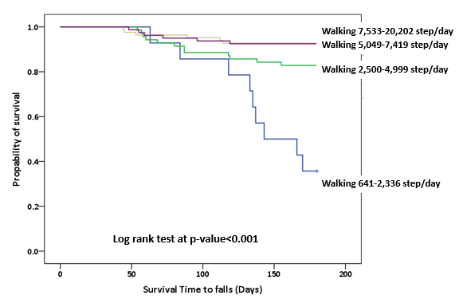
Recent Publications (minimum 5)
- World Health Organization (2007). WHO global report on falls prevention in older age. Geneva. Switzerland. Available from: https://www.who.int/ageing/publications/Falls_prevention7March.pdf.
- Tudor-Locke CE, Craig CL, Aoyagi Y, et al (2011). How many steps/day are enough? For older adults and special populations. International Journal of Behavioral Nutrition and Physical Activity 8(80):1-19.
- Tudor-Locke C, Craig CL, Thyfault JP, Spence JC (2013). A step-defined sedentary lifestyle index: <5000 steps/day. Applied Physiology, Nutrition and Metabolism 38:100-14.
- Johnson M, Meltz K, Hart K, Schmudlach M, Clarkson L, Borman K (2015) Validity of the Actical activity monitor for assessing steps and energy expenditure during walking. Journal of sports science 33(8):769-76
- Jalayondeja C, Sullivan PE, Pichaiyongwongdee S (2014) Six-month prospective study of fall risk factors identification in person post stroke. Geriatrics and Gerontology International 14(4):778-85


Biography (150word limit)
Chutima Jalayondeja has her expertise in physical activity research for all ages. She received national and international funding support for conducting physical activity and sedentary behavior researches in community-dwelling older population, adult office-workers and preschool student. She translated compendium physical activity in Thai version (https://sites.google.com/site/compendiumofphysicalactivities/compendia) and developed the Thai Physical Activity Guideline (TPAG) for physical activity promotion in Thais aged 18-64 years (http://www.pt.mahidol.ac.th/tpag/). Her contributions in health promotion followed her passion and goal in developing the guidelines for improving health and wellbeing in all ages.
Email: chutima.jal@mahidol.edu.
Notes/Comments

