Factors affecting exercise program adherence in patients with acute hip fracture and impact on one-year survival
Ana María Rosas Hernández, PT PhD, Universidad Autónoma de Madrid, España. Universidad del Rosario, Colombia.
Teresa Alarcón, MD, Hospital Universitario La Paz. España.
Rocío Menéndez-Colino Department of Preventive Medicine, Universidad Autónoma de Madrid. España.
Isabel Martín Maestre, RN, Hospital Universitario La Paz. España.
Juan Ignacio González-Montalvo MD, Hospital Universitario La Paz. España.
Ángel Otero Puime, MD, Department of Preventive Medicine, Universidad Autónoma de Madrid. España.

Abstract
Objective: To study the adherence of an Early Inpatient Exercise Program in patients with acute hip fracture, identify variables associated with its performance, and its association to one-year survival. Methods: Observational longitudinal study of a cohort of 509 patients, admitted consecutively with a hip fracture in La Paz University Hospital (Madrid, Spain). Data included sociodemographic variables, pre-fracture physical functioning, cognitive impairment, comorbidities, measure of exercise adherence (pre-surgery exercise, post-surgery exercise, and rehabilitation sessions) and vital status at follow-up. One year after the fracture, either patients or relatives were contacted by telephone to ascertain their vital status. Data were analyzed using logistic regressions and multivariate Cox proportional hazards regression. Results: Three quarters of patients (76.0%) were able to comply with the Early Inpatient Exercise Program. Factors associated with adherence were: living at home (Odds Ratio (OR) = 3.39; 95% Confidence Interval (CI): 2.03, 5.64), absence of pre-fracture disability (OR = 3.78; 95% CI: 2.21, 6.47), absence of pre-fracture cognitive impairment (OR = 2.36; 95% CI: 1.36, 4.07) and comorbidities (OR = 1.66; 95% CI: 1.03, 2.67). Early Inpatient Exercise Program adherence was associated with one-year survival (HR = 1.62; 95% CI: 1.06, 2.49). Conclusions: The adherence with an Early Inpatient Exercise Program is high and is associated with 1-year survival. It is important to make a stronger effort to encourage participation in Early Inpatient Exercise Program in the 24% currently non-compliant, and in those with cognitive and physical impairments.
Image
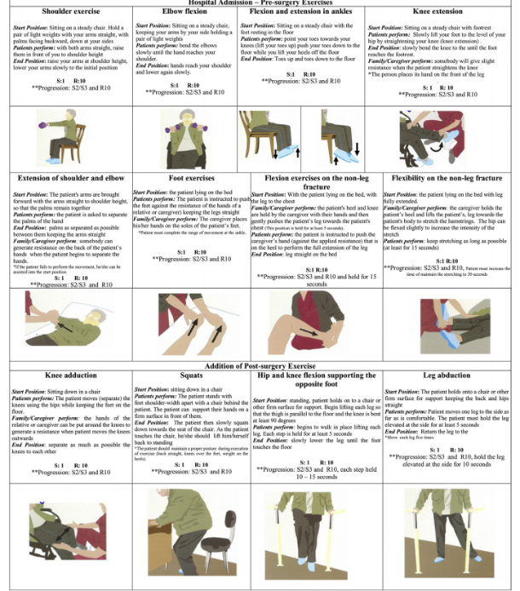
Figure 1. Exercise routine information sheets received by patients with hip fractures during hospitalization (for use before and after surgery)

Recent publications
- Rosas Hernández AM, Alejandre Carmona S, Rodríguez Sánchez JE, Castell Alcalá MV, Otero Puime Á. (2019). [Detection of the largest population susceptible to prescription of a program of exercises in Primary Care to prevent frailty]. Aten Primaria. 2019 Mar;51(3):135-141. doi: 10.1016/j.aprim.2017.11.005.
- Rosas Hernández AM, Castell Alcalá MV, Otero Puime Á, González-Montalvo JI. The lack of adherence to a structured multicomponent program of physical exercise by the frail elderly]. Rev Esp Geriatr Gerontol. 2019 Jan-Feb;54(1):59-60. doi: 10.1016/j.regg.2018.10.007.
- Castell MV, Gutiérrez-Misis A, Sánchez-Martínez M, Prieto MA, Moreno B, Nuñez S, Triano R, de Antonio MP, Mateo C, Cano MD, Garrido A, Julian R, Polentinos E, Rodriguez-Barrientos R, Otero Puime A; MEFAP Group. Effectiveness of an intervention in multicomponent exercise in primary care to improve frailty parameters in patients over 70 years of age (MEFAP-project), a randomised clinical trial: rationale and study design. BMC Geriatr. 2019 Jan 28;19(1):25. doi: 10.1186/s12877-018-1024-8.


Biography
Physiotherapist with clinical research emphasis of Universidad del Rosario (Bogotá, Colombia). Master and PhD in Epidemiology and Public Health of Universidad Autónoma de Madrid (Madrid, Spain). Her researches have focused on detection of frailty from primary care, as well as, design and implementation of physical exercise programs to improve functionality in population with geriatric syndromes through the aim of enhance quality of life.
Email: ana.rosas@urosario.edu.co

