Profiles of ICF Disability In Alzheimer and Vascular Dementia
A. Malara, G. Sgro’, F. Ceravolo, G. Curinga, G.F. Renda, F. Spadea, V. Rispoli

Abstract (300 word limit)
The International Classification of Functioning, Disability and Health (ICF) is a suitable tool to standardize the status of health and disability. A previous study, carried out on 546 subjects included in the database ANASTE (National Association of Nursing Home for Third Age) Calabria, showed that 78.43% of the patients suffered from cognitive impairment whereas 52% had a severe degree of dementia. 65% of them was suffering from Alzheimer’s Disease (AD), whereas 23% from vascular dementia (VD). Aim of this study was to analyse the prevalence of functional impairments, activity limitations and participation restrictions of patients affected by AD and VD. Design: Observational descriptive study. Setting: Nursing Homes ANASTE Calabria. Participants: 10 patients with probable AD (ADPr) and 10 patients affected by probable VD (VDPr). All patients were underwent multidimensional geriatric assessment. The profiles of disability ICF, were expressed in terms of Capacity and Performance, and coded according to mild, medium, severe and complete disability. Environmental factors were skilled in facilitator or no facilitator. Results: The patients with ADPr displayed a severe impairment of functional status, and advanced clinical stage requiring higher care burden compared with VDPr patients. The ICF assessment showed that the global and specific Mental Functions, Communication and Interpersonal Relationships were more reduced in patients with ADPr respect those with VDPr. The identification of a ICF checklist of various forms of dementia, might provides a more detailed description of the profiles of disability and improving therapeutic, rehabilitative interventions and psico-social care.

Image
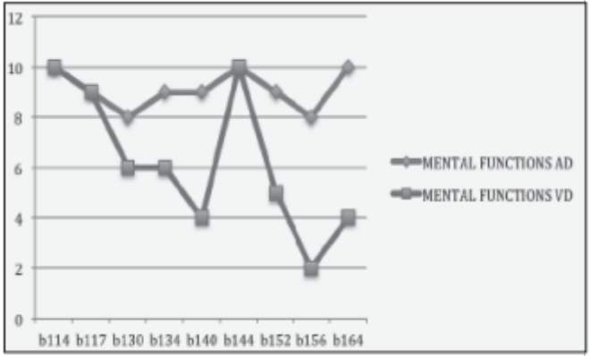
Recent Publications (minimum 5)
- World Health Organization.: International Classification of Functioning, Disability and Health : ICF. Geneva, World Health Organization; 2001.
- Ustun B: The international classification of functioning, disa- bility and health-a common framework for describing health states. 2002. http:// whqlibdoc.who.int/publications/2002/9241545518_Chap7.3.pdf.
- Mueller M, Lohmann S, Strobl R, Boldt C, Grill E. Patients’ functioning as predictor of nursing workload in acute hospital units providing rehabilitation care: a multi-centre cohort study. BMC Health Services Research 2010; 10:295- 307
- Okochi J, Utsunomiya S, Takahashi T. Health measurement using the ICF: Test-retest reliability study of ICF codes and qualifiers in geriatric care. Health and Quality of Life Outcomes 2005; 3:46-59
- Mueller M, Boldt C, Grill E, Strobl R, Stucki G: Identification of ICF categories relevant for nursing in the situation of acute and early post- acute rehabilitation. BMC Nurs 2008; 7:3.

 Biography (150 word limit)
Alba Malara specialized in Geriatrics and Gerontology. Since 2004 she works as Medical Director in a Residential Center and Extensive Rehabilitation Continuous Cycle as well as in several other nursing homes in Calabria. Since 2007 she has worked as Scientific Coordinator of the " Scientific Committee of National Association of Third Age Residences (ANASTE). Since 2011 she has been scientific consultant for the European Confederation Home Care Organitation (ECHO), Brussels, Belgium. Since January 2015 she is Chairwoman of Italian Society Geriatrics and Gerontology (SIGG) Calabria. Dr Malara has set up a research methodology based on daily utilization of multidimensional geriatric assessment tests used for clinical practice in a network of nursing homes in Italy. In particular Dr Malara’s research is primaly focused on geriatric multidimensional assessment, dementia, behavioural problems, pain and farmachological and non pharmachological strategies, care of and of life, care quality and patients' quality of life.

Email: alba.doc@tiscali.it

Notes/Comments

