Title: Factors Influencing Reservoir Quality in the Lower Jurassic Cook Formation of Veslefrikk and

Oseberg Fields, Norwegian North Sea.
Syed Moiz Hasnain, Jens Jahren, University of Oslo, Norway

Abstract

Two wells from the Veslefrikk Field (30/3-4 and 30/3-5S) and one well from the Oseberg Field (30/6-17A), 30 kilometers south of the Veslefrikk field in the northern North Sea was studied. Reservoir depth ranges from 2800 to 3200 meters for the Veslefrikk wells while the Oseberg well is buried about 2400m. Aim of this study was to improve the understanding of reservoir quality in deeper buried Jurassic sandstones of Cook Formation in nearby areas.

Porosity loss in siliciclastic reservoir rocks is related to early mechanical compaction and later chemical compaction from quartz cementation at temperatures above 70°C. Coatings on detrital grain surfaces may prevent or inhibit quartz cementation during deep burial. This study focuses on the formation of chlorite coatings in the Cook Formation.

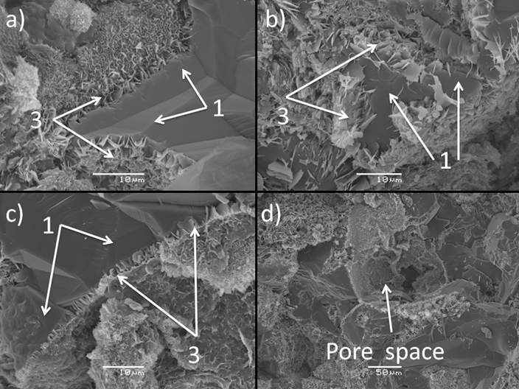
28 thin-sections, stubs, and rock powder samples produced from cores of the wells, were studied for optical point counting, SEM imaging and XRD analysis. Furthermore, sedimentological logging of the cores was performed, suggesting a tidally influenced prograding deltaic environment in the Veslefrikk area and an upper shoreface environment in Oseberg area during deposition of the Cook Formation (fig.1).
Figure 2 - a) Quartz over growth can be seen growing into chlorite (30/3-5S, 4444.70m), b) and c) Flaky chlorite grains are covering the surface of quartz grains (30/3-5S, 4444.70m), d) Pore can be seen chlorite coated form inside (30/3-5S, 4444.70m).

Petrographically, by point counting: grain size, matrix, sorting, porosity and intergranular volume (IGV) were estimated. The Cook Formation was found to be quartz arenitic to subarkosic in composition, moderately to well sorted and with an average IGV of 29%. SEM analysis showed partial to complete chlorite coatings in deeper samples of Veslefrikk area (fig.2), while macroscopic chlorite coatings was not observed in the shallower samples of Oseberg area. Low amounts of quartz cement were detected in the Cook Formation both in the shallow Oseberg well and the deeper Veslefrikk wells. The low quartz cement amounts found in the deeper part (temp. 138°C) of the Veslefrikk wells indicate possible inhibition of quartz cementation by chlorite coatings on detrital grains.
Image
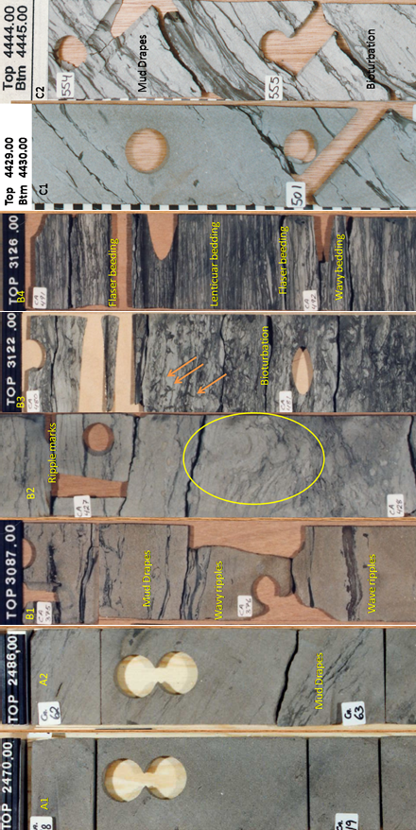
Figure 1 - A1: Sandstone relatively clean (well 30/6-17A, 2470m), A2: Sandstone (well 30/6-17A, 2486m), B1: Sandstone (well 30/3-4, 3087m), B2: Sandstone (well 30/3-4, 3104m), B3: Shaly sandstone (well 30/3-4, 3122m), B4: Mudstone (well 30/3-4, 3126m), C1: Sandstone (well 30/3-5S, 4429m), C2: Sandstone (well 30/3-5S, 4444m).

Biography
Syed Moiz Hasnain holds a master’s degree in Geosciences from University of Oslo and has expertise in reservoir characterization and evaluation. He is interested in hydrogeology, water contamination, climate change among other scientific issues.
Email: geomoiz85@gmail.com
- Full Name: Syed Moiz Hasnain
- Personal Email: geomoiz85@gmail.com
- Mobile Number: +4745525173
- Linked In: www.linkedin.com/in/moizhasnain
- Session Name/ number:
- Category: (Oral presentation)
- Date of Birth: 1985
- Postal Address: Olav M. Troviks vei 2, 0864, Oslo, Norway.

