Seismic Study of Sediment Transport on the Irrawaddy River
Austin Pierce
Dr. Paul Liu
North Carolina State University
Department of Marine, Earth, and Atmospheric Sciences
Jordan Hall 3148

Background

The Andaman Sea is a back-arc extensional basin that is controlled by the convergence zone between the Australian plate and the Southeast Asian plate. Extensive normal and strike-slip faulting occurs within the central basin and the Alcock Rise while the main fault (Sagaing Fault) separates the East basin from the Central basin. The main river systems, Irrawaddy, Salween, and Ganges-Brahmaputra dominate the fluvial environment of Myanmar and drastically shape and reshape the residing topography. The Myanmar coastline is separated into several distinct topographic regions. The Rakhine coastline borders the Bay of Bengal and contains a vastly different and steeper topography than its eastern counterpart, The Gulf of Martaban. The Gulf of Martaban is the eastern most part of the Andaman sea and borders the Salween River. The central basin borders the Mouths of the Irrawaddy and encompasses surrounding delta. The Irrawaddy and Salween river systems join to deliver approximately half of the total dissolved load from the Himalayan Tibetan orogeny. Singularly, the Irrawaddy discharges close to 334e^6 T of sediment into the Andaman Sea (Rodolfo). Impressively, the Irrawaddy-Salween river system is second only to the Amazon in terms of annual organic carbon transport, a yield of 5.7 – 8.8 MT. The river itself stretches 2280km while covering 230,000 km^2 of the continental shelf.
The Myanmar fluvial system combines to discharge over 500MT of sediment, contributing extensively to shoreline progradation at a rate of 2.5km/100 years. The question therefore becomes, where else is it being deposited? Geomorphically speaking, the eastern and central basin are relatively flat (slope of .01 degree up to the 40m contour) and is therefore extremely prone to flooding, especially during monsoon seasons. After the shelf break and on the west side of the Sagaing Fault the topography suddenly becomes increasingly steeper up to the Martaban Depression. Therein lies the primary objective of the two-week research venture on the Andaman Sea. The purpose was to determine how the active tectonics of the region influenced sediment transport, deposition, and stratification. Additionally, the aim was to determine where the sediment officially terminated and by derivation, the maximum length at which it was transported. The research cruise (Dec. 5 – 18 2017) conducted over 1000 nautical miles of track lines, 30 coring stations, and collected upwards of 100 hours of CHIRP 512i data. The CHIRP seismic data analysis will be performed by North Carolina State University and the final product will result in a full rendering of 3D profiles. This will allow a better correlation of sediment thickness, distribution, stratification, pattern recognition, and active tectonics among profiles within the Andaman Sea. This research cruise was funded by the National Science Foundation (NSF) and coordinated by Dr. Paul Liu (NCSU) and Dr. Steve Kiehl (VIMS).

Methods

The CHIRP system used during the Research cruise was a quad transducer 512i. Its acoustic frequencies allow real time visualization of the seafloor stratification and tectonic processes. This data will be processed and rendered into separate 3D profiles for individual and group analysis. The software utilized in the post processing phase will include: EdgeTech Discover – Sub-Bottom 4.04, Open CPN, Photoshop.

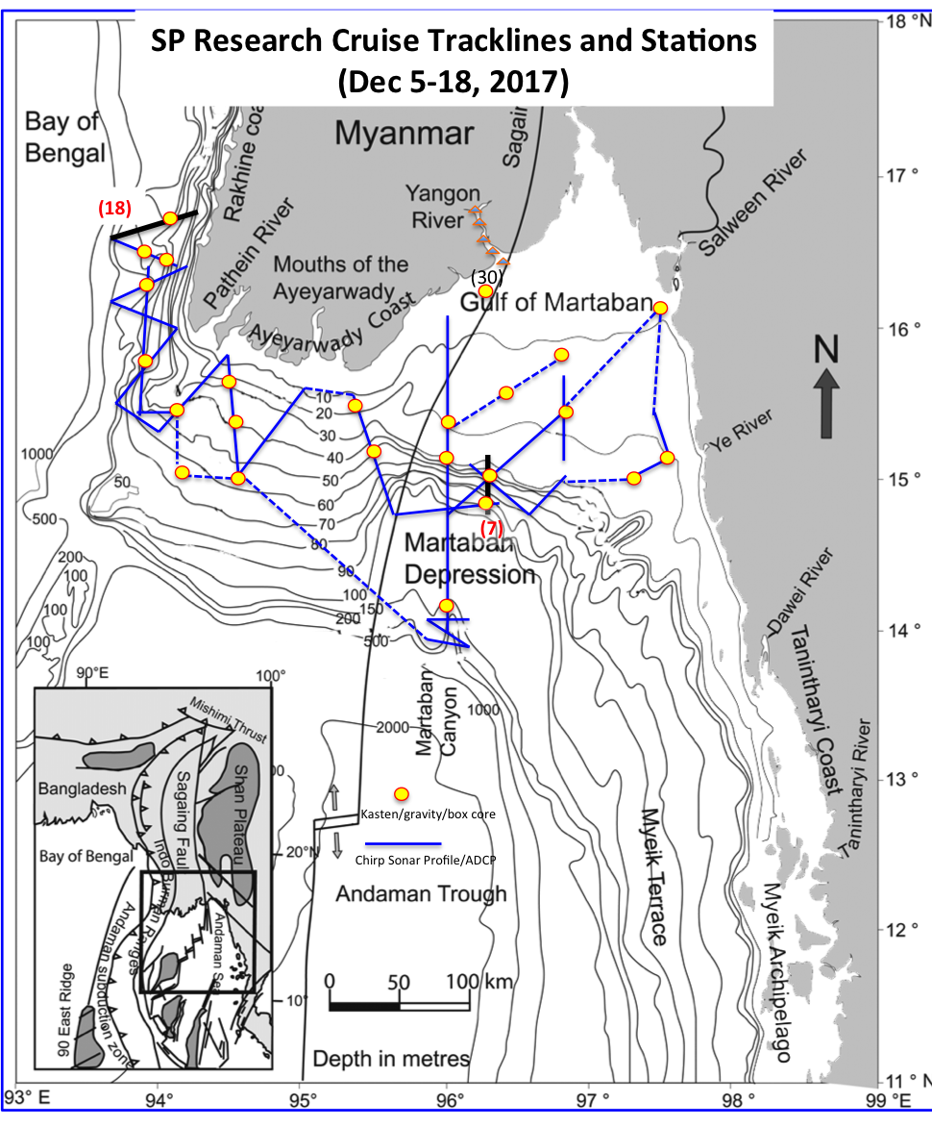

Primary Results

Due to the high-resolution images obtained from the CHIRP system we believe the sediment is being distributed on the western side along the Rakhine coast and within the Gulf of Martaban. Mud thickness in some areas will vary between 50 and 100 meters. Further, we found no evidence of modern sediment being delivered into the Martaban Canyon like previously thought. Slumping and tectonic activity in the delta is present throughout.

