Geological structures of continental China reviewed by aeromagnetic data
Xiong Shengqing, Professorate Senior Geophysicist, China Aero Geophysical Survey and Remote Sensing Center for Land and Resources.
Tong Jing, Engineering Geophysicist,
China Aero Geophysical Survey and Remote Sensing Center for Land and Resources

Abstract (300 word limit)

Using the most advanced method of processing and mapping, the compilation of 1:1000000 series of China land aeromagnetic map has provided high quality fundamental materials of regional geophysics for the research of regional geological structures in our country, which innovates a lot upon mapping of regional aeromagnetic and geological structures, data processing technology, interpretation method and recognition of geological structures etc, also promotes the progress of scientific and technology in related field. Based on about 120000 depth data of magnetic body calculated by surveyed magnetic materials, the depth map of China land magnetic basement was compiled. We carried out research on characteristic of China land rugged magnetic basement, especially the distribution of depression and uplift, and the depth and current status of the sedimentary cover layer, which provided reference materials for the study of regional structures and prognosis of oil-gas exploration target area in China. Depending on the magnetic data, and combining the comprehensive research of gravity, geology and remote sensing data etc, we compiled distribution map of 1:2500000 China land fault and magnetic rocks, regional structure map (fig1) and series of interpretation map of geological structures, and then established the framework of fault structures; found many new faults; delineated concealed and half concealed magnetic rock body; characterized regional structural unit and its boundary; clearly illustrated the characteristics of basal lithofacies structure; evaluated the stability of basement; discussed the characteristics of deep magnetic structure and depth of magnetic layer. These maps will give blueprint for the work of geosciences and benefit a lot to the study of framework. The first aeromagnetic-geological structure maps of continental China, has significantly important reference value for the analysis of regional structures, geological background of oil-gas and mineral resources formation, the evaluation of geological environment, geological disaster, and development of geosciences theory.
Image
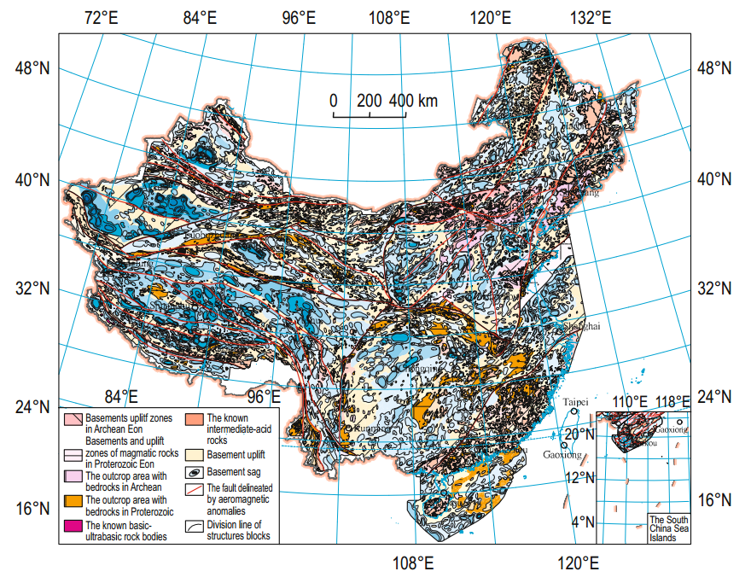
Fig1 Regional geotectonic map of continental China based on aeromagnetic data
Recent Publications (minimum 5)
- Xiong S. Q. 2016, Aeromagnetic data and geological structure of continental China: A review, APPLIED GEOPHYSICS, Vol.13, No.2 (June 2016), P. 227-237.
- Xiong, S. Q., Ding, Y. Y., and Li, Z. K., 2012, Characteristics of gravity and magnetic field in Xizang (Tibet) and new understanding on tectonic framework in Eastern Xizang: Geological Review, 58(2), 201−207.
- Xiong, S. Q., Ding, Y. Y., and Li, Z. K., 2013a, Gravity and magnetic field characteristics and their geological signiﬁcance in Qiangtang basin, China: Oil Geophysical Prospecting, 48(6), 999−1008..
- Xiong, S. Q., Ding, Y. Y., and Li, Z. K., 2014a, Characteristics of China Continental magnetic basement depth: Chinese J. Geophys., 57(12), 3981−3993.
5. Xiong, S. Q., Ding, Y. Y., and Li, Z. K., 2014b, A new understanding on the pattern of deep faults in Tibet and the southwestern Sanjiang area: Chinese J. Geophysics., 57(12), 4097−4109.
6. Xiong, S. Q., Fan, Z. G., Zhang, H. R., et al., 2013b, Aeromagnetic series Map of China’s Land and its specification (1:5,000,000): Geological Publishing House, Beijing

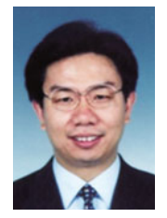 Biography (150 word limit)
Xiong Sheng-Qing is a senior geophysicist and professor. His research interests are in aero geophysics and remote sensing. Presently, he is the chief geoscientist at the China Aero Geophysical Survey & Remote Sensing Center for Land & Resources.
Email: xsq@agrs.cn

Notes/Comments:

Would you please kindly send the conference agenda and invitation letter for the authors above, since these information is required to make foreign affairs plan in 2017 before the end of this month. Your rapid reply will be appreciated.

Contact Person: Tong Jing
Email: tongjing84@163.com
Tel:+86 13811569185

