DISTRIBUTION OF ZONE A AND B RESERVOIR
IN UPPER GABUS AND LOWER ARANG FORMATION,
IN BLOCK ANAMBAS AREA, WEST NATUNA BASIN, INDONESIA.

Resty Intan Putri, Geological Engineering Department, Univ. Gadjah Mada, Indonesia.
Dr. Jarot Setyowiyoto, Geological Engineering Department, Univ. Gadjah Mada, Indonesia.

Abstract
This research took place at an off-shore oil field as a part of Anambas Block in West Natuna Basin, Riau Islands Province approximately 300 km west of Natuna Island which covers the area of 1.320 km². It aims to determine lithology facies and sedimentation environment which lead to distribution, thickness, and the geometry of prospect reservoir. Well log, core, and seismic 2D, as main data of this research, are combined and integrated. Additional data like thin-section and drill stem test (DST) data are also used as well. There are 2 prospect reservoirs are found in this area of study which potentially become drilling target. Specifically, those reservoirs are Reservoir Zone A (A1, A2, A3), as parts of Upper Gabus Formation and Reservoir Zone B, as parts of Lower Arang Formation. Reservoirs Zone A and B are parts of mixed flats and tidal sand bar facies in tidal flats sedimentation environment. It is concluded by the presence of typical tidal activity sediment structures, such as lenticular, wavy, and flaser bedding. Ichnofacies Glossifungites and mineral glauconite is also appear. Both reservoir zones also have a typical elongate geometry with NW-SE orientation, following development of strike-slip fault in research area. Reservoir Zone B is thicker than Reservoir Zone A, but both reservoir zones show the same pattern of thicker Northeast-ward.

Image
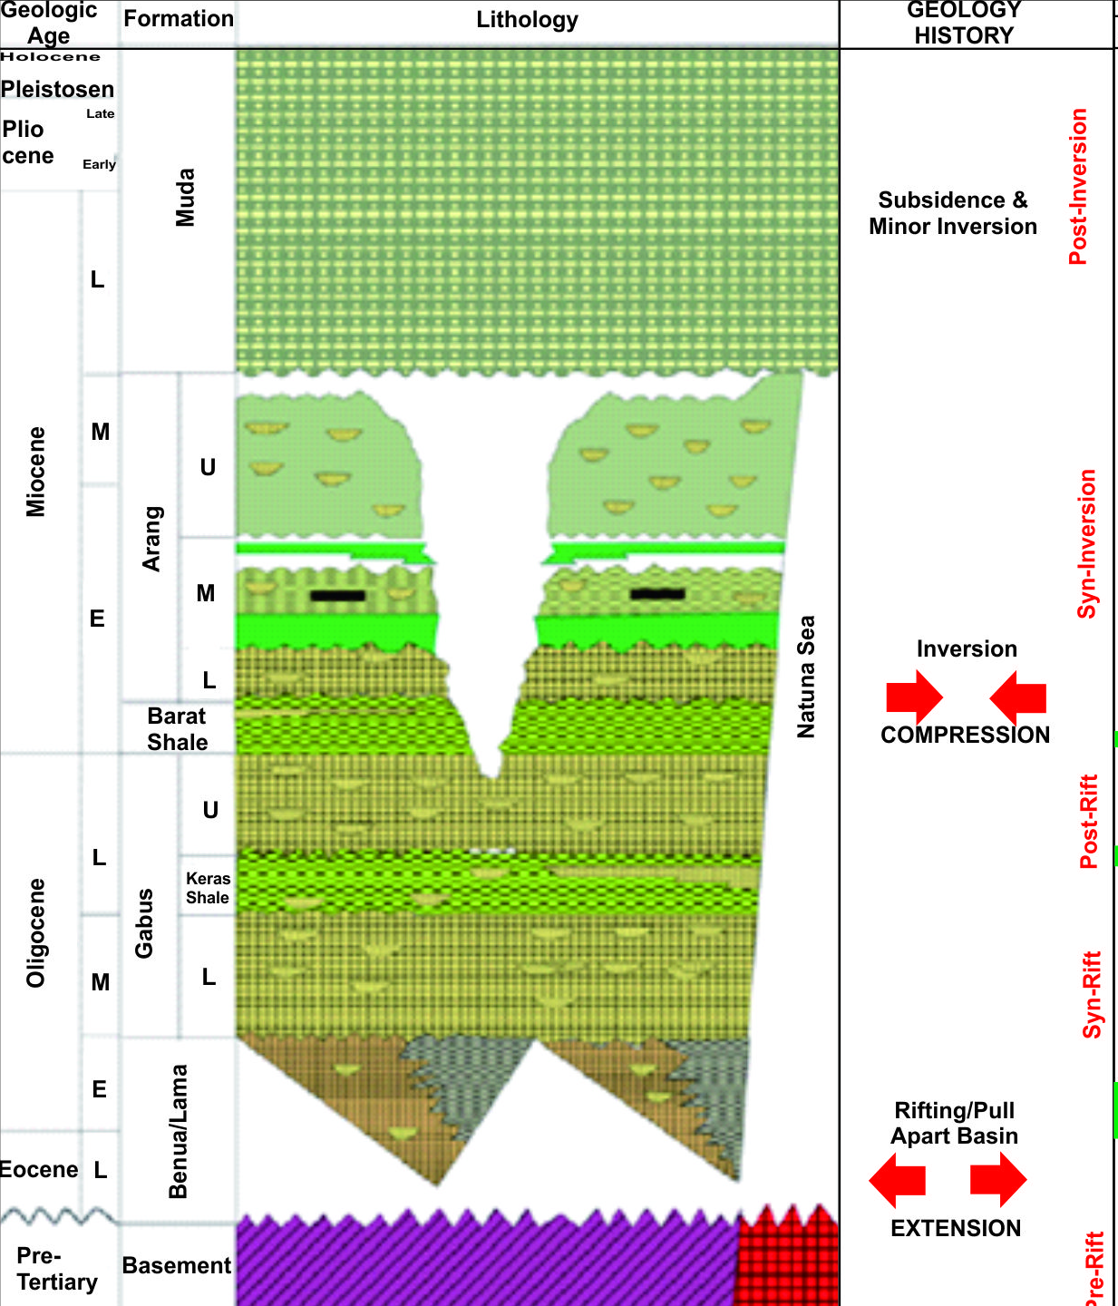
Figure 1. Stratigraphy coloumn in West Natuna Basin. Upper Gabus and Lower Arang Formation in red polygon are target formation.
Recent Publications
- Daidu, F., 2013, Classifications, Sedimentary Features and Facies Associations of Tidal Flats. Journal of Paleogeography vol.2 no.1.
- Dalrymple, R.W., 1992. Tidal Depositional Systems. In R.G. Walker and N.P. James, eds., Facies Models: Response to Sea Level Change. Geological Association of Canada, St. John's,p.195-218.
- Hakim, M.R., Naiola, M.YY., Simangunsong, Y.R.A., Laya, K.P., dan Muda, T.Y.W., 2008. Hydrocarbon Play of West Natuna Basin and Challenge For New Exploration Related to Structural Setting and Stratigraphic Succession, Proceedings Indonesian Petroleum Association.
- Ilona, S.,2006. ‘3D Structural Architecture of The Kra Field, West Natuna Basin, Indonesia’, Proceedings Jakarta 2006 International Geosciences Conferences and Exhibition.
- Pertamina BPPKA, 1996. West Natuna Basin, Petroleum Geology of Indonesian Basins – Principles, Methods, and Application,. vol.XIV, Indonesia.
- Sutoto, A., 1991. Reservoir Geology of the Belida Field South Natuna Sea, Block B. Proceedings Indonesian Petroleum Association, 20th Annual Convention : IPA, Vol.1,p.453-478.
Biography
 Resty Intan Putri is a graduate student of Geological Engineering Department of Universitas Gadjah Mada, Indonesia, with the concentration of Petroleum Geology. In 2014, she participated several exchange progam such as PARE programe in Hokkaido University, Japan, and School on the move program held by Kyushu University, started from Philippines – Japan – Indonesia – Cambodia. She was also a member of UGM Team in Petroleum Competition of AAPG Imperial Barrel Awards in 2015.

Email : resty.intan@gmail.com

