UNIQUE RAIN WATER HARVESTING METHOD
Innovation By Nellore Scientist Dr.A.Jagadeesh
Rain Water Harvesting is buzzword these days. The Previous Government in AP Promoted INKUDU GUNTALU(Percolation Pits) on a massive Scale. About Rs 2000 Crores has gone to Drain. Will Any fool dig 2 – 3 Ft. Depth Inkuduguntalu when Water table is 50 ft. The Better way might have been to locate ground water availability through GIS.
Dr.A.Jagadeesh,Renewable Energy Expert and Director,Nayudamma Centre for Development Alternatives is well known Innovator who believes in Steve Job’s Philosophy of THNK DIFFERENTLY.
Everybody knows that A cone compresses air or water at the lower end.This principle coupled with common sense led to the design of Unique Rain Water Harvesting System which is simple, cost effective and uses local material.
6 inch diameter PVC Pipe is taken(6 ft length). Leaving from top 1 foott the PVC Pipe drilled with holes. The PVC Pipe is covered with Mesh(To arrest the entry of soil/sand) and tightly tied with plastic rope. With Hand Bore a 6 ft. whole is dug. The PVC Pipe is drowned in the bore hole and over it a Funnel(GI Sheet) of 1.3 ft diameter is placed. The Bore hole at the bottom and sides was covered with pebbles for penetration water.
Testing the system:
Water (15 litres) from Bucket is poured in the funnel with a capacity of 20 Buckets(About 300 Litres) . In 10 minutes the water disappeared in the bottom. Because of the pressure and holes in the PVC Pipe water absorption is high.
Advantages:
1. It occupies less space.
2.Funnels are readily available in the Market.
3. All the material PVC Pipe,Mesh and Plastic Wire are available locally.
4. Size of the Funnel(About 1 meter Diameter and PVC Pipe 10 inches) can be designed for large
Scale operation.
5. This simpe system costs Rs 1500 and took 2 hours to install.
In African region this will be a boon.
In our country for dry crops this will help( Ground Water recharge).
Our Prime Minister in his MANN KI BAAT emphasized the need for conservation and Ground Water Recharge. This innovative method will be BHAGIRATH for FARMERS.
In the recent Budget by Union Government it was proposed,” For the sector comprising of Agriculture and allied activities, Irrigation and Rural Development an allocation of about Rs 2.83 lakh crore has been made for the year 2020-21 .”.
This innovative method implemented on a massive scale will help recharge of Ground Water.
Dr.A.Jagadeesh Nellore(AP)
Renewable Energy Expert
Environment Specialist
Recipient
Margaret Noble Foundation Seattle Award in Energy Technology.
E-mail: a.jagadeesh 8@gmail.com
Mobile: 9490125950

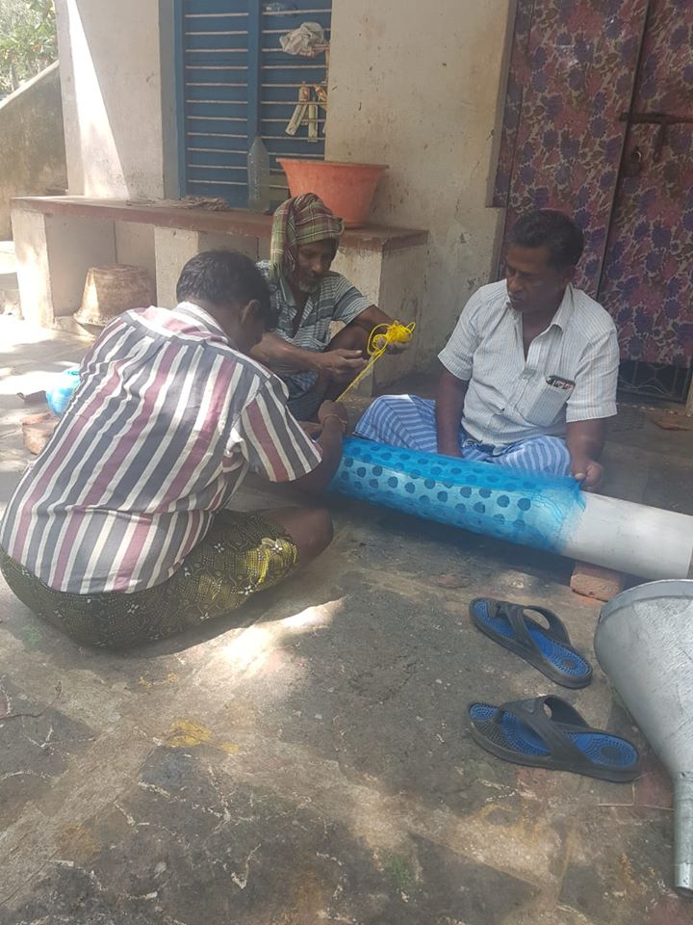
Mesh Covering on the PVC Pipe.
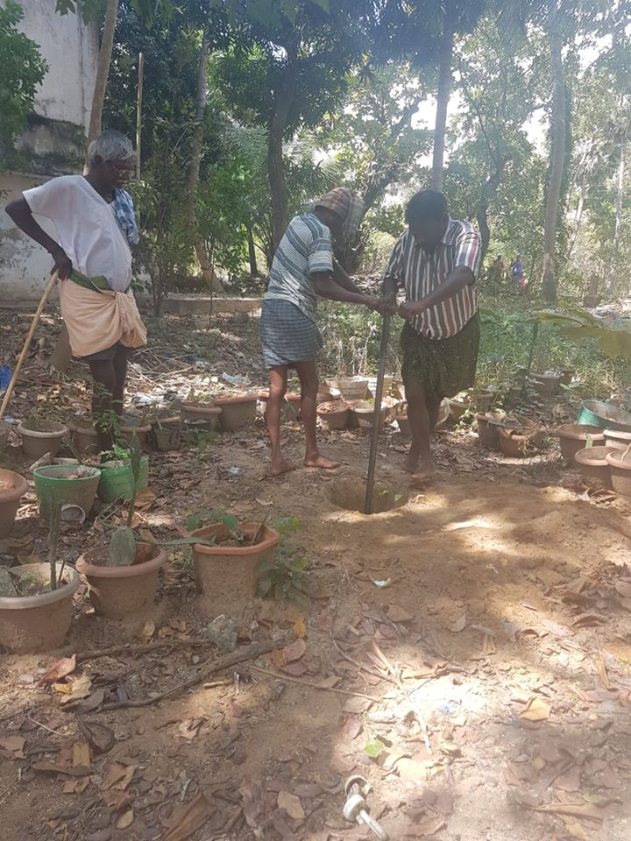
Drilling the Bore.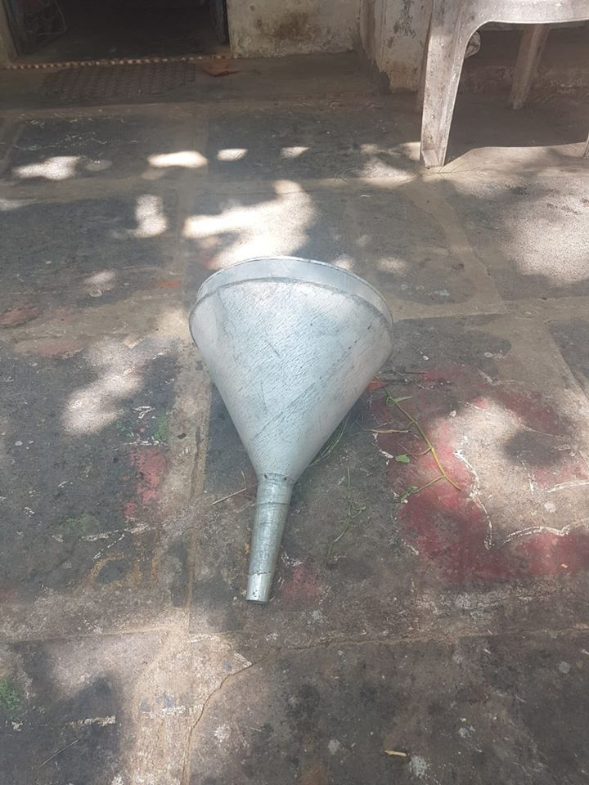
1foot Diameter GI Sheet Funnel

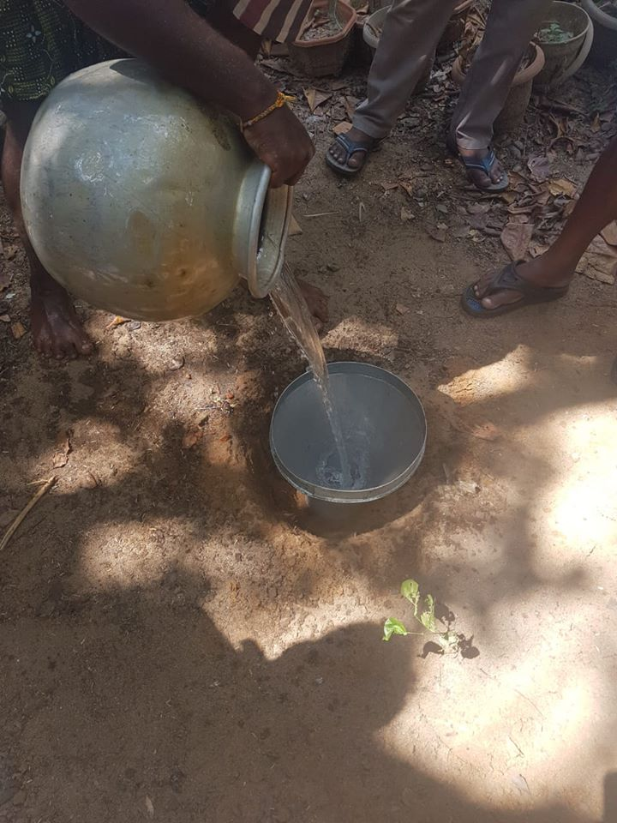
Testing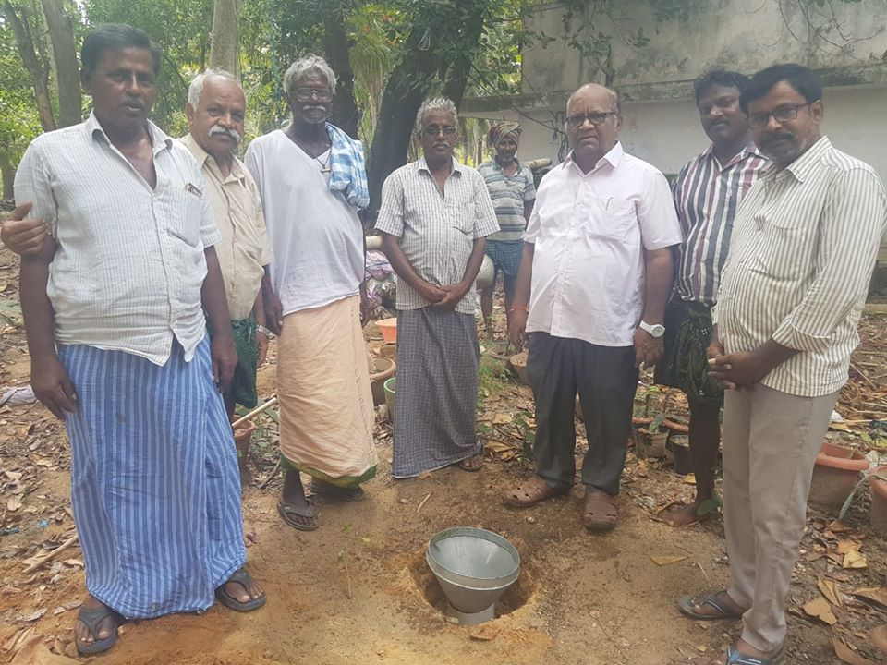
Dr.A.Jagadeesh(Wearing Watch) with local Farmers at the Unique Rain Water Harvesting System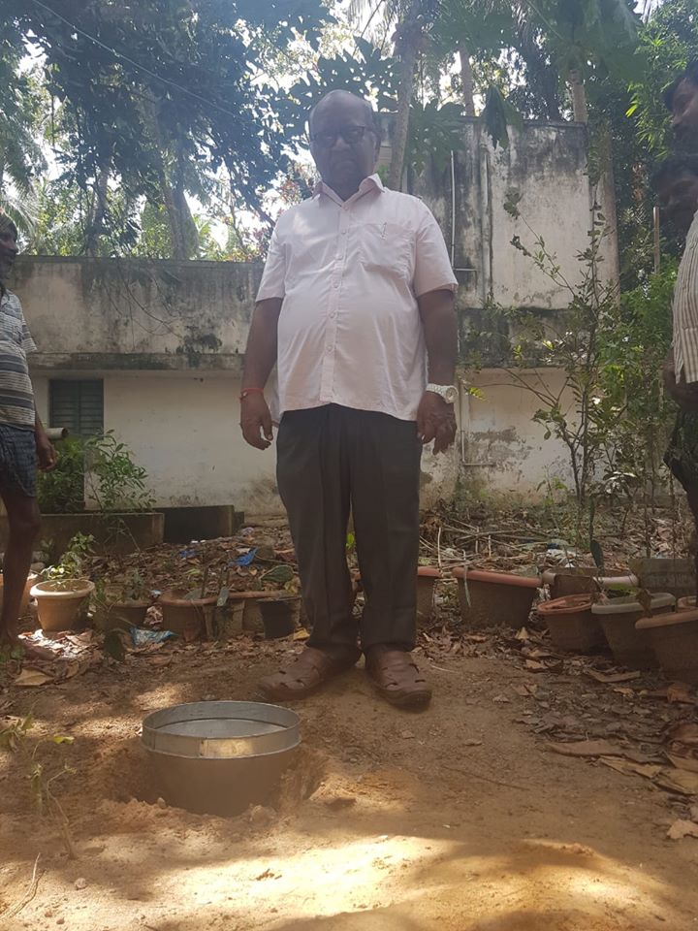
Dr.Jagadeesh’s Innovation of Rain Water Harvesting.
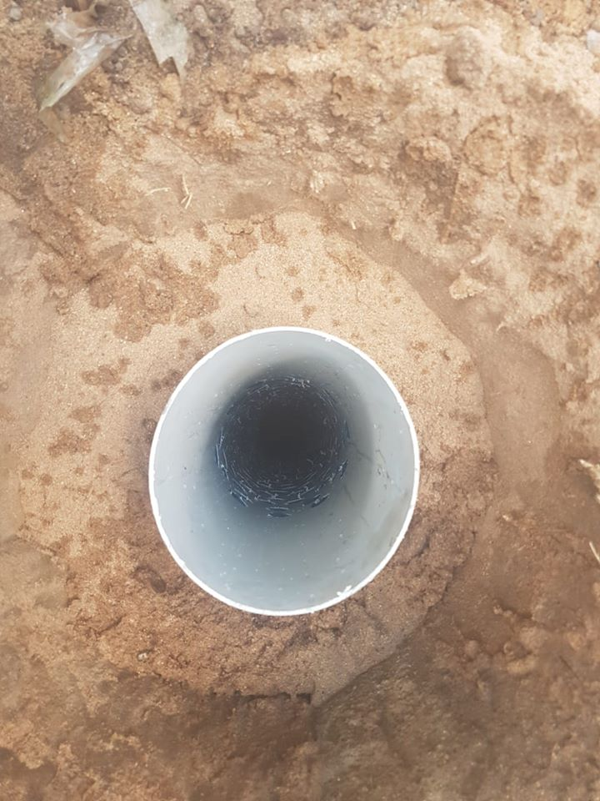
GI Cone on the PVC Pipe
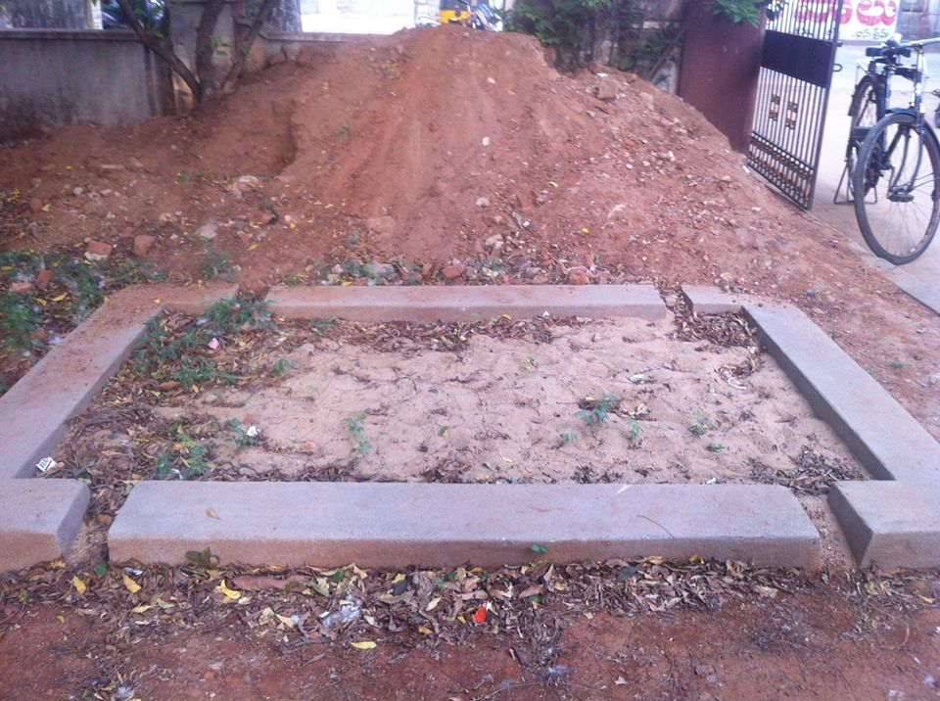
MOST INEFFICIENT INKUDUGUNTA.
