Reconstruction Last Apperance Fossil For Carbonate Reservoirs Surrounding Wrench Fault Zone of RMKS, Sakala Sub.basin
East Java Basin, Indonesia
By :
Mill Sartika Indah1, M.Natsir1, Fahyani Suwidiyanto1, Bambang Parikesit2, Darwin Kadar3
1. Fungsi Geologi, Upstream Technology Center, PT.Pertamina Persero
2. Staff Geologist Exploration, PT.Pertamina Hulu Energy ( PHE West Madura Offsore)
3. Biostratigrapher - LAPI ITB

ABSTRACT
Wrench Fault Zone of RMKS Time is one of the biggest fault zone which connected with distribution of the reservoir , trapping, and migration success element for exploration oil and gas . Key factors during reconstruction of the biomarkers for Eocene-Pliocene chronostratigraphy for carbonate reservoirs found within oil and gas fields near the regional RMKS fault zone. The timeline used within this research was represented by First Apperance/Last Apperance fossil data such as planktonic foraminifera, benthic foraminifera, calcareous nannofossils as well as pollens which are great time indicators as they are widely distributed and are found in shorter existence periods.Planktonic foraminifera and calcareous nannofossils float freely in the water at a certain depth and have cosmopolitan distribution in which many of the species have a shorter period of existence, hence acting as excellent indicators for correlation.
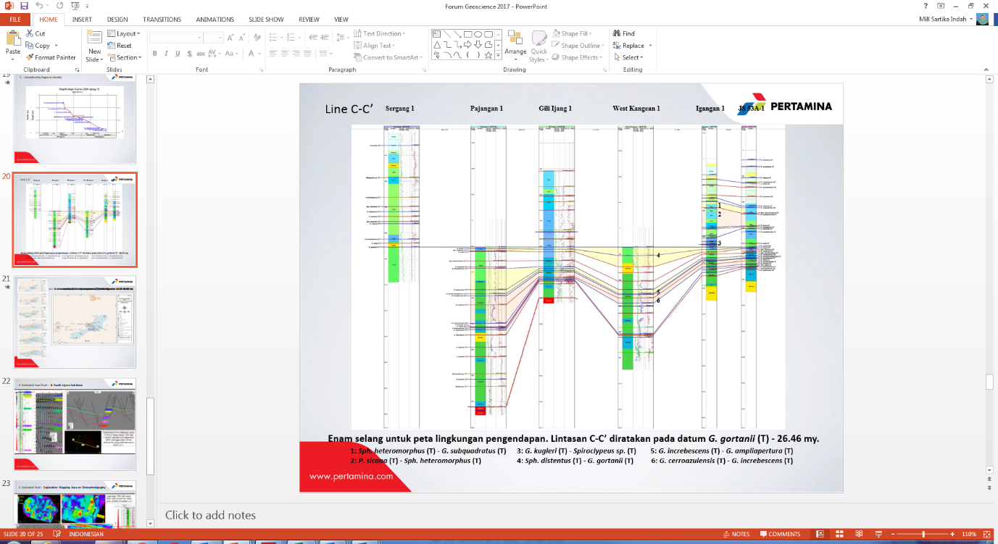
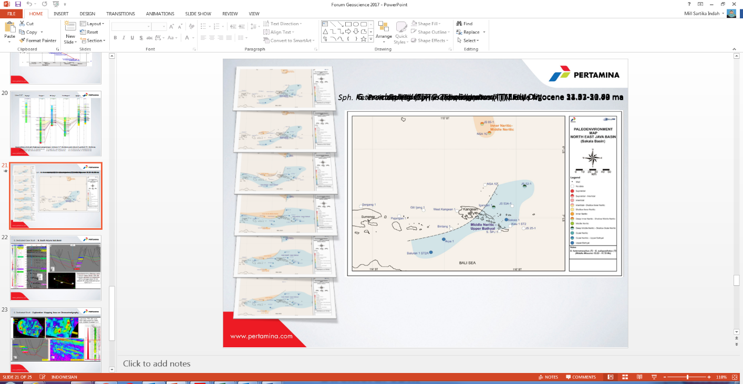
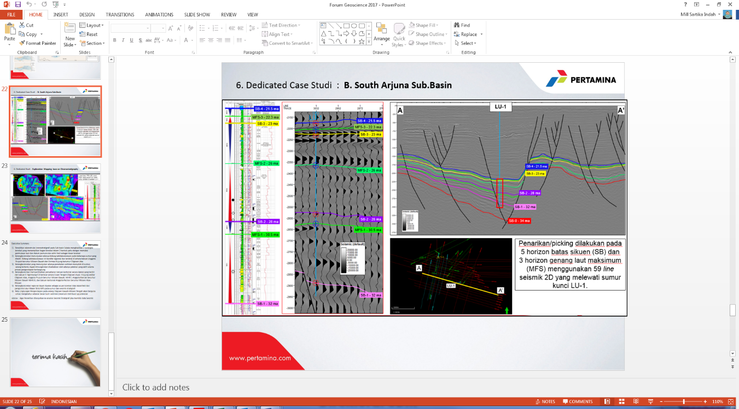
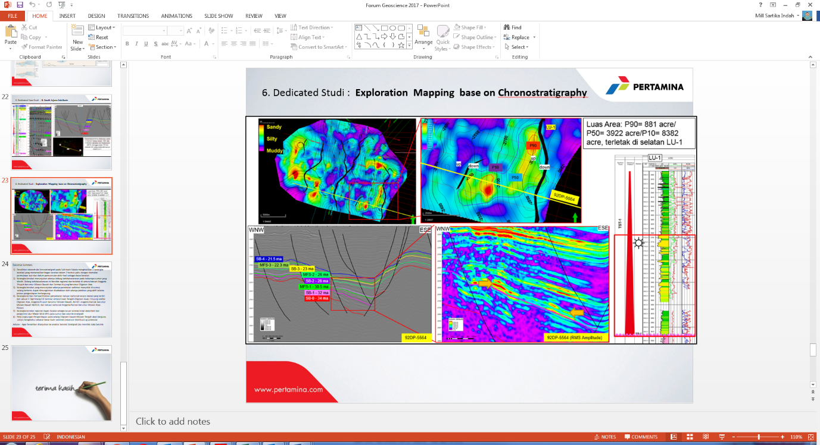
13 correlation frameworks and 6 paleoenvironment maps within the interval of Lower Oligocene – Middle Miocene had been produced and is explained within this paper. Correlation of the northern part of West Java Basin comprises of 35 onshore wells, starting from TNG-1 in the west until AJW-1 in the east. Ten offshore wells were also used within the correlation and are located within Arjuna Subbasin. Correlation was completed in mid-2013 and resulted in 11 trajectory paths and 4 depositional environment maps. Report regarding correlation of this basin is available at UTC.
The correlation framework indicates a prominent thickening of sediments at a certain interval within several wells, such as well Arosbaya-1, Banyubang-1, Belimbing-1, Caluk-A, and Jepon-A. This is due to the continued activity of the fault as sedimentation progressed. The distinctive thick sediment, especially the claystone, will be important as both a source rock and seal for hydrocarbons.The correlation framework also indicates an unconformity within several wells of the project. It is found regionally within the area and is located between the Miocene Prupuh Member and Oligocene Upper Kujung Formation.
The correlation framework shows a lateral distribution of limestones which consists of the Middle Eocene – Early Oligocene Ngimbang Formation/CD units, Upper Oligocene Kujung Formation, Lower Miocene Prupuh Member, N4 – N7, Lower Miocene N8 – N10 Rancak Member, Middle – Upper Miocene Bulu Member, N12 – N15, and Upper Miocene – Pliocene Paciran Limestone Member.
This regional correlation framework may be used as a local reference within a field scale and systematic numbering of specific layers as potential hydrocarbons (management assets) within the whole area of the basin also as a control and reference for sequence boundaries and maximum flooding surfaces in exploration wells if regional correlation based on sequence stratigraphy/seismic stratigraphy is needed to be done. The maps are used to understand potential reservoirs through sedimentary grain sizes in which hydrocarbons accumulate, where is the carbonat reservoir distributed and produce the great speculative potensial area mapping and commercial value prospective resources.

Curriculum Vitae
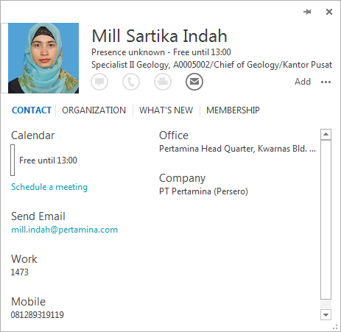
Mill Sartika Indah, she was 12 experiences geologist exploration for PT.Pertamina Persero (Present), Talisman Canadian Ltd, Halliburton Services Welloging, with background education geologist engineering for bachelor degree at Gadjah Mada University and Master of Geophysical Engineering from University of Indonesia.

