The development of paleo-karst systems in the Middle Miocene Carbonate Reservoir, South Song Hong Basin
Anh Vu The Mr, Vietnam Petroleum Institute, Vietnam Phong Van Phung Mr, Vietnam Petroleum Institute, Vietnam

Abstract
Paleo-karst systems are considered as one of the main factors resulting in carbonate reservoir characteristics. Nonetheless, few effective workflows have been proposed to interpret the 3D distribution of such systems. An integrated approach of 3D seismic interpretations, attributes, well log sequence stratigraphic analysis, core samples and nearby analogous fields has been applied to reveal and understand numerous paleo-karst features in the Middle Miocene limestone preserved on the Tri Ton high, South Song Hong Basin. Seismic scale mapping and visualization of the paleo-karst systems can be used to achieve by interpreting circular. The typical seismic and geological evidences of paleo-karst development were observed clearly on the top and slope of a regional uplift beneath an unconformity. Images of paleo-karst networks is demonstrated based on erosional topography and seismic geomorphologic patterns for sinkholes, rivers/canyons, and hills, revealing a mature surface drainage system.

Image
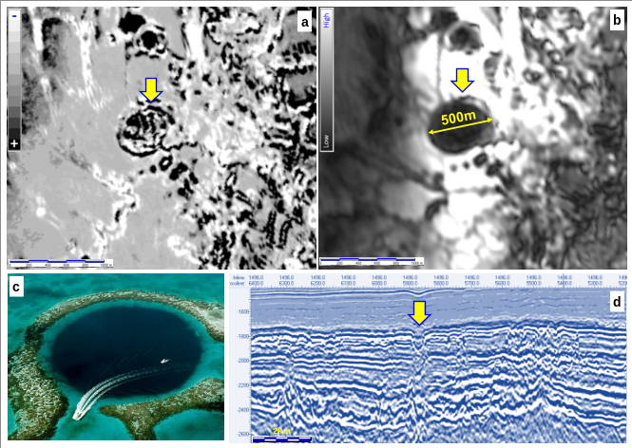
Figure 1: Comparison karst/sinkhole features through the depth-slice at 1800m of seismic attributes (a-Coherence, b-Trace envelop, d- seismic section) and a real sinkhole (c-400m diameter, 145-m-deep Great Blue Hole, Belize. Note the speedboat for scale).

Recent Publications
- Phung (2015) Sequence stratigraphic study and Seismic imaging of Pliocene Lowstand deposits in offshore Vietnam. Bulletin of Earth Sciences of Thailand. Vol 8-2015, 121-128.
- Phong Van Phung (2016) Pliocene -Pleistocene Sequence stratigraphy in block 05-2, Nam Con Son Basin, Offshore Vietnam. Petrovietnam Journal. Vol 10-2016, 14-19.
- Phung (2015) Sequence stratigraphic study and Seismic imaging of Pliocene Lowstand deposits in offshore Vietnam. Bulletin of Earth Sciences of Thailand. Vol 8-2015, 121-128.
- Hoang Bui Huy, Phong Van Phung (2016) Fault seal capacity evaluation in Block 04-3 of Nam Con Son basin, offshore Vietnam, Vol 6-2016, 8-14.

Biography
Phong Van Phung has his expertise in Reservoir Geology as Geo-modeler. He has been working for Vietnam Petroleum Institute since 2010. After four years later, He got a scholarship from PetroVietnam to study Master of Geoscience at Chulalongkorn University, Bangkok, Thailand.
Email: Phongpv8@gmail.com

Notes/Comments:

