The structure and chemistry of some lead-apatite minerals
Inayat Dhaliwal, University of Calgary, Canada
Dr. Sytle M. Antao, University of Calgary, Canada

Abstract

This study is based on some lead-apatite minerals, including pyromorphite, Pb₅(PO₄)₃Cl, mimetite, Pb₅(AsO₄)₃Cl, and vanadinite, Pb₅(VO₄)₃Cl. Emphasis is placed on their crystal structure and chemistry. The lead-apatite minerals belong to the hexagonal space group P6₃/m. In pyromorphite, mimetite, and vanadinite the BO₄ tetrahedra is occupied by P⁵⁺, As⁵⁺, and V⁵⁺ cations, respectively. Based on their general formula, Pb₅(BO₄)₃Cl, the variations in size of these cations result in different B-O bond distances in each mineral, thus influencing their unit-cell dimensions. Three samples of pyromorphite were studied, of which two are from China and one is from Ontario. Our mimetite sample is also from China and our vanadinite sample is from Morocco. To examine the structural trends among these samples, high-resolution powder X-ray diffraction (HRPXRD) results and electron-probe microanalysis (EPMA) analyses were used. Several structural trends were observed and explained in this study. Because of their unique structure, lead-apatite minerals have applications in environmental remediation.

Image
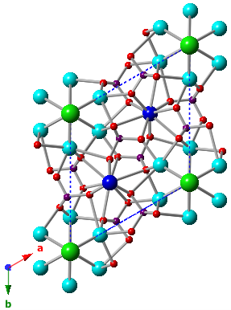
Figure 1. Projection of the lead-apatite structure down c, showing Pb1 (dark blue), Pb2 (light blue), Cl (green), O (red), and B (purple).
References
- Antao, S. M., and Dhaliwal, I. (2017) Growth oscillatory zoning in erythrite, ideally Co₃(AsO₄)₂·8H₂O: structural variations in vivianite-group minerals. Minerals, 7, 136.
- Dai, Y., and Hughes, J.M. (1989) Crystal-structure refinements of vanadinite and pyromorphite. Canadian Mineralogist, 27, 189 – 192.
- Dai, Y., Hughes, J.M., and Moore, P.B. (1991) The crystal structures of mimetite and clinomimetite, Pb₅(AsO₄)₃Cl. Canadian Mineralogist, 29, 369 – 376.
- Okudera, H. (2013) Relationships among channel topology and atomic displacements in the structures of Pb₅(BO₄)₃Cl with B= P (pyromorphite), V (vanadinite), and As (mimetite). American Mineralogist, 98, 1573 – 1579.

5. Rakovan, J.F., and Pasteris, J.D. (2015) A technological gem: materials, medical, and environmental mineralogy of apatite. Elements, 11, 195 – 200.

 Biography
Inayat Dhaliwal is an MSc student at the University of Calgary in the Department of Geoscience. Her area of study is mineralogy and she is focusing on the structure and chemistry of pyromorphite, mimetite, vanadinite, and erythrite. She has completed a BSc in Geology, with a minor in Geophysics, and a BSc in Environmental Science, with a concentration in Statistics.
Email: idhaliwa@ucalgary.ca

