STRUCTURAL STUDY OF TOPOGRAPHIC BASIN OF NYAMUKAO IN ITURI, D.R.CONGO
KAMBALE KAVYAVU. W,
UCNDK, Departement of Geosciences, Université de Conservation de la Nature et de Développement de Kasugho, wisdomkambale@gmail.com
Africa in general and the eastern countries have been a significant field of orogenies. These manifestations caused a varity of magmatic facies. Metalogenicaly, same deposits are specially and nowhere prospected in the world. Acids (granite and associated rocks) intrusions and basic (carbontite, dykes) are due to this earthquake from Afar to Zimbabwe. These manifestations begun in the far time and still in movement in tertian causing the opened rifting, materialized by Virunga- Kahuzi biega volcanic area, Kavumba around Beni; Erta ale in Ethiopia taking only these; we don’t forget all small small volcanic hill. In DRC, all staniferous deposits are in granite of 3000-1800Ma old in Ituri. The major and biggest types of deposits that produce the majority of the Nb-Ta in Pyrochlore in the world is found till now in DRC and due to this earthquake iThere are same: the only one Nickel deposits of Kivu is associated to this orogeny sheeted diabase of Graben. The Mesozoproterozoic leucogranite of Ituri had been victims of the orogeny noticed by opened and fill Quartz fissurations. Actual SOKIMA, KIBALI golden mining and other gold company in this province metalogeny is due to hydrothemalism filons and venilets caused to this orogeny. The objective regarded in this text as those where mines extract gold as the main is to determine the dip and dip direction of the deformation domain of these fill and opened structural elements, gold is teken as the prime metal as it’s the easiest quarried industrially and artisanlly, as we hope, other metals are to be prospected in this area.
The scarcity of geological data in the libraries available to researchers of the first rank deserves a solution. The structural study of lithological units flushing in the Nyamukao topographic watershed deserves an analysis in order to express an idea on the brittle or flexible deformation. It’s identical to the albertin rifting that sits here and there in the horst, graben region of Eastern Africa.
The preferential direction taken of 264 open breaks is estimated at N181⁰E and dipps to west. The rosette of veins and veins highlights the existence of three major families of deformations with preferential direction N7⁰E/40⁰E. The main promoter stress is variable and justifies a domain of distension.
INTRODUCTION
The blue mountain is located in the Irumu territory, in Ituri province. Geographically, near the Bunia town, located at 1°30 ' north and 30° east longitude.
A structural map inadequate tectonics dispositifs witch affect steams and rocks (plis, faults, failles, charriages) and same times these elements in the dip (R. FOUCOULT et A. RAOULT, 2000).
The Bunia-Irumu Depression is a tectonic ditch parallel to Lake Albert’s, separated by a "Blue Mountain " horst, which is the watershed between the Congo River and the basin Nil. The same author continues to say that Bunia-Irumu is a tectonic dambo framed by escarpments attesting the movement of the Panafrican orogeny.
The scarcity of geological formations in the northern and northwestern parts of the basin led us to concentrate on a portion of the study site. This invisibility is due to the important cover of sediments (alterites) which overcomes these formations; Thus, the South East and South West (on the chain of Mont Bleu) and which allowed us to take the structural measures whose treatment led us to know in which area belongs the deformation, the orientation of the major driving constraints of this Deformations which are subjects of our research. We present our field observations, observations concerning the structures resulting from the tectonic manifestations.

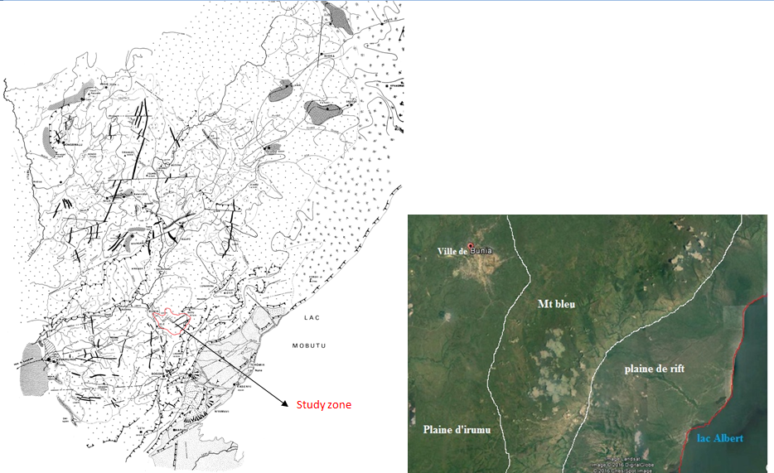
Fig. 1 Localisation of the Blue Mountain of the Irumu Territory

I.1 Materials and Methods
The macroscopic recognition of the formations was carried out following the uplift of the geological formations. Scan by routes (geological sections) oriented perpendicular to the preferential direction of the region. Lithological and Structural observations caused by islets, followed by a mineralogical description, have been completed to give macroscopically the outcrops regardless of our field of study.
In same times, the case of the scarcity of outcrops due to weathering results and alteration, as with any mining prospector, we have resorted to the sharp beds and their abrupt embankments as continuity of buried lithologies. Indeed, the lithological cells of the region are essentially acid (granitoïds) and are intimidated by the few basic (diorites), notwithstanding the presence of some metamorphic ones including schists.
For the realization of the fieldwork, we have resorted to a lot of materials of the geologist prospector of which we quote the most commonly used.
1. GPS: used for the extraction of geographical coordinates for lithological facies,
2. Compass: indispensable, it has a geographical referential orientation. Appart orientation to the wind rose it’s used to locate the geological formations and/or tectonic elements (direction and dip), the orientation of the streams and the access tracks (roads, feet path,…). But also the situation or the location with respects to the North its uses. For a geologist, it must have a bubble level to ensure horizontality and a sighting system to make sightings of cuts.
3. Less: substituting the human eye because it’s not sufficient to detect and recognize the smallest crystals of the rocks unless they are particularly large, which is rare.
4. Hammer: It’s used to bleed at the end of having a particle of reduced size coming from the rock. It’s handled with little blow to make less damage possible, it’s by it samples of the rocks are detached.
5. Decameter: tool allowing measuring the extension of the geological formations during the execution of the cuts to specify their thickness and in case of lithological change.
6. Sulfuric acid: tester for the specification of carbonate rocks such as limestone and dolomitic rocks and well-expected intermediates.

I.1.1 Data processing
The treatment of structural data has two objectives: statistical analyzes (rosette and frequency histogram) and structural representation on Schmidt's canvas to determine the preferential direction of the fracture planes; to get this, the Dips software was mandatory.
Stress tensors that are responsible for geological formations fracturing have been interpreted by Win tensor software which even illustrates the domain of deformation.
II. PETROGRAPHIC STUDY
II.1 Results and Discussion
Much of the DRC lands spatially the North-East is almost homogeneous. The whole of the Northern DRC has enough common geological features and justify considering it as a vast geological region.
These rocks belong to the Kibalian group which consists of series of effusives and intrusive rocks. Some of the Kibalian schistes have schistified lavas nodular, while there are also some doleritic, sils and dykes of uncertain age here and there. The Kibali group thus formed a considerable mass covering a large part of the Upper Ituri basins of Shari and Nizi. (MESSEN) confirms that this fact again by noting that, this block reveals several granite beaches more or less important. The decomposition of the granites is very irregular.
The rocks of the Blue Mountain are in massive structure, grained texture, 75% of Qz, 10% of Feldspar and disseminated sulphide in tracer. Some are granites ss, others are leucogranites. On the ridge and flanks of the Mount, the networks of fractures are barely visible. It should be noted that the tectonic phases of Mount is without hydrothermalism or that differentiation is lacking vein deposit. The Figure 3 shows the few veins on the ground.
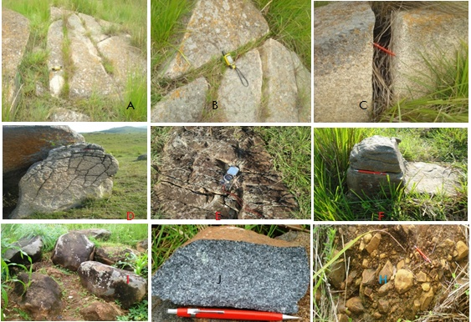
Fig2: Lithology of Mount Blue. A, B, C) Cracking of granitoid, D) microcracking of granitoid, E, F) Cracking of diorite rocks, I, H) Alteration of diorite, J) Diorite.
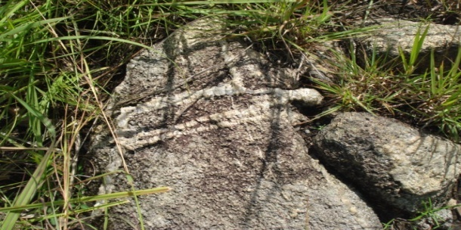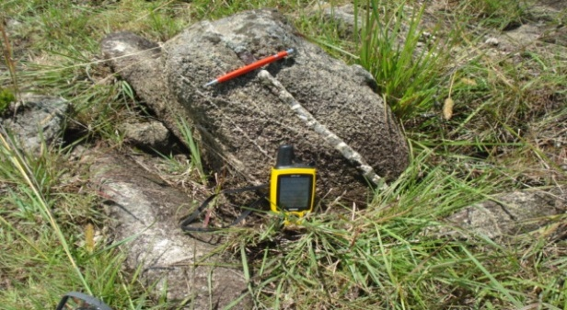
Fig. 3 vein, vein or filament embedded in granite rocks
III. STRUCTURAL STUDY
In some regions, faults of different orientations and movement sense, such as strike-slip and normal faults, may act in concert to accommodate regional extension. These faults are said to be Kinematically compatible. Cinematic analysis of such fault sets should yield a single extension or shortening axis (Stephen M. Rowland)
The data tabulated below were collected within the Ituri province, from fractures in south east of Bunia. Although some local exceptions exist.
Referring to Fig.2, the identification of planar elements originating from tectonics, as stated above, the fractures remain dry and are opened in spite of some vein of Quartz.
III.1 Plans of open breaks
We treat in this part the plans of the fractures which remain yawning. The table N°1 clearly illustrates the structural measurements of the open fracture planes. It shows Strike, the dip and the azimuth took as dip direction.

Table 1 Structural measurement of open fractures ‘planes
Strike° | Dip ° | Azimuth ° | Strike ° | Dip ° | Azimuth° | Strike° | Dip ° | Azimuth° | Strike ° | Dip ° | Azimuth°
356 | 52 | 86 | 112 | 48 | 202 | 65 | 60 | 155 | 190 | 60 | 280
350 | 72 | 80 | 218 | 65 | 308 | 258 | 60 | 348 | 200 | 83 | 290
222 | 63 | 312 | 282 | 72 | 12 | 205 | 64 | 295 | 3 | 56 | 93
110 | 72 | 200 | 60 | 70 | 150 | 320 | 78 | 50 | 205 | 45 | 295
89 | 86 | 179 | 55 | 77 | 145 | 75 | 64 | 165 | 5 | 72 | 95
256 | 80 | 346 | 332 | 47 | 63 | 280 | 50 | 10 | 10 | 30 | 100
202 | 70 | 292 | 117 | 69 | 207 | 218 | 58 | 308 | 338 | 78 | 68
187 | 85 | 277 | 50 | 79 | 140 | 108 | 72 | 198 | 210 | 63 | 300
16 | 70 | 106 | 352 | 80 | 82 | 208 | 87 | 298 | 335 | 63 | 65
240 | 48 | 330 | 21 | 73 | 111 | 330 | 42 | 60 | 238 | 60 | 328
344 | 78 | 76 | 128 | 48 | 218 | 46 | 80 | 136 | 121 | 45 | 211
25 | 44 | 115 | 288 | 23 | 18 | 353 | 55 | 83 | 300 | 82 | 30
82 | 22 | 172 | 205 | 80 | 295 | 252 | 70 | 342 | 237 | 60 | 327
32 | 72 | 122 | 38 | 59 | 128 | 40 | 65 | 130 | 298 | 72 | 38
32 | 72 | 122 | 256 | 80 | 346 | 200 | 62 | 290 | 200 | 62 | 290
320 | 78 | 120 | 122 | 70 | 212 | 258 | 72 | 348 | 77 | 30 | 167
23 | 78 | 113 | 148 | 78 | 238 | 286 | 18 | 16 | 200 | 82 | 290
220 | 88 | 310 | 240 | 83 | 330 | 248 | 85 | 338 | 332 | 58 | 62
220 | 86 | 310 | 68 | 87 | 158 | 262 | 76 | 352 | 300 | 65 | 30
256 | 72 | 346 | 188 | 83 | 278 | 318 | 88 | 48 | 62 | 72 | 152
357 | 83 | 87 | 148 | 78 | 238 | 320 | 90 | 50 | 122 | 72 | 212
67 | 28 | 157 | 289 | 32 | 19 | 102 | 73 | 192 | 20 | 72 | 110
50 | 30 | 140 | 138 | 62 | 228 | 224 | 78 | 314 | 187 | 68 | 277
46 | 30 | 136 | 208 | 38 | 298 | 360 | 84 | 90 | 115 | 70 | 205
126 | 4 | 216 | 335 | 32 | 85 | 216 | 80 | 306 | 200 | 85 | 290
288 | 58 | 18 | 304 | 88 | 34 | 315 | 90 | 45 | 330 | 62 | 60
230 | 82 | 320 | 268 | 83 | 358 | 130 | 20 | 220 | 40 | 80 | 130
151 | 78 | 241 | 10 | 83 | 100 | 84 | 68 | 174 | 140 | 70 | 230
282 | 2 | 12 | 17 | 80 | 107 | 64 | 78 | 154 | 75 | 32 | 165
12 | 68 | 102 | 296 | 69 | 26 | 232 | 50 | 322 | 333 | 80 | 63
136 | 70 | 226 | 330 | 32 | 60 | 35 | 50 | 125 | 310 | 63 | 40
223 | 90 | 313 | 357 | 89 | 87 | 340 | 88 | 70 | 100 | 65 | 190
285 | 80 | 15 | 50 | 90 | 140 | 18 | 80 | 108 | 254 | 32 | 344
250 | 24 | 340 | 252 | 73 | 342 | 150 | 80 | 240 | 360 | 87 | 90
200 | 64 | 290 | 80 | 77 | 170 | 236 | 55 | 326 | 60 | 90 | 150
123 | 78 | 213 | 43 | 83 | 133 | 346 | 52 | 76 | 60 | 80 | 150
345 | 75 | 75 | 78 | 54 | 168 | 123 | 75 | 213 | 132 | 62 | 222
120 | 80 | 210 | 335 | 78 | 65 | 300 | 70 | 30 | 60 | 78 | 150
200 | 80 | 290 | 230 | 48 | 320 | 27 | 53 | 117 | 342 | 47 | 72
356 | 67 | 86 | 143 | 71 | 233 | 120 | 73 | 210 | 160 | 82 | 250
280 | 76 | 1034 | 238 | 87 | 328 | 26 | 56 | 116 | 299 | 61 | 29
268 | 85 | 358 | 273 | 80 | 3 | 242 | 42 | 332 | 7 | 70 | 97
350 | 50 | 80 | 195 | 90 | 285 | 163 | 20 | 253 | 296 | 77 | 26
310 | 84 | 40 | 298 | 80 | 28 | 242 | 45 | 332 | 30 | 70 | 120
339 | 80 | 69 | 252 | 78 | 342 | 6 | 70 | 96 | 120 | 80 | 210
321 | 90 | 51 | 210 | 79 | 300 | 80 | 70 | 170 | 190 | 69 | 280
286 | 88 | 16 | 21 | 27 | 111 | 98 | 72 | 188 | 352 | 89 | 62
285 | 64 | 15 | 245 | 82 | 335 | 346 | 60 | 76 | 362 | 68 | 92
30 | 84 | 120 | 13 | 77 | 103 | 178 | 70 | 268 | 340 | 88 | 70
273 | 64 | 3 | 310 | 40 | 40 | 40 | 85 | 130 | 272 | 78 | 2
193 | 83 | 283 | 223 | 85 | 313 | 110 | 75 | 200 | 237 | 50 | 327
120 | 62 | 210 | 280 | 48 | 10 | 160 | 64 | 250 | 198 | 50 | 288
293 | 68 | 23 | 248 | 70 | 338 | 160 | 60 | 250 | 105 | 49 | 195
314 | 70 | 34 | 219 | 62 | 309 | 173 | 68 | 263 | 126 | 60 | 216
100 | 52 | 190 | 22 | 60 | 112 | 309 | 40 | 39 | 4 | 50 | 94
10 | 75 | 100 | 236 | 89 | 326 | 178 | 50 | 268 | 347 | 70 | 77
100 | 60 | 190 | 234 | 82 | 324 | 56 | 28 | 146 | 228 | 80 | 318
42 | 52 | 132 | 146 | 58 | 236 | 360 | 40 | 90 | 70 | 46 | 160
180 | 80 | 270 | 353 | 58 | 63 | 356 | 75 | 86 | 320 | 28 | 50
335 | 68 | 65 | 40 | 82 | 130 | 80 | 88 | 170 | 118 | 90 | 208
80 | 85 | 170 | 124 | 70 | 214 | 22 | 53 | 112 | 358 | 78 | 88
176 | 55 | 266 | 215 | 38 | 305 | 324 | 58 | 44 | 120 | 60 | 210
37 | 83 | 127 | 40 | 84 | 130 | 70 | 70 | 160 | 223 | 90 | 313
140 | 80 | 230 | 286 | 70 | 16 | 185 | 72 | 275 | 87 | 67 | 177
337 | 72 | 67 | 200 | 70 | 290 | 170 | 78 | 260 | 206 | 88 | 296
183 | 70 | 273 | 274 | 64 | 469 | 270 | 80 | 360 | 312 | 38 | 42
70 | 88 | 160 | 120 | 83 | 210

III.1.1 Treatment of open fractures
The treatment of 266 measurements on the figure 04 indicate their the different planes poles and their distribution on the equal-area plot.
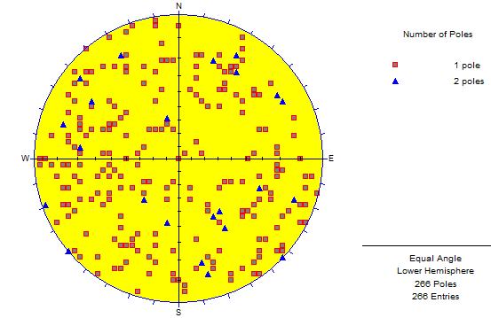
Figure 4. Distribution of plans poles for open breaks in the topographic watershed
The frequency rosette highlights the existence of several networks, the ploted elements gelongs to different families, the major is around 25° and dip to East-Southeast, the second one is near 125° dipping to South-Southwest. The explication of this event is one stress is able to cause many fractures families.
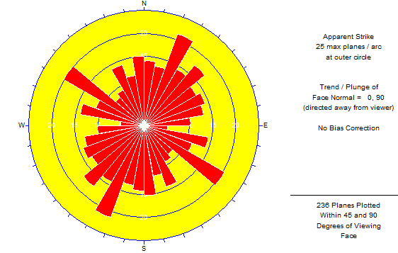
Figure 5. Rosace of open fractures
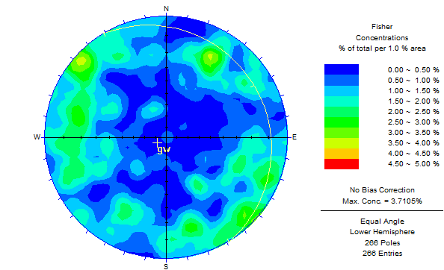
Figure 6. Statistical distribution and preferential direction of open fractures
It might be concluded from Fig,6 that the preferential (weight) strike of the open fractures is preferentially around 324⁰ and dips at 09⁰E on the frequency rosette and the Wolff scrim.
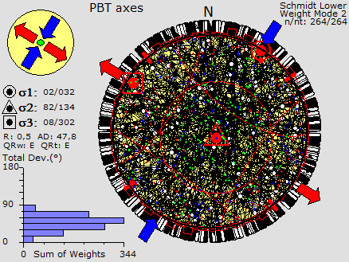
Fig.7: Constraints of deformations
According to this Equal-area plot of 264 reverse fractures, showing the pitch of planes, slip-direction arrows, extension axes, and shortening axes even if the image is dark. Clearly, as showed the figure, the direction of tectonic transport is North northeast. The fracturation planes tectonic is caused by a primary σ1 pression whose strike is 032° and trends about 02 North northeast, σ3 the binary contraint σ2 results of the principal one is about 302° and trends in West-northwest at 08°; minor or tertiary σ3 which is seen in be bisector of primary and binary is the oriented at 134° and it’s dip direction is in South-East around 82° Consistent with this transport direction, the shortening axes trend North northeast and are horizontal, materialized by the position of σ1 and σ3 on the circle; the extension axes are nearly vertical showered by σ2 in the central position. This situation attests a domain of distension.
The three analyses made a well view of axes domains on the dihedron, from left to right the primary axe, σ1, dived the circle to three small domains, the medium is occupeted by poles of insecurity, the second σ2, allows to notice planes around it the stables planes poles, the last, σ3 is interpreted as the first.
In some regions, faults of different orientations and movement sense, such as strike-slip and normal faults, may act in concert to accommodate regional extension. These faults are said to be kinematically compatible. Cinematic analysis of such fault sets should yield a single extension or shortening axis. If kinematic analysis shows two or more distinct extension and shortening axes, the faults are probably not kinematically compatible and may represent different deformational events. Here is an example of the kinematic compatibility test applied to a population of faults (Stephen M. Rowland). Construct one plot showing the orientations of evenements, pitch of slickenlines, and slip directions (as in Fig. 2). There are not enough data to contour, so visually determine the ‘‘best fit’’ extension axis direction (or directions, if there are more than one). Up to our 264 traited dataes, 240 are compatible against 34 which are not. So these mesearements resulted of two or more events of different age.
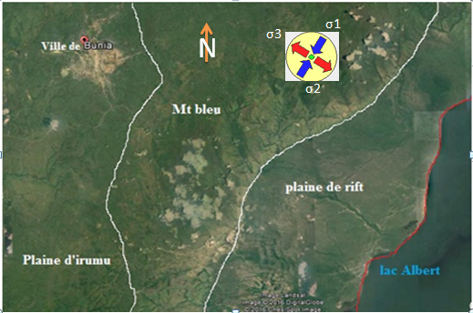
Figure 8. Correlation of statelite view to macrotectonic of study area
Comparing the Google earth data and the stress axes from Schmidt caneva, we notice that the major tectonic axe came from actual Nizi and trend to the same place; at the same image, the extension has been oriented to the actual Bunia town. It allows to conclude the rifting forced the mountain and caused these fracturatons.
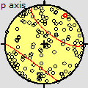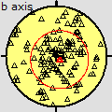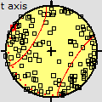
Figure 9. Stabilities of axes
The following image shows how can be the result of a light rotation, the domain of deformation stay the same although all σ values changed. This situation can be seen if the future tectonic does a rotation, the pression is coming so vertical than the first one.
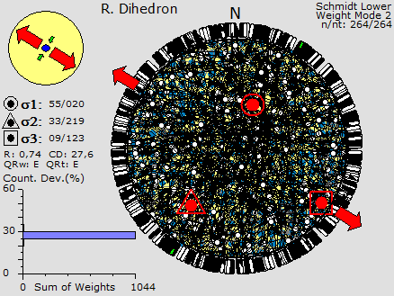
Figure10. Few rotation of deformation axes
The following photograph indicate same values of different parameters, the dip angle of planes measurements which varieted form 45° to 90°, the third one shows the cyclograph lines as images of planes and their extensions axes, the following indicate how planes used as lines tend all strongly near 0° to 30°, the azimuth are surely well distributed, the last one give an idea about the poles of planes.
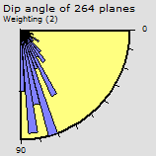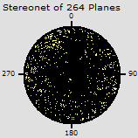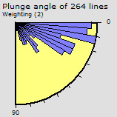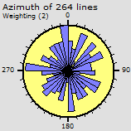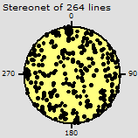
Figure 11
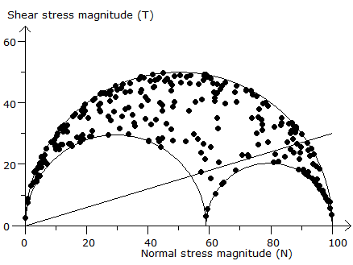
Fig.12 circle of Morh,
From a view to Morh circle of Figure8, our field of study doesn’t have internal friction angle . It allows us to have an idea about the stability of the stood facies, some fracturations are causing instability, and these have they poles under the intersex line. The domage is not so big because no pole is located in under the circles of σ.
III.2 Plans of filled fractures (vein and filament)
In this area same caused fractures are filled of hydrothermal fluids and are spatially of quartz, some of them in the province are mined according it golden percentage carried by pyrites and or other sulphides. The only filled fractures are tabulated in the following section. The and power of these elements allows to take them veins.

Table N°02 structural measurements of veins and some associated images.
Strike | Dip | Azimuth | Strike | Dip | Azimuth
356 | 52 | 86 | 356 | 75 | 86
19 | 49 | 109 | 360 | 40 | 90
82 | 22 | 172 | 340 | 88 | 70
32 | 72 | 122 | 138 | 62 | 228
40 | 85 | 130 | 296 | 69 | 26
178 | 50 | 268 | 330 | 32 | 60
56 | 28 | 146 | 360 | 45 | 90

III.2.1 Treatment of vein measurements
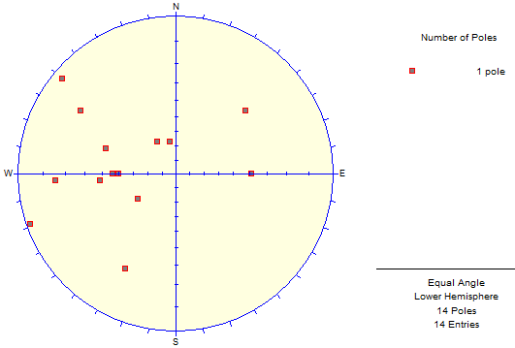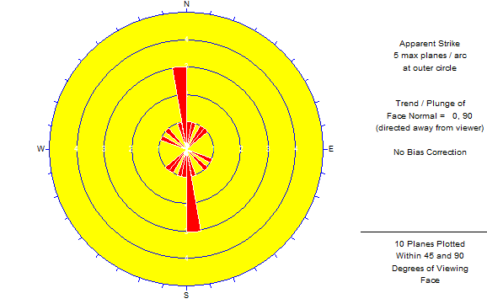
Fig. 9: Distribution of the poles and root of the veins
The frequency rosette of our fourteen plotted elements highlights the existence of one major family of geologic cells, however it shows a preferential weight around 355⁰ dipping to 40^{0 at} East.
Their preferential strike and dipping direction is noticed at the following image, although, some distribution and use of diagram shows that this occupation is irregular. By plotting the results of the measurements of the filled fractures on a stereographic canvas, which makes it possible to determine the orientation of the constrained vectors generated the discontinuities. We have considered here two fracture planes taken as conjugates in order to know if the tectonic domain, Compressive or distensive. 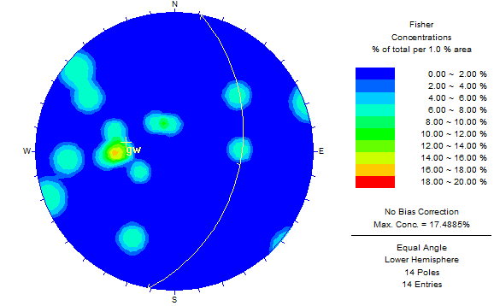 11 39
Fig. 10: Statistical distribution and preferential direction on Stereonet and Wolff canva
Knowing the kinematic orientations which are responsible of these events, the following figures helped us to repair the origin and deformation domain. With regard to Fig. 11, the location of the main stress σ oriented 176/64 almost to the center of the projection followed by σ3 365/26 to its periphery whereas σ2 oriented 266 / horizontal confirm that the domain is like the open breaks distensive.
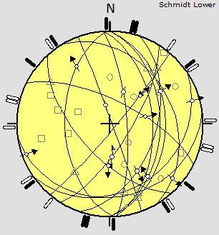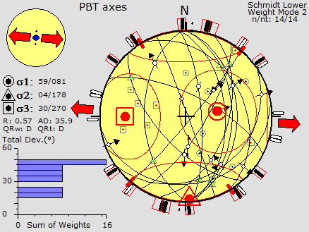
Fig. 11: contraints axes of veins, a. Orientation and cyclographs of the stress generating the fractures of the veins, b. stability zones of axes
According to the following treatment, referring to Otto Morhs circle, the deformation and stress of veins has no instability in the facies, this is witnessed by any plane pole in the two circles of the figue, or in the space under the intresec line.
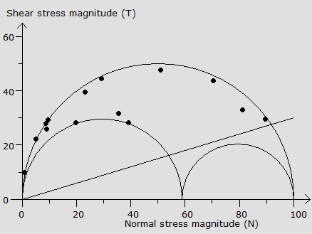
Figure 12. Circle of Morhs of veins
The stability of the pression variables is showered by the figure thirteen, it made us to conclude and read that σ1 is stable around 22.5°to 15° when the σ2 lies in interval of 10° to 5°, the minor, σ3 is around values 72.5° to 52.5°
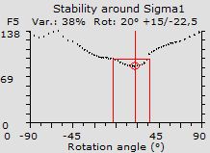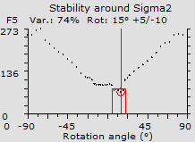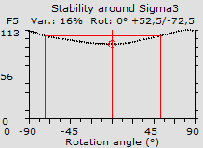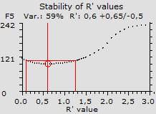
CONCLUSION
The structural study of the geological formations of the Bunia region in the Nyamukao topographic watershed has shown us with no ambiguity that deformation is identical to the albertin rifting which causes here and there in the area in the horst and graben region in East Africa.
Gaping and filled fractures learn from the same domain, depending on the value of the promoters. For the first case, open breaks, the analysis on 266 measurements on the Figure 6. shows that their preferential direction is 324⁰ and dips at 09⁰E, and σ1 is pression has been oriented strike is 032° and trends about 02 North northeast, the binary contraint σ2 around 302° trendings in West-northwest at 08°; tertiary σ3 is oriented at 134° with a dip direction in South-East around 82. This situation attests a domain of distension.
The vein and being rare on this part of Blue Mountain, have a main stress σ fo 176/64 almost to the center of the projection followed by σ3 365/26 to its periphery whereas σ2 oriented 266 In view of all these details, the brittle deformation has a generating energy of distant domain.

Bibliographic reference
- MBULUYO. M, K, Les principales entités géomorphologiques de l'Ituri oriental et les faciès cuirassés associés (Nord-Est du Zaïre) in Bulletin de la Société géographique de Liège, 27, 1991 : 139-148
- MEESSEN J.M.TH, Monograph on Ituri, Brussels, 1951.
- Google earth, 2010
- Stephen M. Rowland, Structural analysis and synthesis, a laboratory course in structural Geology, Third Edition
- R. FOUCOULT et A. RAOULT, 2000, Dictionnaire de géologie, 9e édition.

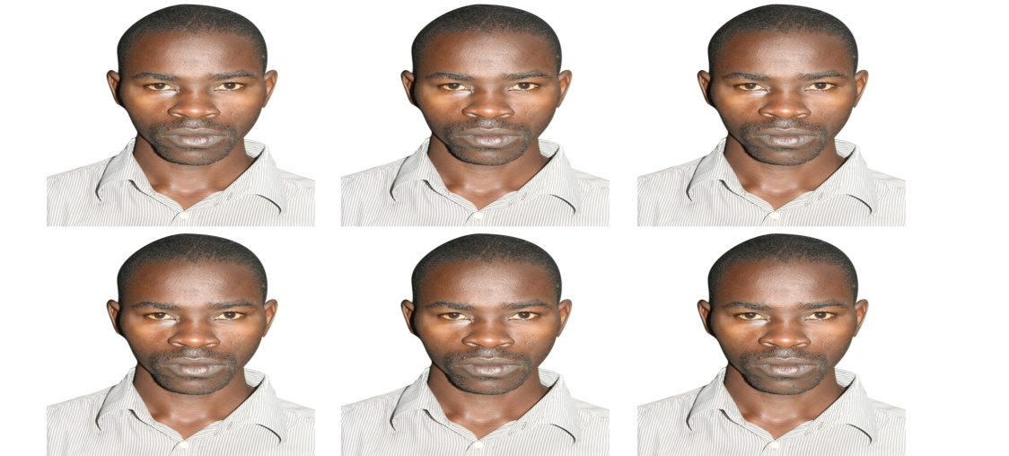
KAMBALE KAVYAVU Wisdom: Had a Diploma in genaral pédagogy, hi completed his suties at Universitaires à l’Université de Conservation de la Nature et de Développement de Kasugho UCNDK where he got a Bac+3 in genaral geology (2008-2011). He choiced to follow Exploration and Minig Geology as specialization where he got a master degre (2011-2013). In November 2013, he entred and be one of senior lecture team in charge of pratical works at UCNDK Geosciences departement; in 2014, he get the seratary of departement, from 2015-2017 his dean ic charge of teachings of the sciences faculty at his university.

MBULUYO. M, K, Les principales entités géomorphologiques de l'Ituri oriental et les faciès cuirassés associés (Nord-Est du Zaïre) in Bulletin de la Société géographique de Liège, 27, 1991 : 139-148

