Moho depth map of the Iranian Plateau from teleseismic receiver functions

Elham Mohammadi, Asistance Prof., Department of Physics, Hakim Sabzevari University, 9617976487 Sabzevar, Iran
Mehdi Rezapour, Associated Prof., Institute of Geophysics, University of Tehran, 14155-6466 Tehran, Iran

Abstract
Using nearly 8000 high quality teleseismic P receiver functions recorded by 100 permanent seismic stations, we obtained new constraints on Moho map across the Iranian plateau. We also used the 1-D forward modeling of receiver functions to find the crustal parameters. Our results obtained from the P receiver function are in good agreement with those obtained from the forward modeling. Ps times of the Moho conversion vary between 3.4 s and 9.0 s within the region, pointing to large variations in Moho depth. The Moho depth map shows evidence for crustal-scale shortening structures beneath the Zagros Mountain which indicates the crustal thickening and shortening of Arabian–Eurasian collision zone in Iran. The boundary between the Arabian and Iranian plates seems to be located northeast of the Main Zagros Thrust (MZT) beneath the. Urumieh–Dokhtar Magmatic Assemblage (UDMA). A maximum Moho depth of ≥70 km is found beneath southeastern UDMA where two crusts (Arabia and Central Iran) are assumed to be superposed. The thickness of crust along the UDMA is increased towards the southeastern part which may be due to the relatively higher rate of convergence in the southeastern part in comparison with the northwestern part. The observed complex structures appear as doubled Moho in receiver functions beneath Sanandaj-Sirjan Metamorphic Zone (SSZ) and UDMA, and in cross sections oriented roughly perpendicular to the trend of the Zagros orogen. We interpret these features as evidence for Moho duplication and associated underthrusting of Arabian crust beneath the central Iranian crust. The Ps Moho conversions at stations located in the Zagros Fold and Thrust Belt (ZFTB) shows that there is no significant crustal thickening along the ZFTB. A minimum Ps time in the northern coast of the Persian Gulf suggests 27 km for Moho depth of this area. Other thin crusts, locally with thickness of around 35 km beneath the southeastern coast of the Caspian Sea and 31 km under eastern coast of the Oman Sea, are found. Furthermore, the average Moho depths of 55 and 48 km are found in the Alborz and Kopeh-Dagh Mountain ranges, respectively. Other regional variations are also imaged, for example an increased Moho depth around 46 km beneath the NW of Iranian plateau and slightly decreased crustal thickness of less than 44 km in Central Iranian Micro Plate (CIMP). Our results show a strong crustal thickness variation across Iranian plateau and indicate that the collision between the Arabian and Eurasian plates in Iran involves the whole crust.

Image
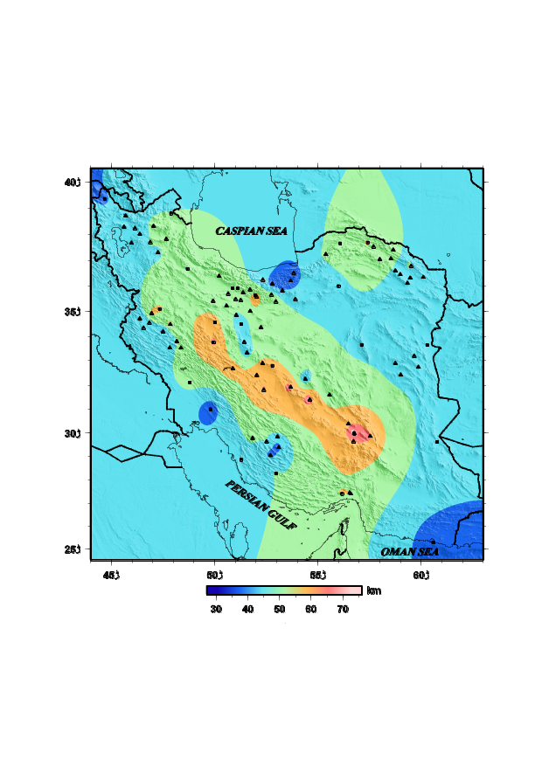
Fig. 1. The Moho depth based on the PRFs image volume. The seismic stations belonging to the IGUT and IIEES are indicated with triangles and squares, respectively. The database on receiver function data comprises of 100 points from permanent seismic stations.
Recent Publications (minimum 5)
- Mohammadi, N., F. Sodoudi, E. Mohammadi, and A. Sadidkhouy (2013a). New constraints on lithospheric thickness of the Iranian plateau using converted waves, J. Seismol.
- Mohammadi, E., F. Sodoudi, R. Kind, and M. Rezapour (2013b). Presence of a layered lithosphere beneath the Zagros collision zone, Tectonophysics 608. 366–375
- Motaghi, K., M. Tatar, k. Priestley (2012a). Crustal thickness variation across the northeast Iran continental collision zone from teleseismic converted waves, J. Seismol. 16, 253–260.
- Motaghi, K., M. Tatar, Z.H. Shomali, A. Kaviani, and K. Priestley (2012b). High resolution image of uppermost mantle beneath NE Iran continental collision zone, Phys Earth Planet Inter 208–209:38–49.
- Motavalli-Anbaran S.H., H. Zeyen M.F. Brunet, and V. Ebrahimzadeh Ardestani (2011). Crustal and lithospheric structure of the Alborz Mountains, Iran, and surrounding areas from integrated geophysical modeling, Tectonics, vol:30.

 Biography (150 word limit)
In the Iranian plateau, there is one location the Arabian–Eurasian collision zone where the oceanic crust of Arabian plate is subducting northward beneath the Eurasian plate. I am curious to know what might happen for tetonic of this zone. The seismic potential of the region is much debated and earth scientists focus on studying this region. Their findings show that there is a clear evidence of active subduction of oceanic crust of the Arabian plate beneath the Iranian Plateau which is correlated with the seismicity pattern. So, as an Assistance Prof., I want to learn about this kind of geological structure. Moreover, I would like to communicate with experts from other countries and exchange our knowledge.

Email: elham.mohammadi@hsu.ac.ir

Moho depth map of the Iranian Plateau from teleseismic receiver functions

Abstract

Using nearly 8000 high quality teleseismic P receiver functions recorded by 100 permanent seismic stations, we obtained new constraints on Moho map across the Iranian plateau. We also used the 1-D forward modeling of receiver functions to find the crustal parameters. Our results obtained from the P receiver function are in good agreement with those obtained from the forward modeling. Ps times of the Moho conversion vary between 3.4 s and 9.0 s within the region, pointing to large variations in Moho depth. The Moho depth map shows evidence for crustal-scale shortening structures beneath the Zagros Mountain which indicates the crustal thickening and shortening of Arabian–Eurasian collision zone in Iran. The boundary between the Arabian and Iranian plates seems to be located northeast of the Main Zagros Thrust (MZT) beneath the. Urumieh–Dokhtar Magmatic Assemblage (UDMA). A maximum Moho depth of ≥70 km is found beneath southeastern UDMA where two crusts (Arabia and Central Iran) are assumed to be superposed. The thickness of crust along the UDMA is increased towards the southeastern part which may be due to the relatively higher rate of convergence in the southeastern part in comparison with the northwestern part. The observed complex structures appear as doubled Moho in receiver functions beneath Sanandaj-Sirjan Metamorphic Zone (SSZ) and UDMA, and in cross sections oriented roughly perpendicular to the trend of the Zagros orogen. We interpret these features as evidence for Moho duplication and associated underthrusting of Arabian crust beneath the central Iranian crust. The Ps Moho conversions at stations located in the Zagros Fold and Thrust Belt (ZFTB) shows that there is no significant crustal thickening along the ZFTB. A minimum Ps time in the northern coast of the Persian Gulf suggests 27 km for Moho depth of this area. Other thin crusts, locally with thickness of around 35 km beneath the southeastern coast of the Caspian Sea and 31 km under eastern coast of the Oman Sea, are found. Furthermore, the average Moho depths of 55 and 48 km are found in the Alborz and Kopeh-Dagh Mountain ranges, respectively. Other regional variations are also imaged, for example an increased Moho depth around 46 km beneath the NW of Iranian plateau and slightly decreased crustal thickness of less than 44 km in Central Iranian Micro Plate (CIMP). Our results show a strong crustal thickness variation across Iranian plateau and indicate that the collision between the Arabian and Eurasian plates in Iran involves the whole crust.

