GEOCHEMICAL CHARACTERISTICS OF OIL SHALE (MAJOR AND TRACE ELEMENTS); DEPOSITIONAL ENVIRONMENT OF TRIASSIC YANCHANG FORMATION (CHANG 7 MEMBER) AT TONGCHUAN, ORDOS BASIN.
Zhigang Yao School of Earth Sciences and Engineering, Xi’an Shiyou University, Shaanxi, China, 710065
Wahid Abbul School of Earth Sciences and Engineering, Xi’an Shiyou University, Shaanxi, China, 710065
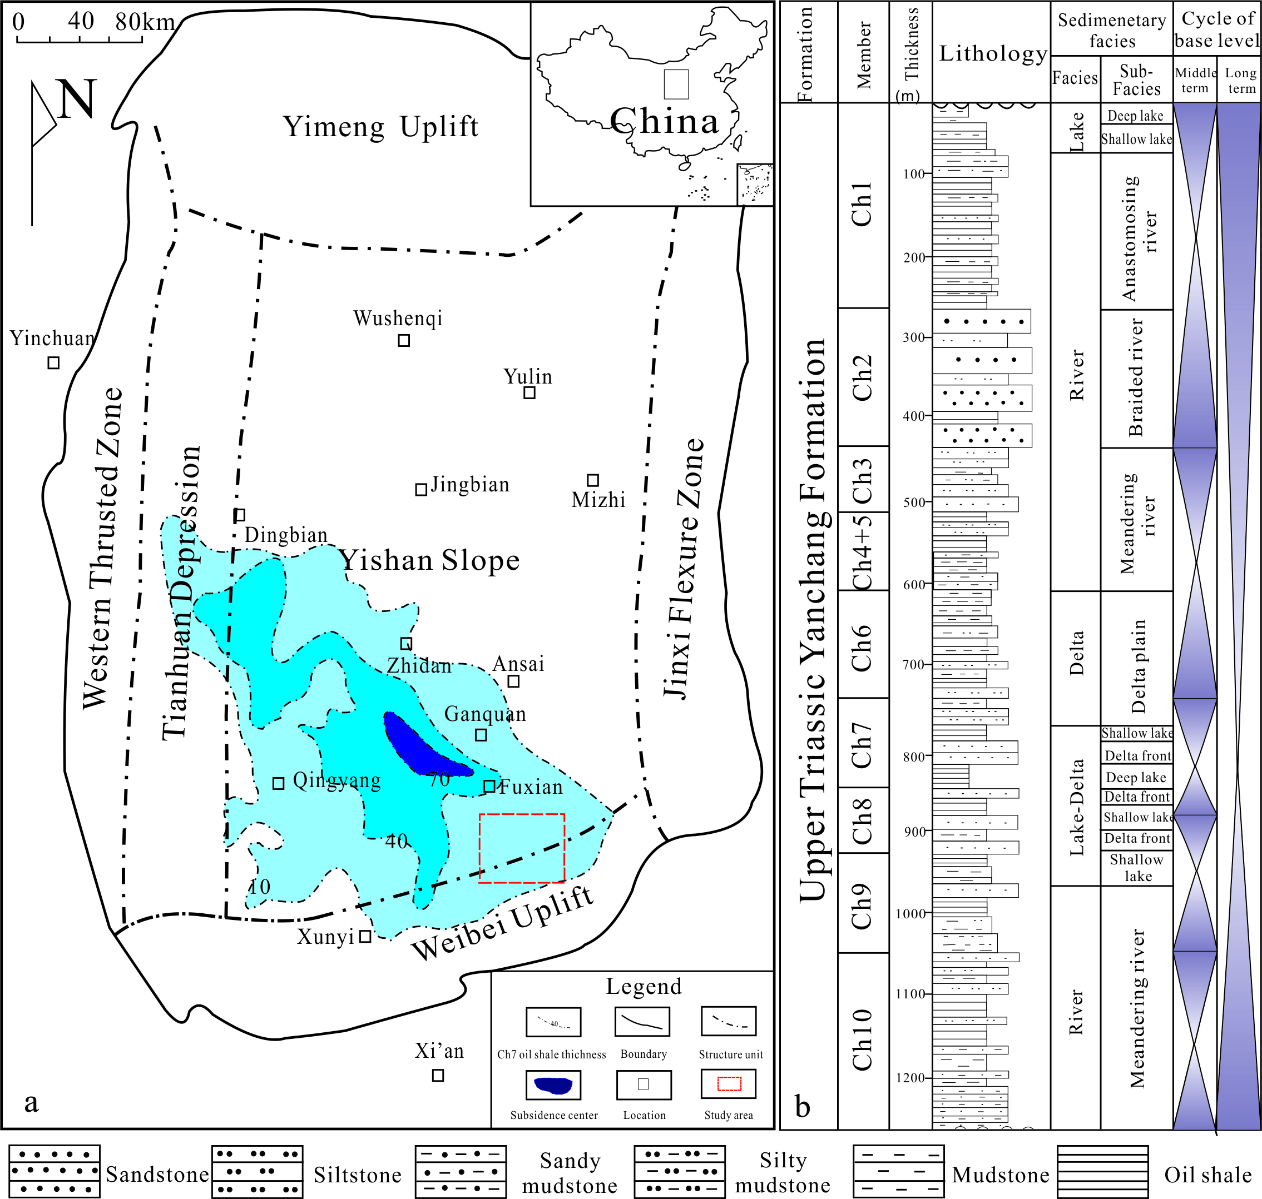
Abstract:
1. Cullers, R. L. (2000). The geochemistry of shales, siltstones and sandstones of Pennsylvanian-Permian age, Colorado, USA: Implications for provenance and metamorphic studies. Lithos, 51(3), 181–203. http://doi.org/10.1016/S0024-4937(99)00063-8
2. GAO, S. (2010). Chemical composition of the continental crust: a perspective from China. Geochemical News, (143), 1–16. Retrieved from papers://32862730-33e4-4f24-9997-a2585c9ed6b6/Paper/p1193
3. Khanehbad, M., Moussavi-Harami, R., Mahboubi, a., & Nadjafi, M. (2012). Geochemistry of carboniferous shales of the Sardar Formation, east central Iran: Implication for provenance, paleoclimate and paleo-oxygenation conditions at a passive continental margin. Geochemistry International, 50(9), 777–790. http://doi.org/10.1134/S0016702912090029
4. Algeo, T. J., & Maynard, J. B. (2004). Trace-element behavior and redox facies in core shales of Upper Pennsylvanian Kansas-type cyclothems. Chemical Geology, 206(3-4), 289–318. http://doi.org/10.1016/j.chemgeo.2003.12.009
5. Rimmer, S. M. (2004). Geochemical paleoredox indicators in Devonian-Mississippian black shales, Central Appalachian Basin (USA). Chemical Geology, 206(3-4), 373–391. http://doi.org/10.1016/j.chemgeo.2003.12.029

Geological map of Ordos Basin and location of studied section and b stratigraphic column of Upper Triassic Yanchang Formation (modified after Qiu et al. 2014)
The Triassic Yanchang Formation (Chang 7) oil shale is widely distributed in Ordos Basin, while Tongchuan is one of the typical outcrop areas of distribution. The objective of this study is to determine the depositional environment and some tectonic setting in which the Oil shale of the study area is deposited. Sixteen selected samples were analyzed by using ICP-MS at the Northwest Institute for Non-ferrous Metal Research for the abundances of some trace elements contents such as V, Ni, Cr, Ba, Sr, U and Th and Rare Earth Elements (REE) contents like La, Yb, Eu and Ce. Paleo-redox indices such as Th/U, V/(V+Ni), V/Cr and δU indicate that the depositional environment of Yanchang Formation is reducing environment. Mo is the diagnostic element for reducing environment under sea water, the enrichment of Mo as compared to other trace elements also supports the reducing environment of study area. Paleosalinity is determined on the basis of Boron (B), Illite, Montmorillonite and kaolinite contents and the results show that the study area belongs to brackish to semi saline water sedimentary environment. The negative values of Ce_{anomaly} and Eu_{anomaly} indicate that the study area belongs to hydrothermal sedimentary environment in redox situation. All the values of Th/U are less than 1; it means the deposition of the study area occurred under hot water. La/Yb-REE and La/Yb-Ce/Yb graphs show that mostly samples fall into basalt and other into overlapping areas. So in the expansion period, the basement fracture activities are responsible of hot fluids at the basement of the lake. In the study area sedimentary period of Chang 7, hydrothermal activities in the lake bottom exist and played a key role in accelerating the extensive development of oil shale.


Biography:

Mr. Yao is an expert researcher to evaluate the geochemistry of rocks and is able to give authentic predictions about characteristics of reservoirs on the basis of geochemistry. Different researchers approached differently to determine the characteristics of rocks just like provenance, tectonic setting, kerogene type and depositional environment, but his methodology is based on inorganic contents and gave his expert and authentic predictions about the characteristics of Yanchang Formation, Chang 7 member. In this article, on the basis of his research in the field and lab experiments (geochemical analysis of trace and Rare Earth elements of Chang 7 oil shale) after a long time, He gave expert opinions and predictions about depositional environment and some tectonic setting of the study area. His approach to determine the depositional environment, based on paleoredox indices, paleosalinity and enrichment of REE, is applicable widely and is a revolutionary step for the petroleum companies.

ab.wahid786@yahoo.com
yzg123@xsyu.edu.cn

