Solid Expandable Tubulars; Full-Scale Testing and Analysis
Sayyad Zahid Qamar, Sultan Qaboos University, Oman

Abstract (300 word limit)
Economically feasible extraction of oil and gas is becoming more and more challenging, especially from old and difficult reservoirs. Some major hurdles are reducing cost and increasing efficiency of well completion operations; isolation of water-producing and other undesirable zones; successful production from mature reservoirs; reworking of abandoned wells; etc. In the last couple of decades, solid expandable tubular (SET) technology has been able to overcome some of these obstacles. SET applications involve in-situ expansion of a tubular by propagating a conical mandrel through it, achieved by hydraulic push or mechanical pull. Integrity of well structure is directly dependent on factors such as burst and collapse strength of the tubular after expansion. In collaboration with the national petroleum development industry, a full-scale expansion test rig has been designed, fabricated, and commissioned at Sultan Qaboos University. Real-time experimental data are recorded during expansion of actual petroleum tubulars under various field conditions. Mechanical testing and microscopic analysis is also carried out for pre and post-expansion material characterization. Some of the studies carried out with the help of this facility are Design, fabrication, and commissioning of SET test rig; Experimental and numerical simulation of in-situ tube expansion; Effect of cold work on mechanical properties of expandable tubulars; Optimum mandrel configuration for efficient down-hole tube expansion; Estimation of burst and collapse strengths of expandable tubulars; Experimental and finite-element comparison of advanced high-strength steels as tubular materials; Analytical model for stick-slip phenomenon in solid tubular expansion; Use of Solid expandable tubulars in cased and open holes — comparison between aluminum and steel; Solid tubular expansion in horizontal wells; etc.

Image

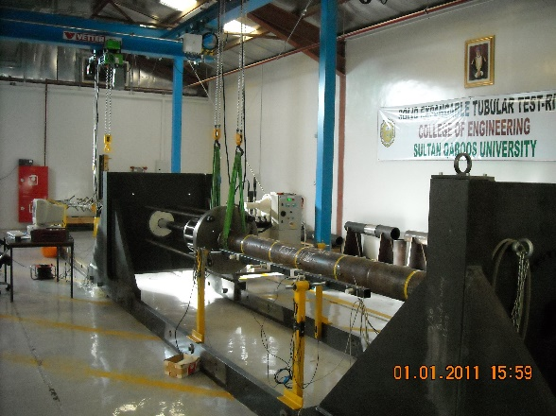
Figure-2 Solid expandable tubular test rig at Sultan Qaboos University, Muscat, Oman

Solid expandable tubular test rig at Sultan Qaboos University,
Muscat, Oman

Recent Publications (minimum 5)

- Al-Abri OS, Pervez T, Qamar SZ, Khan R (2016) “On the Performance Analysis of AHSS with an Application to SET Technology ⎯ FEM Simulations and Experimental Measurements,” Thin Walled Structures, 101 (2016), p 58-74
- Al-Abri OS, Pervez T, Qamar SZ, Al-Busaidi AM (2015) “Optimum Mandrel Configuration for Efficient Down-Hole Tube Expansion,” Journal of Manufacturing Science and Engineering, Transactions of the ASME, 137 (6), 01 December 2015
- Qamar SZ, Pervez T (2014) “Pre and Post-Expansion Mechanical Behavior of Expandable Tubulars,” Materials Science & Technology 2014 (MS&T-2014), 12-16 Oct 2014, Pittsburgh, USA
- Pervez T, Qamar SZ, Al-Abri OS, Khan R, Al-Abri BH (2012) “Experimental and Numerical Simulation of In-Situ Tube Expansion for Deep Gas Wells,” Materials and Manufacturing Processes, 27 (7), 2012, p 727-732
- Qamar SZ, Pervez T, Al-Houqani S, Velden M (2012) “Effect of Cold Work on Mechanical Properties of Expandable Tubulars,” 16th International Research/Expert Conference “Trends in the Development of Machinery and Associated Technology” (TMT-2012), 10-12 September 2012, Dubai, UAE

 Biography (150 word limit)
Prof Sayyad Zahid Qamar is currently associated with the Mechanical and Industrial Engineering Department, Sultan Qaboos University, Muscat, Oman. He has worked both as a university academician and a researcher, and as a field engineer (mechanical), during his twenty-five years of professional service. His main research areas are Applied materials and manufacturing; Applied mechanics and design; Reliability engineering; and Engineering education. He has worked on different funded projects in excess of 4 million US dollars. He is the author of one research monograph (book), two book chapters, over 120 publications in refereed international journals and conferences, and 31 technical reports. He has also edited two technical book volumes, and is serving on the editorial boards of various well-known research journals. He has conducted experimental, numerical, analytical, and stochastic studies in the areas of Swelling and inert elastomers; Solid expandable tubulars; Metalforming process, product, and tooling; etc.
Email: sayyad@squ.edu.om; zahidqam2000@yahoo.com

Notes/Comments:

