Hyper-prevalence of submicroscopic Plasmodium falciparum infections in a rural area of western Kenya with declining malaria cases
Kevin O. Ochwedo, PhD Candidate, University of Nairobi/Sub-Sahara International Centre of Excellence for Malaria Research, Nairobi, Kenya

Abstract
Persons with microscopically undetectable infections may go untreated, contributing to ongoing transmission to mosquito vectors. This study determined the magnitude and determinants of undiagnosed submicroscopic Plasmodium falciparum infections in a rural area of western Kenya. A health facility-based survey was conducted, and 367 patients seeking treatment for symptoms consistent with uncomplicated malaria in Homa Bay County were enrolled. The frequency of submicroscopic P. falciparum infection was measured by comparing the prevalence of infection based on light microscopic inspection of thick blood smears versus real-time polymerase chain reaction (RT-PCR) targeting P. falciparum 18S rRNA gene. Long-lasting insecticidal net (LLIN) use, participation in nocturnal outdoor activities, and gender were considered as potential determinants of submicroscopic infections. Microscopic inspection of blood smears was positive for asexual P. falciparum in 14.7% (54/367) of cases. All of these samples were confirmed by RT-PCR. 35.8% (112/313) of blood smear negative cases were positive by RT-PCR, i.e., submicroscopic infection, resulting in an overall prevalence by RT-PCR alone of 45.2% compared to 14.7% for blood smear alone. Females had a higher prevalence of submicroscopic infections (35.6%, 72/202, 95% CI 28.9–42.3) compared to males (24.2%, 40/165, 95% CI 17.6–30.8). The risk of submicroscopic infections in LLIN users was about half that of non-LLIN users (OR = 0.59). There was no difference in the prevalence of submicroscopic infections of study participants who were active in nocturnal outdoor activities versus those who were not active (OR = 0.91). Patients who participated in nocturnal outdoor activities and use LLINs while indoors had a slightly higher risk of submicroscopic infection than those who did not use LLINs (OR = 1.48). Microscopic inspection of blood smears from persons with malaria symptoms for asexual stage P. falciparum should be supplemented by more sensitive diagnostic tests in order to reduce ongoing transmission of parasites to local mosquito vectors.


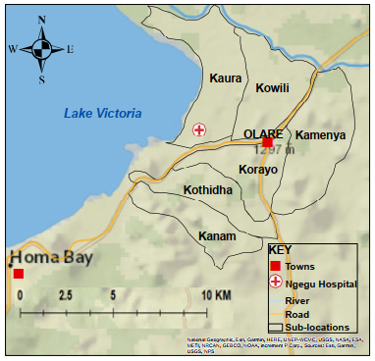
Figure 1: The study area map shows study sites (sub-locations) in Homa Bay. The circle with the red cross represents the Ngegu health facility, where patients from the six sublocations seek medical services.

Recent Publications (minimum 5)
- Ochwedo, K. O., Omondi, C. J., Magomere, E. O., Olumeh, J. O., Debrah, I., Onyango, S. A., ... & Guiyan, Y. (2021). Hyper-prevalence of submicroscopic Plasmodium falciparum infections in a rural area of western Kenya with declining malaria cases. Malaria journal, 20(1), 1-8.




 Biography
Kevin O. Ochwedo is a molecular biologist with a passion for improving people's health and well-being by participating in programs aimed at malaria transmission reduction and eradication. He is actively involved in genetic epidemiology and entomological studies of malaria parasites and vectors. His most recent publication on Plasmodium falciparum passive surveillance aims to persuade public health policymakers to supplement microscopic examination of blood samples with ultrasensitive diagnostic tools in order to support WHO's strategy of early detection and treatment of malaria patients. This, he believes, will help reduce the large number of untreated patients with false-negative malaria diagnoses who may be acting as a reservoir for P. falciparum transmission to vectors within malaria endemic zones in Sub-Saharan Africa.
Email: kevinochwedo@gmail.com

Notes/Comments:

Presenting author details
Full name: Kevin Omondi Ochwedo
Contact number: +254714388916
Mail id: kevinochwedo
Category: Oral presentation

