SPTBN5, encoding βV-spectrin protein, leads to a syndrome of intellectual disability, developmental delay, and seizures.
Amjad Khan^{1*}, Lucia Pia Bruno^{2,3*}, Anna Maria Pinto⁴, Muhammad Umair^{5,6}, Alessandra Fabbiani^{2,3,4}, Maria Antonietta Mencarelli⁴, Alessandra Renieri^{2,3,4}, Sara Resciniti^{2,3,4}, Karla A. Peña-Guerra⁷, Francisco J. Guzmán-Vega⁷ , Stefan T. Arold^{7,8} ,Shahid Niaz⁹ , Francesca Ariani^{2,3,4}.

Abstract (300 word limit)
Whole exome sequencing has provided larger opportunities for the discovery of novel candidate genes for intellectual disability and autism spectrum disorders. The spectrin genes SPTAN1, SPTBN1, SPTBN2, and SPTBN4 have yet been associated with neurological disorders, but currently no phenotypes have been associated with SPTBN5. This is the first report in which four different likely pathogenic variants in SPTBN5 have been found in four families with probands affected with neurodevelopmental disorders. The SPTBN5-associated clinical traits include intellectual disability (mild to severe), aggressive tendencies, accompanied by variable features such as craniofacial and physical dysmorphisms, autistic behavior, gastroesophageal reflux.
We also provide a review of the existing literature related to spectrin genes, which highlights clinical features partially overlapping with SPTBN5.

Image

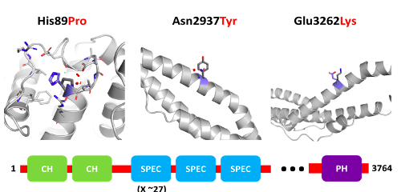

Biography (150 word limit)
Paste your Logo here
Deanna Mulvihill has her expertise in evaluation and passion in improving the health and wellbeing. Her open and contextual evaluation model based on responsive constructivists creates new pathways for improving healthcare. She has built this model after years of experience in research, evaluation, teaching and administration both in hospital and education institutions. The foundation is based on fourth generation evaluation (Guba& Lincoln, 1989) which is a methodology that utilizes the previous generations of evaluation: measurement, description and judgment. It allows for value-pluralism. This approach is responsive to all stakeholders and has a different way of focusing.
Email: drXXXXXXX@xxxmail.com

Notes/Comments:

Presenting author details
Full name:
Contact number:
Mail id:
Category: (Oral presentation/ Poster presentation)

