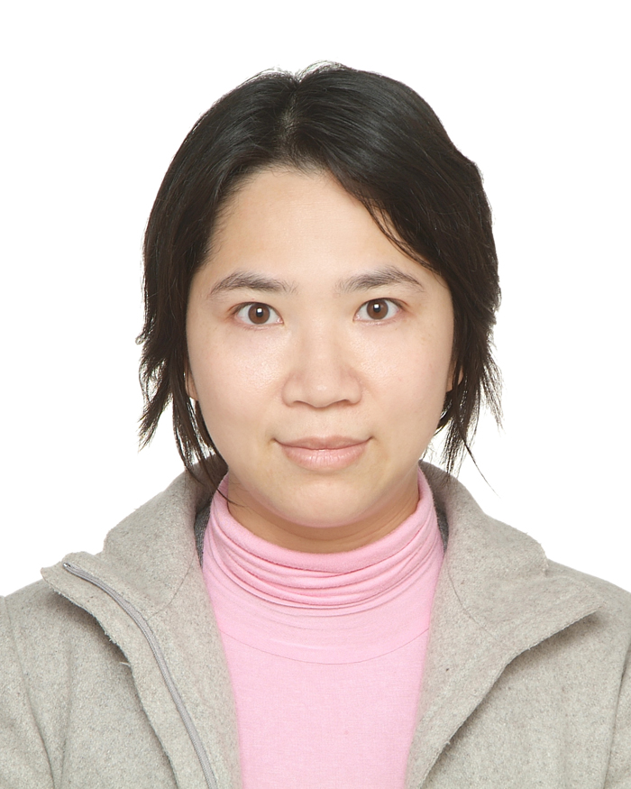

Paste your Logo here

Title: A PEOPLE-CENTERED SYSTEM OF MANAGING A HORTICULTURE TRAINING GROUP FOR SERVICE USERS WITH MENTAL ILLNESS IN OCCUPATIONAL THERAPY DEPARTMENT CLINICALLY

Name: Chan Man-yin
Occupational Therapist, Hong Kong

Horticulture therapy is the use of plants as a therapeutic medium by a trained workers to achieve a defined goal clinically. The evidence shows horticulture could promote physical, psychosocial, cognitive and economical well-beings. The techniques of horticulture therapy could facilitate service users to learn new skills or regain from their premorbid situation. Using of horticultural-related activities to instill hope for them are very impressive during growth of the plants, or even the chance to foster a love to themselves similarly or for nature at our rooftop garden. Therefore, a new system of work is introduced with focused learning strategies so as to enrich service performance and outcomes with adequate safety and supervision.

Retrospectively, treatment return of the group was reviewed from 2011 to 2012. Data was categorized into (1) attendance, (2) new service users to join in the group, (3) working days (4) total service users per month, and (5) compliance rate in using of personal protective equipment (P.P.E.) after in-cooperating biweekly tool box talk with randomly spot checking in the workplace.

Discussion group was held among people in-charge, related staff and every service users with interactive management style incorporated new initiatives including (1) hourly session for service users from acute admission and sub-acute wards, (2) tool box talk by asking which types of P.P.E. to protect them during work and (3) quarterly reinforcing activities of barbecue and outing. Individual feedback sessions were also held half yearly to gather some qualitative data for improvement continuously.

The most reflective data was added numbers of daily attendance from 3.1 service users of first two quarters in 2011 to 5.6 service users from last two quarters in 2011 to whole year of 2012. The monthly total number of attendees increased from 57.8 service users to 115.4 service users. The compliance rate of P.P.E. was 100% after conducting of tool box talk. All staffs and service users satisfied with the new management style.

The findings gathered support an interactive management style which could enrich performance statistics and satisfaction of service users. The key element of managing a workgroup was to strike a balance between the potential therapeutic value and risk management under the people-centered approach.

Biography

Ms. Chan Man-yin has graduated her Bachelor of Science in Occupational Therapist in Hong Kong. She is an occupational therapist in Hospital Authority. She is a mature and competent therapist demonstrating drive and determination to improve herself as well as her professional practice. She is also actively involved in Occupational Health and Safety activities in hospital, with more than 22 years of working experience in psychiatric rehabilitation. She is able to manage many pioneer projects multi-disciplinary within and outside hospital. She has organized several oversea training and attachment before.

She is uniquely positioned within the occupational therapy profession. She has authored various publications with ample experience as a conference presenter.

Presenting author details
Full name: Chan Man Yin
Contact number: (852)69990312
Twitter account: Nil
Linked In account: Nil
Session name: Clinical Genomics
Category: Oral presentation

mychan312@yahoo.com.hk

