Identification of prognostic biomarkers in hepatitis B virus-related hepatocellular carcinoma and stratification by integrative multi-omics analysis
Haitao Zhao, MD，Associate Professor of Surgery
Department of Liver Surgery，Peking Union Medical College Hospital
Chinese Academy of Medical Sciences and Peking Union Medical College (CAMS & PUMC)，China

Abstract (300 word limit)
Background & Aims: The differentiation of distinct multifocal hepatocellular carcinoma (HCC): multicentric disease vs. intrahepatic
metastases, in which the management and prognosis varies substantively, remains problematic. We aim to stratify multifocal HCC and identify novel diagnostic and prognostic biomarkers by performing whole genome and transcriptome sequencing, as part of a multi-omics strategy.
Methods: A complete collection of tumour and somatic specimens (intrahepatic HCC lesions, matched non-cancerous liver tissue and blood) were obtained from representative patients with multifocal HCC exhibiting two distinct postsurgical courses. Whole-genome and transcriptome sequencing with genotyping were performed for each tissue specimen to contrast genomic alterations, including hepatitis B virus integrations, somatic mutations, copy number variations, and structural variations. We then constructed a phylogenetic tree to visualise individual tumour evolution and performed functional enrichment analyses on select differentially expressed genes to elucidate biological processes involved in multifocal HCC development. Multi-omics data were integrated with detailed clinicopathological information to identify HCC biomarkers, which were further validated using a large cohort of
HCC patients (n = 174).
Results: The multi-omics profiling and tumour biomarkers could successfully distinguish the two multifocal HCC types, while accurately predicting clonality and aggressiveness. The dualspecificity protein kinase TTK, which is a key mitotic checkpoint regulator with links to p53 signaling, was further shown to be a promising overall prognostic marker for HCC in the large patient cohort.
Conclusions: Comprehensive multi-omics characterisation of multifocal tumour evolution may improve clinical decision-making, facilitate personalised medicine, and expedite identification of novel biomarkers and therapeutic targets in HCC

Image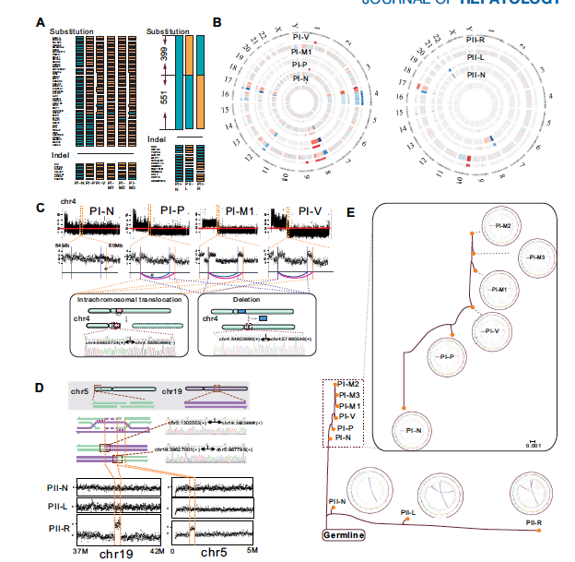

Recent Publications (minimum 5)

1. Miao R, Wu Y, Zhang H, et al. Utility of the dual-specificity protei kinase
TTK as a therapeutic target for intrahepatic spread of liver cancer. Sci
Rep 2016;6:33121.
2. Lin J, Wu L, Bai X, et al. Combination treatment including targeted
therapy for advanced hepatocellular carcinoma. Oncotarget 2016 .
3. Wu L, Xu Q, Zhang H, et al. A new avenue for obtaining insight into the
functional characteristics of long noncoding RNAs associated with
estrogen receptor signaling. Sci Rep 2016;6:31716.
4. Yang X, Li M, Liu Q, et al. Dr.VIS v2.0: an updated database of human
disease-related viral integration sites in the era of high-throughput deep
sequencing. Nucleic Acids Res 2015;43:D887-92.
5. Zhang H, Zhu C, Zhao Y, et al. Long non-coding RNA expression profiles
of hepatitis C virus-related dysplasia and hepatocellular carcinoma.
Oncotarget 2015;6:43770-8.

Biography (150 word limit)
Dr. Haitao Zhao has extensive expertise in the diagnosis, treatment and prognosis of hepatobiliary disease. He has focused on basic research (molecular biology in liver cancer) as well as clinical research (personalized medicine for hepatobiliary malignancy). He has successfully led several projects from international and national funding bodies. He also serves as an expert in the evaluation committee for many foundations. In addition, he has been serving as a senior reviewer for several peer-reviewed, high impact journals including Scientific Report, Oncotarget and BMC. He currently serves as an editor of World Journal of Gastroenterology and an associate Editor-in-Chief of Hepatobilliary Surgery and Nutrition. Overall, he has published 40 original articles and owns four patents. The total impact factor is more than 140 and the total citation is over 1000. He has received multiple prestigious honors including First Prize of Excellent Scientific Paper Award and New Century Excellent Talents in University.
Email: ZhaoHT@pumch.cn

Notes/Comments:

