Twenty-two new mutations in mitochondrial tRNA genes in patients with Alzheimer's Tabriz, Iran

Shahin Asadi(Molecular Genetics )

Author;shahin Asadi
Young Researchers and Elite Club,Tabriz Branch,Medical Siences University,Tabriz,Iran.
Email address;shahin.asadi1985@gmail.com
Tell;+984134474829,+989379923364
Postal Code; IRAN- Tabriz; 5178856651
Address;Iran,Tabriz,st.Railway,alley.Behrad,No.37

Abstract
Alzheimer's disease is the main form of memory, and memory loss in the elderly is the interplay of genes and environment play a role in its formation. The role of mitochondrial mutations in various neurological diseases, has effectively proven that some of these mutations of Alzheimer's disease in a non-Mendelian maternal mode of inheritance that are inherited.
All mitochondrial tRNA genes in 24 patients and 50 healthy controls using nucleotide sequences, was tested. Mitochondrial tRNA genes were found in fifteen change. The polymorphisms were eleven of them. Four changes T1633A, C1631A (in tRNA parents), T14723T, Q14704C, were classified as pathogenic mutations, such as heteroplasmy observed in patients, mutations of nucleotide sequences in different organisms has been identified. Polymorphism A12308G, eight patients were found in tRNA leucine. This change in various neurological diseases, as well as control samples has been reported.
We believe that these changes may influence the pathogenesis of Alzheimer's disease or the disease process act as a secondary injury. The percentage of heteroplasmy may be involved in the development of symptoms or onset of the disease.
Keywords: transfer, RNA, Mitochondrial, DNA, Alzheimer's, A12308G
Introduction
Alzheimer's disease, the neurological disorder in adults is corruption. For example, the disease, with a gradual and progressive loss of consciousness and memory show ¹. Pathogenic processes, structural and functional damage in the form of neurons, neuronal connections are in place and the physiological mechanism of cell death shows ², for example, regulate hormones and reduce impaired cell-mediated immunity and humoral immunity have been reported to increase ³. Of genetic diversity, and environmental health and psychological processes related to aging man set that led to the weakening of the nervous system in Alzheimer's disease ⁴. Epidemiology studies suggest that the risk of late model, in offspring of parents with Alzheimer's disease or inherited maternally inherited mitochondrial disease, which is fully compatible with the pattern ⁵. Mitochondrial DNA mutations strong opinion, caused the disease in a non-Mendelian pattern of inheritance mother who inherited ⁶.
A critical factor in the creation of small memory Alzheimer's disease, reducing the activity of genes is RbAp48. This protein increases with age and decreased physical activity and brain of man in man. Abnormal mitochondrial function in patients with Alzheimer's disease is related to all sorts of changes. Doctor Blass and his colleagues were the first ones as damage to energy metabolism, in Alzheimer's is an essential component ⁷. Mitochondrial mutations may have a role in disorders of nerve damage. In Alzheimer's disease, amyloid beta can inhibit mitochondrial oxidative phosphorylation system ⁸. Human suffering, exclusive of certain mutations in the mitochondrial genome is inherited defect that causes the electron transport chain, the chain is damaged, causing a cascade of damaging processes in the mitochondria functions such as the production of DNA and RNA, production of energy and fat metabolism and the incidence of Alzheimer's disease ⁹. Gene 16S rRNA, mitochondrial functional peptide that encodes the peptide nerve cell death, caused by mutant genes in the family pattern of Alzheimer's disease is induced, suppressed ¹⁰.
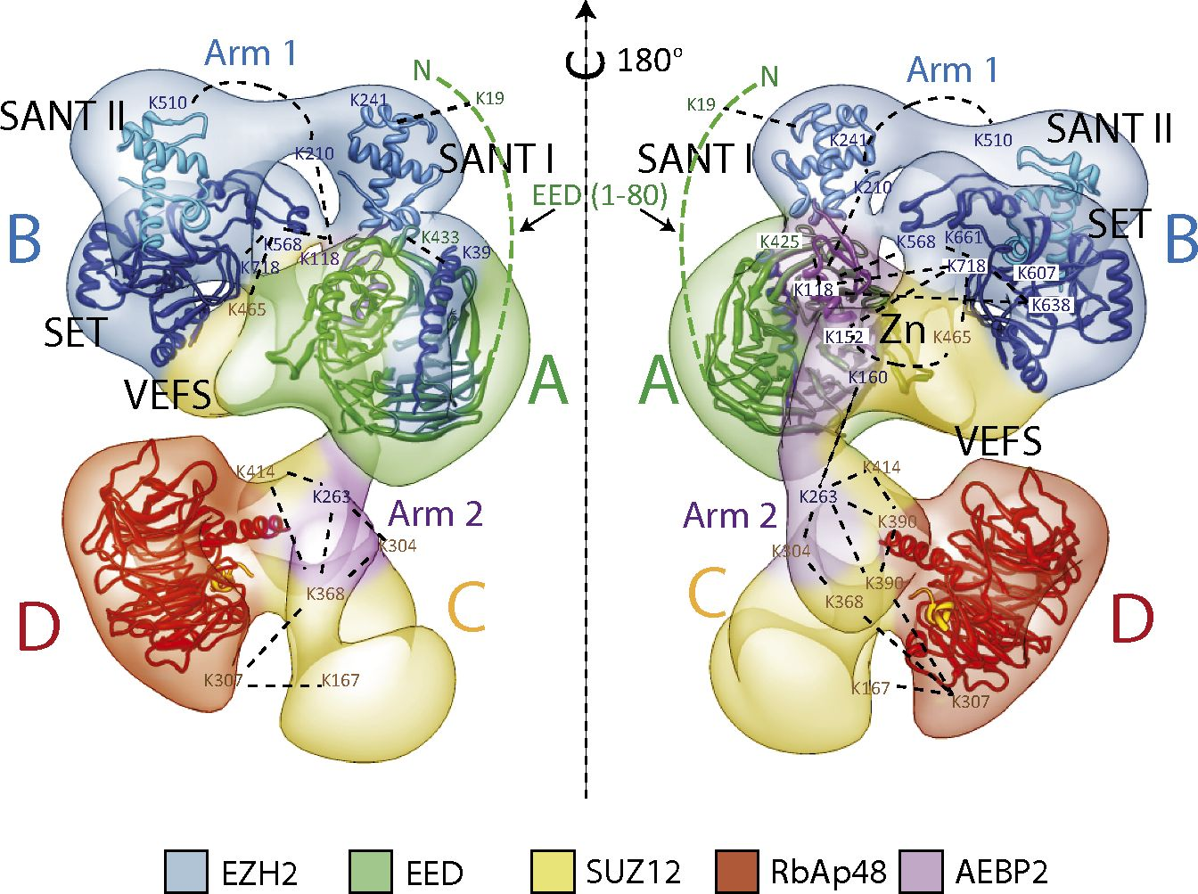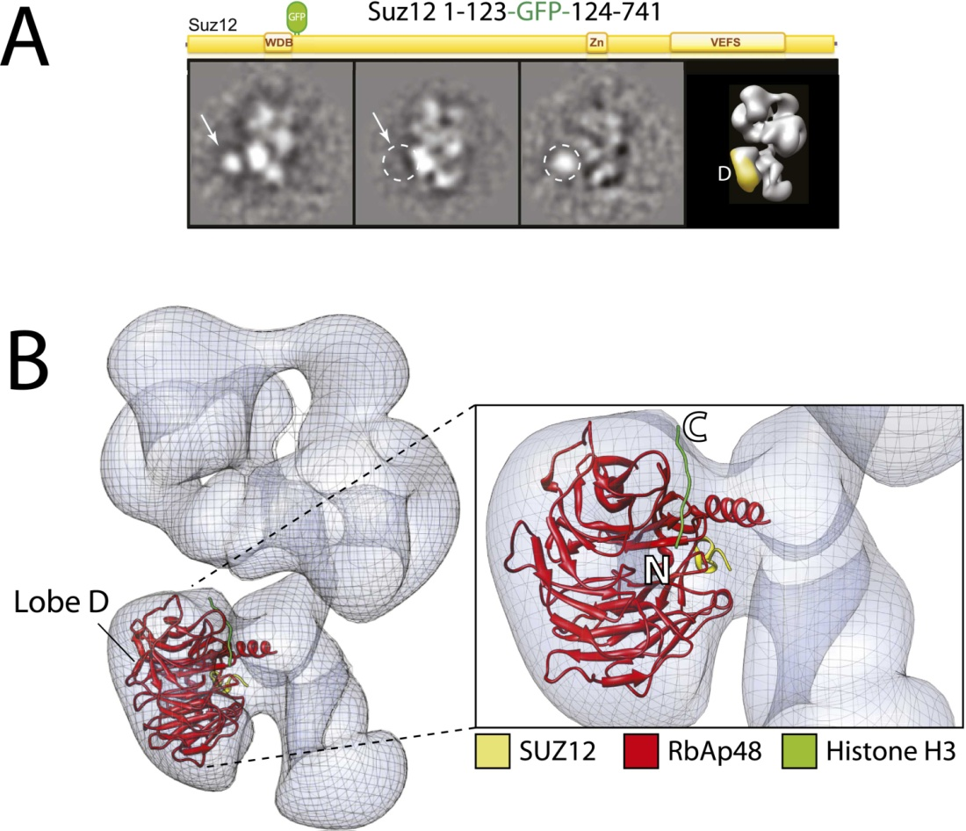
The geneticists suggest that the variant A4336G tRNA glutamine increases Alzheimer's risk 11. As a result, mitochondrial tRNA genes for further investigation on 22 May, the pathogenesis of Alzheimer's disease at the molecular level to reveal.

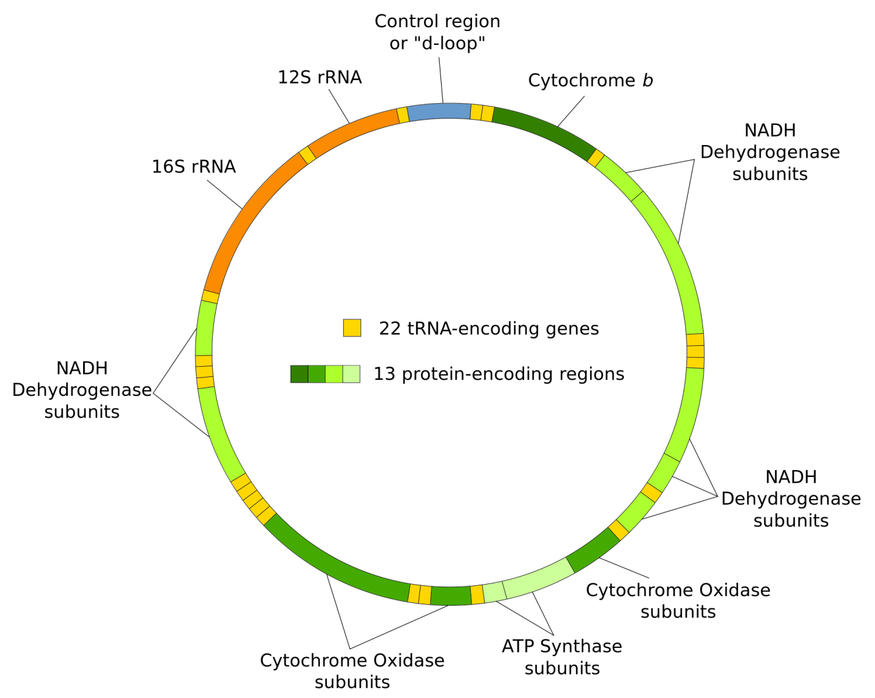
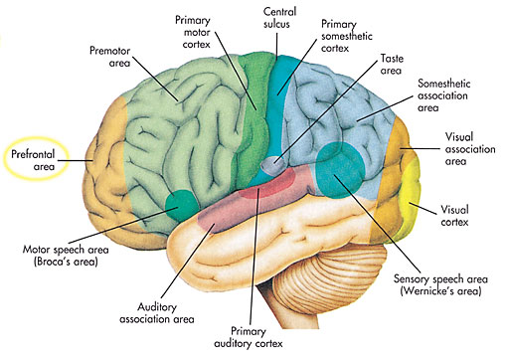

Materials and methods
Iranian blood samples from 24 patients with Alzheimer's disease (52-76 years) and 50 healthy subjects as controls (56-75 years old) were taken. Control samples were selected at random from among those who had no symptoms of the disease and their families, someone who did not exist. These people by a neurologist, were examined to any disease dementia and other neurological disorders in them fails. All patients had a complete physical test and a complete history of symptoms and medical history with drugs were used. Clinical trials conducted by a neurologist.

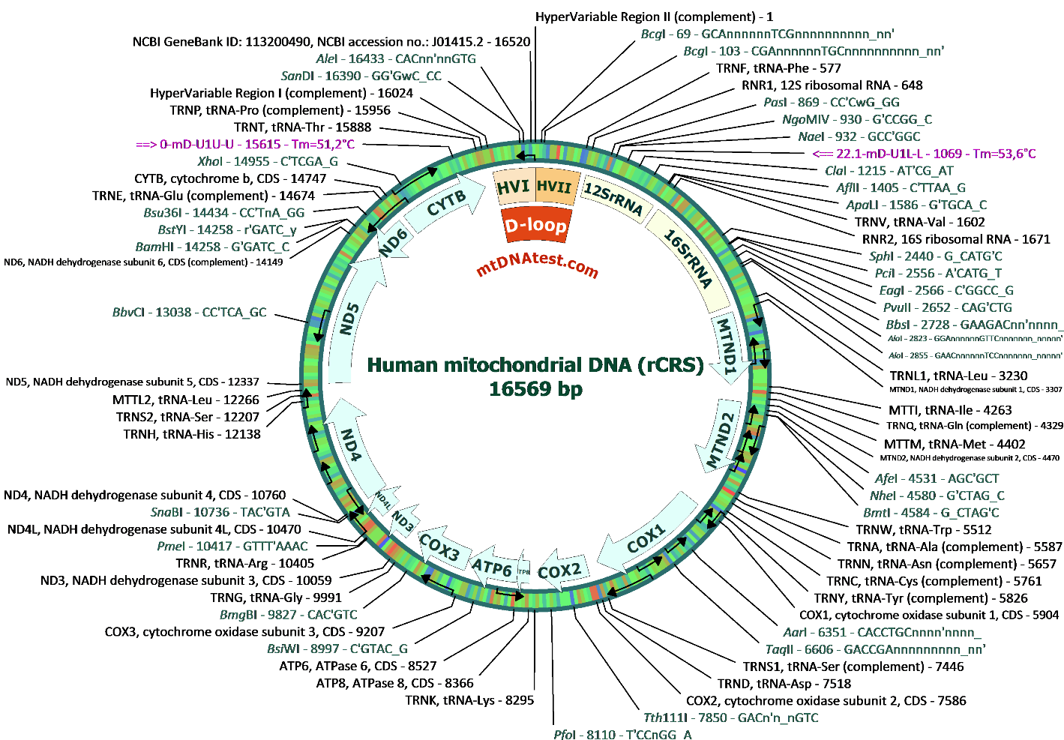
All patients and controls were in relation to the objectives of this study and the consent form, signed for genetic study.
Peripheral blood samples were collected and DNA using DNA extraction kit diatoms Biogen German company, extracted and purified. Gene amplification with primers 12, 22 tRNA gene and PCR conditions have to be quite precise and without any contamination on the blood of patients and controls were analyzed. PCR products with leading or returned primers, the nucleotide sequence and those with control samples, were compared Finch TV software.
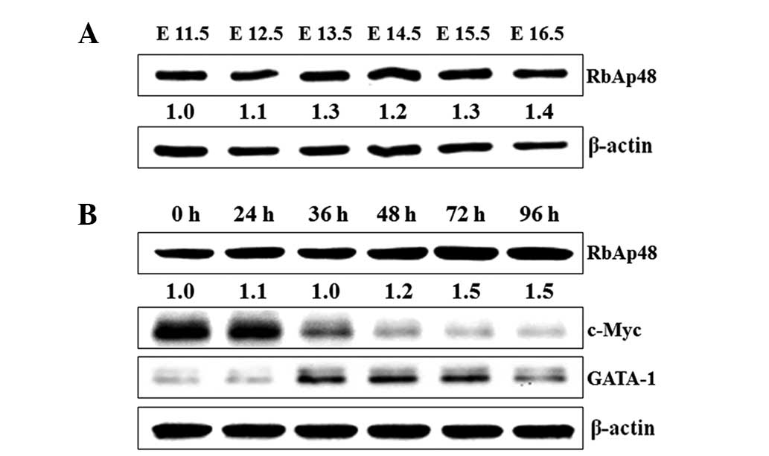
Figure 1: Schematic view of the pattern of proteins in the nervous system, the brain's memory bandwidth.
Findings
Mitochondrial tRNA genes were found in 15 changes. G709A in tRNA Phe, C1631A, G1719A, T1700C, T1633A, and A1811G of tRNA valine, C5583T in tRNA Ser, T10034C, (UCN) in glycine tRNA, G12172A in tRNA histidine, A12308G in tRNA leucine, T14704C, (CUN) and T14723T in tRNA glutamate, A15924G and A15951G in tRNA regulatory tyrosine and G16129A mtDNA were found in the area. C1631A and T1633A for heteroplasmy mutations in six patients, but was not seen in the control samples. T14704C and T14723C mutations and mutations A14704G and A14723G for heteroplasmy in a patient, but was not seen in the control samples. Other changes in the patient and control samples were found to be Hemoplasmia.

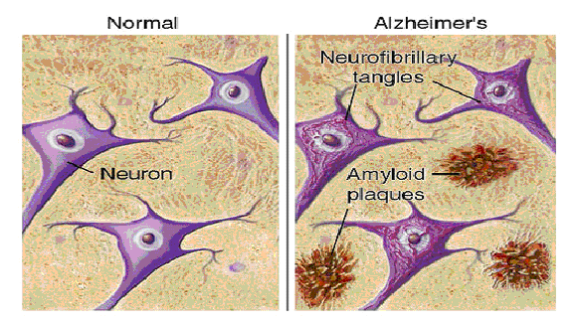

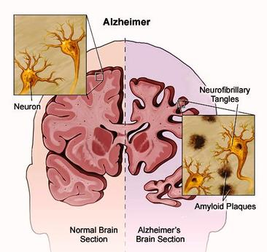
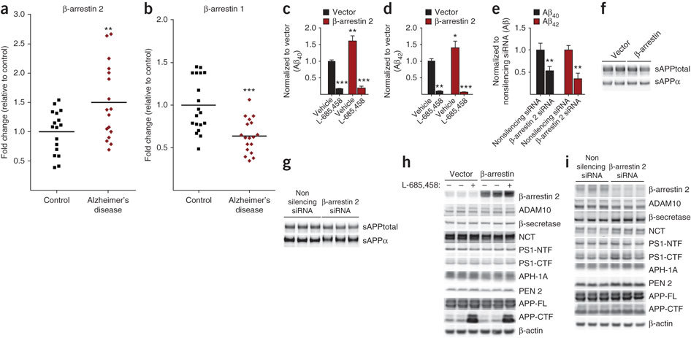
Figure 2: DNA banding pattern of Alzheimer's patients and control groups were formed in the PCR reaction.

Reported | He | Ho | M | P | C.AA | tRNA | Allele | No
* | - | * | - | * | N | F | G709A | 1
- | * | - | * | - | N | V | C1631A | 2
- | * | - | * | - | N | V | T1633A | 3
* | - | * | - | * | N | V | T1700C | 4
* | - | * | - | * | N | V | G1719A | 5
* | - | * | - | * | N | V | A1811G | 6
* | - | * | - | * | N | S(UCN) | C5583T | 7
* | - | * | - | * | N | G | T10034C | 8
* | - | * | - | * | N | H | G12172A | 9
* | - | * | - | * | N | L(CUN) | A12308G | 10
- | * | - | * | - | N | E | T14704C | 11
- | * | - | * | - | N | E | T14723C | 12
* | - | * | - | * | N | T | A15924G | 13
* | - | * | - | * | N | T | A15951G | 14
* | - | * | - | * | N | - | G16129A | 15
Table 1: C.AA: change of amino_asids, N: none, P: polymorphism, M: mutation, Ho: hemoplasmy, He: hetroplasmy, reported.
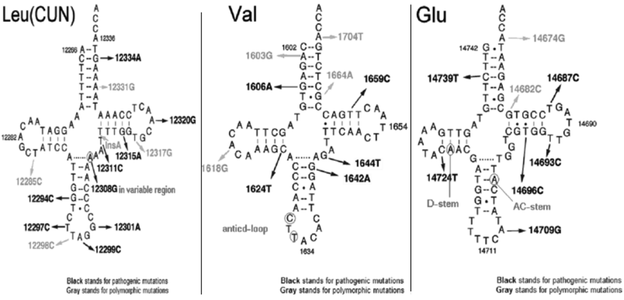
tRNA Leu (CUN) (A12308G),
tRNA Val (C1631A and T1633A),
tRNA Glu (A14704G and A14723G).
5’CCCAACTTACACCTTAGG3’ | HUMAN
5’CCCAAATAACACTTAGG3’ | PATIENT
5’CCCAACTTACACTTAGG3’ | GORILLA
5’CCTAGCTTACACTGAGA3’ | XENOPUS
5’TCTACCTTACACTGAGA3’ | ANGUILLO
5’CAACGATGGTTTTCATATCAT3’ | HUMAN
5’CGACGATGGTTTTCATATCGT3’ | PATIENT
5’CAACGATGGTTTTCATATCAT3’ | GORILLA
5’CAACGATGGTTTTCATATCAT3’ | LEMUR
5’CAACGATGGTTTTCATATCAT3’ | CATTLE
5’CAACGATGGTTTTCATATCAT3’ | RHINOCEROS
Up: Conserved sequence in tRNA Val. (C1631A and T1633A)
Down: Conserved sequence in tRNA Glu. (A14704G and A14723G)
Table 2: conserved sequences.
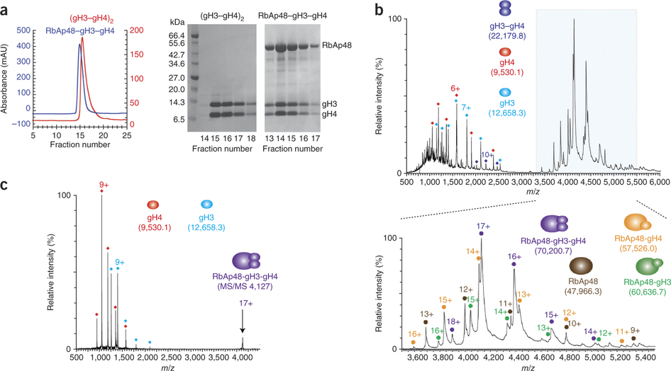
Figure 3: Schematic view of the extent of protein in the human brain RbAp48
Discussion and Conclusion
Mutations in mitochondrial tRNA genes have been reported in various neurological diseases and the risk of developing Alzheimer's disease revealed by mitochondrial mutations. Cutler and colleagues documented evidence that the basic defect in mitochondrial enzyme activity increases with age and occurs in the mitochondria of cells And the mitochondria may play a role in Alzheimer's disease. Kasakan and colleagues showed that 65% of patients with mutations in the brain, but the T414G mutation was observed. NADH dehydrogenase subunit 331 second key point mutations in the brains of Alzheimer's patients, there were 10 cases of 19, while in 11 healthy subjects was ¹¹. The mtDNA defects associated with the aging process, specific mutations in mitochondrial genes have been identified that are fields and infrastructure for Alzheimer's disease¹². A12308G polymorphism was found in 8 patients with leucine tRNA, the change in the number of control samples and a number of diseases have been reported, such as illness CPEO, illness Storke, Parkinson's disease and cardiomyopathy. A12308G polymorphisms associated with increased risk of developing the disease and retinal pigment abnormalities, short stature, discomfort in swallowing and heart conduction defects¹³. This Haplo groups of mtDNA may regulate mitochondrial between clinical Encephalomyocarditis myopathy large deletions in mtDNA that is due.
Acknowledgments
Of all the partners who have helped us in this project, particularly from respected families of patients to collaborate in the project and appreciate.

References
1. Mucke L. Alzheimer disease. Nature. 2009; 461:895-897
2. Heininger K. A unifying hypothesis of Alzheimer’s disease II. Pathophysiological processes. Human psychopharmacology1999; 14:525-581
3. Chan-palay V, Lang W, Allen YS, et al. Cortical neurons immunoreactive with antisera against neuropeptide Y are altered in Alzheimer’s-type dementia. J Camp Neura 1985; 238:390-400

4. Touitou Y, Haus E. Ageing of the human endocrine and neuroendocrine time structure. Ann N Y Acad Sci 1994;
719: 378-397

5. Martel JC, Alagar R, Robitaille T, et al. Neuropeptide Y receptor binding sites in humen brain; possible alteration in Alzheimer›s disease. Brain Res 1990; 519:228-235

6. Jacques D, Dumont Y, Tong Y, et al. Neuropeptide Y receptors in the human brain: gene expression, anatomical
localization and possible alteration in Alzheimer›s disease. Soc Neurosci Abstr 1996; 22:1549

7. Antonaci S, Garofalo AR, Chicca C, et al. Senile dementia, J Clin Lab Anal 1990; 4:16-21 Alzheimer type: a distinct entity in the immunosenescence?

8. Satoh, M.; Kuroiwa, T. (1991). "Organization of multiple nucleoids and DNA molecules in mitochondria of a human cell". Experimental Cell Research 196 (1): 137–140.

9. The details of the tests were published at Gil et al., 'Identification of the Remains' The Duke of Fife was officially named as the source of the comparison sample of mtDNA in Ivanov, 'Mitochondrial DNA', p. 419.

10. Sharp, Stephen J; Schaack, Jerome; Cooley, Lynn; Burke, Deborah J; Soll, Dieter (1985).

11. Rogers Theresa E. et al. (2012). "A Pseudo-tRNA Modulates Antibiotic Resistance in Bacillus cereus". PLoS ONE 7 (7): e41248.

12. Telonis Aristeidis G. et al. (2014). "Nuclear and Mitochondrial tRNA-lookalikes in the Human Genome". Frontiers in Genetics 5: 00344.

13. White RJ (1997). "Regulation of RNA polymerases I and III by the retinoblastoma protein: a mechanism for growth control?". Trends in Biochemical Sciences 22 (3): 77–80.

