Role of Pharmacogenomics in Identifying Cancer Survivors at Risk for Adverse, Persistent Toxicities
M. Eileen Dolan, PhD

Abstract (300 word limit)
Statement of the Problem: There are now over 28 million cancer survivors worldwide, and as a result, there is a heightened awareness of the long-term toxicities resulting from treatment and their impact on quality of life. Understanding the role of germline genetic factors in the development of cancer treatment-related toxicities is critical for the identification of patients at risk as well as for the development of drugs to treat or prevent these toxicities. The purpose of this presentation is to review current understanding of genetic susceptibility to adverse outcomes among cancer survivors following chemotherapy with a particular focus on genome wide association studies (GWAS). Few of the findings from earlier narrowly focused candidate gene studies have been replicated in independent populations. A major strength of genome-wide approaches is that they do not require a priori assumptions about the genes or pathways involved in the pharmacologic trait. The challenges include the need for large cohorts of patients with homogeneous treatment exposures and systematic evaluation of well-defined outcomes as well as replication in independent study populations. Persistent calls to incorporate ancestrally diverse populations into genomic efforts resulted in a recent rise in the number of studies utilizing cohorts of East Asian descent; however, few pharmacogenomic studies to date include cohorts of African, Native American and admixed populations. These disparities could contribute to the widening gaps in health outcomes. In addition to discussing an overview of this approach, the presentation will pay particular attention to recent studies identifying genetic variants associated with chemotherapy-induced peripheral neuropathy and ototoxicity (hearing loss and tinnitus). Conclusion & Significance: Genetic associations hold tremendous promise for more precisely identifying patients at highest risk for developing adverse treatment effects and potential identification of targets for prevention or treatment of the long term toxicities associated with chemotherapy.

Image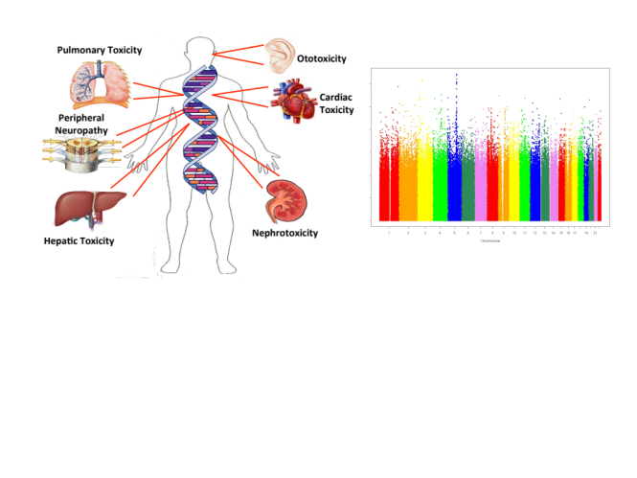

Recent Publications
- Mapes, B., El Charif, O., Al-Sawwaf, S., Dolan, M.E., (2017) Genome-Wide Association of Chemotherapeutic Toxicities: Genomics of Inequality, Clinical Cancer Research, 23:4010-4019.
- Dolan, M.E., El Charif, O., Wheeler, H.E., Gamazon, E.R., Ardeshir-Rouhani-Fard, S., Monahan, P., Feldman, D.R., Hamilton, R.J., Vaughn, D.J., Beard, C.J., Fung, C., Kim, J., Fossa, S.D., Mushiroda, T., Kubo, M., Einhorn, L.H., Cox, N.J., Travis, L.B., for the Platinum Study Group (2017) Clinical and Genome Wide Analysis of Cisplatin-Induced Peripheral Neuropathy in Survivors of Adult-Onset. Clin Cancer Res 23(19):5757-5768.
- Wheeler, H.E., Gamazon, E.R., Frisina, R.D., Perez-Cervantes, C., El Charif, O., Mapes, B., Fossa, S.D., Feldman, D.R., Hamilton, R.J., Vaughn, D.J., Beard, C.J., Fung, C., Kollmannsberger, C., Kim, J., Mushiroda, T., Kubo, M., Ardeshir-Rouhani-Fard, M., Einhorn, L.H., Cox, N.J., Dolan, M.E., Travis, L. B. (2017) Variants in WFS1 and other Mendelian deafness genes are associated with cisplatin-associated ototoxicity. Clin Cancer Res, 23(13):3325-3333.
- Brewer, J., Morrison, G., Dolan, M.E., Fleming, G.F. Chemotherapy-Induced Peripheral Neuropathy, (2016) Gynecologic Oncology, 140(1):176-183.
5. Diouf, B., Crews, C.R., Lew, G., Pei, D., Cheng, C., Bao, J., Zheng, J.J., Yang, W., Fan, Y., Wheeler, H.E., Wing, C., Delaney, S.M. Komatsu, M., Paugh, S.W., McCorkle, J.R., Lu, X., Winick, N.J., Carroll, W.L., Loh, M.L., Hunger, S.P., Devidas, M., Pui,C-H., Dolan, M.E., Relling, M.V., Evans, W.E., (2015) Association of an inherited genetic variant with vincristine-1 related peripheral neuropathy in children with acute lymphoblastic leukemia, JAMA, 313(8):815-23, 2015.


Biography (150 word limit)
M. Eileen Dolan’s lab is focused on improving the quality of life of cancer patients through the identification of genetic variants associated with risk for severe and persistent toxicities following chemotherapy (i.e. peripheral neuropathy, ototoxicity, tinnitus), particularly in children and young adults whose adverse sequelae could persist throughout their lifetimes. To this end, they perform clinical genome wide association studies (GWAS) to identify genetic variants associated with toxicity in patients following chemotherapy. In addition, they develop preclinical models to elucidate the biochemical and cellular impact of genes identified in clinical GWAS studies of chemotherapeutic toxicity. More recently, her laboratory has developed an induced pluripotent stem cell derived neuronal cell model to evaluate genes contributing to chemotherapeutic-induced neuropathy, a common adverse event of multiple chemotherapeutic agents. Using patient derived induced pluripotent stem cells, they are developing models that will have broad applicability for gaining insight on druggable targets to treat or prevent this devastating side effect of chemotherapy.

Email: edolan@medicine.bsd.uchicago.edu
Gender: Female
Mobile no: 708-655-3300
Date of Birth: 09/25/1957
LinkedIn account: https://www.linkedin.com/feed/
Category: Oral (or) Poster: Oral

Notes/Comments:

