Can a pragmatic intervention improve supportive care for family caregivers of patients with cancer? Results of a randomized trial
Michele Aubin MD PhD, U. Laval, Quebec, Canada
Lucie Vezina MA, Laval Fam. Med. Unit, Quebec, CA
Rene Verreault MD PhD, IUCPQ Palliat care Unit, Qc, CA
Sebastien Simard PhD, UQAC, Quebec, Canada
Lise Tremblay MD FRCP (C), U. Laval, Quebec, Canada
Jean-François Desbiens RN PhD, U. Laval, Quebec, CA
Serge Dumont PhD, U. Laval, Quebec, Canada
Maman Joyce Dogba PhD, U. Laval, Quebec, Canada
Pierre Gagnon MD FRCP (C), U. Laval, Quebec, Canada

Abstract
Statement of the Problem: Family caregivers (FC) of patients with cancer often report high distress. The purpose of this study is to assess the effectiveness of an intervention to improve supportive care for FCs. Methodology: FCs of patients with lung cancer were randomized to the intervention or the control group. The intervention included: 1) systematic FC distress screening and problem assessment near their relative´s cancer diagnosis, and every 2 months; 2) privileged contact with an oncology nurse (ON) to further identify and address FC problems; 3) liaison by the ON with the family physician of FCs reporting high distress (thermometer score ≥ 4/10). FCs completed validated questionnaires every 3 months, up to 9 months. The primary outcome was distress. Secondary outcomes included quality of life, preparedness to the caregiving role and perceived burden. Individual interviews were conducted with a purposive sample of FCs from the experimental group (EG) to assess the perceived usefulness and relevance of the intervention. Findings: A total of 109 FCs were enrolled from of a single center specialized in lung cancer, in Quebec, Canada. Compared to baseline level, FC distress decreased over time, but no difference was found between groups. Similarly, there were no differences on any of the secondary outcomes. However, FCs from the GE felt better prepared to play their caregiving role than the controls (p=0.05). Ten FCs from the EG were interviewed and they all considered the intervention useful and relevant, even though they under used it. Knowing they could contact the ON served as a security net. Conclusion & Significance: Although the intervention was not found effective, some of its aspects were positively perceived by FCs. Building on these results, an improved intervention may be developed to support FCs in their role and address their distress, as it remains an important problem.

Recent Publications
- Girgis A, Lambert SD, McElduff P, Bonevsky B, Lecathelinais C, Boyes A, Stacey F. Some things change, some things stay the same: a longitudinal analysis of cancer caregivers’ unmet supportive care needs. Psycho-Oncol 2013; 22(7): 1557-64. DOI: 10.1002/pon.3166. Epub 2012 Sep 3.
- Chambers SK, Girgis A, Occhipinti S, Hutchison S, Turner J, Morris B, Dunn J. Psychological distress and unmet supportive care needs in cancer patients and carers who contact cancer helplines. Eur J Cancer 2012; 21(2): 213-23.
- Bee PE, Barnes P, Luker KA. A systematic review of informal caregivers’ need in providing home based end of life care to people with cancer. J Clin Nurs 2009; 18(10): 1379-93.
- Aubin M, Vézina L, Verreault R, Simard S, Tremblay L, Desbiens JF, Dumont S, Fillion L, Dogba MJ, Gagnon P. Effectiveness of an intervention to improve supportive care for family caregivers of patients with lung cancer: study protocol for a randomized controlled trial. Trials 2017 Jul 4; 18(1): 304. doi: 10.1186/s13063-017-2044-y.
- Northouse L, Williams AL, Given B, McCorkle R. Psychosocial care for family caregivers of patients with cancer. J Clin Oncol 2012; 30(11): 1227-34.
- Fridriksdorrir N, Saevarsdottir O, Halfdanardottir SI, et al. Family members of cancer patients: needs, quality of life and symptoms of anxiety and depression.Acta oncologica 2011; 50: 252-8.

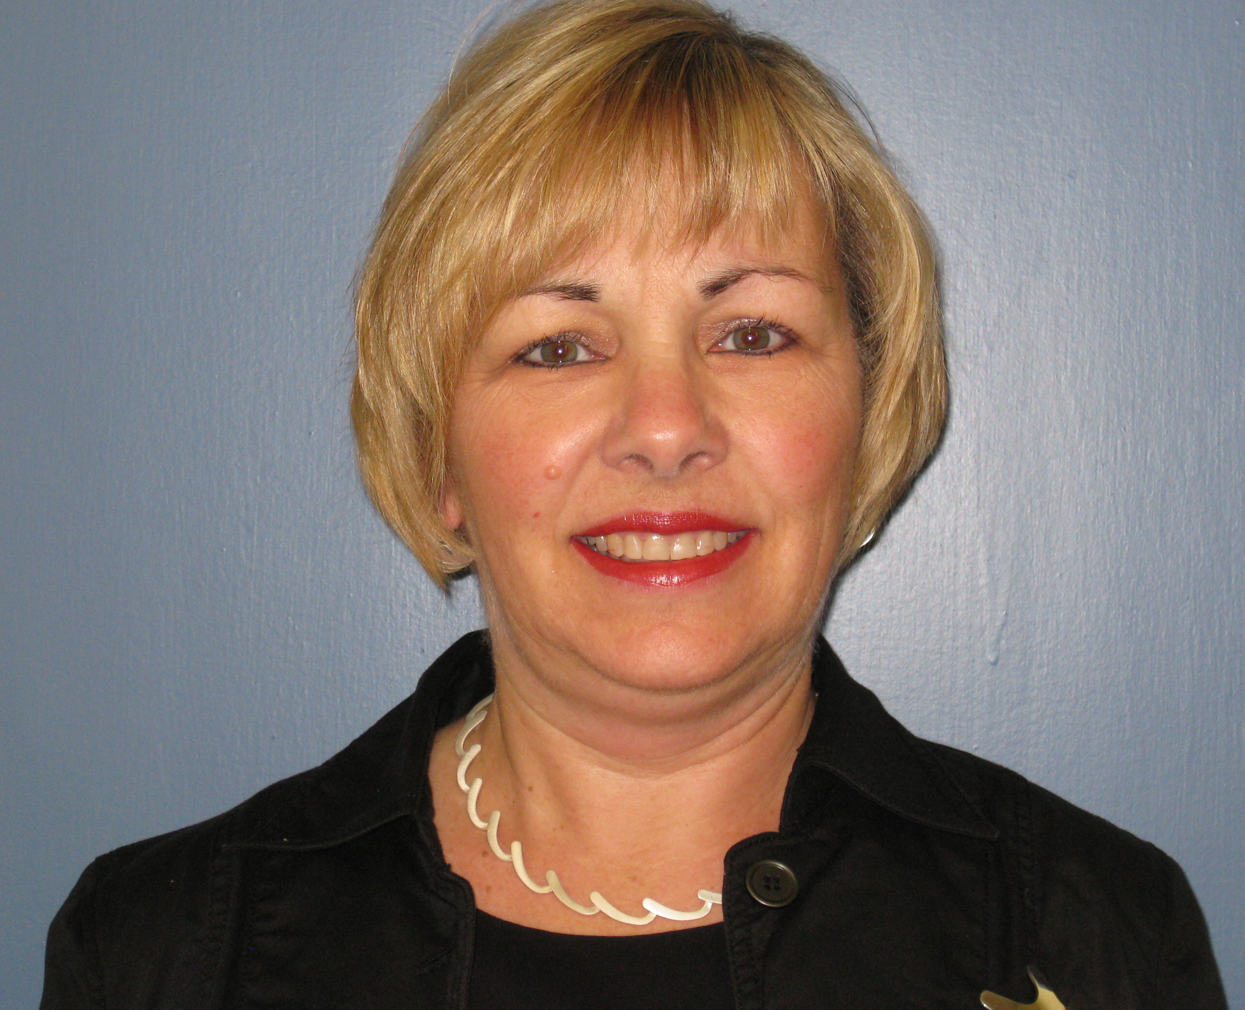Biography
Michele Aubin is a family physician working in a family medicine teaching unit affiliated to the Department of Family Medicine and Emergency Medicine, Laval University, Quebec, (Qc), Canada. She is also professor in that department, and she holds the Research Chair of Palliative Care at the Faculty of Medicine, Laval University. Finally, she is a clinical researcher working in projects related to improvement of primary care and of palliative care services, as well as health services organization (implementation and evaluation of innovative interventions).
Email:Michele.Aubin@mfa.ulaval.ca

Notes/Comments:

