Gastric Mucosal Calcinosis
Vedat Goral*, Irem Ozover**, Ilknur Turkmen**
*Medipol University Medical Faculty Gastroenterology Department. Istanbul
**Medipol University Medical Faculty Pathology Department. Istanbul

ABSTRACT
Gastric mucosal calcinosis is a very rare pathology of the gastric mucosa. It may develop secondary to several diseases but may also be idiopathic in some cases. In this case, gastric mucosal calcinosis was diagnosed with endoscopic biopsy performed for a patient who presented to our clinic with heartburn and abdominal discomfort. The endoscopy performed for the 43–years-old male patient who presented to our clinic with dyspeptic and epigastric pain demonstrated Mallory-Weiss syndrome and chronic gastritis. No white, flat plaques were seen with endoscopy. The result of the biopsy with haematoxylin and eosin (H&E) staining performed on the material taken during endoscopy was reported as chronic gastritis and gastric mucosal calcinosis characterized by chronic infiltrate. Helicobacter pylori was negative and no atrophy, intestinal metaplasia or dysplasia was detected. Staining with Von Cossa clearly demonstrated gastric mucosal calcinosis with large, dense, irregular C accumulation (Picture 1, 2). Pathology department’s opinion was that the mucosal calcinosis observed in the corpus mucosa could be associated with calcium dysregulation and could also be secondary to medication, and recommended analyzing correlation with clinical findings. Patient’s physical examination and routine hematology yielded results that were within normal ranges. USG revealed hepatosteatosis. Abdominal computed tomography (CT) also yielded normal results. Serum PTH was 31.96 pg/ml (N: 15-65 pg/ml) , serum calcium was 10.69 mg/dl (N: 8.6-10 mg/dl) and serum phosphorus was 4.88 mg/dl (N: 2.6-4.5 mg/dl). The opinion of endocrinology was therefore sought. Endocrinology department docor’s said that there is no hyperparathyroidism. Therefore, hyperparathyroidism was not reported. It was considered to be due to the antacids the patient was taking. The patient was given empiric 40 mg pantoprazole to be taken in the morning before breakfast on empty stomach and 20 ng famotidine to be taken at bedtime. When the patient returned for follow-up, he was free of gastric complaints. This case involves a very rare gastric pathology, and is being studied here with reference to literature data.
Key words: Gastric mucosal calcinosis

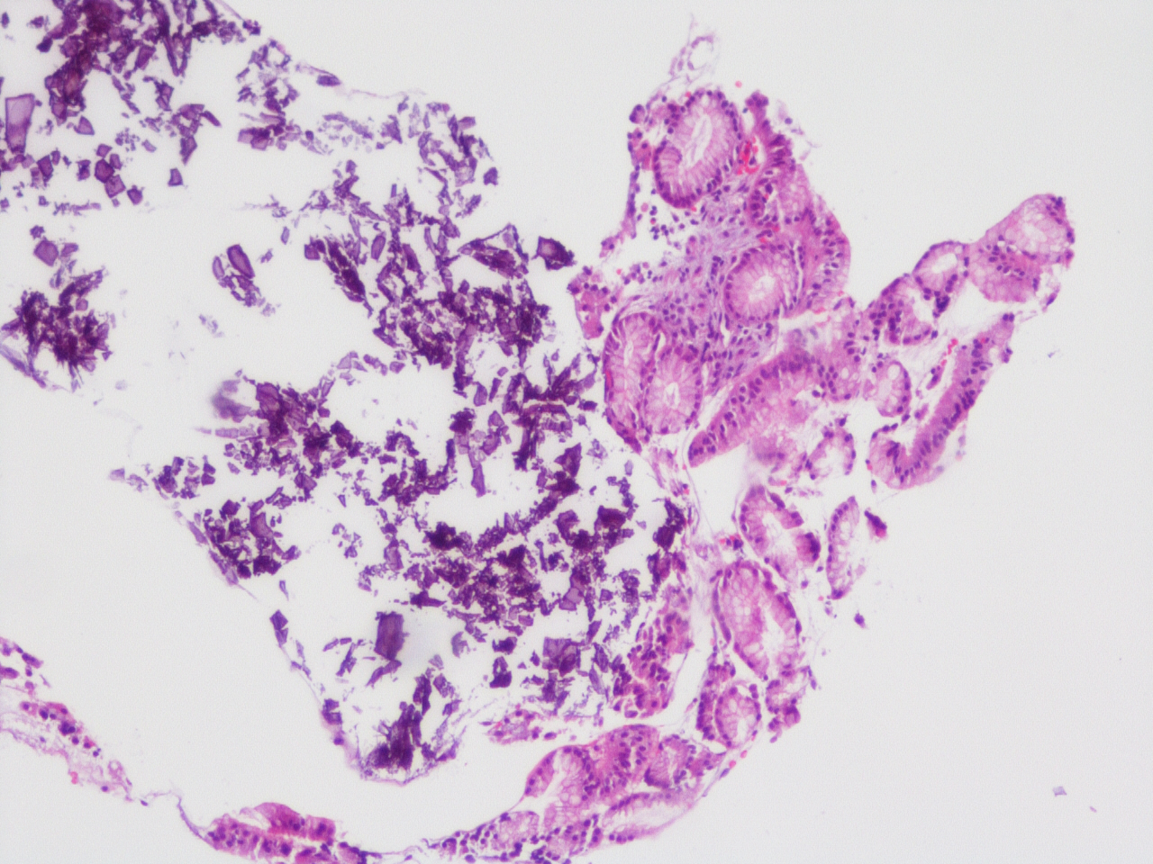
Picture 1A: Amorphous basophilic calcium deposits in gastric mucosa (A, HE, x100) verified with Voncossa stain (B, Von Cossa, x200)
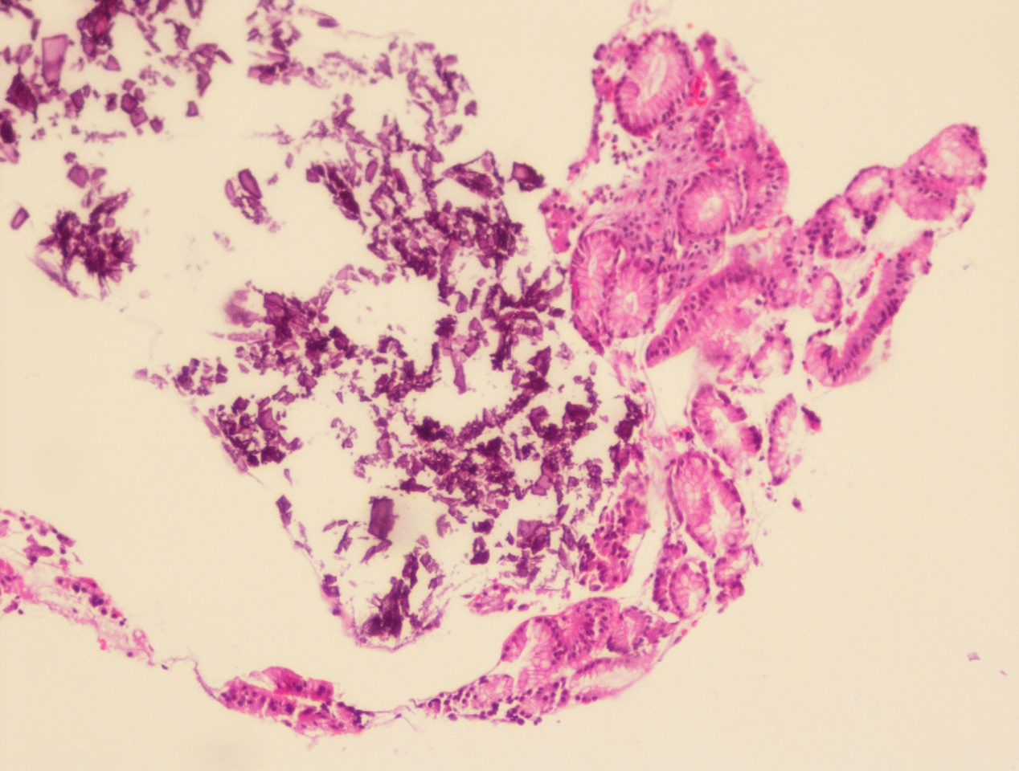
Picture 2A: Amorphous basophilic calcium deposits in gastric mucosa (A, HE, x100) verified with Voncossa stain (B, Von Cossa, x200). H&E x 10

.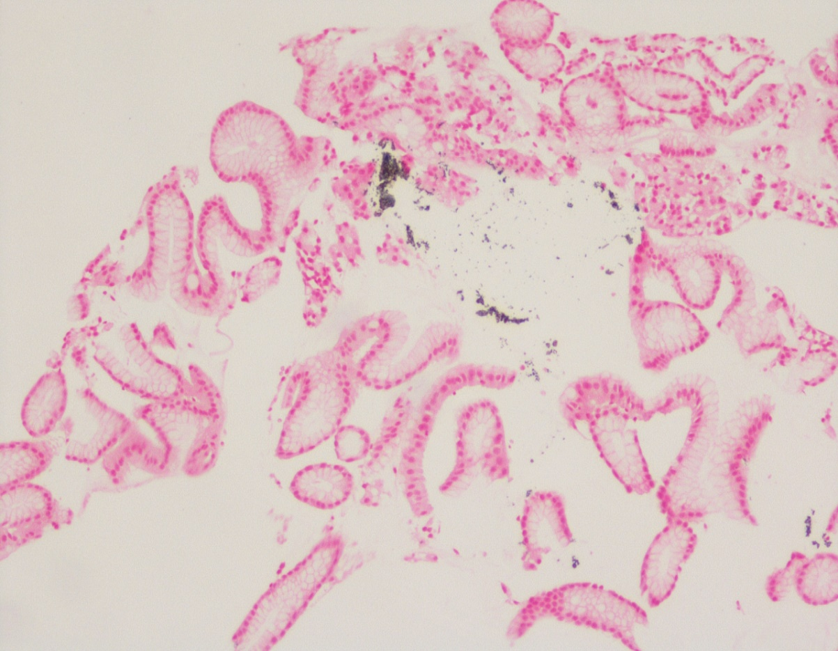
Picture 2B: Amorphous basophilic calcium deposits in gastric mucosa (A, HE, x100) verified with Voncossa stain (B, Von Cossa, x200)
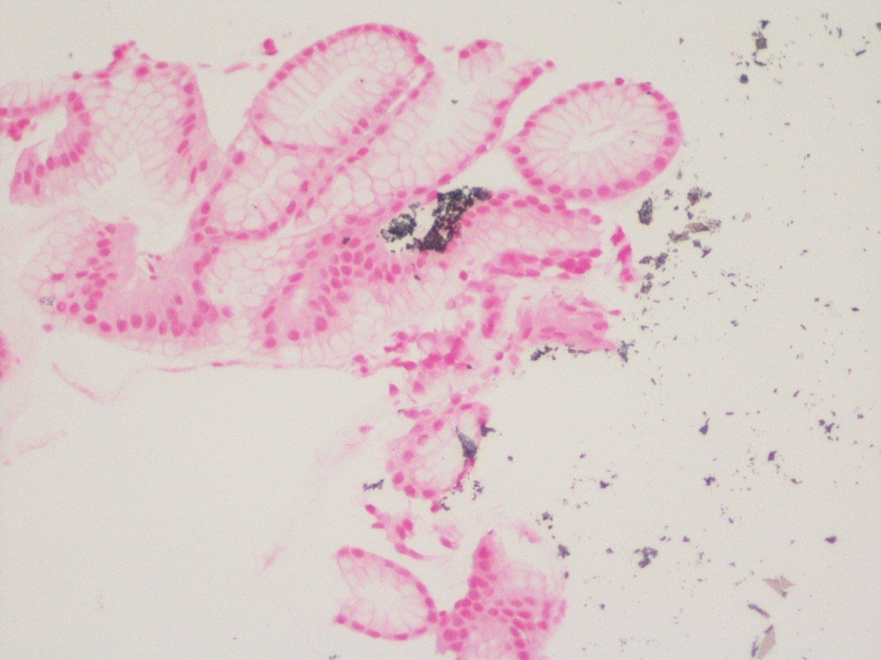
Picture 1B: Von Cossa x 20 Amorphous basophilic calcium deposits in gastric mucosa (A, HE, x100) verified with Voncossa stain (B, Von Cossa, x200)

