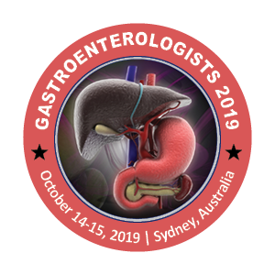

19th World Gastroenterologists Summit

October 14-15, 2019 Sydney, Australia

Theme: Multidisciplinary Approach and Innovations in Gastroenterology


Title: Gurvits Syndrome in a 78- year old male Filipino Patient: A Case Report
Authors’ Names: Ma. Charisse P. Menchavez, MD and Karen S. Batoctoy, MD
Cebu Velez General Hospital

Gurvits Syndrome, or The Black Esophagus, is a rare life-threatening clinical entity with an estimated incidence of 0.001 to 0.2%. Only 88 patients over a span of 40 years have been recorded, but the true prevalence is likely underestimated [1]. There has been no reported case among the Filipino population, moreover, in Asia. It is postulated to arise from a multifactorial background of ischemic insult from hemodynamic compromise and low-flow states, corrosive injury, inadequate mucosal barrier function and in the setting of critical conditions, more often in patients with hyperglycemic crises. [2]
This is a case of a 78-year old Filipino patient who presented with hematemesis in the setting of hyperosmolar hyperglycemic state. An upper gastrointestinal endoscopy revealed a distinctly diffuse circumferential necrosis of the esophagus [Figure 1] with abrupt demarcation at the gastroesophageal junction [Figure 2]. Biopsy of the esophagus was not done due to the risk of perforation; However, multiple gastric biopsy samples were taken and revealed a benign gastric mucosa, negative for H. pylori. The strange endoscopic findings were initially a diagnostic dilemma, until we discovered Gurvits Syndrome. The characteristic esophageal necrosis with an unremarkable gastroesophageal junction and gastroduodenal mucosa were consistent with Gurvits Syndrome. Insulin drip, fluid resuscitation, broad-spectrum antibiotics and absolute bowel rest were instituted. After eight days, repeat upper GI endoscopy revealed that the previously necrotic esophagus [Figure 1] significantly improved to a remarkably pink viable esophageal mucosa with significant granulation tissue, with few areas of erosion and occasional purulent discharges [Figure 3]. This striking characteristic distinguishes this rare condition from the more common causes of hematemesis.
The potential reversibility of this life-threatening condition upon appropriate glycemic control, adequate bowel rest and hemodynamic stabilization overemphasizes the importance of timely recognition and appropriate management.

Figures:

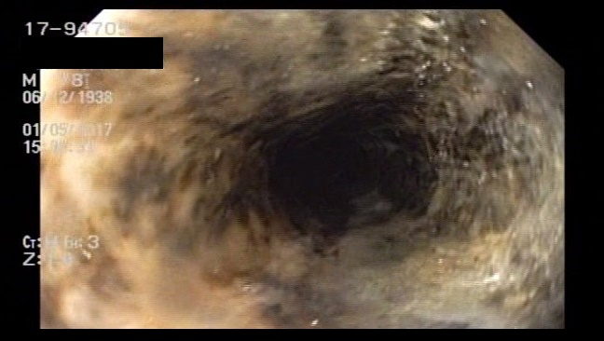
Figure 1: Initial endoscopy revealed circumferential necrosis of the esophagus, with purulent exudates.
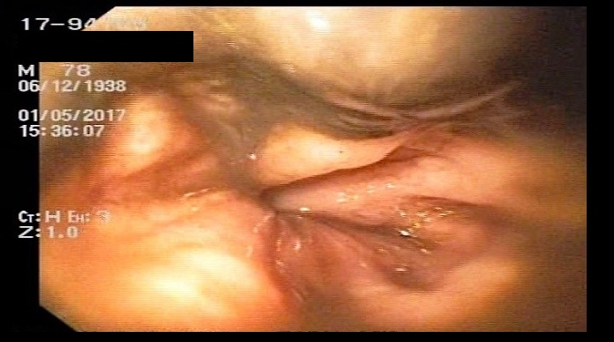
Figure 2: There is a notable abrupt normalization of the mucosa in the gastroesophageal junction in contrast with the diffusely black esophagus in Figure 1.

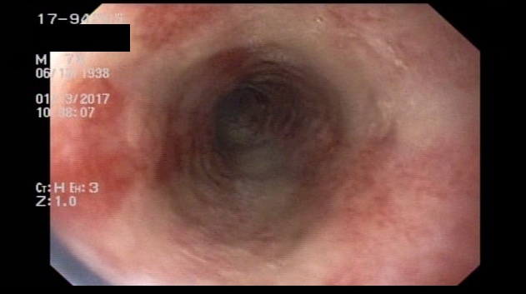
A comparison of the endoscopic findings. The right photo reveals the distinctly black esophageal mucosa noted upon initial endoscopy. In contrast to the pink mucosa with occasional erosions seen on repeat endoscopy after eight days of treatment.

Biography

Ma. Charisse Menchavez is a second year resident physician of the Department of Internal Medicine of Cebu Velez General Hospital located in Cebu City, Philippines. She finished her degree at the Cebu Institute of Medicine. She is a dedicated physician who aspires to enhance her knowledge and skills and to further her training in the field of research. This case was presented and awarded as the winner in the 2nd Department of Health Region VII Research Congress. It was also a finalist in the 23rd Annual Philippine College of Physicians- Central Visayas Research Paper Contest and in the CIM Research Contest held last December 2017.

Presenting author details
Full name: Ma. Charisse P. Menchavez
Contact number: +639175843036
Email id: charissemenchavez@yahoo.com
Category: (Oral presentation/ Poster presentation)

Research interest:
Gastroenterology, Nephrology, Endocrinology

