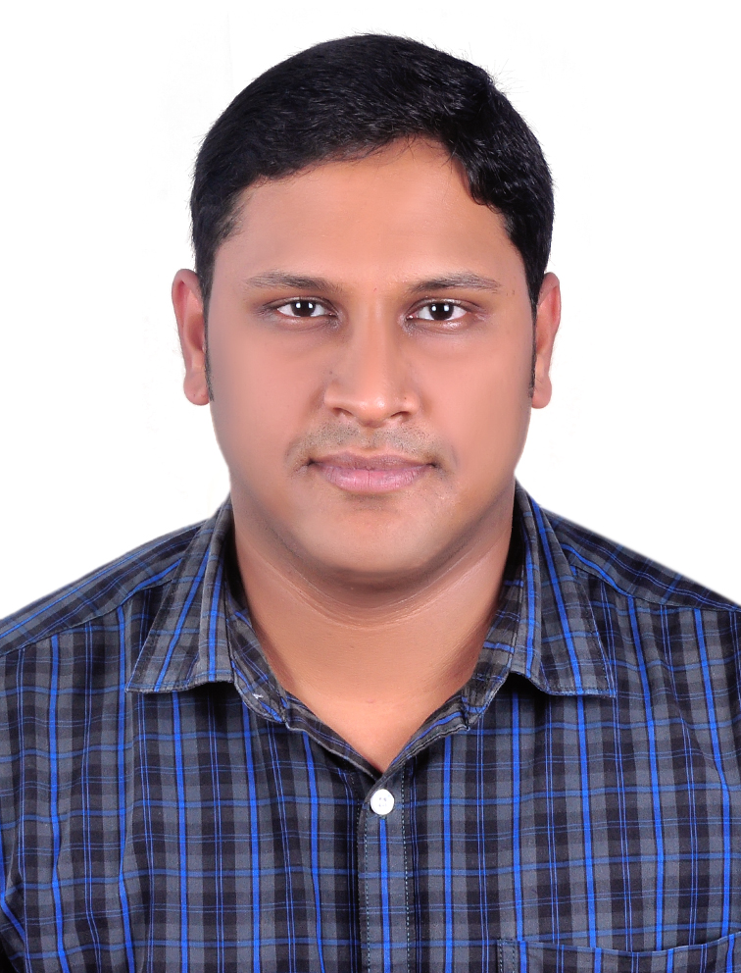
Transient Elastography in Non-cirrhotic Portal Fibrosis: A Comparative Study With Child A Cirrhosis In a Tertiary Care Centre

MOHAMMED NOUFAL B*, PREM KUMAR K*, VENKATESWARAN A R*, KANI SHAIKH M*, RATNAKAR KINI *, PUGAZHENDHI T*, RADHAKRISHNAN N*, THINAKAR MANI B*, SIBITHOORAN K*
* Institute of Medical Gastroenterology, Madras Medical College, Chennai, India-600003

Abstract
Background: Non-cirrhotic portal hypertension (NCPH) is one of the important causes of variceal bleed in tropical countries. In chronic liver disease a very useful non-invasive method for the diagnosis of fibrosis is Liver stiffness (LS) measurement by transient elastography (TE) .There are only limited studies evaluating TE in patients with Non-cirrhotic portal fibrosis (NCPF). Aim of this study was to evaluate role of TE in NCPF.
Methods: This is a case control study of retrospectively collected data from 25 patients of NCPF from September 2015 to August 2017 . All patients had liver biopsy, TE, computed tomography of abdomen . Twenty five age and gender matched healthy subjects and fifty age matched patients with cirrhosis with Child's A were taken as controls.
Results: The mean age of the patients was 26.5 (15–40) years, with female predominance (Female>Male = 19:6). Of the 25 patients 21 had variceal bleed requiring endoscopic band ligation and 3 required glue thaerapy for fundal varices. The platelet count (87 vs 115x10 ³ /ml) was lower and total leucocyte count (2.5 vs 5.9x 10 ³ /cumm P <0.05), was significantly lower in patients with NCPF compared to patients with cirrhosis .TE (Fibroscan) was significantly low in patients with NCPF compared to cirrhotic patients (8.2 vs 47.4 kPa, P <0.005) but high compared to healthy controls (8.2 vs 4.7 kPa, P < 0.005).
Conclusion: Transient elastography (Fibroscan) is significantly low in patients with NCPF compared to patients with cirrhosis. It is a very useful non-invasive technique to differentiate between Child's A cirrhosis and non-cirrhotic portal fibrosis.
Keywords: NCPF, Liver stiffness, Transient elastography

Biography

Dr Mohammed Noufal B has completed his MBBS and MD internal medicine from The Tamilnadu Dr MGR Medical University. He is currently pursuing his post graduate course,DM in medical gastroenterology at the Madras Medical College Chennai,India.He has published papers in reputed journals and conducting various research studies.
Presenting author details
Full name: MOHAMMED NOUFAL B
Contact number: 0091-9567144373 E-mail: drnoufaldm@gmail.com
Session name/ number: Others
Category: Oral presentation

Corresponding author details
PREMKUMAR K E-mail: drpremgastro@gmail.com

