Anastomoses in colorectal surgery. Risk factors related to leak: current situation and evidence.

Ana María Minaya-Bravo, Henares Hospital, Madrid. Spain.

Statement of the Problem: Anastomotic leak is the most dreadful complication in colorectal surgery. It has a great clinical impact on patients leading to high mortality and morbidity; in addition, it is associated to cancer recurrence and lower overall survival. In the modern era; despite the development of minimally invasive approaches and surgical devices, anastomotic leak is still a concern and challenge for the surgeon. For centuries, surgeons have put all their efforts on identifying causes of leakage. It is estimated that anastomotic leak rate following colorectal surgery ranges from 1.8% to 19% depending on the site of the anastomosis, being lower for the right colon.
Methodology & Theoretical Orientation: In order to identify risk factors for leak, a review of the main papers published was performed and contrasted with the recent results of the 2015 and 2017 European Society of Coloproctology international snapshots.
Findings: The 2015 ESCP right hemicolectomy audit found that stapling technique is an independent risk factor for leak when compared to handsewn anastomoses. However, this differs from the Cochrane review (2011) that recommends stapling following right hemicolectomy for cancer. The 2017 ESCP international snapshot audit of left colon, sigmoid and rectal resections found preparation and oral antibiotics as protective factors for leak. The 2015 and 2017 ESCP international snapshots concluded that open surgery is a risk factor for major complications when compared to laparoscopic surgery. Similar results have been reported by other authors. However, the relation between ASA, BMI or diabetes and leakage is less consistent.
Conclusion & Significance:
The ideal anastomosis technique has not been described yet; however, open surgery, nutritional status, emergency, age and male have been reported as consistent risk factors for leakage in different studies.

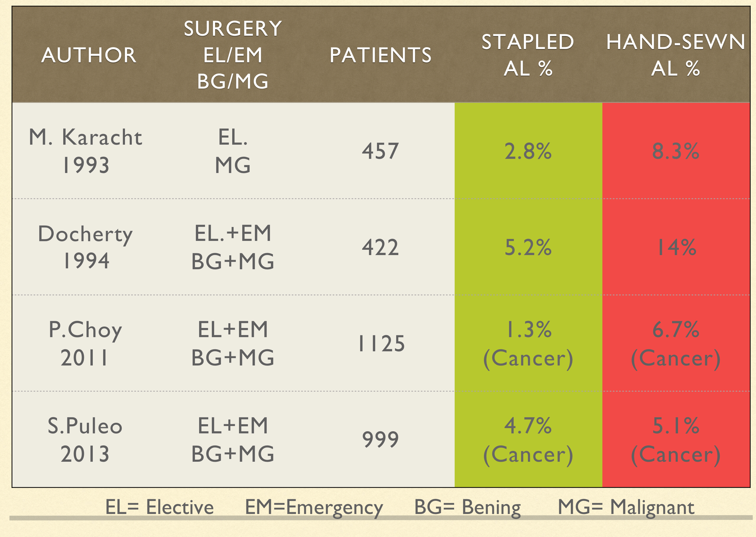
Recent Publications
- 2015 European Society of Coloproctology collaborating group. The relationship between method of anastomosis and anastomotic failure after right hemicolectomy and ileo-caecal resection: an international snapshot audit. Colorectal Dis. 2017 Mar 6.
- Jessen M, Nerstrom M, Wibek TE, Roepstorrf S, Rasmussen MS, Kraup PM. Risk factors for clinical anastomotic leakage after right hemicolectomy. Int J Colorectal Dis (2016) 31: 1619-1624
- Choy PY, Bissett IP, Docherty JG, Parry BR, Merrie A, Fitzgerald A. Stapled versus handsewn methods for ileocolic anastomoses. Cochrane Database Syst Rev 2011; 9:CD004320
- Fleettwood VA, Gross KN, Alex CG et al. Common side closure type, but not stapler brand or oversewing, influences side-to-side anastomotic leak rates. Am J Surg 2017; 213: 590-5
- 2017 European Society of Coloproctology collaborating group. Association of mechanical bowel preparation with oral antibiotics and anastomotic leak following left sided colorectal resection: an international, multi-centre, prospective audit. Colorectal Dis. 2018 Sept; 20 Suppl 6:15-32. doi: 10.1111/codi.14362.
- 2017 European Society of Coloproctology collaborate group. Safety of primary anastomosis following emergency left sided colorectal resection: an international, multi-centre prospective audit. Colorectal Dis. 2018 Sep;20 Suppl 6:47-57. doi: 10.1111/codi.14373.
- Frasson M., Granero-Castro P, Ramos-Rodriguez JL. Risk factors for anastomotic leak and postoperative morbidity and mortality after elective right colectomy for cancer: results from a prospective, multicentric study of 1102 patients. Int J Colorectal Dis. 2016 Jan;31(1):105-14. doi: 10.1007/s00384-015-2376-6.
- C. Jurowich, S. Lichthardt, N. Matthews et al. Effects of anastomotic technique on early postoperative outcome in open right‐sided hemicolectomy. Br J Surg. 2018 Sept; https://doi.org/10.1002/bjs5.101

 Biography Ana María Minaya-Bravo
Ana María Minaya-Bravo graduated as medical doctor from Autonomous University of Madrid, Spain in 2002 and then completed her General Surgery Residency at University La Princesa Hospital, Madrid; she was also trained in Oxford, UK.
She is an enthusiast of Colorectal and Oncological Surgery and has worked at this field for more than a decade. She has authored several papers and reviewed manuscripts for many international journals.
She has also participated in international clinical trials and is a member of cohort studies sub-committee of the European Society of Coloproctology.

Research interest:
Colorectal Surgery; Oncological Surgery; Endorectal Ultrasound; Medical clinical trials; Gastroenterology

Email: Ana-minaya@hotmail.com
Phone: +34-605891145

Notes/Comments:

