New possibilities for detecting liver metabolic dysfunction and non-pharmacological effects on it.
Yury Marakhouski, Olga Zharskaya. Department of Gastroenterology and Nutrition Belarusian Medical Academy of Postgraduate Education (BelMAPE), Minsk, Belarus

Abstract (300 word limit)
The criteria for liver metabolic dysfunction remain highly controversial. At the same time, metabolic liver dysfunction is directly related to metabolic flexibility. Aim: To determine the possibility of alternative liver ketogenesis induction and assess the effect of a special variant of drinking water on this process. Methods. Part1: Search and analysis of publications on ketogenic amino acids (AA) for conducting a clinical study confirming the ketogenic effect of the selected AA. Part 2: Drinking water with special properties (effect on the body metabolically active components) and their confirmation in preclinical and clinical studies. Part 3: Selective induction of hepatic ketosis before and after 14 days of water intake. Results. Part1: L-lysine is predominantly indicated as a ketogenic AA, but the ketogenic effect of lysine was not described in humans. Clinical study showed: Area Under Curve (AUC) at lysine doses 1,0 g and 2,0 g was 1155 and 5070, maximum ketones (breath test) on 120 min in both doses was 16 ppm at 1,0 g and 46 ppm at 2,0g. Ketosis index gave the following results in ppm/minute: in 30% cases – 1,0 and more (fast inductors), 0,1 - 0,4 (medium inductors) and with the absence of ketosis - slow inductors. Part 2: We selected the drinking water (DWP) after special processing (details are not disclosed, patent is being filed). In groups of animals (rats) that received DWP, the survival rate after radiation exposure (dose of 5 Gy) increased by 30%, compared with the control group (water with same composition). Results in animals with DWP showed an improvement in the whole series of metabolic parameters. Clinical study. The total response to the DWP intake in terms of active cell mass (ACM), intracellular fluid (ICF) and phase angle impedance characterized that water as having a stabilizing effect on the ACM of the body, ICF and cell membranes hydration. The incidence of altered blood glucose values (above 5.5 mmol/l) significantly decreased on the 28-day course of DWP intake. The same results were obtained in the incidence of altered liver biomarkers. Part 3: Selective induction of hepatic ketosis before and after 14 days of DWP intake. We calculated a ketosis coefficient (KC): the intensity of ketosis multiplied by 100 and divided by the active cells body mass (bioimpedance detected) in kg. The median KC was 2,8 (25/75 Quartiles = 2,1 – 5,9). It was determined, that the patients with a KC 2.0 and lower had liver pathology – MAFLD. According to the results, the L-lysine ketosis induction test is valuable in the liver metabolic flexibility assessment, and DWP drinking increases the liver metabolic flexibility. Conclusion. A simple and non-invasive method has been developed for liver metabolic status evaluation. The liver metabolic potential can be improved by the regular intake of a special drinking water.

Image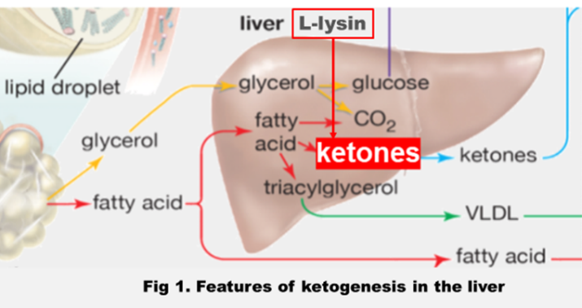
Recent Publications (minimum 5)
- Metabolic Catabolism of Individual Amino Acids/ P. Newsholme [et al.] in Comprehensive Biotechnology (Second Edition), 2011.
2. Gerald Litwack. Metabolism of Amino Acids., in Human Biochemistry, 2018.
3. Dwight E Matthews. Review of Lysine Metabolism with a Focus on Humans. The Journal of Nutrition. 2020; Vol. 150, Suppl. 1, P. 2548S–2555S.
4. Olson KA, Schell JC, Rutter J. Pyruvate and metabolic ﬂexibility: illuminating a pathtoward selective cancer therapies. Trends Biochem Sci. 2016; Vol. 41, Suppl. 3, P. 219–230.
5. Reuben L. Smith, Maarten R. Soeters, et all.Metabolic Flexibility as an Adaptation to Energy Resources and Requirements in Health and Disease. Endocrine Reviews. 2018; Vol. 39, P. 489 – 517.

Biography (150 word limit)

Dr. Yury Marakhouski. approved as Professor of Clinical Medicine in 2005 year by the Higher Certification Commission of the Council of Ministers of the Republic of Belarus. He is head of the Department Gastroenterology and Nutrition of the Belarussian Medical Academy of Postgraduate Education. He has published more than 30 papers in reputed journals and is serving as a member of the editorial board of several reputed journals (predominantly in Russia and Belarus). His Current Position is Head of Department of Gastroenterology and Nutrition, Belarussian Medical Academy of Postgraduate Education (BelMAPE).He is principal investigator on numerous clinical (18) and preclinical (6) studies and has been involved in the study of many medication including mesalazine, amino acids, anti-TNF drugs.
Email: drXXXXXXX@xxxmail.com
Notes/Comments:

Presenting author details
Full name: Yury Marakhouski
Contact number: +375447587414
Mail id: marakhouski@yahoo.co.uk
Category: Oral presentation

