TITLE : 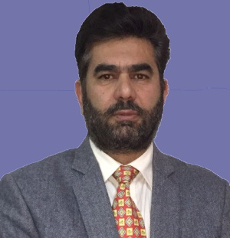
Surgical complications of Ascaris lumbricoides –An Overview
PRESENTER - Prof ( Dr) Ajaz Ahmad Rather
MBBS MS ,FICS ,FCLS,FACS, FACRSI.
Prof & Head SURGERY SKIMS Medical College/Hospital ,
Srinagar, KASHMIR,INDIA ABSTRACT : Ascaris lumbricoides (Round worm) is one of the largest of the parasites that infest the human bowel, common in regions with poor sanitation, in the tropics and subtropics. Massive infestation in children may give rise to grave complications that demand expert surgical care. Third World surgeons practicing in general hospitals that take care of patients of low economic capacity are usually familiar with the diagnosis and management of this pathology; surgeons who practice in the industrialized nations only occasionally face such problems. The greater mobility of today's societies and the rather massive migrations that take place in current times have resulted in an increasing incidence of these entities in the hospital populations of the large urban centers of these nations
.Common acute surgical abdomen caused by Ascaris infestation include small gut (intestinal) obstruction, volvulus, intussusception and perforation usually involving the appendix (causing acute appendicitis ) bilary ascariasis (leading to CBD obstruction,Chollangitis, cholecystitis), Liver Abscess ,Meckles Diverticulitis,entero-cutaneos fistulas
I PERSONALLY HAVING A LONG SURGICAL EXPERIENCE (LONG 18 YEARS)OF DEALING WITH SUCH CASES SHARE MY EXPERIENCE WITH FOLLOWING OBSERVATIONS;
Worm Obstruction Gangrene Gut(VOLVULUS) WORM IN APPENDIX

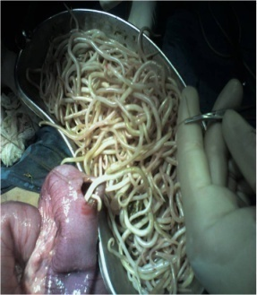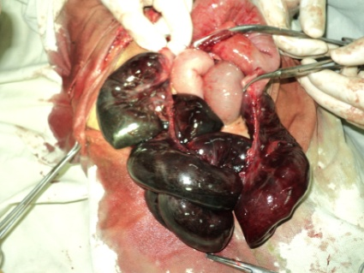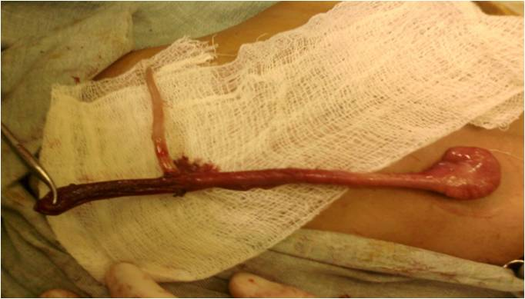
GUT OBSTRUCTION WORMIN APPENDIX
with PERFORATION

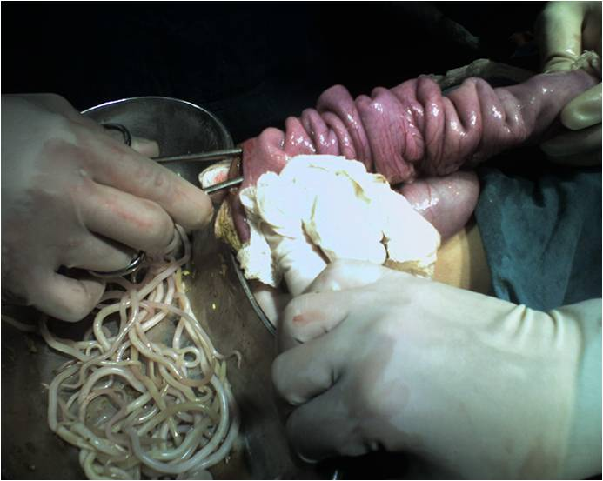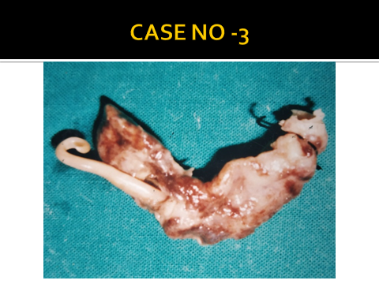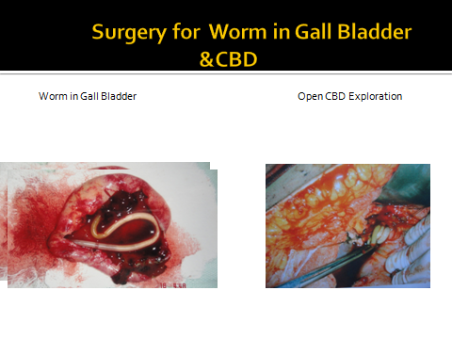

OBSEVATIONS & RESULTS
Age in years | Male | Female | Total | Male/ Female Ratio
4-7 | 26 (57.8%) | 19(42.2%) | 45 | 1: 0.73
8-11 | 10 (58.8) | 7 (41.2) | 17 | 1:0.70
12-14 | 4(50%) | 4(50%) | 8 | 1:10
Total | 40(57.1%) | 30 (42.9%) | 70 | 1:0.75 (57.1%:42.9%)

REGIONAL DISTRIBUTION
Urban | 26 (37%)

Rural | 44 (62.0%)

Age distribution
AGE NUMBER
4-7 | 45
8-11 | 17
12-14 | 8
Total no. of patients 70

SEX DISTRIBUTION

Age in years | Male | Female | Total | Male/ Female Ratio
4-7 | 26 (57.8%) | 19(42.2%) | 45 | 1: 0.73
8-11 | 10 (58.8) | 7 (41.2) | 17 | 1:0.70
12-14 | 4(50%) | 4(50%) | 8 | 1:10
Total | 40(57.1%) | 30 (42.9%) | 70 | 1:0.75 (57.1%:42.9%)

WORM IN APPENDIX WORM IN GALL BLADDER Patent VI DUCT worm from Nose
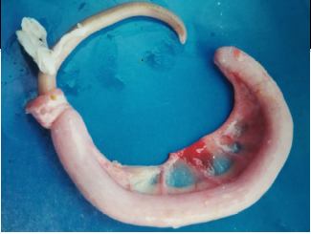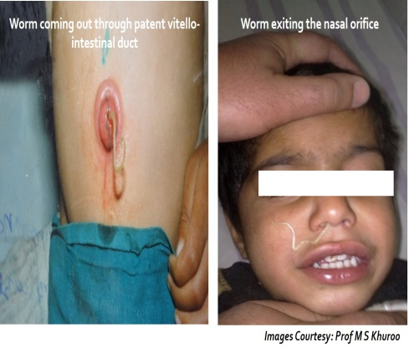
WORM IN MECKLES Diverticulum
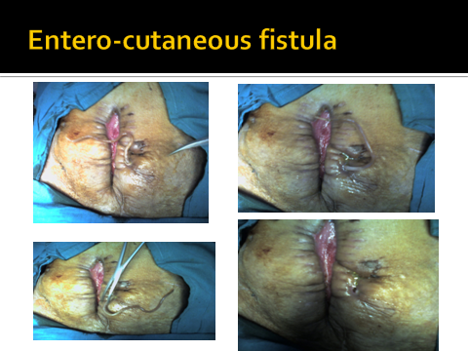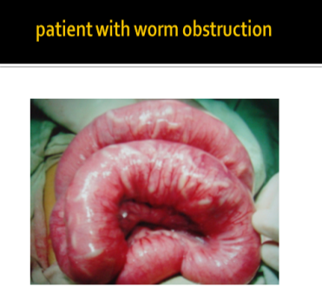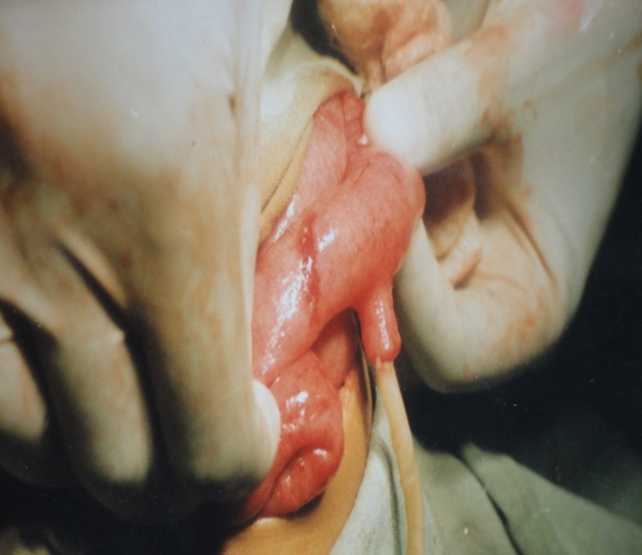

ETIOLOGY
Worm Obstruction | 51 (73%)
Adhesion Obstruction | 8 (11.4 %)
Intussusception | 3 (4.3 %)
Obstructed Inguinal Hernia | 2 (2.86 %)
Band Obstruction | 2 (2.68 %)
Volvulus | 1 (1.4 %)
Intestinal tuberculosis (ileal) | 1 (1.4%)
Unknown etiology | 2 (2.86%)

WORM OBSTRUCTION MANAGEMENT
Total No. of Patients | 51
1. Conservative Management | 37 (72.5%)
2. Operative | 14 (27.5%)
Operative procedure | No. of patients
a. Enterotomy with removal of worms 6
b. Small bowel resection with E-E Anastomosis 5
c. Kneading of worms (milking) 3
Other worm related surgical problems managed
Acute Appendicitis- 4 pts
Cholecystitis-1 fistula(-Entero cutaneous -1Pt
CBD-OBST 1pt C CONCLUSION
Worm obstruction is still the commonest cause of acute intestinal obstruction in children in our part of the country. Majority of the patients are from rural areas due to lack of health education, poor hygiene and sanitation, poverty and low standard of living, use of open field defecation, use of human excreta as manure, and eating of raw uncooked vegetables (salads). Early and prompt treatment is essential to prevent morbidity and mortality in these patients. A mass deworming programme of children in endemic areas should be taken at public health to save the population from the dreadful complications because of worms.
BIOGRAPHY
Dr AJAZ A RATHER I, is PROF & Head Surgery SKIMS Medical College Srinagar.,having more than 60 publications in various National & International Journals, has delivered lectures in more than 40 confrences, is having 5 international Fellowships & 8 memberships, HAS TRAINED MORE THAN 1000 MBBS STUDENTS AND IS POSTGRADUATE GUIDE TO 6 STUDENTS,HAS CONTRIBUTED IN MANY BOOKS & IS IN Editorial Board/ Advisory Board to many international journals
Presenting author details
Full name: Prof ( Dr ) AJAZ AHMAD RATHER
Email Id: drajazrather@gmail.com
Contact number: +19,9419013839
Category: (Oral presentation/ Poster presentation)- ORAL PRESENTATION AS INVITED GUEST SPEAKER

