TITLE; Complications of Ascariais- Surgical Aspect
Name. Prof (Dr) AJAZ A RATHER
MBBS,MS,FICS,FACS,FACRSI,FCLS.
Prof & Head Surgery Skims Medical college /Hospital Bemina Srinagar Kashmir,INDIA
- Absract; Ascaris is Cosmopolitan in distribution and is particularly found in Tropical regions.world wide prevelence-25% and about 1.5 billion people around world infested ,In United states only about 4 million people infested ,It has been found that 70 % children in India are stool +ive for ascariasis and In Kashmir it is upto 85% .10,000-20,000 children die Anually globally /yr. There is a high prevalence in underdeveloped countries with poor sanitation-Asia,south America & Africa,even occurs in developed countries like United States in rural area Occurs during rainy months in tropical & subtropical countries.
Ascaris lumbricoides is the largest nematode parasitizing the human intestine,found mainly in Jejunum & upper part of ileum.More common in Children than adults As many 500-5000 adult worms may inhabit a single host
Mode of transmission -Poor Socio-economic conditions ,poor sanitation ,inadequate sewage disposal,Poor Pry. Health Service, Delayed medical attention Health ignorance, Poor personal hygiene,illiteracy
I hereby present my personal experience of dealing with rare compliations caused by ascariasis viz Acute Appendicitis , enterocutaneous fistula(, Feacal peritonitis , Mekels Diverticulitis, Biliary colic ,Obstructive Jaundice, Cholangitis,Liver abscess, acute Cholecystitis, cholelithiasis,Pancreatitis &gut obstruction/gangrene
- My STUDY ON INTSTINAL OBSTRUCTION -Both - Retrospective (2000-2006) & prospective (2007-2010)study conducted at SKIMS Medical College
Paed . Age group------4 -14yrs, Total No. of pts ---------------70

- Etiology
Worm Obstrruction | 52 | 74.3 %
Adhesion Obstruction | 6 | 8.6 %
Intussusception | 3 | 4.3 %
Obstructed I.Hernia | 3 | 4.7 %
Volvulus | 2 | 2.9 %
Hirschprungs | 2 | 2.9 %
Perforated appendix | 1 | 1.4 %
Band obstruction | 1 | 1.4 %

Management of worm Obstruction Total-52,Conservative-41(78.8%),operative-11(21.2%)
Operative procedure | No. | %
Enterotomy | 5 | 45.5
Kneading of worms | 3 | 27.3
Ressection /E-E anastamosis | 3 | 27.3
SOME OF MY PERSONAL PICTURES DURING SURGERY
Acute appendicitis
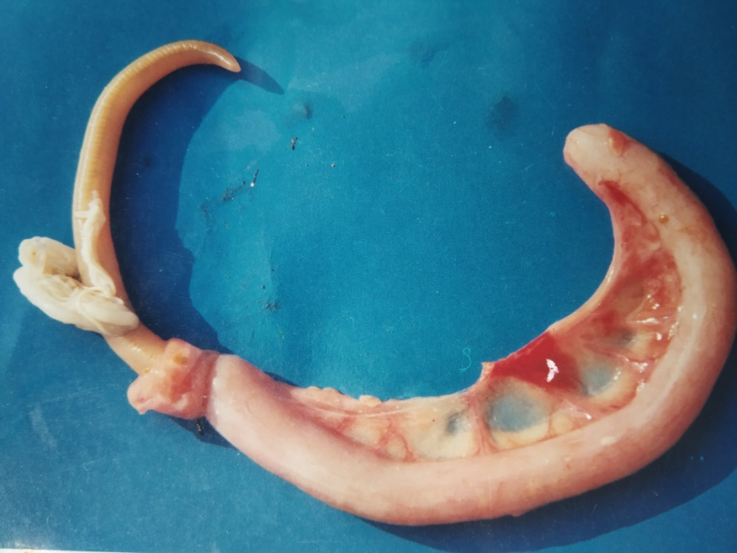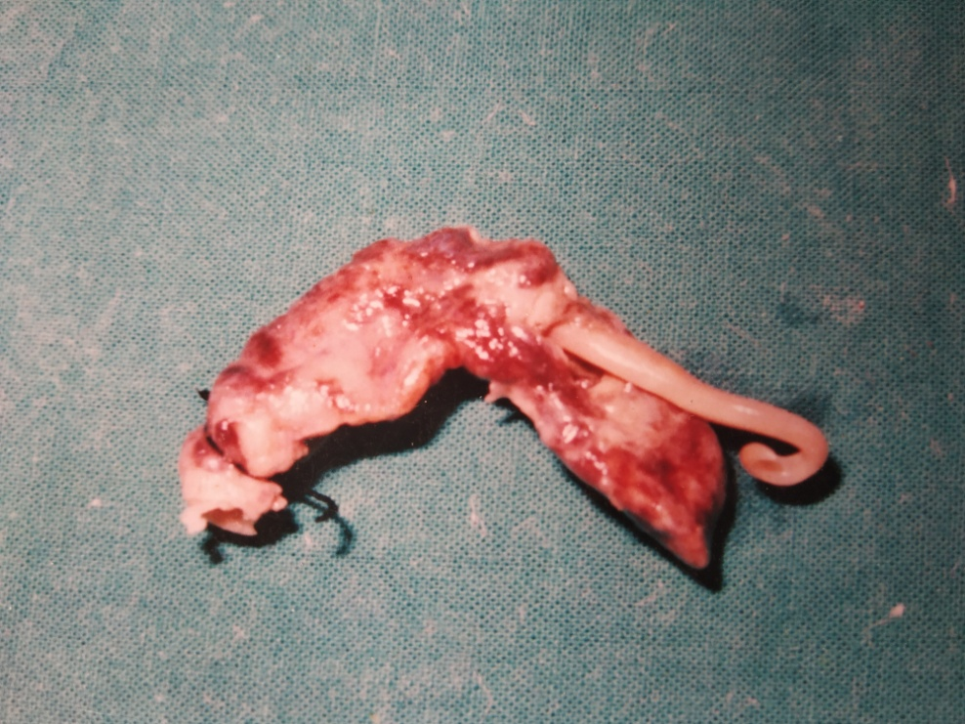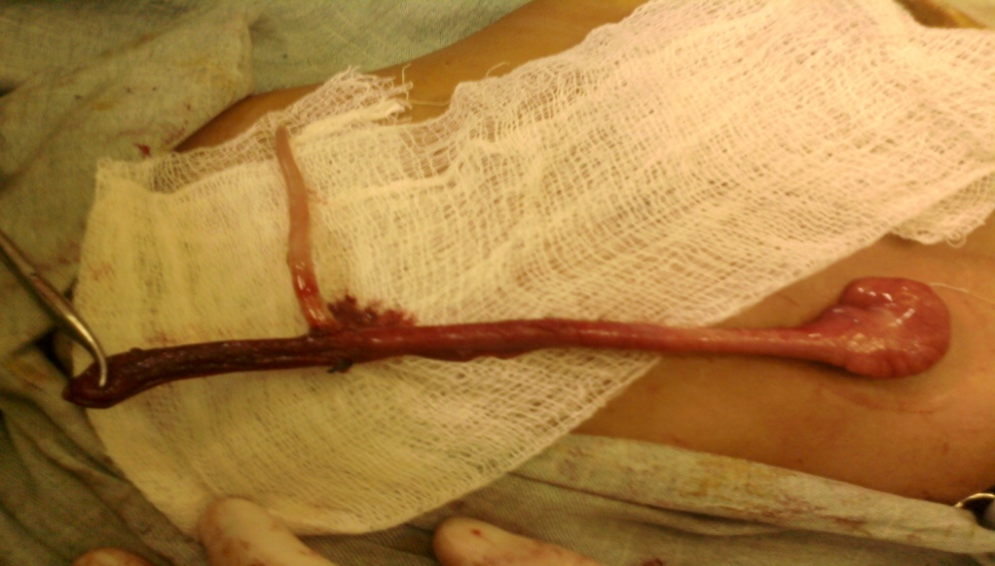
Worm in Gall bladder Entero-cutanoeus Fistula Patent Vitello intes,Duct
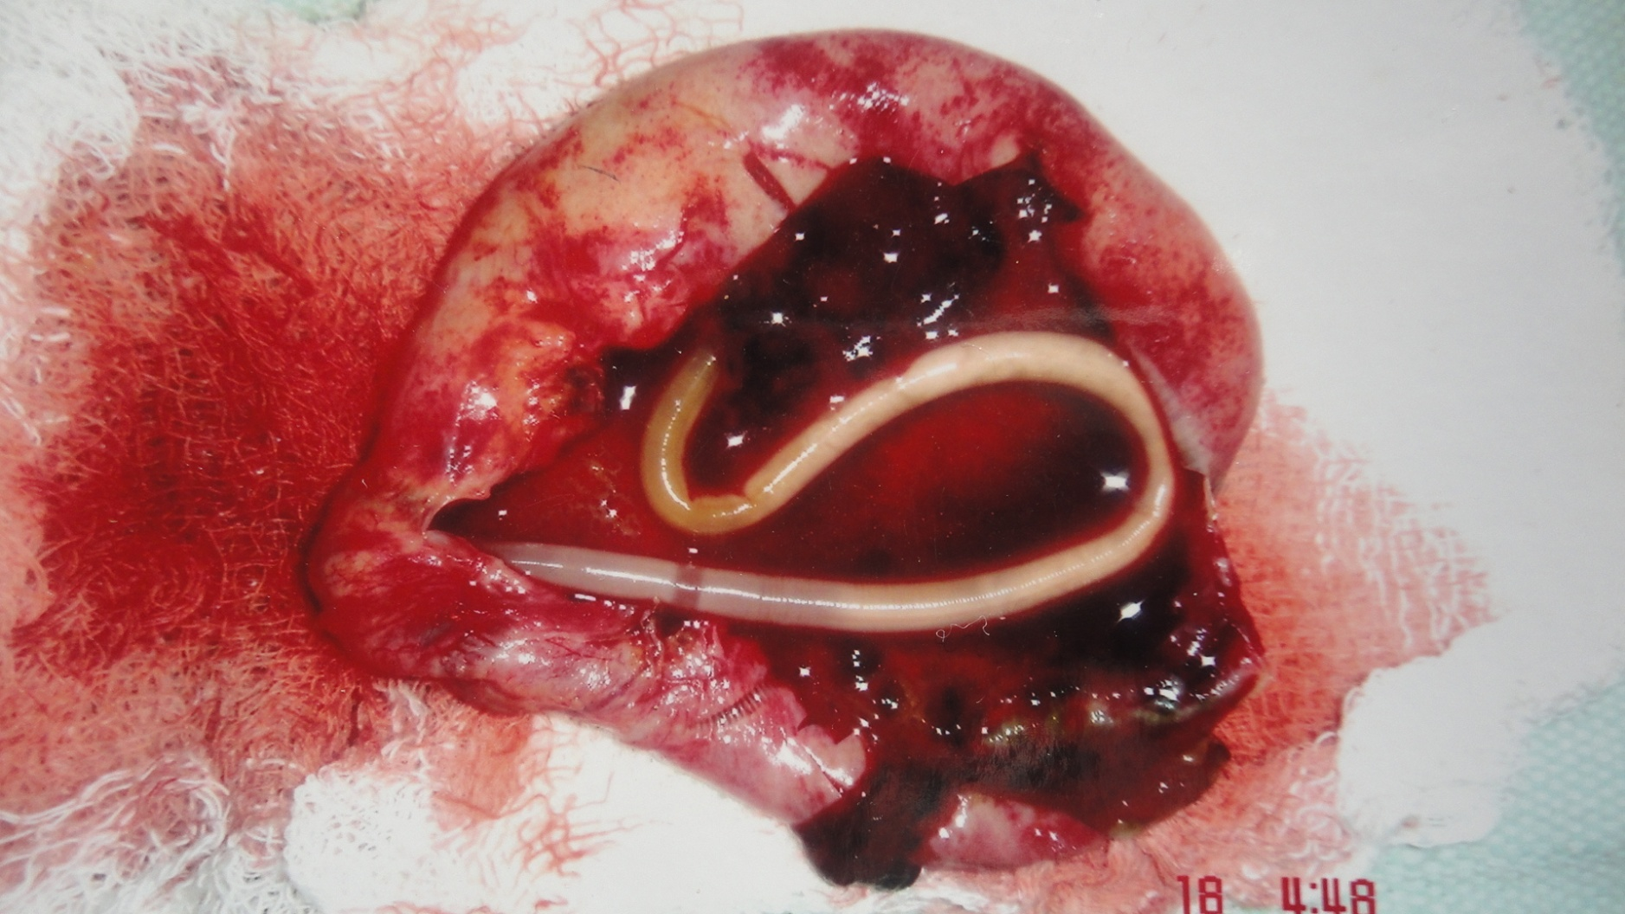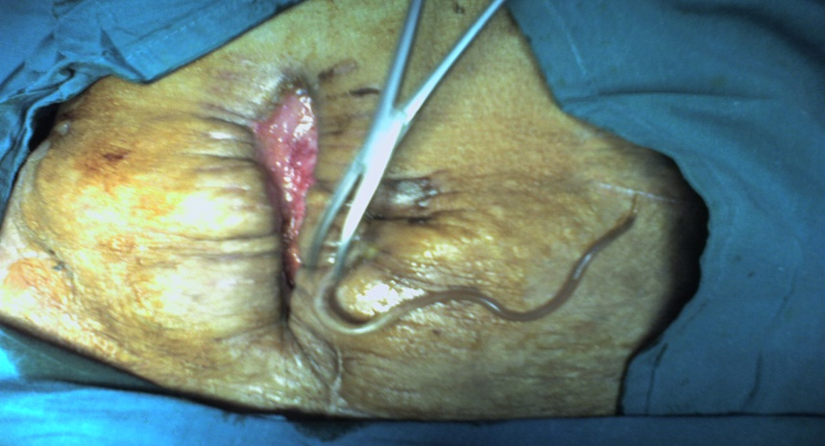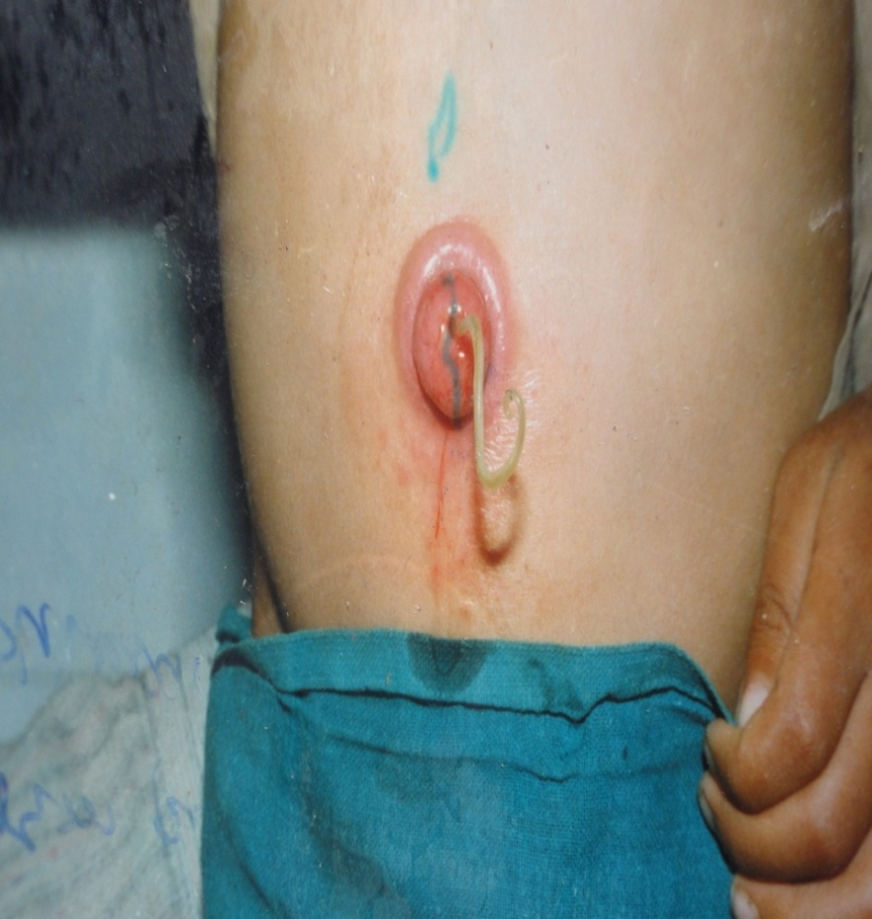
Meckles Diverticulum worm through Nose
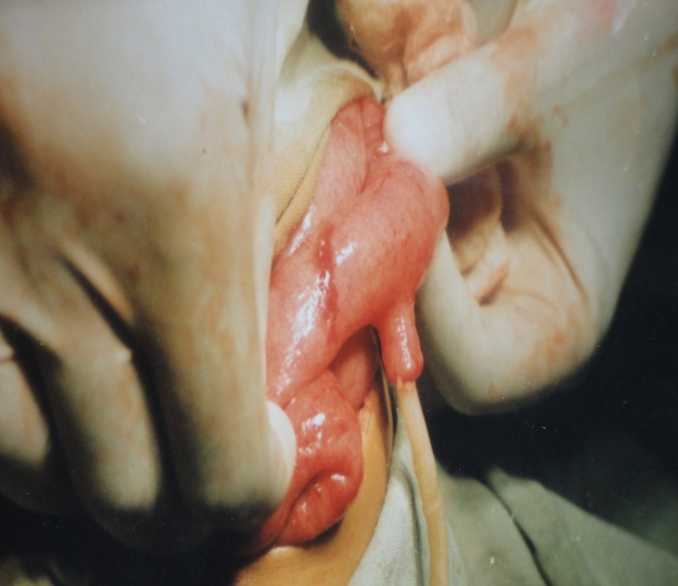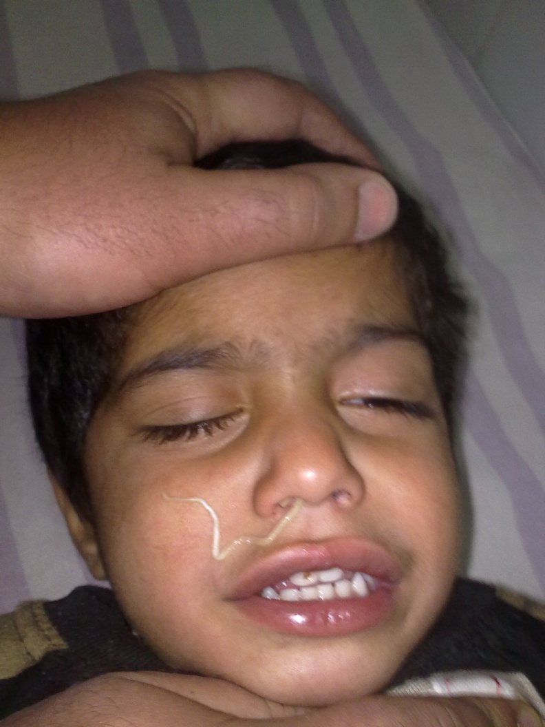
Small Gut ostruction/Gangrene due to worms
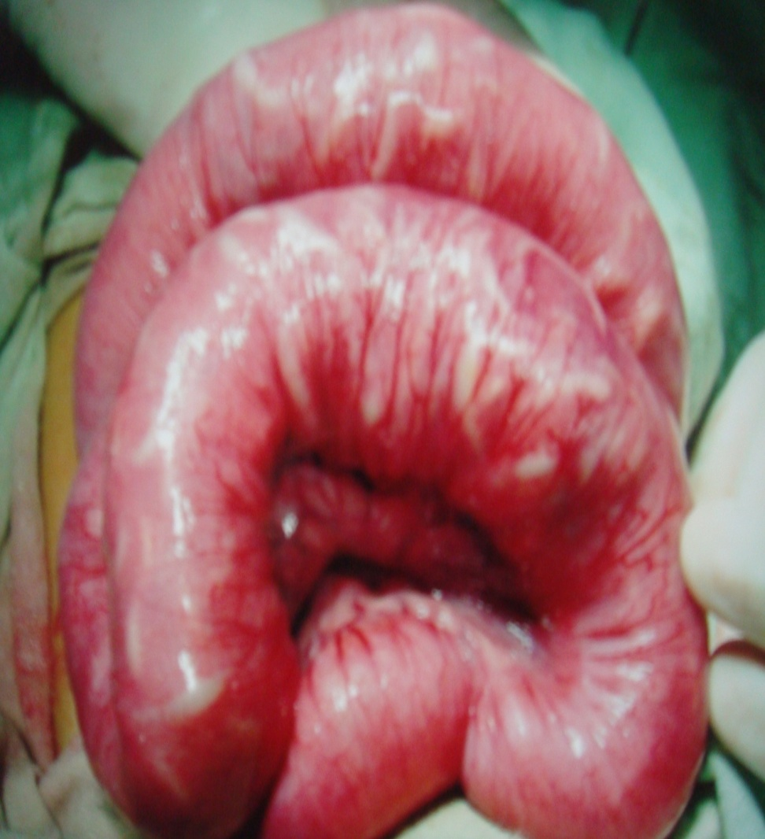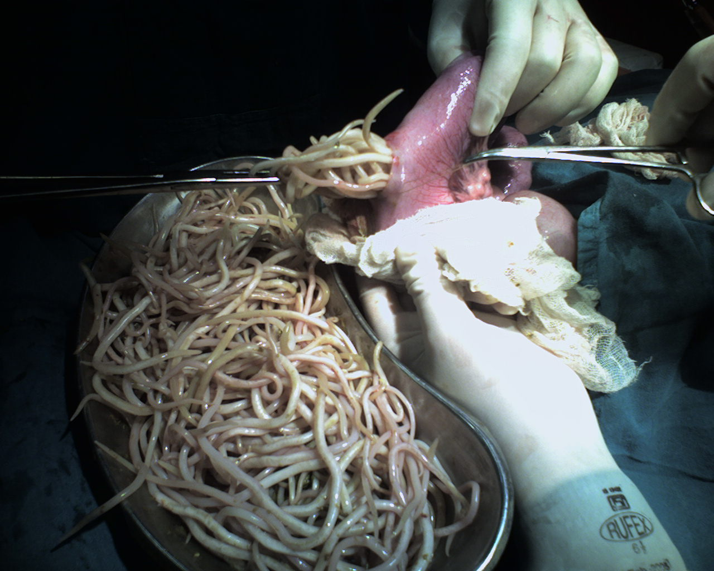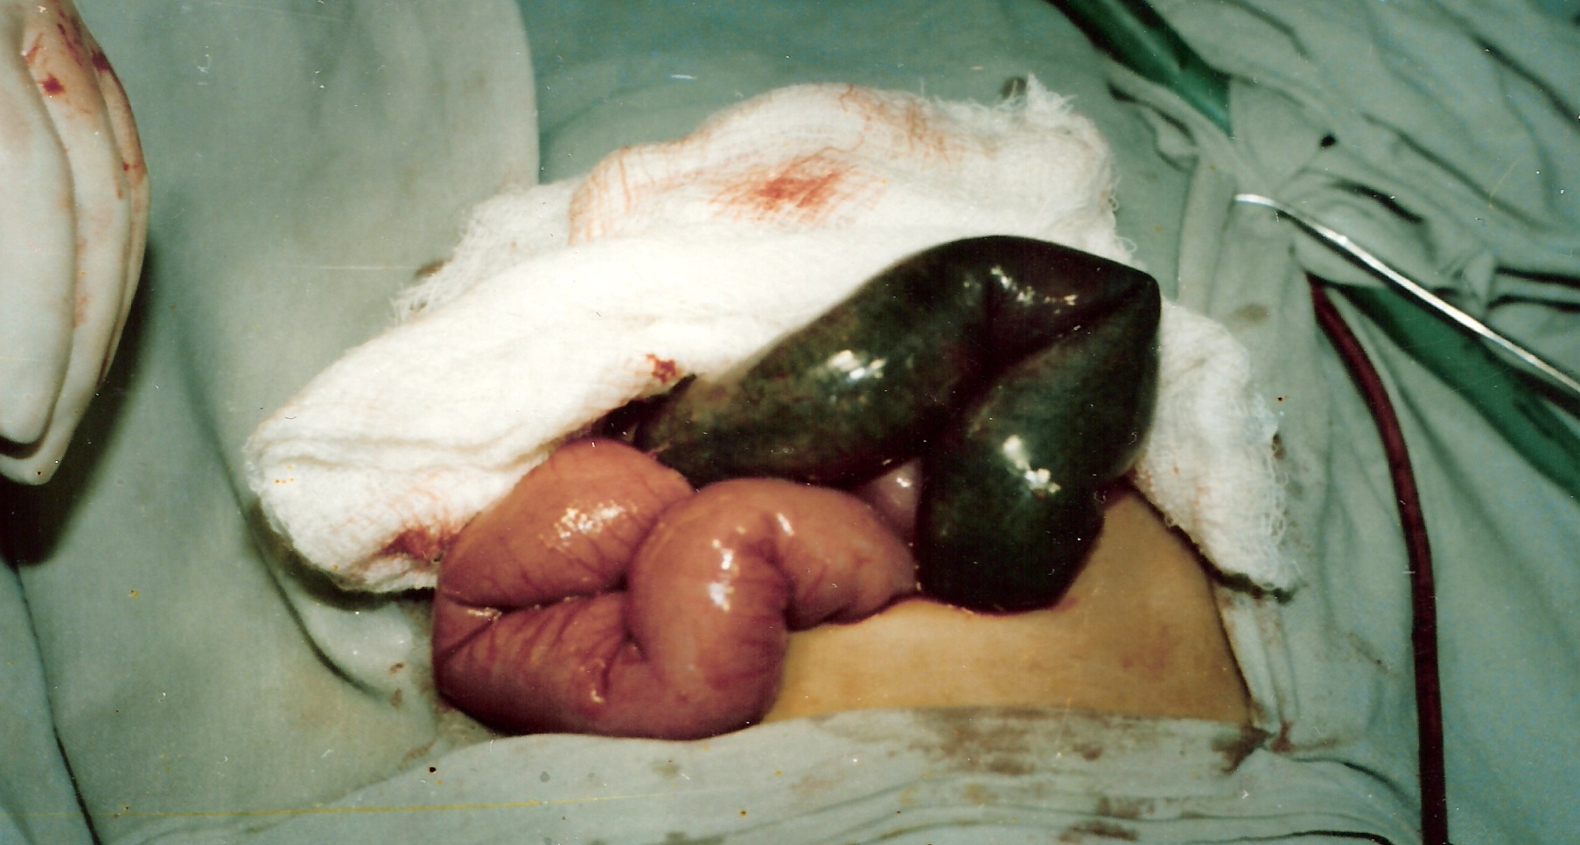

Kindly find My Citations in Following Journals:
World Journal Gastroenterology , International journal of Preventive medicine,
Turjkish Journal Of Gastroenterology, Surgical Journal Of North India.International Journal of Current surgical practice,journal of college of physicians &surgeons of pakistan 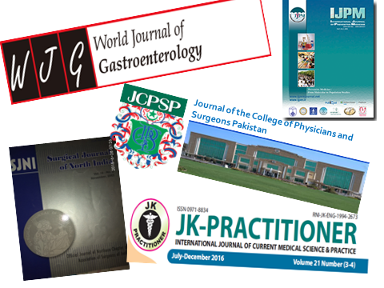 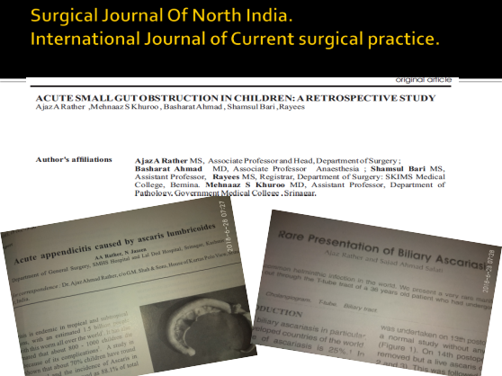

Biography
Prof. Dr AJAZ AHMAD RATHER
Prof Ajaz did his MBBS from Govt Medical college Srinagar Kashmir in 1990,did his Masters degree from same college in 2002.He joined as Faculty in Sheri-Kashmir institute of Medical Sciences (SKIMS) Medical College/ Hospital in 2016.He has been working as Head of the Department Surgery since 2013.He has been working as Professor since 2017.He has 62 publicationsin peer reviewed National / Internatinal Journals to his credit.He has presented papers in more than 42 National & International Confrences.He is member of Eight Associations and has got five Fellowships to his Credit
- Fellowships
- ,Fellow International College of Surgeons (F.I.C.S)
- Fellow Association of Colorectal Surgeons of India -(F.A.C.R.S.I)
- Fellow American college of surgeons (F.A.C.S)
- Travelling fellowship in Colo-Rectal Surgery-Birmingham UK
- Fellowship International College of Laparoscopic Surgeons (FCLS) –AIIMS
MEMBERSHIPS(8)
1)Life Member Association Surgeons of India 2)LifeMember of Indian Medical Association 3) Life m ember North-zone ASI 4)Life Member Association of Colon &Rectal Surgeons of India 5)Member International Surgical Society –Switzerland (SOCIE’T’E INTERNATIONALE DE UROLOGY) 6)Life member-Indian Doctors for peace & Development. 7) Member International Iraqi Medical Association . 8) Member Society for endoscopic & Laparoscopic Surgeons of India(SELSI)
He has contributed in two books and is a National Editorial membersof many Journals.He is an Undergraduates & post Graduate Examiner to many Colleges & Universities

