SETD7 was identified as candidate serum biomarker of colorectal cancer by mass spectrometry

Baojun Duan^{1,a}, Yan Zhang^{1,c}, Xiaofei Wang^{1,b}, Jiyu Miao^{1,b}, Xiaofan Xiong^{1,b}, Fei Wu^{1,b}, Con Han^{1,b}, Jun Bai^{1,a}, Chen Huang^{1,b}
a Department of medical oncology of Shaanxi provincial people’s hospital, Xi’an, P. R. China
b Key Laboratory of Environment and Genes Related to Diseases (Xi’an Jiaotong University), Ministry of Education of China, Xi’an, P. R. China
c Department of respiratory of Shaanxi provincial people’s hospital, Xi’an, P. R. China

Abstract (300 word limit)
Objective To screen the serum biomarker of colorectal cancer by MB-WCX and MALDI-TOF MS. Methods The serum samples of normal control (CRTL, n=36) and colorectal cancer (CRC, n=36) were collected in Shaanxi province people''s hospital between 2014-9-1 and 2016-9-1. Serum proteomic profiles of CRTL and CRC were established using MB-WCX separation followed by MALDI-TOF MS. The proteomic profiles data was analyzed with ClinProtTools software, and the different expression peptides were identified utilizing LC-ESI-MS/MS. ELISA (CRTL, n=38 and CRC, n=38) and immunohistochemistry (CRTL, n=40 and CRC, n=40) were used to validate the differently peptides in serum and tissue respectively. Bioinformatics was utilizing to analyze the relationship between different expression peptides and clinicopathology features of CRC. Results 67 m/z peaks were distinguished between CRTL and CRC, 10 peaks were significantly different (P< 0.000001). Compared with CRTL, 6 peaks were up-regulated and 4 peaks were down-regulated in CRC. 2 of the 10 peaks (m/z: 4793.25 and m/z: 2663.45) were identified as SETD7 and FGA. Moreover, SETD7 expression was significant higher in serum (P=0.000) and tissue (P=0.003) of CRC respectively. Bioinformatics showed that SETD7 expression was up-regulated in CRC (P=0.008), and was related to the size of primary tumor (P=0.019) significantly. Conclusion The proteomic profiles of CRTL and CRC were different significantly, and SETD7 is expected to be a new serum biomarker of CRC.
Recent Publications (minimum 5)
No.

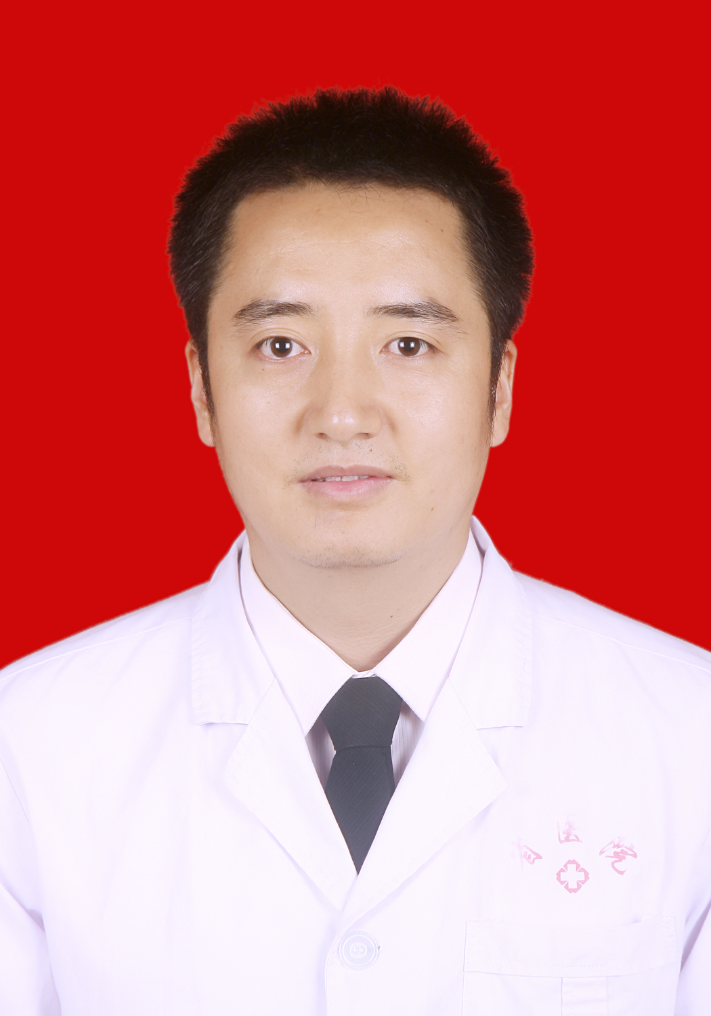Biography (150 word limit)
Baojun Duan has his expertise in medical oncology. He is mainly engaged in the comprehensive treatment of tumors. His major is colorectal cancer and proteomics.
Email:duanbaojun.cn@163.com

Notes/Comments:

