BENEFITS OF AUTOMATIC MASSAGE WITH MOWOOT ON CHRONIC CONSTIPATION
I. Herrero-Fresneda (1)(3), J. Klamburg (2), M. Benet (1), A. Calzada (1), M. Wilhelms (1). (1) USMIMA S.L., c/LLacuna 162, 08018 Barcelona, Spain; (2) Consulta médica privada, c/Gomis, 47 Ppal 1ª, 08023Barcelona; (3) Corresponding autor.

Abstract (300 word limit)
It has been demonstrated that colon-specific massage is effective against constipation (ref). This study aimed to assess the effectiveness of MOWOOT, a medical device that automatically reproduces the abdominal massage of health professionals.
Sample: 15 people (45-86yo) suffering from chronic constipation for >5years who didn’t use manual abdominal massage as treatment.
Treatment: 15 minutes of massage with MOWOOT daily at the same time for 15 days. Patients should not discontinue their usual pharmacological treatments.
Methods: Before (PRE) and after (POST) treatment patients answered validated questionnaires to quantify fecal consistency (Bristol scale) and constipation index (CCCS). During treatment, they filled out a bowel diary. Patients with anal sphincter dyssynergia and those with <50% adherence to treatment were excluded from the analysis.
Each patient served as his own control T-Student (paired values) or Mann-Whitney tests were used for quantitative or non-parametric variables. P<0.05 was considered statistically significant.
Results: No adverse effects were reported. All the people described a pleasant relaxing sensation during the massage. Two people left the study. Three were excluded due to lack of adherence. Out of 10 people who completed the treatment, two were excluded due to anal dyssynergia. The final sample analyzed was n = 8 (70.70±3.94yo). The results showed a clear increase in the average number of bowel movements per week (4.75±0.86 pre vs 6.5±1.09 post, P= 0.0062); significant improvement in fecal consistency (Bristol 3.09±0.66 pre vs 5.02±0.41 post, P= 0.0335) and halving the defecation time (8.55±1.48 pre vs 4.59±0.74 min post, P= 0.0036), resulting in a clear reduction in the constipation index (11.50±1.25 pre vs 8.25± .08 post, P= 0.0001).
Conclussions: The specific massage of colon administered automatically with MOWOOT reduces the fecal consistency, increases the frequency of evacuations, and decreases the time of deposition, improving chronic constipation in adults.

Image
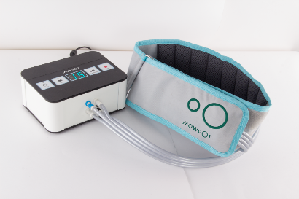
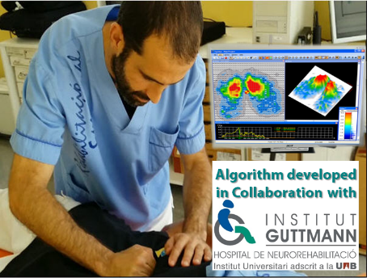
Recent Publications (minimum 5)
- Wald A, et al. The burden of constipation on quality of life: results of a multinational survey. Aliment Pharmacol Ther. 2007; 26:227-36.
- Leung L, et al. Chronic Constipation: An Evidence-Based Review. J Am Board Fam Med 2011;24:436 – 451
- Lämås K, et al. Effects of abdominal massage in management of constipation--a randomized controlled trial. Int J Nurs Stud. 2009 Jun;46(6):759-67.
- Sinclair M. The use of abdominal massage to treat chronic constipation. J Body Mov Ther. 2011;15:436-45
- Diego MA et al. Preterm infant massage elicits consistent increases in vagal activity and gastric motility that are associated with greater weight gain. Acta Paediatrica 2007; 96:1588–1591
- McClurg D, et al. Abdominal massage for the alleviation of constipation symptoms in people with multiple sclerosis: a randomized controlled feasibility study. Mult Scler. 2011 Feb;17(2):223-33.
- Herrero-Fresneda, et al. “Colon-specific automatic massage ameliorates idiopathic chronic constipation in aged women.” Eur Ger Med 2016; Supp:P-593.


Biography (150 word limit)
Dr. Immaculada Herrero-Fresneda is PhD in Biological Sciences and has wide experience in biomedical research and university teaching. She’s publicated more than 50 original articles in specialized peer-reviewed journals. She’s always wanted to let behind her a better world than that she have found. For half of her professional life she did it as Principal Investigator in experimental renal transplantation at Bellvitge Hospital, and Associate Professor of cell biology at the Univ. Barcelona. While looking for a professional change she began to assess the viability of a lot of business ideas she had always had. In the 1st edition of the d-HEALTH program of MOEBIO she met the team with whom she cofounded usMIMA and created MOWOOT. Working in MOWOOT as Chief Scientific Officer she has discovered that she can leave a better world by helping people. And she is delighted.
Email: ihf@mowoot.com

