Bi₂O₃/CuBi₂O₄ enabled photocatalytic sensor for aflatoxin detection in the environment, food, and urine
Xiao Chen, Huimin Wu, College of Chemistry & Chemical Engineeing, Hubei University, China
Zhaowei Zhang, Oil Crops Research Institute of the Chinese Academy of Agricultural Sciences, China

Abstract
Aflatoxin attracts an ever-growing concern due to its serious harm. Current detection methods lack sensitivity and anti-interference capacity. Introducing high-performance photoelectrochemical biosensors can enhance detection sensitivity and anti-interference ability. We synthesized a Bi₂O₃/CuBi₂O₄ nanomaterial and then constructed a photoelectrochemical biosensor to detect aflatoxin for the first time. The Bi₂O₃/CuBi₂O₄ nanomaterials demonstrated a high surface area and good visible light response. The sensitive biosensor for aflatoxin detection depended on the photogeneration, separation, or migration of electron-hole pairs by absorbing solar light. Using a user-controlled electrode interface, the photoelectrochemical sensor showed a wide linear range from 0.1 pg/mL to 20 ng/mL, recoveries of 99.2%-117.1% in wheat, peanut, lake water, and urine. A high agreement of detection results was recorded between this photoelectrochemical biosensor and high-performance liquid chromatography-tandem mass spectrometry. This work is envisioned to allow effective mycotoxin detection.

Image
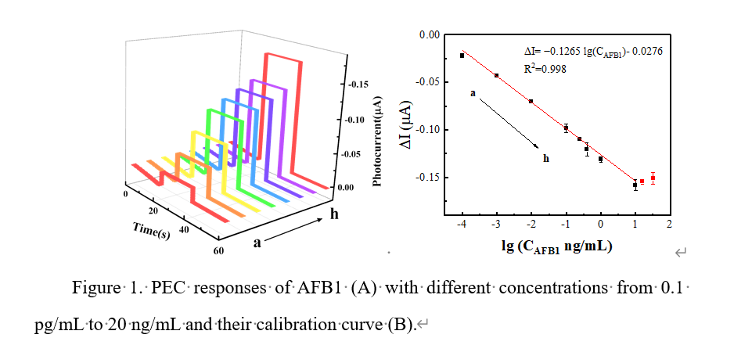
Recent Publications (minimum 5)
- Di C, Huimin W (2022) Bifunctional photoelectrochemical sensor based on Bi/Bi2S3/BiVO4 for detecting hexavalent chromium and hydrogen peroxide. Sensors and Actuators B: Chemical 353.
- Zhao T, Huimin W (2020) Simultaneous determination of heavy metals by an electrochemical method based on a nanocomposite consisting of fluorinated graphene and gold nanocage. Mikrochim Acta, 187(7): 414.
- Zhao T, Huimin W Zhaowei Z (2020) Determination of selenium in food and environmental samples using a gold nanocages/fluorinated graphene nanocomposite modified electrode. Journal of Food Composition and Analysis, 94.
- Di C, Huimin W (2021) Highly sensitive detection of chromium (VI) by photoelectrochemical sensor based on p-n heterojunction of carbon nitride-modified BiOI. Journal of Alloys and Compounds, 882.
5. Xiaoqian T, Zhaowei Z (2020) A competitive-type pressure-dependent immunosensor for highly sensitive detection of Diacetoxyscirpenol in wheat via monoclonal antibody. Analytical Chemistry, 92(5): 3563-3571.

Biography

Xiao Chen obtained her B.Sc. degree in Chemistry in 2020. Currently, she is studying for a master’s degree under the guidance of co-tutors from Hubei University and the Oil Crops Research Institute of the Chinese Academy of Agricultural Sciences. Her interest is electrochemistry sensing for food safety and environmental monitoring.
Email: chenxiao_xc@126.com

Notes/Comments:

Presenting author details
Full name: Xiao Chen
Contact number:
Twitter account:
Linked In account:
Session name/ number:
Category: (Oral presentation)

