Halloysite clay nanotubes as biocompatible multi-functional tablet compression excipient

Yuri M Lvov, Raghuvara Yendluri, Institute for Micromanufacturing, Louisiana Tech University, Ruston, USA

Abstract
Statement of the Problem: There are wide variety of nano scale materials that are being developed for drug delivery. Commercial use of some of these materials is limited by accelerated clearance and toxic side effects. We introduce natural aluminosilicate halloysite clay nanotubes as a potential pharmaceutical tablet compression filler. This abundantly available, cheap and biocompatible tubule material has outer diameter 50 ± 10 nm; inner lumen 10 - 15 nm; length of 700 ± 300 nm. A number of researchers developed HNTs as a nanovehicle for the loading of drugs with 5-10 wt. % loading efficiency and release for 5-20 hours at a sustained rate. Halloysite being a non-biodegradable material cannot be used for intraperitoneal delivery and oral (tablets, capsules) and transdermal (cosmetics) delivery is a plausible approach [1-5].
Methodology & Theoretical Orientation: We demonstrated halloysite nanoclay as a dual purpose tablet filler i.e. vehicle for drug and compression excipient. Flow and compressibility properties such as Hausner ratio, Carr’s index and brittle fracture index were determined as similar to the best industrial formulations. Nifedipine and paclitaxel were loaded at 6-8 wt. % capacity in unmodified halloysite lumen and incorporated in a 100 mg tablet formulation. Release studies were conducted in simulated gastric and intestinal fluids which allowed to employ pH 1-7 switch due to the tubes’ PMMM coating [3].
Findings: Hausner ratio, Carr’s index and BFI were 1.1, 13 and 0.08, correspondingly, and release studies demonstrated pH-switchable and sustained drugs’ release for more than 20 hours, a tenfold increase compared to commercial formulations.
Conclusion & Significance: We introduced natural aluminosilicate halloysite clay nanotubes as a pharmaceutical tablet compression and demonstrated this nanoclay as a dual purpose tablet filler i.e. vehicle for extended drug release and tablet compression excipient [2].

Image

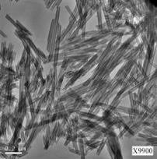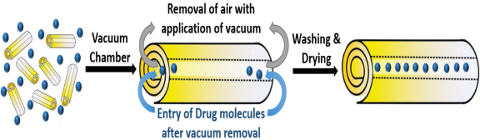

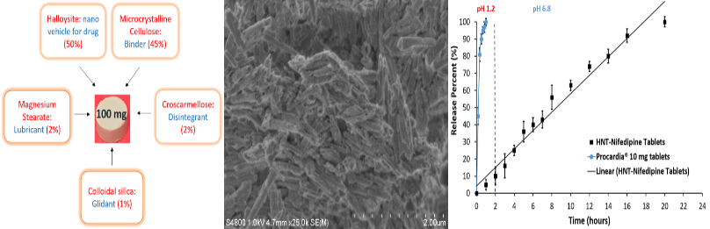
Recent Publications
1) Yendluri R, Otto D, DeVilliers M, Vinokurov V, Lvov Y. Application of halloysite clay nanotubes as a pharmaceutical excipient. International Journal of Pharmaceutics 521: 267-273.
2) Lvov Y, De Villiers M, Fakhrullin R. The potential of halloysite tubule clay in drug delivery applications. Expert Opinion in Drug Delivery 13: 977-988.
3) R. Yendluri, Y. Lvov, M. DeVilliers, V. Vinokurov, E. Naumenko , R. Fakhrullin, J. Pharm. Sci, v.106, 2017 “Paclitaxel Encapsulated in Halloysite Clay Nanotubes for Intestinal and Intracellular Delivery,” DOI: 10.1016/j.xphs.2017.05.034.
4) Vergaro V, Abdullayev E, Lvov Y, Leporatti S. Cytocompatibility and uptake of Halloysite Clay Nanotubes. Biomacromolecules 11: 820-826.
5) Fakhrullina G, Akhatova F, Lvov Y. Toxicity of halloysite clay nanotubes in vivo: a Caenorhabditis elegans study. Environmental Science Nano 2: 54-59.

 Biography
Yuri M. Lvov is a Professor of Chemistry, T. Pipes Eminent Endowed Chair on Micro and Nanosystems at Louisiana Tech University. He got Ph.D. from M.Lomonosov Moscow State University and then worked in Mainz University and Max Planck Institute for Colloids and Interfaces, Germany, in Japan (NIMS, Tsukuba), and at Naval Research Laboratory, USA. His area of interest is nanoassembly of ultrathin organized films, construction of ordered shells on tiny templates (drug nanocapsules), clay nanotubes for controlled release of chemical agents and drugs, functional organic-inorganic nanocomposites. He published 250 papers and has over 22,000 citations of his works.
Yuri M Lvov
Tel: 318-257-5144
Session Name/Number
Category: Poster presentation only
Email: ylvov@latech.edu

Notes/Comments:

Poster presentation only

