A Novel Method Development and Validation for Determination of 2,4,6-Trinitrotoluene and its Metabolites on LC-MS/MS

Muhammad Aamir¹, Sobia Irum¹, Amer Siddiq², Hafiza Monaza Batool^{1,3} (Presenter), Nisar Ahmed^{1,3}, Muhammad Hamid Awais¹, Sadiq Ali^{1,3}.

¹Department of Chemical Pathology and Endocrinology, Armed Forces Institute of Pathology, Rawalpindi, Pakistan.
²Watim Medical & Dental College Rawalpindi
³Forensic Toxicology Department, Armed Forces Institute of Pathology, Rawalpindi, Pakistan

Abstract
LC-MS/MS has recently emerged as the best practice for simultaneous analysis of 2, 4, 6 Trinitrotoluene (TNT) and its metabolites. We have developed and validated an LC-MS/MS method for simultaneous quantification of 2, 4, 6 Trinitrotoluene (TNT) and its metabolites 4-ADNT, 2-ADNT, 2,4-DNT, and 2,6-DNT in urine samples. These four metabolites were acid hydrolyzed using 1mL of urine followed by extraction using n-Hexane and ethyl acetate as an extracting solvent. Separation was achieved by centrifugation, and the supernatant was dried under nitrogen, reconstituted with water and acetonitrile, and then filtered. Chromatographic separation was achieved on Agilent Poroshel 120 EC-C18 column (2.1mm × 75mm × 2.7 µm) utilizing two mobile phases 0.1% formic acid in water and 0.1% formic acid in acetonitrile in gradient flow. The validated AMR of TNT and its metabolites was 7.8-1000 ng/mL. The method showed an excellent correlation (> 0.99) for TNT and its metabolites. Accuracy and within/between day precision of TNT and its metabolites were within ±15%. The integrity of diluted samples was maintained for each dilution factor. The method was found stable after storage and freeze-thaw cycle. The presented method can be used for TNT screening in occupationally exposed ordnance factory workers.
Keywords: Liquid Chromatography-Mass Spectrometry Mass Spectrometry (LC/MS/MS), Trinitrotoluene (TNT), Lower Limit of Quantitation (LLOQ), Method development, Validation

Image:
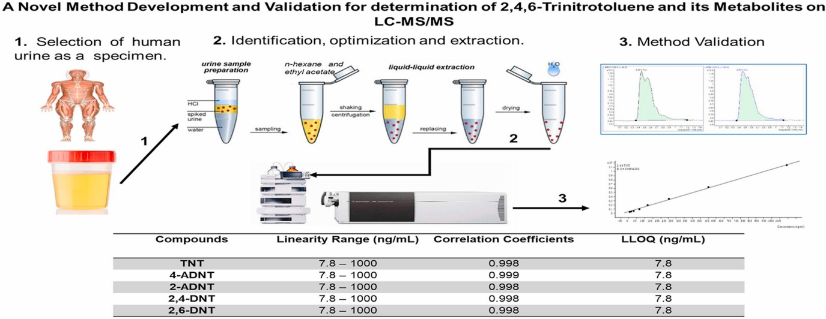
Biography.
Muhammad Aamir has presented this method for TNT screening in occupationally exposed ordnance factory workers. In third-world countries like Pakistan, this issue has never been highlighted, nor is any detection facility available yet. Hence, a study was conducted to develop and validate a sensitive and specific LC/MS/MS method for the simultaneous quantitative determination of TNT and its four important metabolites, 4-ADNT, 2-ADNT, 2,4-DNT, and 2,6-DNT, for effective detection in urine samples.

Presenting author details
Full name: Hafiza Monaza Batool (monazabatool786@gmail.com)
Contact number: +923005413073
Twitter account:
Linked In account:
Session name/ number: https://www.linkedin.com/in/monaza-batool-2b0498131
Category: Oral presentation

