EFFECT OF SALICYLIC ACID ON CONTROL OF POSTHARVEST DISEASE (BOTRYTIS CINEREA) OF TOMATO FRUITS
By
Nasiru Yahaya Ahmed, Sani Isa Abubakar and Mohammed Abubakar Clarkson
Department of Agricultural Technology, School of Engineering Technology
Federal Polytechnic P.M.B 05 Bali, Taraba State Nigeria
Email: nasiryahyahmed@yahoo.com
Phone No: +2347035055015, +2348028073440

Abstract
This study systematically reviews that Salicylic acid enhanced stress tolerance, maintains firmness and reduced decay in tomato fruit. The fruits were wounded and treated with SA at low concentrations (0.2, 0.5 and 1.0 mM SA) and high concentrations (10, 20 and 30 mM SA), whilst the sterilized fruits with 10% ethanol solutions were included as control in the experiment. The fruits were inoculated with Botrytis Cinerea spores 10 minutes after the treatments and incubated at 10$℃±$1$℃$ and 85 – 90% relative humidity for 17 days in every succession. The result revealed that treatments with high concentrations of SA have the greater inhibition effect of Botrytis cinerea on the tomato fruits. While the low concentration treatments resulted to a marginal inhibition effect and shows no much significant difference with the control (Appendix I). Statistically significant (p<0.05) minimum lesion diameter was observed on fruits treated with 20 and 30mM SA as compared to 10 mM SA. The mixed Anova result has shown there is a significant effect of SA concentration on lesion diameter. Similarly there is significant effect of time on lesion diameter, the interaction between time and SA concentration is also significant. Finally, postharvest treatment with SA and increase in concentrations has enormous potential use as an alternative to chemical fungicides in inhibiting postharvest decay on tomato fruits and possibly prolong the shelf life. Thus, the findings have significant contribution to reduce economic postharvest losses of perishable fruit and evidence to researchers.
Key words
Botrytis Cinerea, Salicylic Acid, Tomato fruits, Postharvest treatment.

Introduction
Pre-harvest and post-harvest disease, improper post-harvest handling and other conditions are some of the factors that highly affect the quality and nutritional value of the fresh tomato fruits (Rees et al. 2012; Etebe et al. 2013). Other principal causes of post-harvest losses and poor quality include bruising, over-ripening at harvest, water losses, chilling injury, compositional changes, and decay (Kadar and Kitinoja 2003). Post-harvest losses in tomato is also influenced by some common factors such as; lack of appropriate production techniques in the farming system (selection of variety with short shelf life, poor control measure for insect pest and disease infestation); poor application of the recommended treatments; inadequate maturity, sub-optimal harvesting; bulk packaging without cleaning, sorting and grading; poor storage facilities and method; bad transportation system; distance and time of the distribution to reach the final consumers (Rees et al. 2012; Agrios 2005).
Tomatoes are highly perishable commodity with short shelf-life and vulnerable to fungal infection attributes to their low pH, high moisture content and nutrient composition, thus, affecting its quality and nutritional value by decaying and make the fruit unfit for consumption by producing mycotoxin (Marin et al. 2013). The world post-harvest losses of the fresh fruits were estimated between 30 – 40% by Agrios (2005) and 25 – 40% by Yang et al. (2013). The losses are mainly caused by mechanical, physical and chilling injuries, and decay due to fungal and bacterial attack during handling, storage and transportation (Yang et. al., 2013). The crop is growing rapidly with a growing period of 90 – 150 days. The most favourable Daily average growth temperature is between 19 – 25°C with night temperature between 10 – 25°C. The crop is very sensitive to frost and high temperature. Pest and diseases attack as well as fruit rotting are associated with high humidity (FAO 2013).
Grey Mould caused by Botrytis cinerea is a common and often serious fungal post-harvest disease of tomato plant. The pathogen is an excellent saprophyte which grows on an extensive host range with a typical diagnostic fuzzy grey coloured mould on the lesion surface. The lesion may occur anywhere on the fruits, including the stem-end and the blossom-end., also manifestation of dead brown patches on the leaves, stems and buds, white or pale brown spots on the petals and fruit, and rotting on an unplanted bulb. It’s survived on plant debris and soil, and can be spread by wind; it usually requires a wound or dead tissue to begin its infection (Snowdon 1991; Bartz et al. 2002). Cold and high humid conditions favour the development of grey mould (Rees et al. 2012); others are low calcium or poor-limed soil, chilling and physical injuries, and storage temperature (Snowdon 1991). Infection occurs at an optimum temperature between 18° and 24°C, with high relative humidity for the production of prolific spore’s, while temperature above 28°C suppress the growth and spore production (Bartz et al. 2002; Yang et al. 2013).
Salicylic acid (SA) is as an endogenous plant growth regulator which generate a wide range of metabolic and physiological responses in plants, its regulate stress responses and plant development process such as disease resistance. It’s also induced plant defence against biotic and abiotic stress and enhances chilling tolerance (Asgharia and Aghdam 2010). SA treatment of the harvested tomato fruit trigger the defence gene which contributes in reducing decay incidence and lessen chilling injury (Loon et al. 2006). The SA are important phytohormones that responses to abiotic and biotic stress and pathogenesis in plants. In sufficient concentration SA may cause temporary low level of oxidative stress in plant and acts as a hardening process, improving the antioxidative capacity of the plant and help to induce the synthesis of protective compound like polyamines (Loon et al. 2006).
Materials and methods

The Fruits material sterilization
The matured tomatoes were obtained from market with a supplier quality assurance that certifies maximum product safety and quality such as free from defect, contamination, decay symptoms or any other disorders. The fruits were selected based on firmness, uniform size, shape and the absence of any visual defect. The fruits were grouped into 3 replicates of 15 samples per replicate for each treatment and sixty (60) samples for each experiment and surface sterilized with 70% ethanol solution prior to the mechanical wounding. 500ml of 70% ethanol solution was prepared by adding 150ml of dH₂O to 350ml of pure ethanol.

Treatments solution
The fruits epidermis were mechanically cut on the equator with sterilized 6mm diameter Cork borer and disposable scalpel was used to remove the epidermis. The treatment solutions were prepared using a range of concentrations of SA (0.2 – 30 mM). The solutions were prepared by dissolving the pure SA in 10% ethanol solution and add dH₂O. Based on this experiment, 500ml solutions were prepared for all the different concentrations with 50ml pure ethanol plus 450ml of dH₂O.The different concentrations of SA solution prepared were 0.2 mM with 0.013812g/500ml, 0.5 mM with 0.03453g/500ml, 1.0 mM with 0.06906g/500ml, 10 mM with 0.6906g/500ml and 30 mM with 2.07189g/500ml. The prepared treatment solution was dispensed on the wounded tomato samples using a 200µL pipette and 200µL disposable pipette tip. Experiments 1 comprises 0.2, 0.5 and 1.0 mM SA treatment, while Experiment 2 comprises 10, 20 and 30 mM SA treatment both with 10% ethanol as control.

Fungal pathogen inoculation
Botrytis cinerea the causal agent of grey mould was cultured on potato dextrose agar (PDA) in the microbiological laboratory. The media was prepared by suspending 39 g of the PDA powder in a litter of dH₂O, dissolving the agar in a microwave with intermediate agitation at intervals of 30 second for the medium to dissolved completely. The bottles of media were sterilised by autoclaving at 121°C for 15 minutes, dispensing the medium in a petri dishes once the media had cooled to 55°C incubating the plates at 25°C in an inverted position (ager side up) with increased humidity, and finally the cultures were examined at four (4) days of incubation for fungal growth. Botrytis cinerea was inoculated onto freshly treated wounds 10 minutes after using a disposable inoculation loop. The fruits were arranged in a plastic punnet with a wet paper towel underneath and wrapped in a cling film to support the rise of humidity at approximately 95 –100%, and incubated at 10°C for 17 days.
Statistical analysis
Data generated from laboratory analysis were analysed by comparing the 7 treatments analytically using descriptive statistics. ANOVA was performed using the SPSS software package to determine the least significant difference (LSD) among treatment at p < 0.05.
Results and Discussion
Result
From figure 1 the results of the experiment using low concentrations treatments (0.2, 0.5 and 1.0 mM SA) indicate spreads of disease on lesion diameter of the treated fruits obviously after 3-5 days of inoculation. 0.5 and 1.0 mM SA nearly have same lesion diameter, but by day 10 and thereafter infection rates among treatments and control were almost similar.

Figure 1 Effect of different treatment with low concentrations of SA
The Figure 2 below shows that the prevalence of Botrytis cinerea is much less with 20 and 30 mM SA treatment compared with 10 mM SA treatment. However, treatment with 10 mM SA is better than the control. Thus, increase in SA concentrations during treatments significantly inhibited the incidence of the disease.

Figure 2 Effect of different treatment with high concentrations of SA
Discussion
The effect of fungal pathogen on fruits like tomato generally starts as a result of wound infection or latent infection generated during cultivation practices (Wang et al. 2010). The results from this experiment indicated that treatment with increase in concentrations of SA prove to be the successful strategy to inhibit post-harvest decay on cherry tomatoes under post-harvest storage conditions. This result revealed that treatments with higher concentrations are more effective than treatment with lower concentrations. However, the 20 and 30 mM SA treatment considered to be the most effective treatment compared with neither the 10 mM SA nor the low concentrations treatment. The efficiency of 20 and 30 mM SA treatment significantly inhibited the effect of Botrytis cinerea on lesion size of the fruits (Figure 2). These results are in line with Loon et al. 2006; Asgharia and Aghdam 2010; Yang et al. 2013, reported that application of SA treatment on the harvested tomato fruit trigger the host-plant defence gene which contributes in reducing decay incidence and lessen chilling injury. Similarly, in controlling post-harvest losses of horticultural crops like tomato, SA has been recognised as a natural and safe phenolic compound that exhibited a high potential in reducing disease spread (Asgharia and Aghdam 2010). Hence, post-harvest application of SA has a significant effect on enhancing the shelf life of tomato fruits and other horticultural crops like pears, apple and peaches by maintaining their firmness, preventing background colour loss and quality during storage and marketing. (El – Ramdy et al. 2015). It was also observed that the fruit treated with high concentrations of SA maintain their colours and remain firm even at d₁₇ of incubation, this is due to SA efficacy which enhanced the immune response and maintained the firmness of the fruits. As reported by Li et al. (2012) that SA is an important hormone that plays a major role in plant defence responses.
Conclusions and Recommendations

Conclusions
The result of the study indicates that the high concentration treatment with 20 and 30 mM SA proved the most effective treatment that inhibit the prevalence of Botrytis cinerea development on wounded tomato fruits (Appendix 1). The treatments significantly enhanced pathogen resistance in the inoculated fruits, also the fruits remain firm and retain background colour at the 17 days (d₁₇) of the treatments. However, treatment with 10 mM SA reduce decay incidence on the inoculated fruits. The of low concentrations treatment (0.2, 0.5 and 1.0) mM SA show limited effect against Botrytis cinerea infection, indicating insignificant difference with the control. Thus, the effectiveness of tomato fruit treatments against Botrytis cinerea infection is often dose related as this study signifies that increase in SA concentrations could improve the control of the disease spread. Therefore, pre-harvest application of these treatment has the potentials of controlling decay incidence, extends shelf-life and decrease excessive deterioration during packing, storage and transportation.

Recommendations
It is recommended for tomato producers to investigate further the use of SA, which is an organic acid and function as a plant hormone, also as an alternative method to minimise the substantial economic loss caused by pathogenic organisms and its high perishability attribute. Therefore, to achieve effective treatment, with minimal loss and excellent pathogen inhibition, it is essential to maintain uniformity during the application of the treatments.
The low concentrations treatment shows no much difference with the control, therefore, in the absence of any chemical treatment as an alternative method, the tomatoes can be stored in modern storage systems like controlled atmosphere storage (CA) which monitor and adjust the CO₂ and O₂ levels continuously, either within a gas tight store or container.
Further study is essential on perishable commodity using and integrated method of SA with other hormone like MeJa, CaCl₂ in different concentrations and linked the technology with the entrepreneur concept for the benefit of consumers and producers.

APPENDICE I

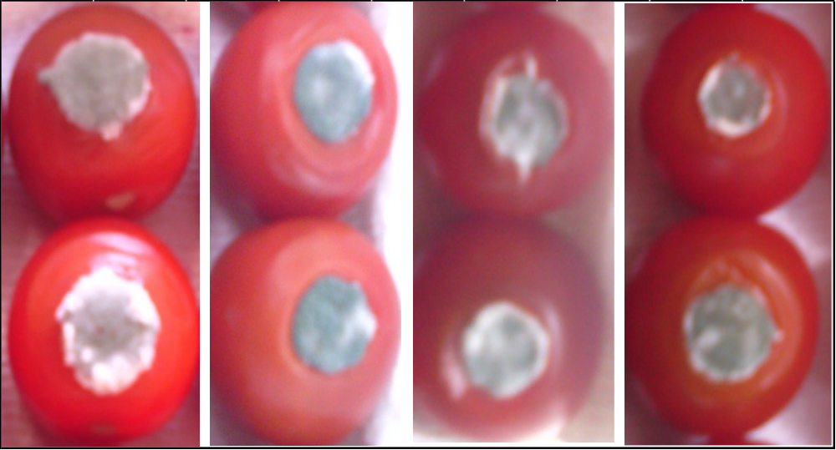
(d)
(c)
(b)
(a)
Plate 1: Shows the inoculated tomato samples with (a) Control, (b) 0.2 mM SA (c) 0.5 mM SA and (d) 1.0 mM SA treatments.
Source: The Author
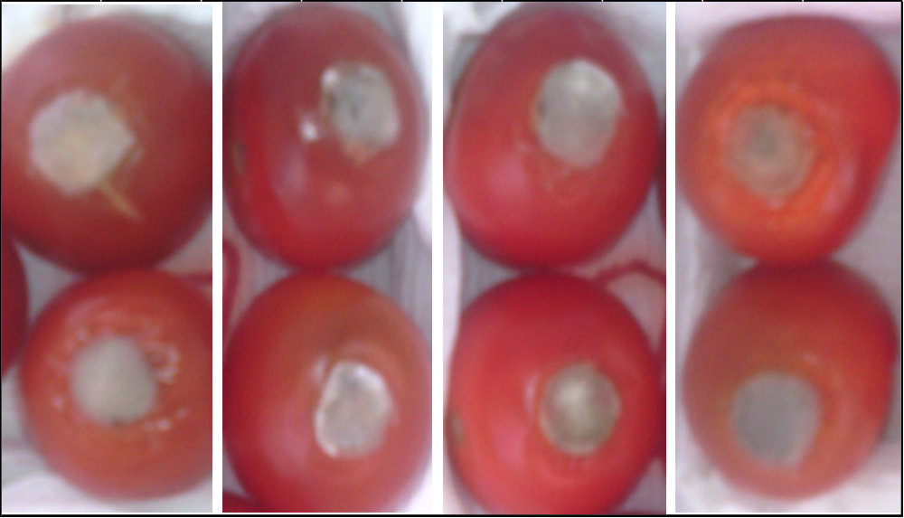
(d)
(c)
(b)
(a)
Plate 2: Shows the inoculated tomato samples with (a) Control, (b) 10 mM SA, (c) 20 mM SA and (d) 30 mM SA treatments.
Source: The Author

REFERENCES
Agrios, G.N. (2005). Plant pathology, Elsevier Academic press, 5th Edition pp8-54 New York, USA. (http://www.dbbe.fcen.uba.ar/contenido/objetos/Agrios2005PARTEI.pdf)
Asghari, M. and Aghdam, M. S. (2010), Impact of Salicylic acid on post-harvest physiology of horticultural crops, Journal of food science of Technology Review – 21, 502-509
Bartz, J., Mahovic, M. and Sargent, S. A. (2004) Guide to identifying and controlling postharvest tomato diseases in Florida, Universidad de Florida IFAS Bulletin HS866. (http://edis.ifas.ufl.edu/pdffiles/HS/HS13100.pdf).
El-Ramady, H. R., Abdalla, N. A., Taha, H. S. and Fari, M. (2015) Postharvest Management of Fruits and Vegs. Storage in Sustainable Agric Reviews Springer, 65-152.
Etebu, E., Nwauzoma, A. and Bawo, D. (2013) Postharvest Spoilage of Tomato and Control Strategies in Nigeria, Journal of Biology, Agriculture and Healthcare, 3(10), 51-61.
FAO (2013) Crop water information: Tomato, Water development & management unit. (http://www.fao.org/nr/water/cropinfo_tomato.html).
Kader, A. A. and Kitinoja, L. and (2002) Small-scale postharvest handling practices: a manual for horticultural crops, UC, Davis, PT. Research and Information Centre.
Li, L., Li, T., Xu, T., Qi, M., Yu, Z. and Zhang, K. (2012) Role of calcium in tomato (Lycopersiconesculentum Mill.) resistance to Botrytis cinerea, African Journal of Biotechnology, Pretoria, 11(37), 9013-9022
Loon, L. C., Geraats, B. P. and Linthorst, H. J. (2006) Ethylene as a modulator of disease resistance in plants, Trends in plant science, 11(4), 184-191.
Marin, S., Ramos, A., Cano-Sancho, G. and Sanchis, V. (2013) Mycotoxins: occurrence, toxicology, and exposure assessment, Food and Chemical Toxicology, 60, 218-237.
Rees, D. (2012) Crop Post-Harvest: Science and Technology, Perishables. G. Farrell and J. Orchard. pp. 5-17. John Wiley and Sons
Snowdown, A. L. (1991). A colour atlas of post-harvest diseases and disorders: Vegetable Vol 2, pp. 25-78. Manson Publishing Ltd
Wang, Y., Ren, X., Song, X., Yu, T., Lu, H., Wang, P., Wang, J. and Zheng, X. (2010) Control of postharvest decay on cherry tomatoes by marine yeast Rhodosporidium paludigenum and calcium chloride, Journal of applied microbiology, 109(2), 651-656.
Yang, T., Peng, H., Whitaker D. B. and Jurick, M. W., (2013), Differential expression of calcium/calmodulin – regulated SISRs in response to abiotic and biotic stresses in tomato fruit. International journal for plant Biology 148, 445-455.

