Food safety and quality: Day to Day Challenges and Prevention
Rishov Sircar², S.H.U.A.T.S, Allahabad, India Aditya lal¹, S.H.U.A.T.S, Allahabad, India Sujeet Upadhyay³ S.H.U.A.T.S, Allahabad, India

Abstract
From last few decades, it has been a growing recognition and involvement of public health issue. Now a days, foodborne disease are as famous as a celebrity, new generation foods, improper food preparation, storage, emerging pathogens and distribution practices but can be prevented by adopting food handling practice. Many factor which indicate the increasing of foodborne disease globally. There are many factors which outbreak the foodborne illness at home, which includes raw food supply that is frequently contaminated, Insufficient training of retail employees, an increasing global supply and due to lack of awareness regarding food safety and contamination in general public, mistake of food handling and prevention at home deliberate consumption of raw and undercooked foods, often described as 'risky eating behavior. Raw foods, which including meat, eggs, fish, and fruits and vegetables, should all be considered as entry sources of foodborne pathogens into the home. Infectious agents which comes inside the home via food includes, species of Salmonella, Camylobacter, Listeria and E coli O157.
In the present scenario, we are facing many different challenges, and in view of this we require a global solution. One of the challenges is the spread of infectious diseases that emerge between animals, humans and the surroundings in which they live. Foodborne disease will continue to be the major concern in the world wide but the objective is to minimize the global impact of diseases is to control of food-borne diseases which starts at home itself by sanitizing the equipments and work place for preparing food, pest control, sanitization process and CIP (Clean in process) at restaurants and food industries, creating awareness in public, how to make the food safe or to avoid it completely, or advice consumers to throw away the suspect food from their pantry or refrigerator.

Image
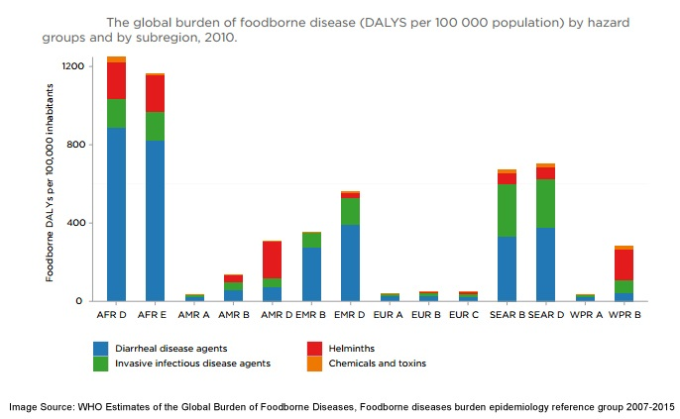
Recent Publications
- Sonam Chaurasia Aditya Lal (2016) Development of biodegradable packaging films using potato starch.
- D Ade Kuldip, Aditya Lal (2015) Development and quality evaluation of pineapple pomace and wheat bran fortified biscuit
- R. N. Shukla Virendra Parmar, Aditya Lal (2015) Mathematical Modelling Of Mass Transfer During Osmotic Dehydration Of Bitter Gourd Slices In Binary Solution
- Aditya Lal¹ Rishov Sircar³ (2017/on process) Development And Value Addition Of Food Products By Finger Millet (Eleusine Coracana L.) To Fight The Nutritional Challenge
- Aditya Lal Rishov Sircar (2017/on process )Food By-Product Utilization to Develop Functional Food Products
- Sushant Chandra , Rishov Sircar (GIS and RS an Emerging technology for Food Safey and Crop Production. Nov. 2017 till present.

  Biography
Rishov Sircar, is from New Delhi in country India, Pursuing his degree in B.tech Food Technology at Sam Higginbotttom University of Agriculture Technology and Sciences Allahabad, India. An internal auditor of FSMS 22000/2005. Vice President of Society of Food Engineers, he was the part of Organizing committee to
organize several Invited talks, one-day seminar, an international workshop in the area of Food Processing and Technology., Currently, he is working on few researches

Er. Aditya Lal , working in the capacity of Assistant Professor at Sam Higginbottom University of Agriculture Technology And Sciences Allahabad, India. Specialized in Food Engg. And bioprocess technology.

Sujeet Upadhayay of B.tech Food Technology at Sam Higginbotttom University of Agriculture Technology and Sciences Allahabad, India, he was the part of Organizing committee to organize several Invited talks, one-day seminar, an international workshop in the area of Food Processing and Technology
Email: rsircar2402@hotmail.com

Notes/Comments:

Rishov Sircar² currently not having any publication but in the process and will take time, so gave my last two abstract presented in international conferences, Aditya Lal is having Several publication which is mentioned.

