CHARACTERIZATION AND
ENCAPSULATION OF PROBIOTIC
LACTOBACILLUS CELLS ISOLATED FROM
FERMENTED CURD AND EVALUATION OF
THEIR SURVIVAL UNDER SIMULATED GASTRO INTESTINAL CONDITIONS”
Anil Kumar, V., Saisankar, M., Jyothi, P., Sameera, B. Sk.,

ABSTRACT

Probiotic lactic acid bacteria are health promoters and have traditionally consumed without the knowledge that they have beneficial properties. These bacteria mainly involve in secreting antimicrobials, enhance immune modulatory effects and preserve the intestinal epithelial barrier by competitively inhibiting the pathogenic organisms. The aim of this study was to investigate the in-vitro probiotic properties of lactic acid bacteria isolated from fermented curd and to encapsulate them by using sodium alginate along with addition of whey protein and to study their survival rate under simulated gastric and intestinal conditions subjected to different times.
The fermented curd sample was serially diluted using pure culture techniques using sterile 0.1% peptone water as diluent and 1 mL of sample was inoculated on to the sterile MRS agar plates and incubated at 37⁰ C. Then pure culture was obtained through sub culturing on MRA agar plates. Based on the morphological and biochemical characterization of these pure cultures can be identified and confirmed as Lactobacillus sps.
These isolates were utilised for further in vitro studies to prove their probiotic efficacy. The isolate exhibited strong tolerance towards bile salts (survival >53.65 to 80.71 % at 0.3% bile salts w/v), acidic pH , antibiotic susceptibility test and antibacterial activity against Staphylococcus aureus were evaluated. Further encapsulation of Lactobacillus sps can be done with the addition of 0.1% whey powder along with alginate (0.5, 1.0, 1.5 and 2.0%) was used as hydrogel matrix. These encapsulated beads were studied for the protective effects on probiotic bacteria under simulated gastrointestinal conditions. On the other hand SEM analysis of both encapsulated probiotic beads and free capsules without probiotic cells reveals the internal structures of the capsules and also showed that the protective nature of protein-polysaccharide material between the probiotics under the harsh environment.
Keywords: Probiotic, lactic acid bacteria, encapsulation, sodium alginate, whey protein.

Related Image If Any
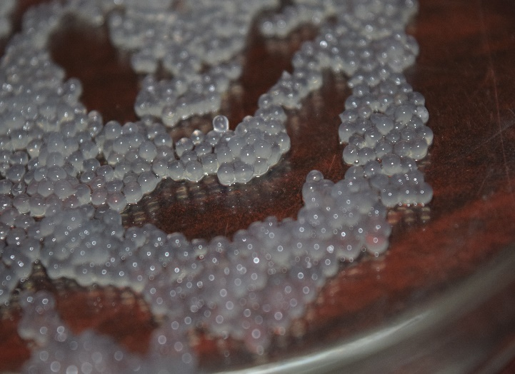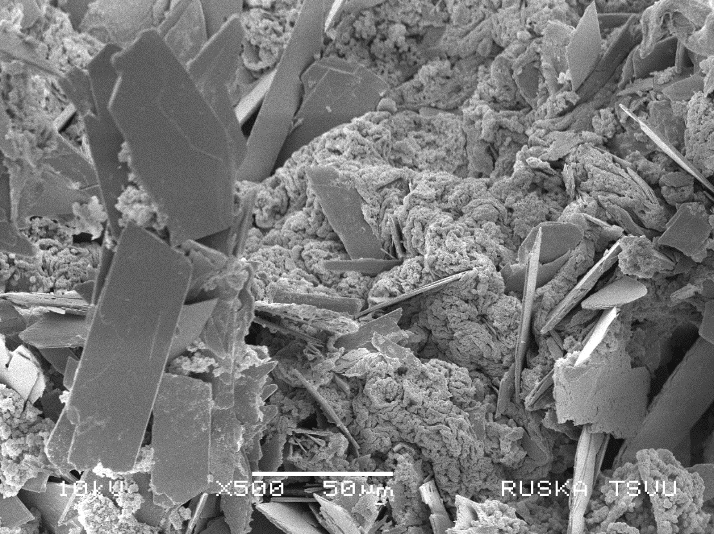



Biography (150 word limit)
Hi, Myself Mukkanti Saisankar, Completed B.tech in Food Technology at ANGRAU, Bapatla. Me and my classmates done thesis work in 6th semister on probiotics under guidance of one of my college associate teacher Mr.Anil Kumar. We are successfully Completed our thesis with best reference. And we want publish this thesis in other research papers.

Presenting author details
Full name: Mukkanti Saisankar
Email: saisankar.foodtech@gmail.com
Contact number: +91 9603932129
Twitter account: -
Linked In account: -
Session name/ number: -
Category: (Oral presentation/ Poster presentation)

Notes/Comments:

