Polyphenolic composition and antioxidant capacity of red wines made with the main grape varieties grown in Uruguay by two alternative methods of winemaking
Gustavo González-Neves^{1*}, María Pérez Serratosa², Guzmán Favre¹, Diego Piccardo¹
¹ Facultad de Agronomía. Universidad de la República. Avda. Garzón 780. C.P. 12900. Montevideo, Uruguay. ² Universidad de Córdoba. Plaza de Puerta Nueva s/n. 14002. Córdoba, Spain.

Abstract
The antioxidant capacity (AC) of wine is related to its polyphenolic composition. Genetic factors have a significant impact on the composition of grapes and wines. The wine-growing conditions modify the extraction of compounds from grape skins and seeds. The aim of this study was to evaluate the antioxidant capacity and the polyphenolic composition of the red wines of Merlot, Cabernet Franc, Cabernet Sauvignon, Syrah, Marselan and Tannat produced by two alternative methods of winemaking. The wines were elaborated by delayed extraction of anthocyanins plus extended maceration (DEA + EM) and by traditional maceration (TM). The wines were produced using 70 kg of grapes in each winemaking, with two replicates. The polyphenolic composition and AC were analyzed at 6 months after vinification. Phenolic families were quantified using classical spectrophotometric methods, while AC was evaluated using DPPH and ABTS methods. The AC values obtained with each method were significantly different. The wines of the different varieties showed significant differences in the polyphenolic composition. Tannat and Marselan wines had the highest antioxidant capacities and the highest polyphenol contents. Polyphenol indices were significantly correlated with AC measurements. Winemaking techniques showed a significant impact on the phenolic composition of the wines although this fact did not affect their AC. It can be concluded that the grape variety and the vinification conditions determined important differences in the polyphenolic composition and in the antioxidant capacity of the wines. The polyphenol contents of the wines of each variety presented great differences that can determine important variations in their sensory properties and chemical evolution.

Related Image
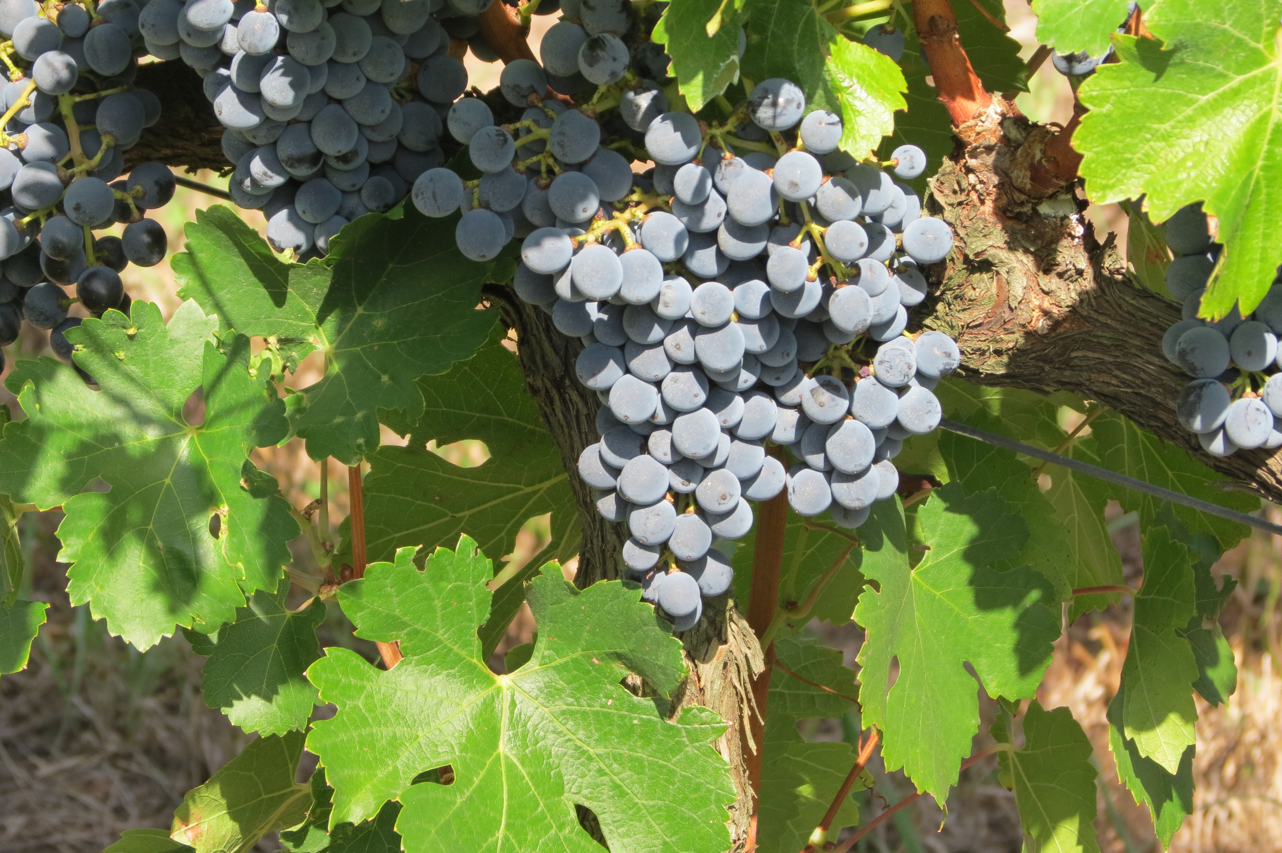

List of Recent Publications
1. González-Neves, G.; Favre, G.; Piccardo, D.; Gil, G. 2016. Anthocyanin profile of young red wines of Tannat, Syrah and Merlot made using maceration enzymes and cold soak. International Journal of Food Science and Technology 51(1), 260-267.
2. Ferrer, M.; Echeverría, G.; González-Neves, G. 2015. Influence of the microclimate defined by the training system on the vineyard behaviour and the oenological quality of Merlot grapes. International Journal of Agricultural Sciences and Natural Resources 2(4), 95-108.
3. González-Neves, G.; Gil, G.; Favre, G.; Ferrer, M.; Charamelo, D. 2015. Effect of cold pre-fermentative maceration on the color and composition of young red wines cv. Tannat. Journal of Food Science and Technology 52(6), 3449-3457.


Biography (150 word limit)
Professor of Enology. Department of Food Technology. Facultad de Agronomía. Universidad de la República, Uruguay. Since 1993. Dr. in Food Sciences. ENSAM. Université de Montpellier II, France. 2005. Master in Viticulture and Enology. Universidad Politécnica de Madrid, Spain. 1992. Agricultural Engineer. Facultad de Agronomía. Universidad de la República, Uruguay. 1987.

Presenting author details
Full name: Gustavo González-Neves
Email: gustavogn.fagro@gmail.com
Contact number: +598-98039948
Twitter account:
Linked In account: Gustavo González-Neves
Session name/ number: Food Processing, Preservation and Packaging
Category: Poster presentation

Notes/Comments: Red wines are the most produced in Uruguay. Tannat is the main grape variety grown in the country.

