Title: Proteolytic, lipolytic and microbiological changes in dry-fermented chicken sausages throughout the fermentation and drying process

Eda Demirok Soncu, PhD, Ankara University, Turkey
Seyma Yenioglu Demiralp, BSc, Ankara University, Turkey
Nuray Kolsarici, Prof. Dr., Ankara University, Turkey

Abstract
The purpose of the current study was determination the microbiological, proteolytic, and lipolytic changes in dry-fermented chicken sausages throughout the production process. The sausage dough was produced from skin-on chicken thigh meat, chicken skin, and following ingredients: salt (1.5%), garlic (2%), hot red pepper (0.5%), sweet red pepper (2%), cumin (1%), pimento (0.3%), black pepper (0.4%), saccharose (0.3%), sodium nitrite (0.01%), starter culture (0.05%). Upon kneading, the dough was stuffed into collagen casings in pieces of 150 g. Then, sausages were hang on and allowed to fermentation (3 days) and drying (11 days) process under controlled temperature and humidity conditions. The experiment was repeated three times. Total mesophilic aerobic bacteria (TMAB), lactic acid bacteria (LAB), Micrococcaceae, total yeast and mold counts, proximate composition, the changes in color, pH, TBARS, –SH groups, and sensory properties were determined during 14 days of production.

The moisture, protein, fat and ash content of final product were 32.48%, 30.79%, 29.67%, and 4.70% respectively. The pH value decreased from 6.24 to 4.66 at day 4 due to acidification activity of LAB (p<0.05). The initial counts of LAB, TMAB, Micrococcaceae, total yeast and mold were 2.47, 4.93, 1.63, and 2.50 log CFU/g, respectively. These values significantly increased during fermentation and reached to 9.29, 9.30, 6.58, and 5.24 log CFU/g, respectively. While LAB, TMAB, Micrococcaceae counts were stable during drying, total yeast and mold counts decreased (p<0.05). Darker and more redness color was measured during drying process (p<0.05). Regarding TBARS value, an indicator of lypolytic changes, a slight increase was determined during fermentation, but that value significantly raised from 0.71 to 3.32 mg MA/kg during drying (p<0.05). Alterations in proteins were measured by the loss of –SH groups during production. In the sensory panel, sausages were evaluated as having a darker color, soft texture, acidic taste and flavor.
Image
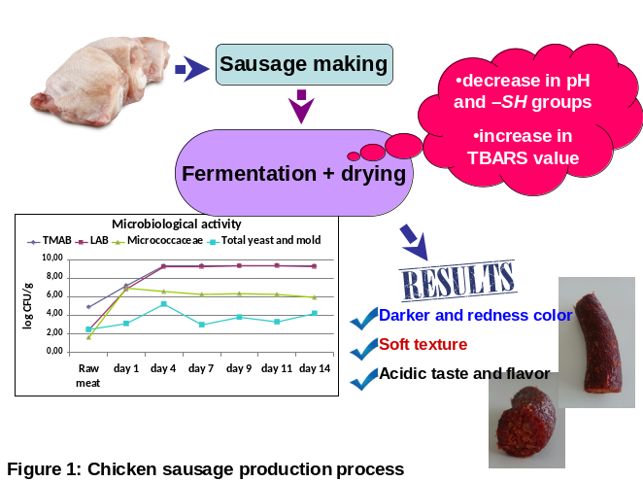
List of Recent Publications

Menegas LZ, Pimentel TC, Garcia S, Prudencio, SH (2013) Dry-fermented chicken sausage produced with inulin and corn oil: Physicochemical, microbiological, and textural characteristics and acceptability during storage. Meat Science 93(3):501-506.
- Bozkurt H, Erkmen O (2002) Effects of starter cultures and additives on the quality of Turkish style sausage (sucuk). Meat Science 61(2):149-156.
- Dalmış Ü, Soyer A (2008) Effect of processing methods and starter culture (Staphylococcus xylosus and Pediococcus pentosaceus) on proteolytic changes in Turkish sausages (sucuk) during ripening and storage. Meat Science 80(2):345-354.

Lizaso G, Chasco J, Beriain MJ (1999) Microbiological and biochemical changes during ripening of salchichón, a Spanish dry cured sausage. Food Microbiology 16(3):219-228.

Ordóñez JA, Hierro EM, Bruna JM, de la Hoz L (1999) Changes in the components of dry-fermented sausages during ripening. Critical Reviews in Food Science and Nutrition 39(4):329-367.

Biography

The presenting author graduated from Ankara University, Faculty of Engineering, Department of Food Engineering in 2007. In the same year, she applied for PhD candidate. During PhD, she worked as a visiting student at Texas A&M University, Poultry Science Department between 2011 and 2012. In 2014, she graduated from Ankara University, Department of Food Engineering and got PhD degree. The subject of her thesis was investigation of acrylamide in further processed chicken products during frying. She has been still working at the same department as a Dr. Research Assistant. From 2007 to date, she has been participated in 9 projects. She has 9 international and 4 national scientific papers. Additionally, she has presented a large number of presentations in 20 international and national scientific meetings. Her academic research area is meat science and technology, poultry science, food safety, food quality and nutrition.

Presenting author details
Full name: Eda DEMIROK SONCU
Email: edemirok@eng.ankara.edu.tr
Contact number:+90 554 732 5115
Twitter account:------
Linked In account: https://tr.linkedin.com/in/eda-demirok-soncu-b5b438138
Session name/ number: Food processing, preservation and packaging
Category: (Oral presentation/ Poster presentation): Poster presentation

